Buildserver-monitor

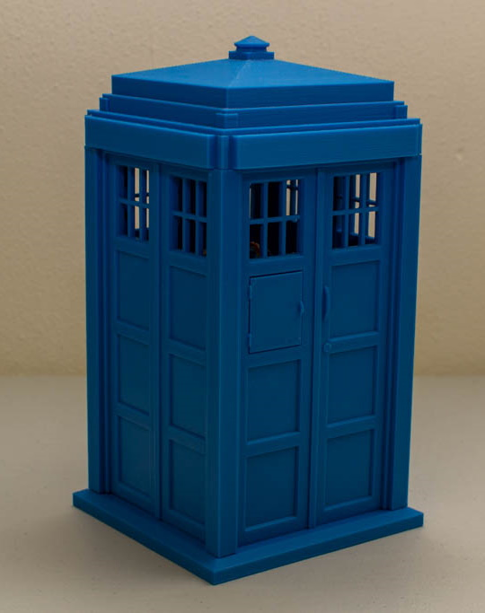

Index
Idea and intent 3
Wemos Lolin D1 mini Pro 4
Pins and how to connect things 5
Development environment 6
Arduino IDE 6
JSON library - build status parsing 11
NeoPixels library - LEDs 12
Power Circuit 13
NeoPixels – LEDs 14
A word of caution 14
Connection schematic 14
Schematic 15
Soldering 16
Connecting the NeoPixels to the power circuit 17
Programming the NeoPixels 18
WiFi connection 19
Connect to Jenkins 19
Software architecture 21
Led behavior 22
When the firmware is flashed the status of the device is made visible via the leds. 22
Note: this assumes commit 9863ed68b2598021881cdcebe3be6df746d04502, or the state of 17 May 2022. 22
Assembly 23
BOM – bill of materials 27
NeoPixel strand – 4 LEDs 28
Power Circuit 30
Micro-controller + charger 30
3D Housing 30

Idea and intent
The buildserver-monitor as presented here is intended to be a fun and functional gadget, a means to learn something new, to tinker with – all the while being useful as it can assist with quality control during the development of software.

The buildserver-monitor can be taught of as a DIY kit, a manual (this manual) which, if followed properly, will result in a functional electronic device that can read the status of a build server (Jenkins) via WiFi and display this status with some LEDs.

The firmware is written in C/C++, using the Arduino IDE. Configuration is required – but it is kept to a minimum and available via configuration files (mentioned later in this manual).

Later versions are expected to feature a small OLED screen (to display the branch name), a vibration motor and a buzzer.

Wemos Lolin D1 mini Pro
The buildserver-monitor uses a Wemos Lonin D1 mini Pro module as controlling heart of the system. It features an ESP-8266EX microcontroller to do the processing, a WiFi module and some GPIO pins to communicate with peripherals. Programming (and charging the battery) is done via USB.
The board:
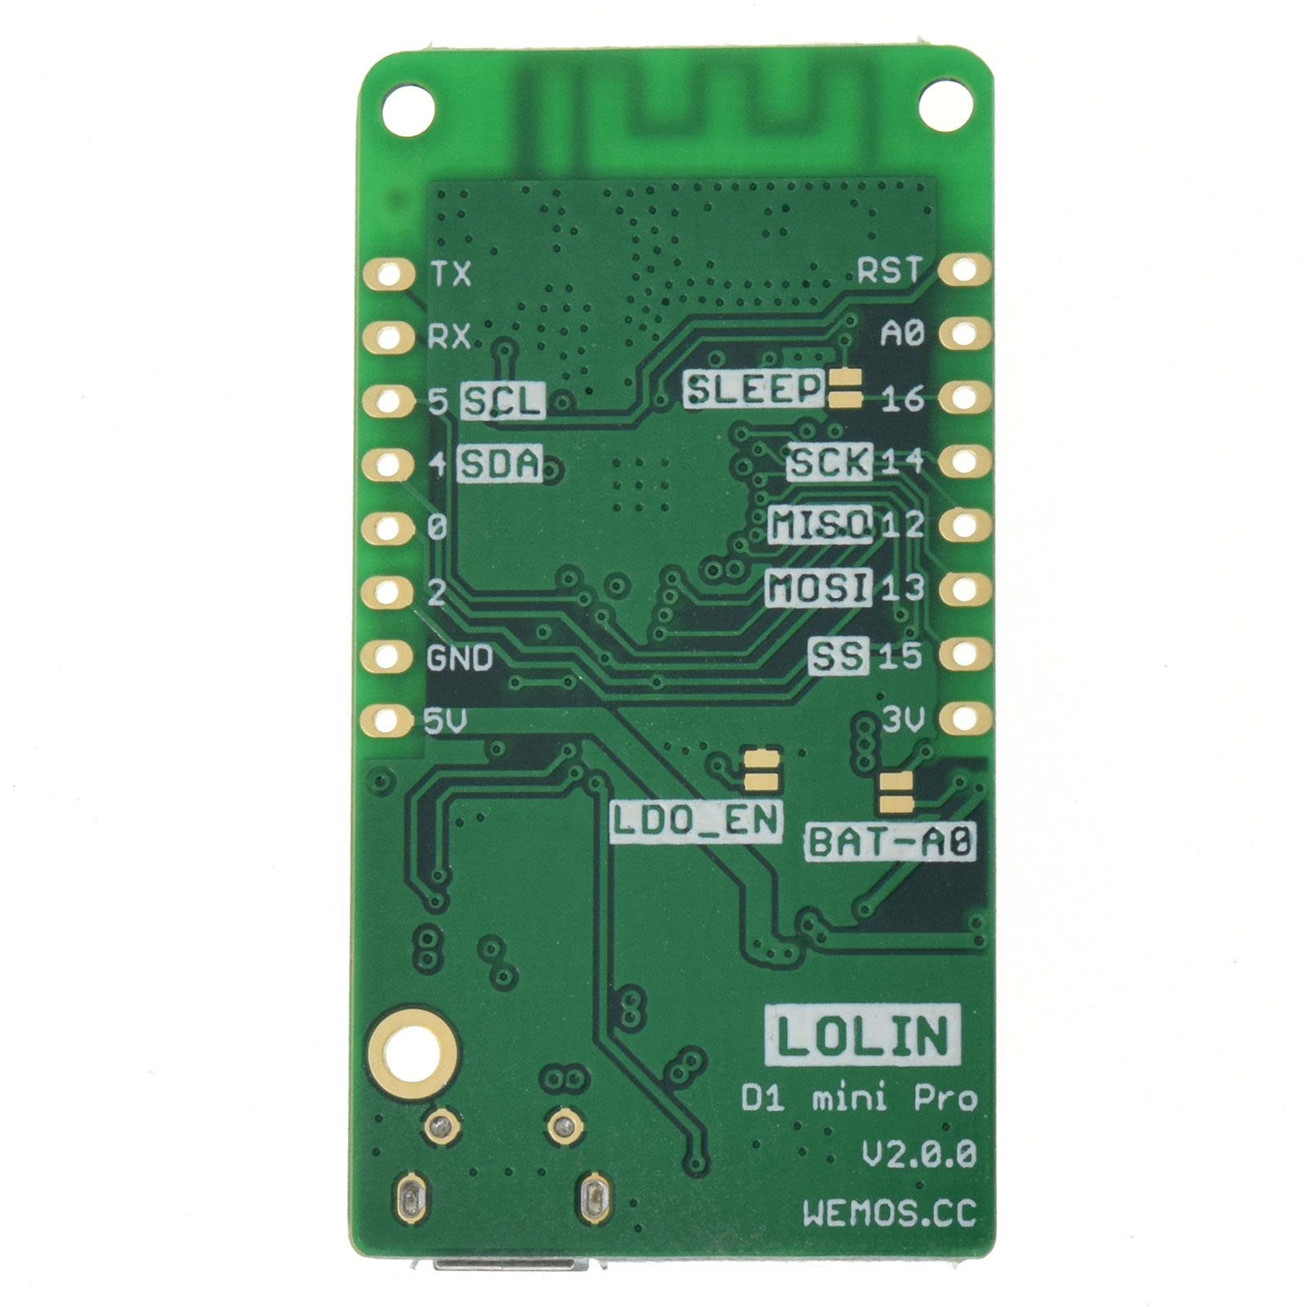
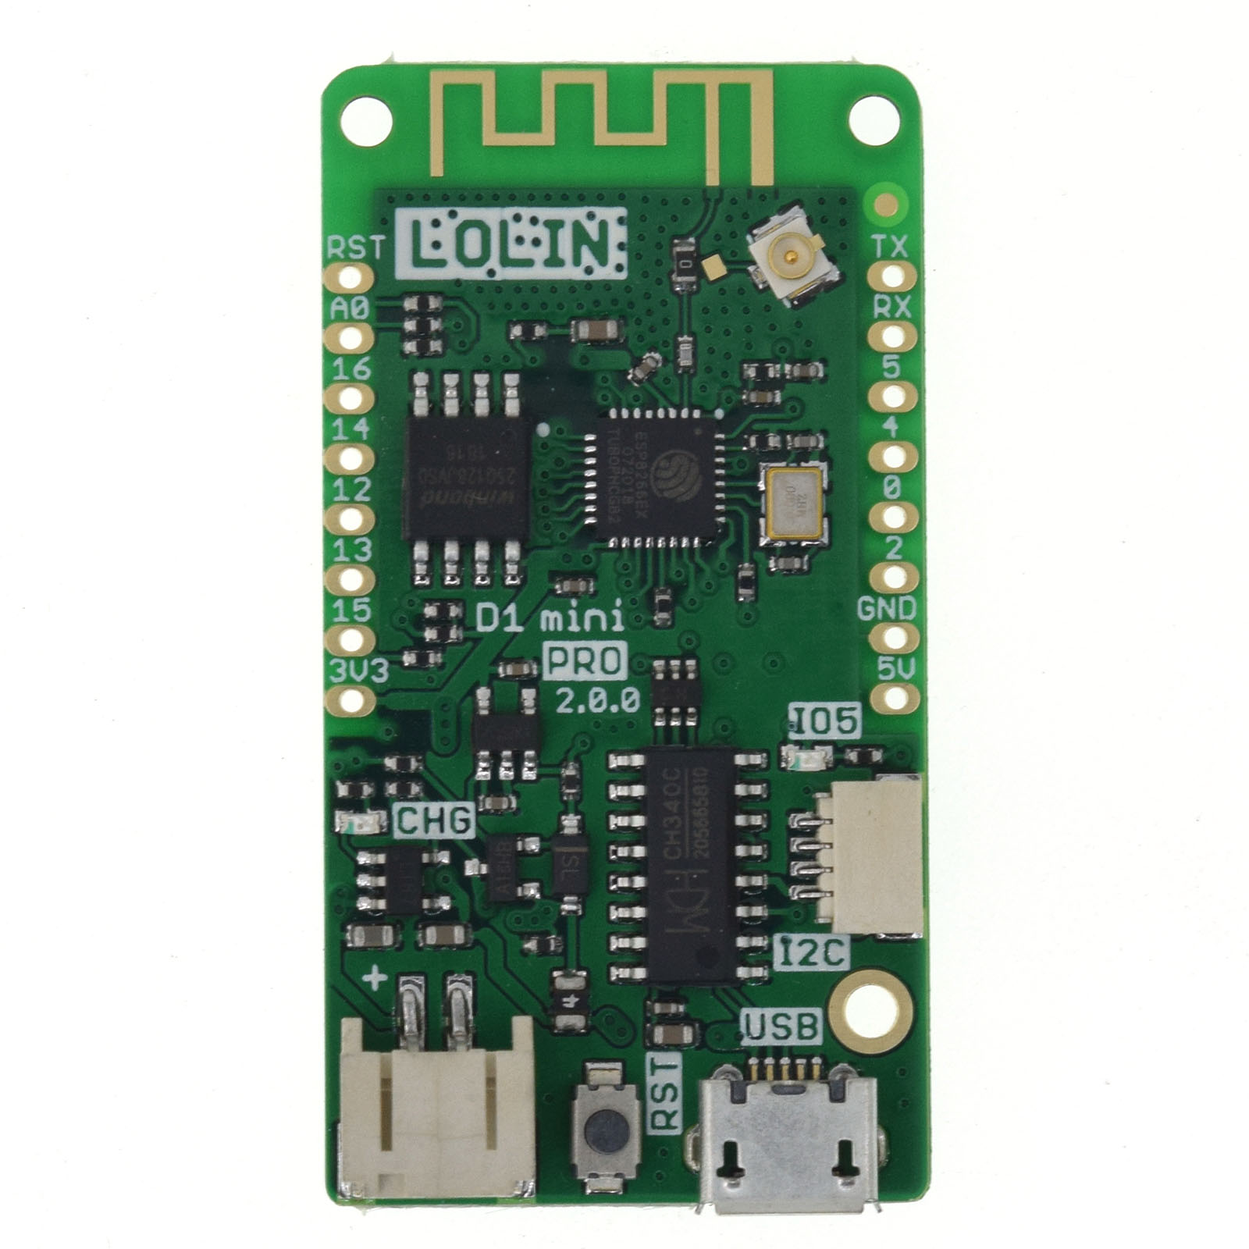

Pinout:
Pin | Function | ESP-8266 Pin
TX | TXD | TXD
RX | RXD | RXD
A0 | Analog input, max 3.2V | A0
D0 | IO | GPIO16
D1 | IO, SCL | GPIO5
D2 | IO, SDA | GPIO4
D3 | IO, 10k Pull-up | GPIO0
D4 | IO, 10k Pull-up, BUILTIN_LED | GPIO2
D5 | IO, SCK | GPIO14
D6 | IO, MISO | GPIO12
D7 | IO, MOSI | GPIO13
D8 | IO, 10k Pull-down, SS | GPIO15
G | Ground | GND
5V | 5V | -
3V3 | 3.3V | 3.3V
RST | Reset | RST

If no peripherals (other than the NeoPixels) are used, then only GPIO2 (D4) is used.
More information of the board can be found at the manufacturers website:
https://www.wemos.cc/en/latest/d1/d1_mini_pro.html

Or in the manufacturers datasheet of the microcontroller:
https://espressif.com/sites/default/files/documentation/0a-esp8266ex_datasheet_en.pdf

Pins and how to connect things
https://randomnerdtutorials.com/esp8266-pinout-reference-gpios/
(note: the pinout of the Wemos Lolin D1 mini / Pro is the same).

Development environment
The setup of the development manual is described for a Windows 10 PC, note that development is certainly not limited to this.

Arduino IDE
The Arduino IDE is used as default IDE for source code creation. Download the Arduino IDE from the official website: https://www.arduino.cc/en/Main/Software (the windows installer, not the app)

Install the Arduino IDE.

Goto "File->Preferences". Add the following URL to "Additional Boards Manager URL":
https://arduino.esp8266.com/stable/package_esp8266com_index.json

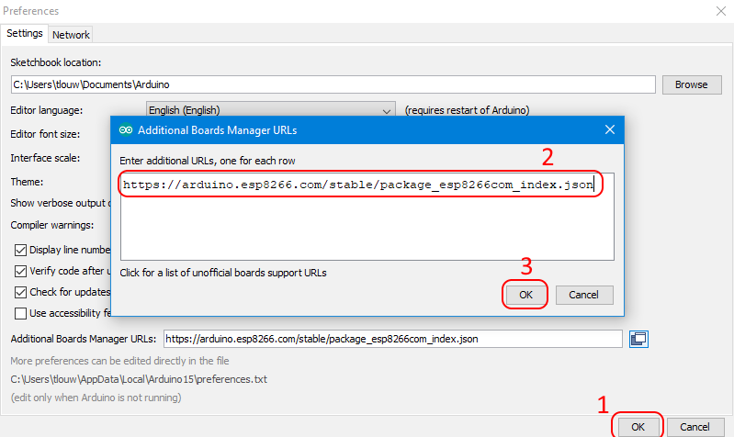
Goto "Tools->Board [...]->Board Manager".
Enter: "esp8266", then select the package and "Install".
This will take some time. Once done click "Close".
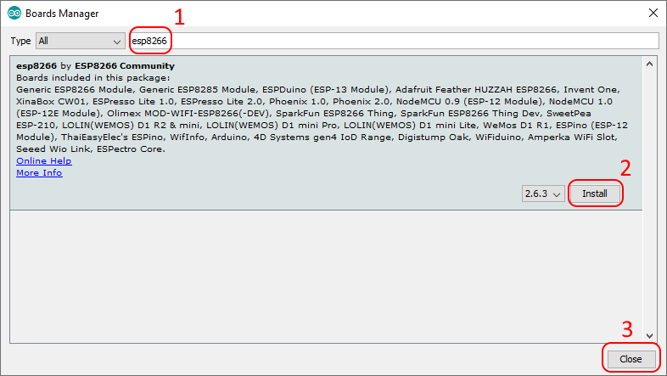
Click "Close".

Select the proper board, goto: "Tools -> Board […] -> ESP8266 Boards (…) -> LOLIN(WEMOS) D1 mini Pro".

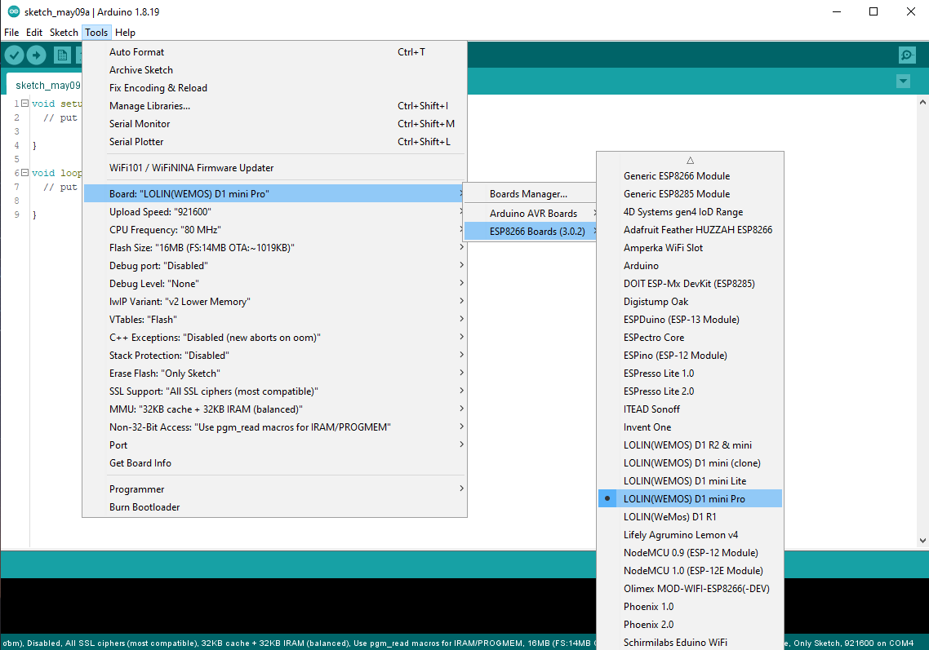
Insert USB cable with the board connected. The battery does not need to be connected.

Goto: "File -> Examples -> ESP8266", select "Blink". Note the ESP8266 is under the “LOLIN(WEMOS) D1 mini Pro” part.

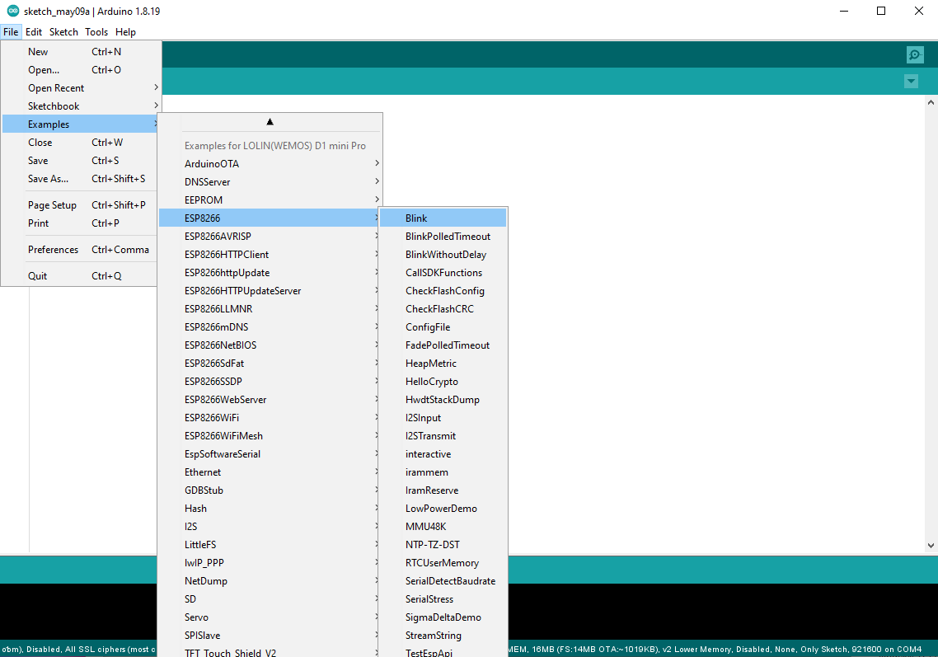
Compile and run the application, it should be downloaded to the Wemos device, after which it will run automatically. At this point the Blue led should be blinking.

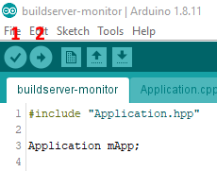
Compile the application by clicking (1), the Verify button.
Output of the compilation process is shown in the output windows at the bottom of the screen.

Upload (and run) the application by clicking (2), the Upload button. This will transfer the build application to the Wemos.

Modify the code slightly by adding the "Serial.begin()" and some print statements. Note the baudrate. Since Tx is also the Blue led, we cannot toggle the led and use Serial.println() at the same time.
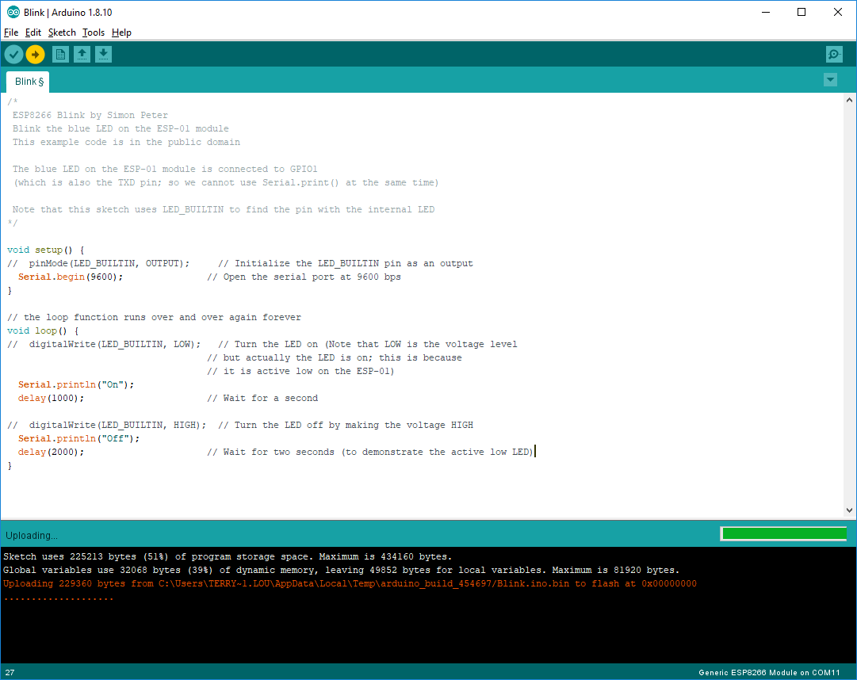
Compile and run the application, it should be downloaded to the Wemos device, after which it will run automatically.

Open the debug window: goto: "Tools -> Serial Monitor". Fill the proper baudrate.

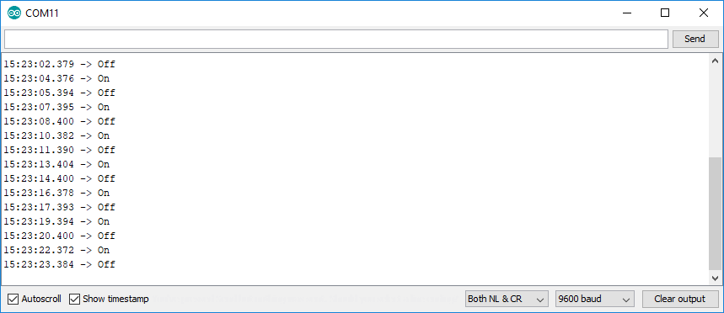
Congratulations, the development environment works!

JSON library - build status parsing
To parse the Jenkins build status we need a JSON library to assist us.
Goto: “Tools -> Manage Libraries...”.
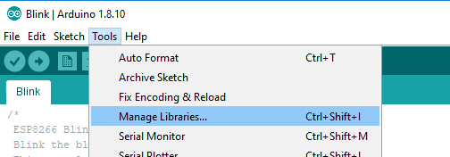
Enter: "json", then select the "ArduinoJSON" library. Click "Install".
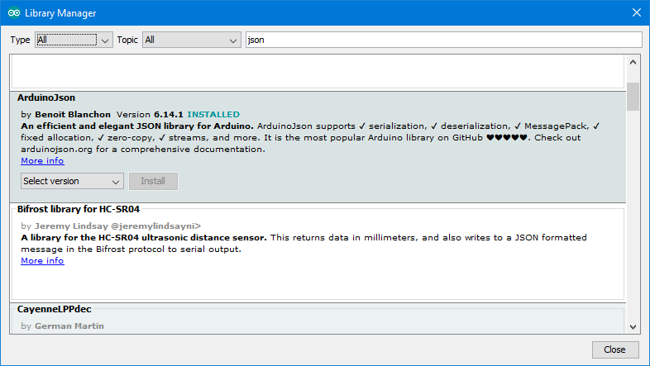
Examples are on its info page: https://arduinojson.org/?utm_source=meta&utm_medium=library.properties

NeoPixels library - LEDs
Goto: “Tools -> Manage Libraries...”.
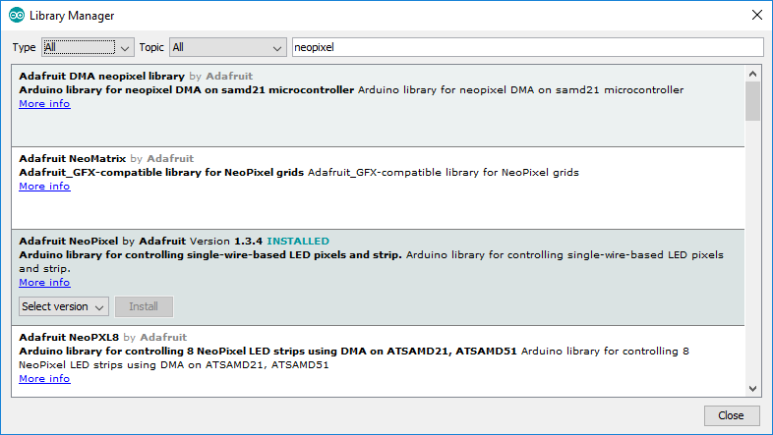
Enter: "neopixel", then select the "Adafruit NeoPixel by Adafruit" library. Click "Install".

Examples are on its info page: https://github.com/adafruit/Adafruit_NeoPixel

Power Circuit
The unit is to be powered via a Li-Po battery. The Wemos device has a charging circuit, which eases handling the battery and prevents overcharging it. Simply connect a USB cable, as long as this is connected the battery will be charged. Charging voltage is 4.2V.

The micro-controller (ESP-8266EX) has an operating voltage of 3.3V. The board has a step-down which provides the proper voltage to the micro-controller, regardless if the battery is being charged or not.

Changes made are:
- The + and – pins are reversed on the battery. The Wemos device has it different than the default of how the battery was provided – we swapped them on the battery side.
- An on/off switch is added – it is placed in series with the + line of the battery. This allows to switch off the entire device, but requires it to be on while charging the battery.

The micro-controller (ESP-8266EX) has an operating voltage of 3.3V. The board provides a voltage regulator which makes sure the right voltage is applied to the micro-controller, regardless if the battery is being charged or not.

Schematic:
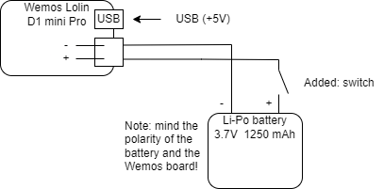

NeoPixels – LEDs
NeoPixels are (in short) uniquely addressable RGB LEDs which can be chained together in large strands. Each led can be colored and dimmed individually.
See: https://learn.adafruit.com/adafruit-neopixel-uberguide/the-magic-of-neopixels for more information.
These LEDs are quite handy for this project for 2 reasons:
- Each led can be addressed individually, meaning in a strand each led can have a different color and brightness.
- They have their own PWM generator inside, meaning they can be set once to a brightness and no need to provide a PWM signal to each LED.
- The Arduino library for controlling these LEDs is quite mature, meaning we can easily integrate it in the project.
The NeoPixels come in a lot of different shapes and sizes, the ones used in the project are these:
https://www.adafruit.com/product/4356
Note: they are available in different pack sizes, take a look at the BOM where to find them more cheaply.

A word of caution
There are several instances in the NeoPixel guide where the user is warned about how to connect and power the LEDs.
The LEDs used by this project can be powered by 3.3V – the same voltage as the data line. A resistor close to the LEDs is placed to prevent spikes on the data line (corrupting communication with the LEDs) and a large capacitor on the power supply is placed to prevent damage to the LEDs and/or micro-controller.
The connection schematic is adapted with these remarks in mind.

Connection schematic
The data-sheet tells us that a logic high input will be detected at a minimum voltage of 0.7 * Vcc. We connect the LEDs directly to 3.3V. The logic high input is the data line from the micro-controller, which is also 3.3V. Taking the formula from above: 0.7 * 3.3 = ~2.3V, this means the 3.3V of the data line is sufficient and will be detected properly by the LEDs. Using 3.3V to power the LEDs (and not 5V) means the LEDs are slightly dimmed and consume a little less energy. Note that we can only connect a few LEDs else we draw too much power causing issues with Vcc.

Schematic
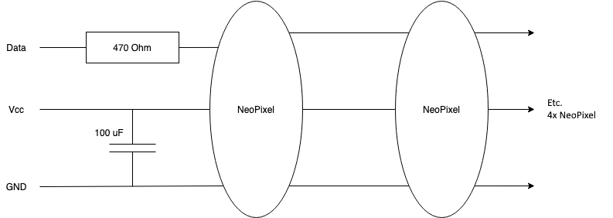
The intend is to have a strand of 4 NeoPixels in total.

Soldering
Soldering the NeoPixels is quite straightforward: with a soldering iron with a small tip, a steady hand and a little patience they are assembled without much trouble.
Each NeoPixel has a direction arrow on the back:
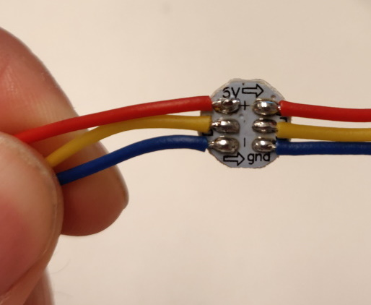
Some tips:
- Make sure the heat of the soldering iron is high.
- Try to avoid heating a soldering pad for too long, this will break the component eventually. As rule of thumb: the shorter the better.
- Put some soldering tin on the pads and wires first, before connecting them. This makes it easier to join the two.
- Do not use to much soldering tin, you really do not need that much.

After the soldering the end result will look somewhat like this:
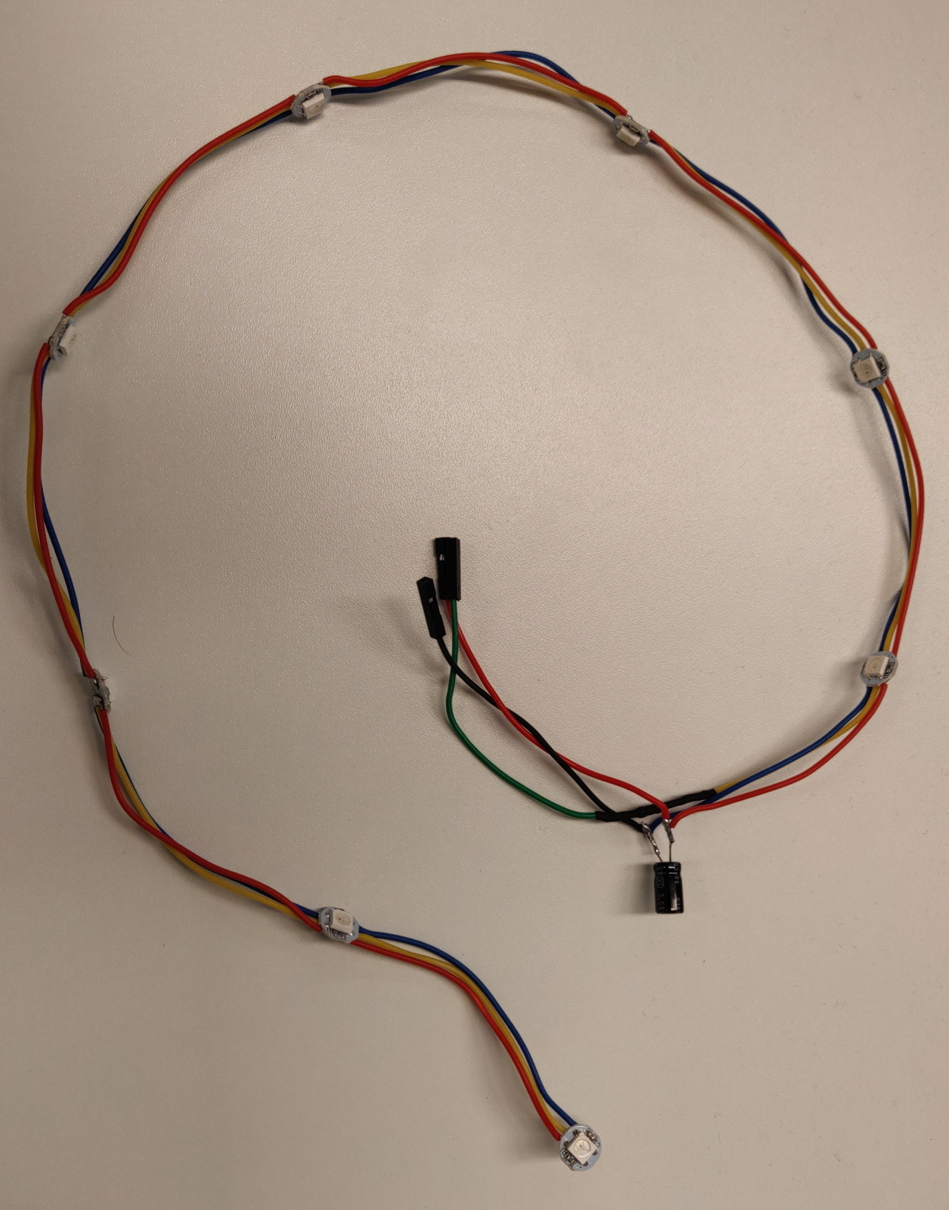
The 470 Ohm resistor is hidden under some shrink tubing in the image.

The wire ends are made of some jumper wire ends, for easier assembly in the unit later.

Some shrink tubing is used to prevent many open pieces of metal/wire.

Note: if a single NeoPixel is/gets damaged the entire chain does not work. Best to test the entire strand first in separation, before trying the full application.

Example code for a strand of 5 leds is available here: https://github.com/tlouwers/buildserver-monitor/commit/ac570f306501735aabdafa7b3580a849af753960
Make sure to set the define “NUMBER_OF_NEOPIXELS” to the correct number of leds in your connected led strand!

Note: the final version will use 4 leds.

Connecting the NeoPixels to the power circuit
To connect the NeoPixels, the ESP-01 and the Power Circuit, the following schematic is used.
The idea is to have the NeoPixels be powered directly from the battery – this would be 4.2V when charging, ~3.7V when operating on battery only. The Data is connected to pin GPIO_2 on the ESP-01, this is at 3.3V.

By connecting things such, the switch allows the buildserver-monitor to be turned off completely (although the battery still can be charged while the unit is off). In case a hard reset is needed, the entire enclosure does not need to be oped to do so.

Schematic:
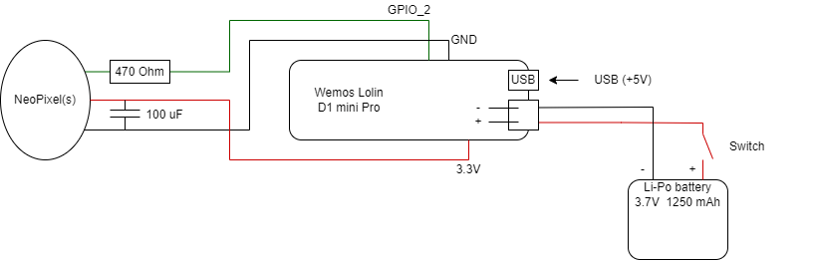

Programming the NeoPixels
The ‘Development Environment’ section describes how to install the NeoPixel library used for controlling the LEDs.

The NeoPixels are controlled via a single data line. Commands are send to each pixel individually or to a range. For this purpose the NeoPixel library needs to be configured to the correct number of NeoPixels in the strand and the GPIO pin to use. Defaults are set in the ‘config.h’ file.

To ease programming, a ‘Led’ class is created which can set a single, or all LEDs to a specified color. Note that much more functionality is available in the library.

WiFi connection
To be able to connect via WiFi to a build-server (Jenkins is assumed), some configuration must be done.

Connect to Jenkins
The current build assumes:
- A 2.4 GHz WiFi network, secured via WPA2
- A build PC running Jenkins
- Jenkins requires an https connection
- Jenkins requires a login via a user (monitor) account.

In the file ‘wifi_config.h' the connection parameters for connecting to the WiFi network need to be set:
- WIFI_SSID This is the SSID (name) of the network to connect to.
- WIFI_PASSWORD This is the password needed to connect to the network.

In the file ‘http_config.h' the connection parameters for the build PC need to be set.
- USERNAME This is the user (monitor) account to log in to Jenkins – is the name generated with the token. This could be a user email address for instance.

- BASIC_AUTHENTICATION_TOKEN This is the basic authentication token belonging to the user and is used as alternative to the password to login to Jenkins. This token can be acquired by logging in to Jenkins via the user (monitor) account and generate the token from within Jenkins.
To create a User API Token in Jenkins:
- Log into Jenkins.
- Click on your username (in the top right).
- Click on “Configure” (on the left).
- Under the “API Token” section, click on “Add new Token”, and “Generate” and record the generated token.
Note: it is not required to give the token a name: the username is used, not this name.

- JENKINS_API_URL This is the full URL to the Jenkins job to retrieve the build status from. Typically this is the lastBuild. The buildserver-monitor only uses the result from this build, thus we request only this information from Jenkins by adding the “?tree=result” after the “/api/json” part. The entire URL is expected to have the following format:
https://{server}/{job}/lastBuild/api/json?tree=result

For instance: https://dummy_server.com/job/my_project/job/branch_name/lastbuild/api/json?tree=result
Note: to test put this entire URL in the browser and check if the JSON file of the build is shown.

- SHA1_FINGERPRINT[FINGERPRINT_SIZE] Between the curly brackets ‘{}' the SHA1 hash of the https connection to Jenkins is to be stored.

The SHA1 has is used by the buildserver-monitor to check if the server connected to (Jenkins) is who it claims it is (what Chrome does with the certificate).

Example (assuming the Chrome web browser is used):
- Login to Jenkins using the USERNAME and initial user password.
- Click the ‘lock’ icon (top left), open the Certificate by clicking on it.
- Goto the ‘Details’ tab.
- Note/write down the expiration date. It is good to write this date in the comments near the SHA1 hash, once this date is reached the SHA1 hash needs to be retrieved/refreshed again.
- Note/write down the ‘Fingerprint’. This is the SHA1 hash that needs to be added between the curly brackets.

Software architecture
The architecture of the buildserver-monitor is kept simple as the main goal of the device is to be a simple to build gadget.

The code works its way through a main application loop, a state machine.
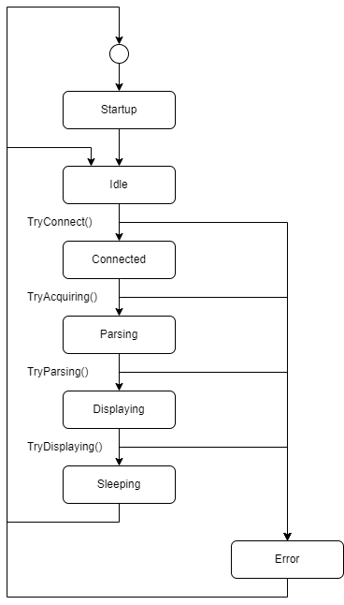

The device will startup, then try to make a WiFi connection to the (Jenkins) build-server. It tries to fetch a build result (*.json file), which is then parsed. If a build result can be found then the status of the build is displayed, after which the device goes to sleep to save power. After some time the cycle is repeated.
If anything goes wrong the device enters an error state: here the WiFi connection is closed (if needed) and the device resets itself.

Led behavior

When the firmware is flashed the status of the device is made visible via the leds.

Note: this assumes commit 9863ed68b2598021881cdcebe3be6df746d04502, or the state of 17 May 2022.
Color | Meaning
White | Either:  - Before/during initialization: the NeoPixel strand is not yet initialized via code.  - Branch status is NOSTATE (should not occur)
Blue (1 led) | During initial startup, when trying to connect to the WiFi network.
Red (blinking) | An error occurred which is not recoverable. Will blink for 10 seconds, then the board will reset itself.
Green | Branch status is SUCCESS
Yellow | Branch status is UNSTABLE
Red | Branch status is FAILURE
Blue | Branch status is ABORTED
Purple | Branch status is NOTBUILD

Assembly
For the assembly a 3D printed model of the Tardis is used; this looks similar to an old fashioned phone booth. The model can be retrieved here (from Thingyverse).

All items are to be printed at 100% of the original size. This to make sure the unit is large enough for all components to fit inside.

The following files need to be 3D printed:
- 1 x TARDIS_base_ring
- 3 x TARDIS_panel_x3
- 1 x TARDIS_panel-door
- 1 x TARDIS_top_ring
- 1 x TARDIS_roof
- 1 x OLD_LED_holder
- 1 x TARDIS_lamp_top_grooved
- 1 x TARDIS_switch_bracket

The other files are not needed for this project.

Using a simple glue gun we attach some of the components together.
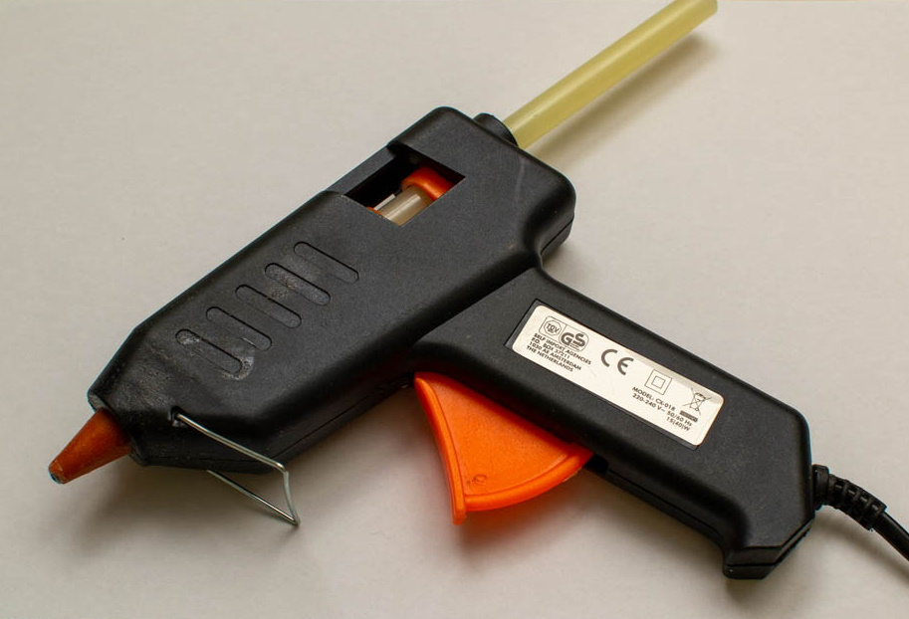
Starting with the LEDs on top of the OLD_LED_holder:
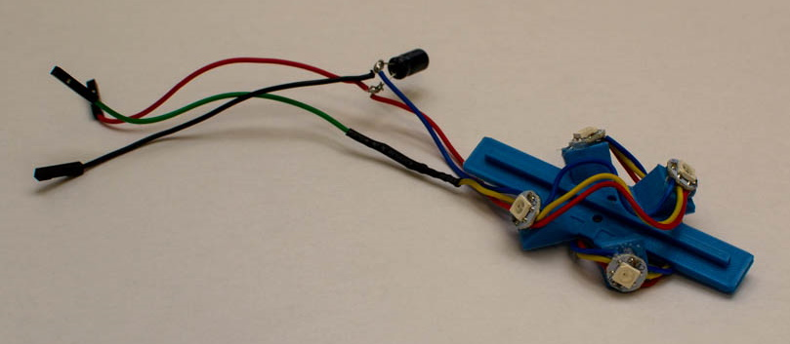

On one of the door panels (TARDIS_panel_x3) we glue the battery. Here we also glue the LED support and the switch support.
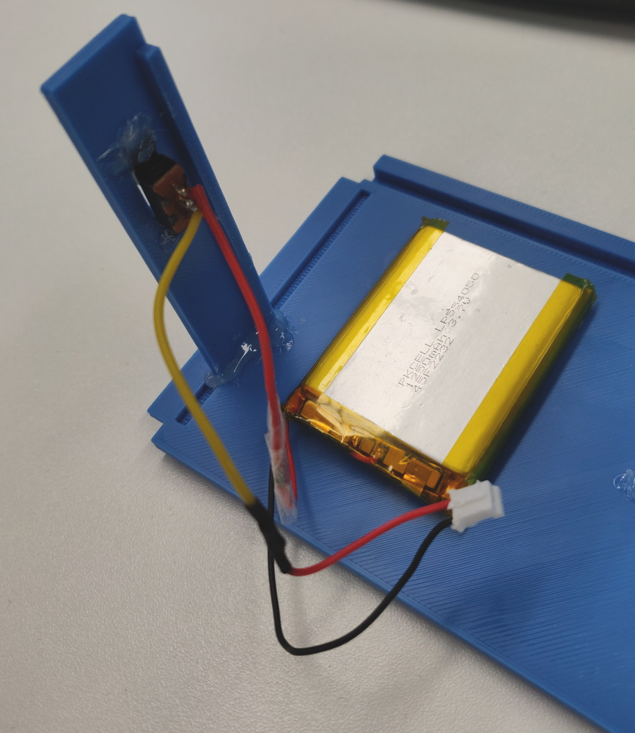
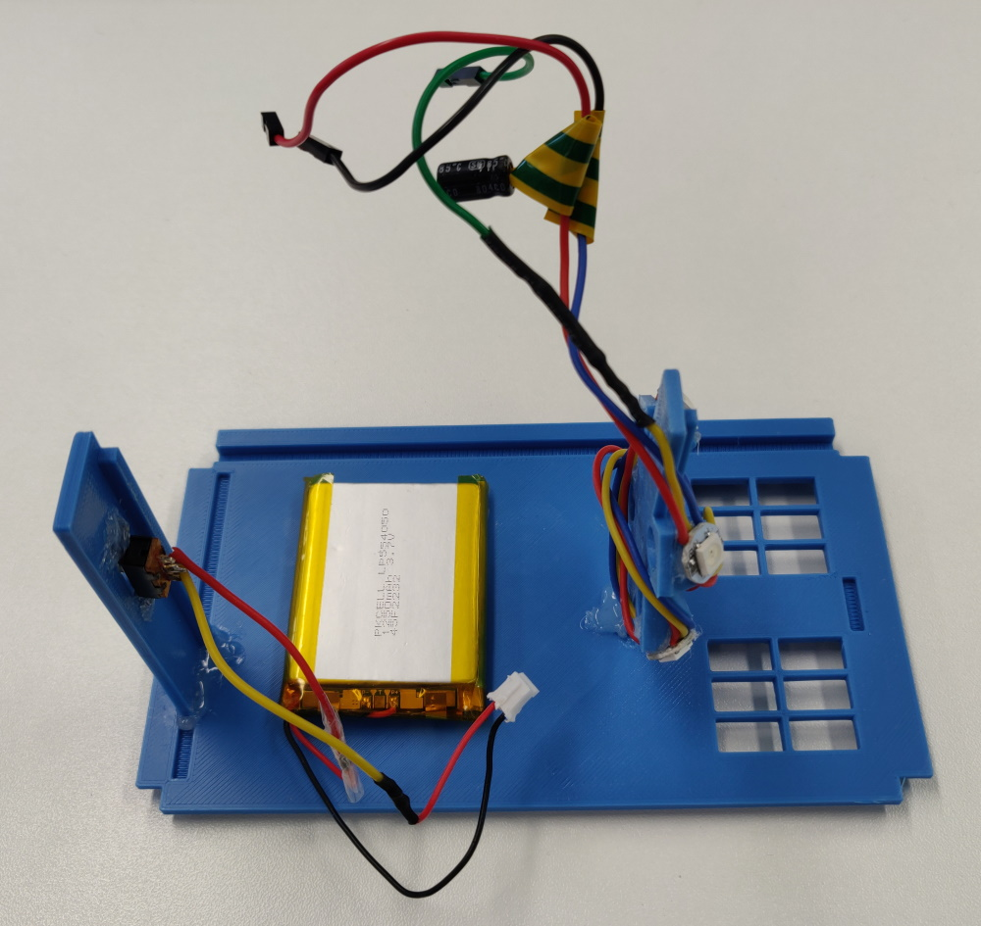

By gluing all on a single panel we can more easily take the unit apart if something breaks done and a repair is needed.
The micro-controller is added by some scotch (tape) put on top of the battery. Connect the battery and LEDs strand as in the picture:
- Vcc for the LEDs (red wire) to the 3.3V pin
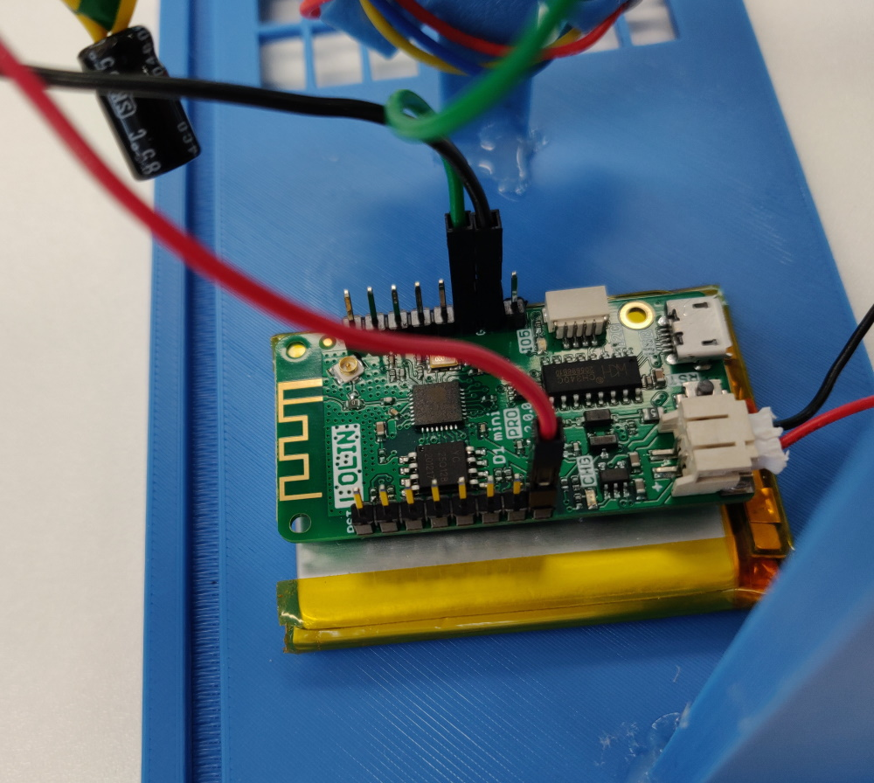
- GND (black wire) to GDN
- Data (green wire) to GPIO_2

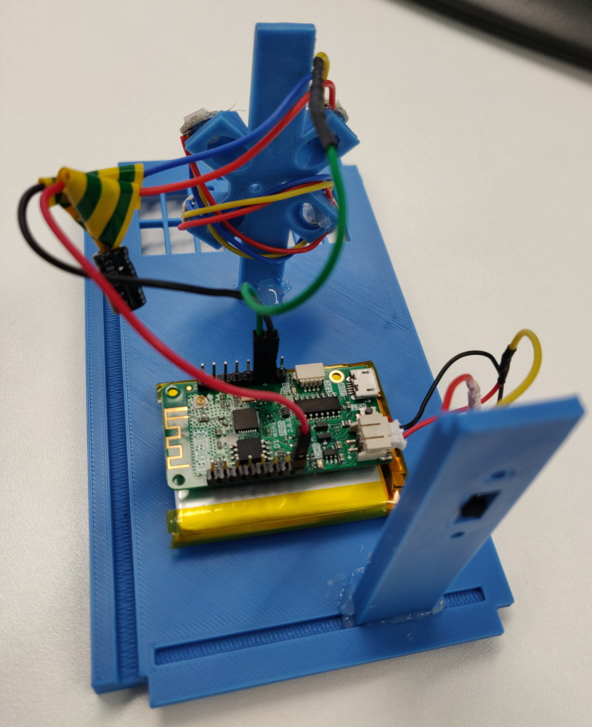

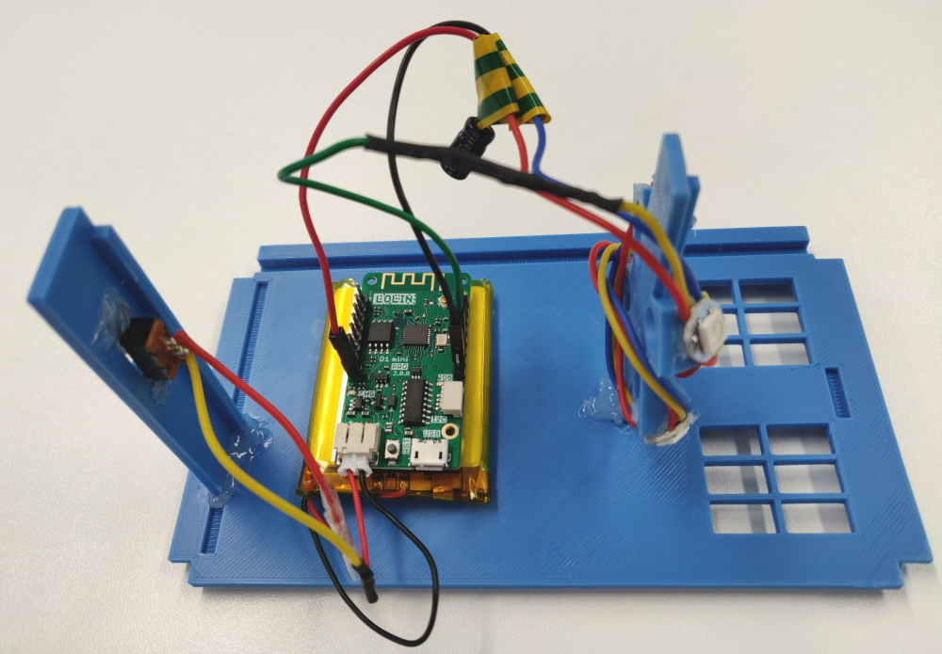
Which is then followed by carefully putting it together. Note that the base ring underneath the unit should be the open one, else the switch cannot be operated.
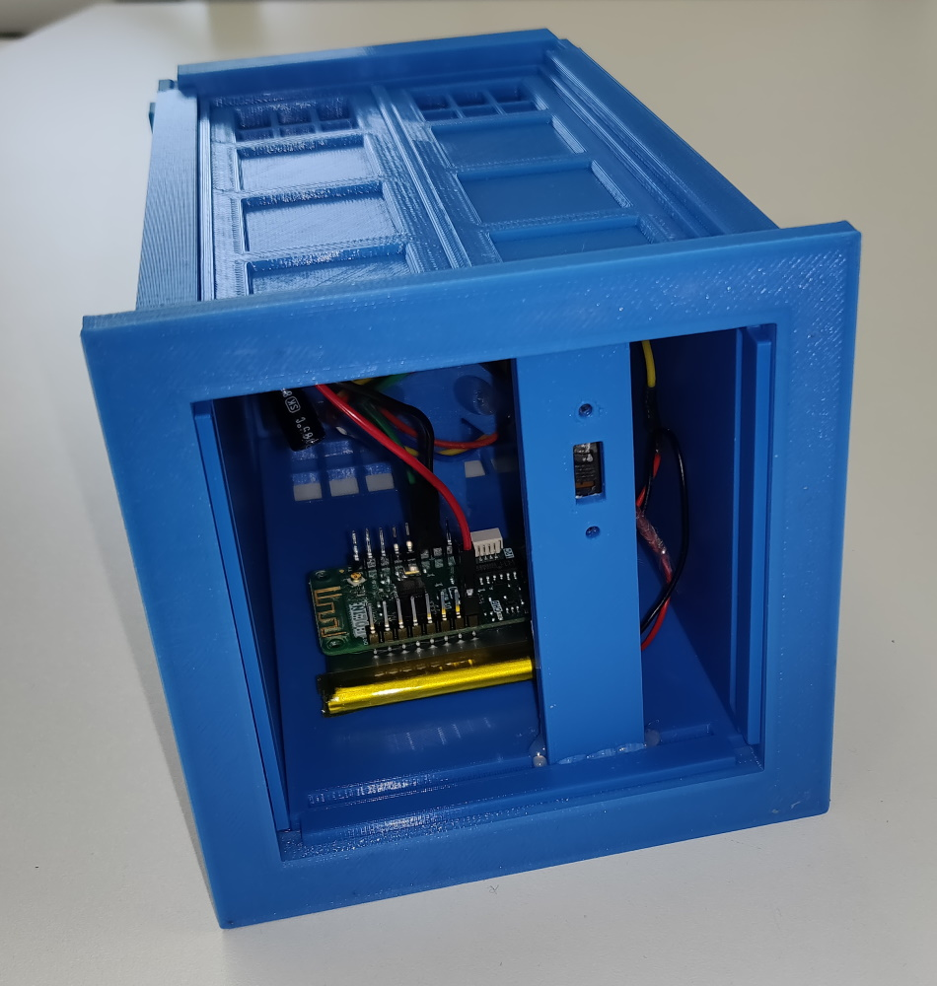

The TARDIS_lamp_top_grooved is simply glued to the TARDIS_roof.
Fully assembled the unit looks like this:
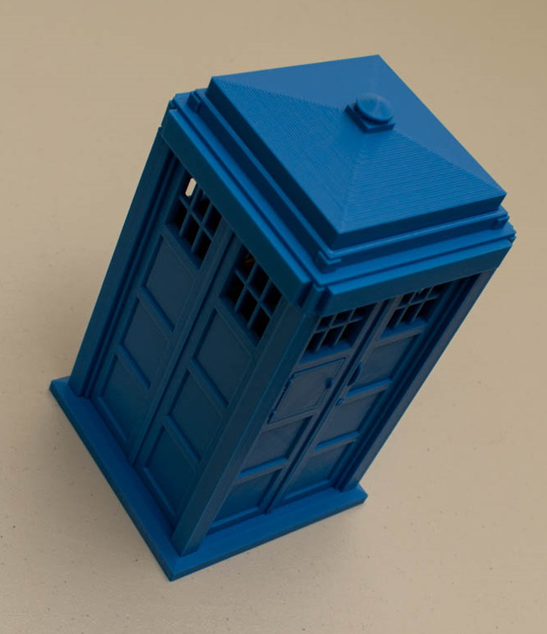

BOM – bill of materials
Described below is the list of components used for the buildserver-monitor.
Note: the URLs in this document are used as example and often show a picture of the component required – most of this can be ordered via something like AliExpress, or via your local electronics shack. Prices probably be better there as well.

NeoPixel strand – 4 LEDs
pieces | details
8 | NeoPixel Button PCB  https://www.adafruit.com/product/1612  note: these can be ordered at different locations and in different pack sizes, for instance:  https://nl.aliexpress.com/item/32966321827.html?spm=a2g0o.productlist.0.0.30c6206aaSIyUB&s=p&algo_pvid=7773d8dd-fb90-427f-bdfd-372e26ecd068&algo_expid=7773d8dd-fb90-427f-bdfd-372e26ecd068-1&btsid=2594c913-d050-4b27-a4c1-55f1e67105bb&ws_ab_test=searchweb0_0,searchweb201602_8,searchweb201603_55
1 | Resistor, 470 Ohm, ¼W, 1%  https://www.tinytronics.nl/shop/nl/componenten/weerstanden/weerstanden/470%CF%89-weerstand
1 | Capacitor, 100 uF, 25V  https://www.tinytronics.nl/shop/nl/componenten/condensatoren/100uf-25v-elektrolytische-condensator  note: the NeoPixelUberGuide uses 1000 uF, but this seems a bit much for the amount of NeoPixels we use.
3 (colors) | Wire, about 50 cm – use different colors: red, black, green  https://www.tinytronics.nl/shop/nl/kabels-en-connectoren/kabels-en-adapters/prototyping-draden/losse-draden/alpha-wire-draad-enkeladerig-solide-%C3%B81.5mm-0.33mm2-rood-1m
3 | Jumper wires, 20 cm, female-female  https://www.tinytronics.nl/shop/nl/kabels-en-connectoren/kabels-en-adapters/prototyping-draden/dupont-compatible-en-jumper/dupont-jumper-draad-female-female-20cm-10-draden

Optional:
pieces | details
1 | Heat shrink tubing  https://www.tinytronics.nl/shop/nl/gereedschap-en-montage/installatie-en-montagemateriaal/krimpkousen/krimpkous-kit-zwart  Or: some tape will do as well. The intent is to shield some of the open connections.

Final result:
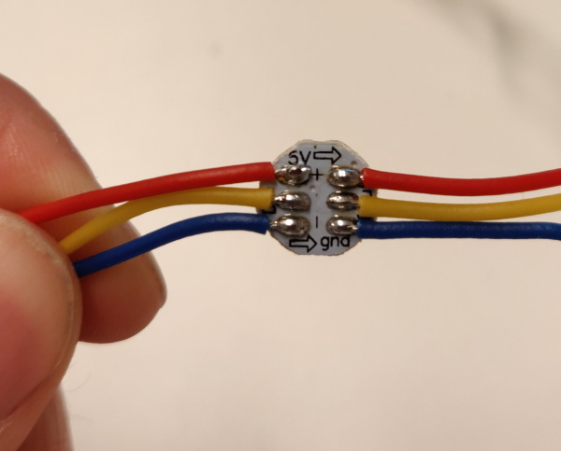
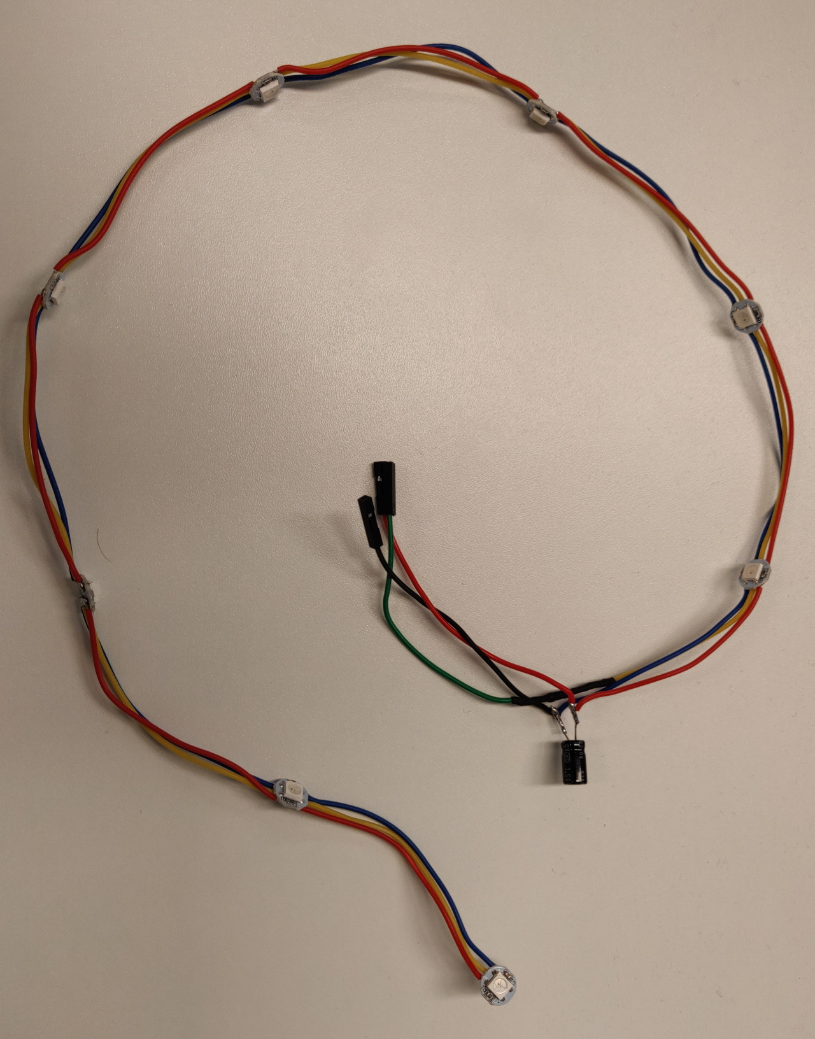
Displayed is a strand of 8 pixels, we only require 4 for the project.

Power Circuit
pieces | details
1 | Battery – LiPo – 1250 mAh  https://www.tinytronics.nl/shop/nl/power/batterijen/li-po/li-po-accu-3.7v-1250mah-jst-ph-lp554050
1 | Switch  https://www.tinytronics.nl/shop/nl/schakelaars/manuele-schakelaars/schuifschakelaars/inbouw-schakelaar-on-off-ss22g08

Optional:
pieces | details
1 | Heat shrink tubing  https://www.tinytronics.nl/shop/nl/gereedschap-en-montage/installatie-en-montagemateriaal/krimpkousen/krimpkous-kit-zwart  Or: some tape will do as well. The intent is to shield some of the open connections.

Micro-controller + charger
pieces | details
1 | Wemos Lolin D1 mini Pro  https://www.tinytronics.nl/shop/nl/development-boards/microcontroller-boards/met-wi-fi/wemos-lolin-d1-mini-pro-v2-esp8266-ch340c

3D Housing
As example it is the Tardis model, but feel free to pick your own. If you have a 3D printer or know someone who can create this it will be your best option, else look for a service which can do it for you.
pieces | details
1 | Tardis Deluxe Kit.  Model: https://www.thingiverse.com/thing:124033

