Architecture

This document describes the architecture of the main application.

Inhoudsopgave
Architecture 1
Architecture 2

Architecture

The architecture of the buildserver-monitor is kept simple as the main goal of the device is to be a simple to build gadget.

The code works its way through a main application loop, a state machine.
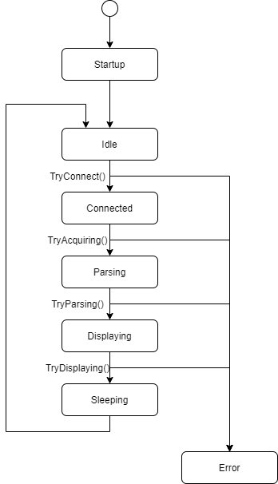

The device will start up, then try to make a WiFi connection to the (Jenkins) buildserver. It tries to fetch a build result (*.json file), which is then parsed. If a build result can be found the status of the build is displayed, after which the device goes to sleep to save power. After some time the cycle is repeated.
If anything goes wrong the device enters an error state: here the WiFi connection is closed (if needed) and the device resets itself.

