**The OECD Fragility Clusters are, well, Fragile**

The [OECD](http://www.oecd-ilibrary.org/development/states-of-fragility-2015_9789264227699-en) made an important decision recently to disaggregate their annual “fragile” designation for countries into five constituent dimensions or clusters of fragility: Violence, Justice, Institutions, Economic Foundations, and long term Resilience. On the one hand, it [shows](http://www.ua.undp.org/content/undp/en/home/presscenter/articles/2015/03/27/undp-welcomes-new-oecd-report-on-fragility-.html) [conceptual](http://www.afdb.org/en/news-and-events/article/oecd-report-on-states-of-fragility-echoes-findings-of-afdb-high-level-panel-report-14145/) [progress](http://www.usip.org/events/states-of-fragility-post-2015-ambitions) toward an understanding of what exactly fragility means and therefore what states and the international community should focus on. Now countries like Benin and Cambodia are seen as having very different vulnerabilities requiring different responses. On the other hand, its presentation and execution reveal that there is still a lack methodological understanding of how to conceptualize and measure fragility. Despite a lengthy good faith effort to understand and reproduce their results, I’ve found their methodology opaque and far short of standards of reproducibility in the social sciences.

The easiest way to grasp the problem is to stare at the main product of the report, a five-dimensional Venn diagram that I’ve started to call the pentagram of fragility. For each of the five dimensions, the OECD created an index by taking the average of three inputs that are normalized to a scale of 0 to 100. So the Violence dimension is calculated by taking the average of a country’s scores on measures of battle deaths, interpersonal injuries, and political instability. The 50 countries with the lowest averages are considered vulnerable in that dimension. The report and its Venn diagram focus on those countries that are vulnerable in more than one dimension.

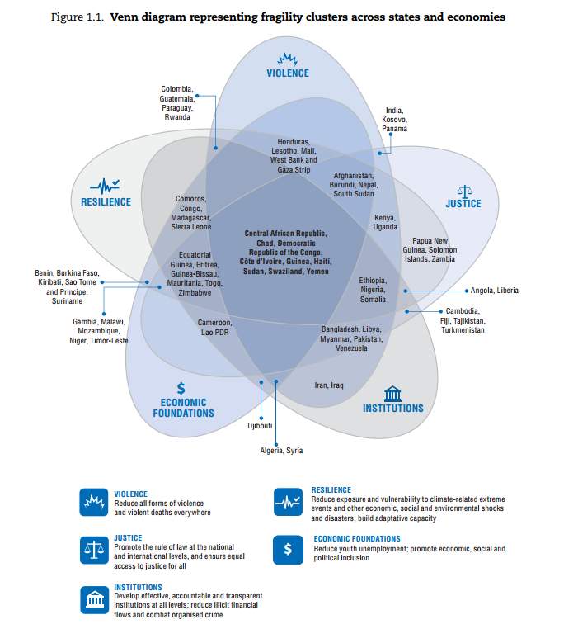

Do the clusters make sense? Take Afghanistan as an example, which is listed as vulnerable in every cluster except Institutions. How is that possible? Afghanistan regularly [ranks poorly on corruption indicators](https://www.transparency.org/country/#AFG). General Allen identified corruption as “the existential threat to the long term viability of modern Afghanistan.” How then did Afghanistan not make the bottom 50 for the Institution dimension?

Unfortunately, it is impossible to say what went wrong since they do not follow any good replication practices that are making their way into [political science](http://journals.cambridge.org/action/displayIssue?jid=PSC&volumeId=47&seriesId=0&issueId=01) or highlighted in the [OECD handbook for constructing indicators](http://www.oecd.org/std/42495745.pdf). My replication along with the datasets and R script I used are [available on GitHub](https://github.com/tlscherer/OECD-States-of-Fragility-2015-Replication) for anyone to replicate and engage with. All I can say is that however I follow the recipe, what I make doesn’t match the picture on the box.

First, the methodology is vague in several places such as how to handle missing data or whether to include territories and small island states. The report says it uses data from “2012 or most recent year” which could mean closest to 2012 without going over – standard Price-is-Right rules - but could allow for 2013 data when available. In each case I tried every interpretation with similar results

Second, the underlying data and codebook are not released with the report. I pushed on, gathering the datasets including coding [health-care capabilities from a map](http://www.dni.gov/files/) (a depressing reverse paint-by-number). I cleaned and merged the datasets that the OECD cites and then calculating the indices using the report’s methodology.

No matter how I interpret the OECD’s methodology, I find that over half of the Venn diagram is wrong. Only 30 of the 70 listed states are in the right spot. I made the edits found in one of my closer specifications on the Venn diagram below in a visualization using more arrows than a [plan to take over Europe](http://www.newworldencyclopedia.org/entry/File:1939-1940-battle_of_france-plan-evolution.jpg).

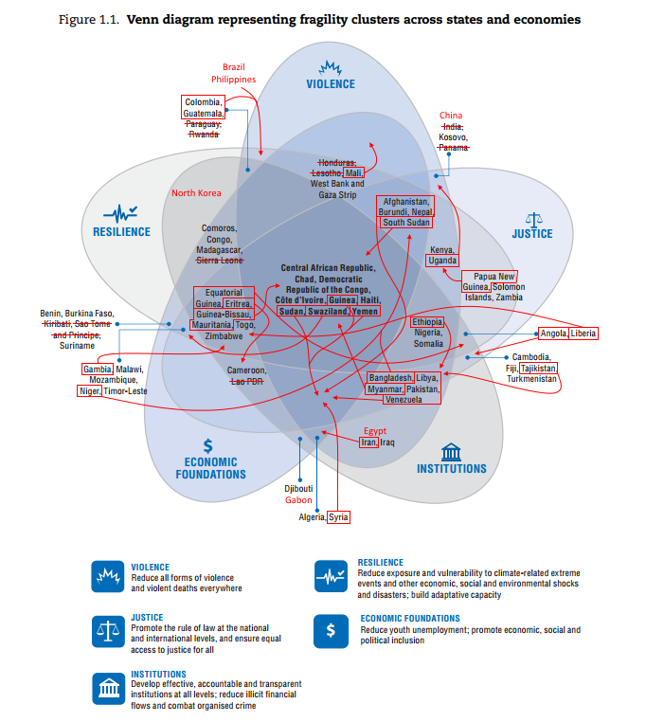

These errors are not minor; some rankings make small hops across the fragility threshold, but other changes are huge. North Korea has been on the one-dimensional Fragile State Index every year since 2008 but does not appear on the OECD’s original Venn diagram. In my replication North Korea is ranked as the worst country for Institutions and Resilience in my replication.

North Korea may have been excluded because it is missing some inputs, but not as many as Kosovo or Somalia. The Philippines is missing no data and similarly did not make the OECD diagram, but in my replication it ranks 19th from last in Violence and 15th from last for Resilience. On the other end of the spectrum, I drop Lesotho from the diagram as it ranks as 124th from the bottom for Violence, far from the bottom 50 cutoff.

Of course, just the fact that something is wrong doesn’t make it worth correcting; otherwise we’d never escape [the internet’s comments sections](https://xkcd.com/386/). In terms of policy relevance, it is hard to argue that it is important for the OECD to get this right given the striking [lack of evidence that foreign aid disbursement is based on need](http://onlinelibrary.wiley.com.proxygw.wrlc.org/enhanced/doi/10.1111/isqu.12191/).

However, the OECD report is good at starting discussions on [conceptualizing fragility](http://www.fragilestates.org/2015/04/17/what-the-oecd-still-does-not-understand-about-fragile-states/) and on [policy recommendations](http://securelivelihoods.org/blogpost/78/The-new-OECD-States-of-Fragility-report-exciting-analysis-let-down-by-bland-policy-prescriptions). [According to Jeffrey Sachs](http://www.project-syndicate.org/commentary/sustainable-development-goals-shift-by-jeffrey-d-sachs-2015-03), the report’s policy target, the [Sustainable Development Goals](https://sustainabledevelopment.un.org/focussdgs.html), really do matter. At some point, those goals will need some form of measurement and can look at the OECD’s model for ideas, at which point it has to matter that the OECD’s model is done right.

If nothing else, the issues highlighted here should serve as a call to arms for some changes in the policy community of agencies, IGOs, and NGOs. Just as the [Reinhart-Rogoff replication scandal](https://politicalsciencereplication.wordpress.com/2013/04/19/what-reinhart-rogoff-means-for-the-replication-debate/) reinvigorated the discussion of best practices in the social sciences, the policy community needs to get serious about creating norms of best practice for sharing data and methods from policy reports. Failure to do so is akin to saying we have no interest in being credible or having people engage with us.