**PERFORMANCE ANALYSIS - Examples**

**ROUTE – LOGIN – LOAD TESTING**

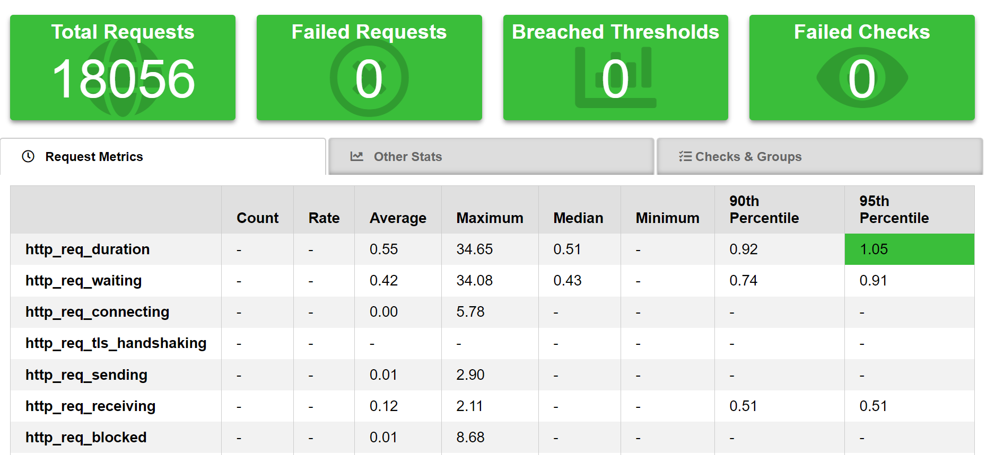

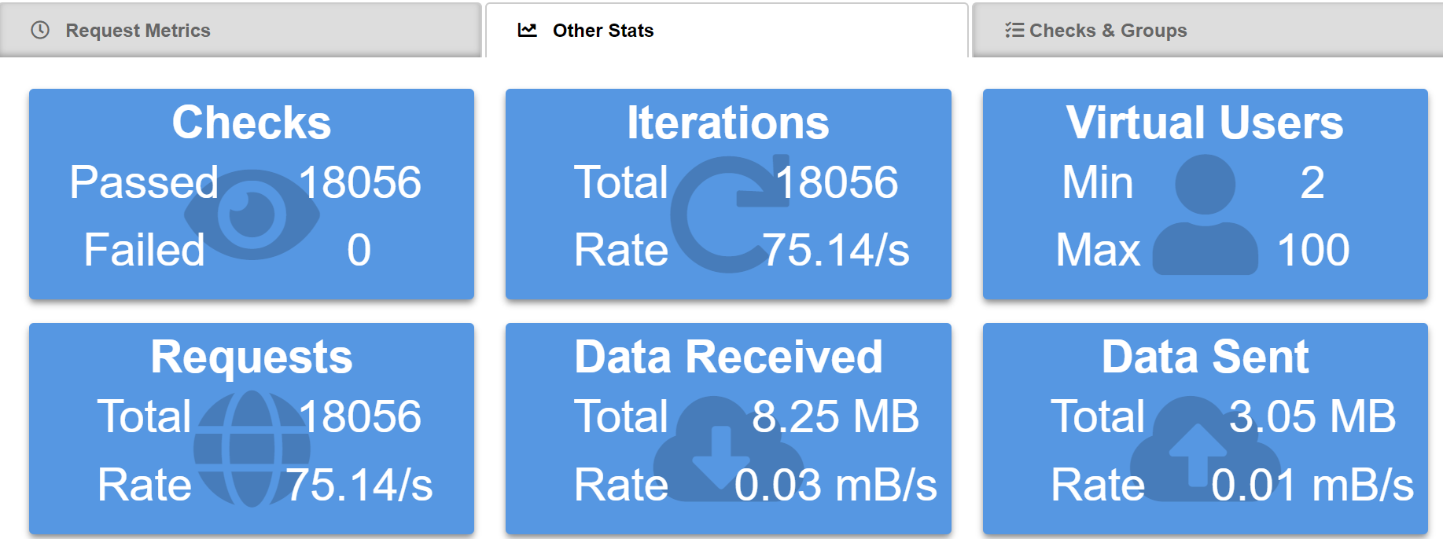

- The number of users at the same time sending requests increased during the first minute, then stabilized for 2 minutes in 100 users, then decreased by 1 minute again  
- P95 is less than 500ms which is really good  
- No failures detected  
- The number of requests per second was approximately 75, which can be considered good. Considering the production environment maybe this value is not so good if it’s expected a huge number of requests.

ROUTE – POST ORDER – LOAD TESTING

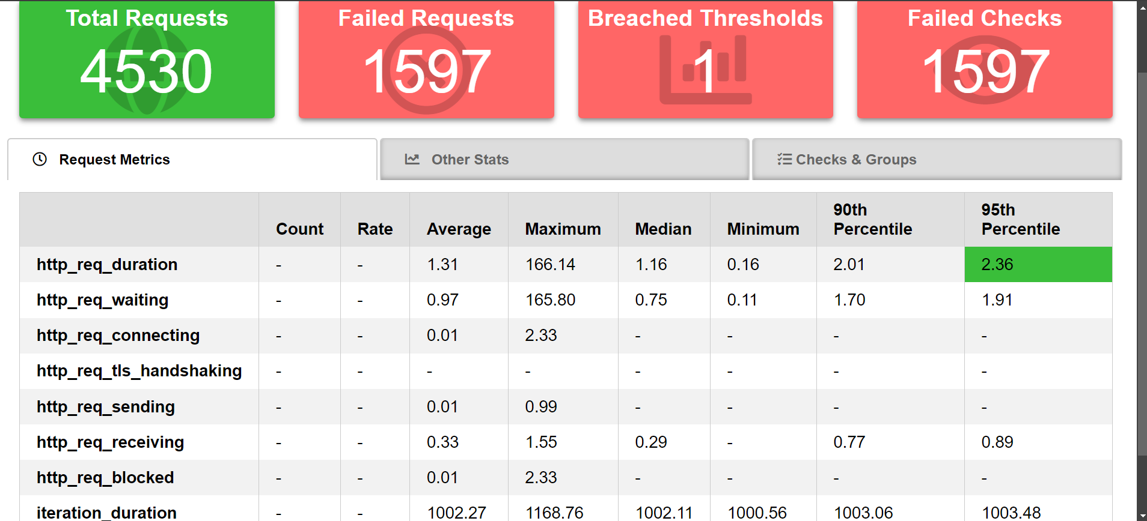

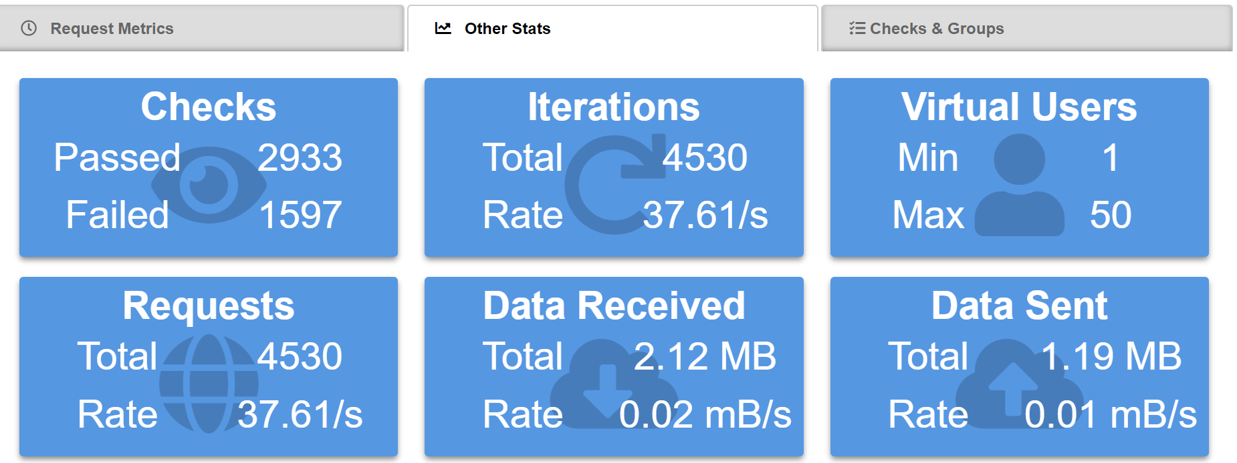

- The number of users at the same time sending requests increased during the 30 seconds, then stabilized for 1 minute in 50 users, then decreased by 30 seconds again  
- P95 is less than 500ms which is really good  
- 1597 failures detected, the errors were 500 (internal server error) and started at 1 minute and 12 seconds after execution which can mean the API is facing server issues for instability. This suggests there is a resource limitation maybe  
- The number of requests per second was approximately 37, which is not good. This suggests the server may not have enough capacity to support this number of requests.

ROUTE – E2E Test – SMOKE TESTING

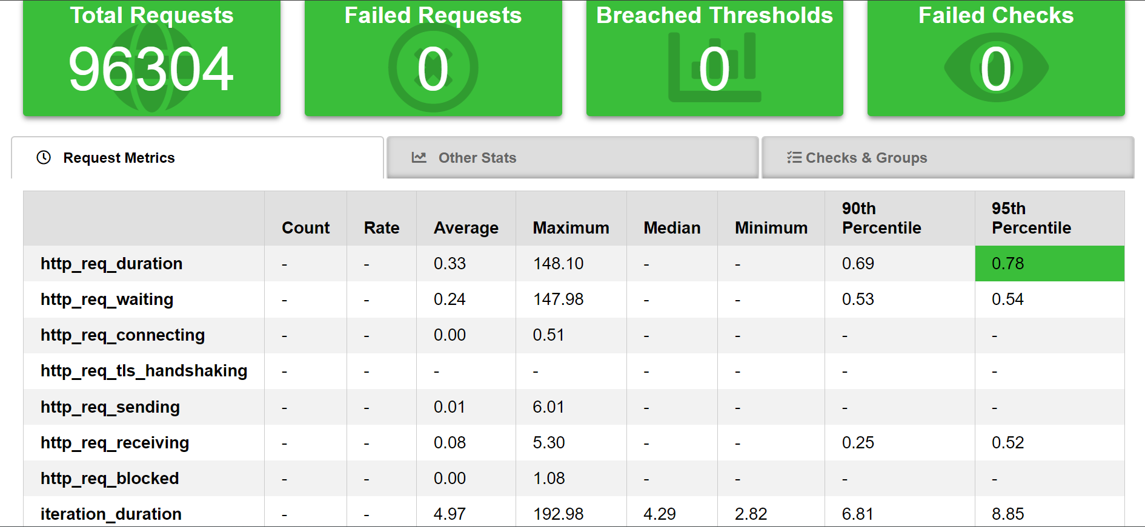

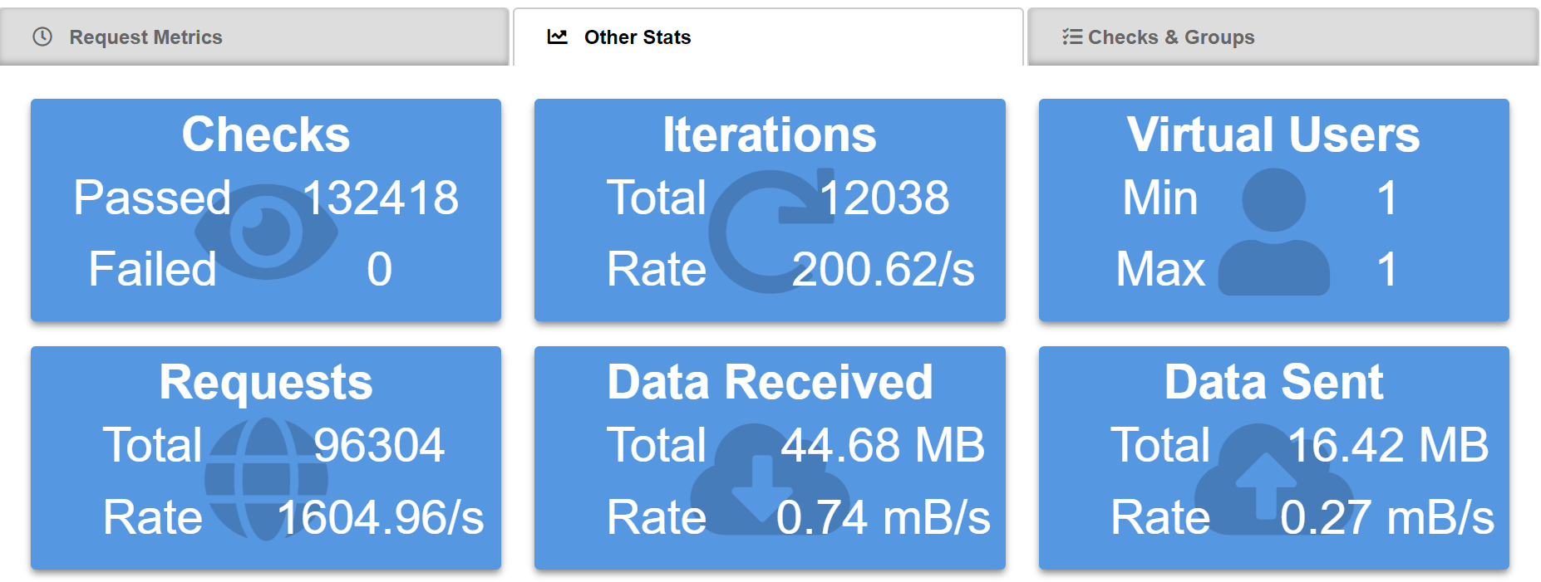

- As a smoke testing, the number of users is small (used 1 user) and the time duration is small too (1 minute), as an E2E test this test simulates a user creation, then a Login, then a new pet being added, then a new purchase ordered and then a logout  
- P95 is less than 500ms which is really good  
- No failures detected  
- The number of requests per second was approximately 1604 which is good, the system is healthy