
Kelton Uncertainty Plus

Applying an Uncertainty Plus Licence

Applying an Uncertainty Plus Licence
The UNCERTAINTYPLUS.lic' file that you have been provided with allows you to use our software on your designated PC.
You can apply your licence file in one of two ways:

Importing via FloCalc Software
Open the software and click on "Licence Manager" displayed in the top right-hand corner of the main application screen. Click on "Import" and locate the UNCERTAINTYPLUS.lic file that has been supplied. Once selected, the licence will be added to the correct location and allow you to use the software.

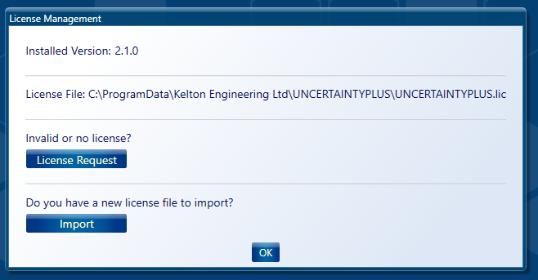

Importing via File Explorer

You can apply your licence file by copying this into the following location on your PC:
C:\ProgramData\Kelton Engineering Ltd\UNCERTAINTYPLUS

You may find that this location is hidden and you need to either type or paste the path: C:\ProgramData\Kelton Engineering Ltd\UNCERTAINTYPLUS into Windows Explorer as shown below.

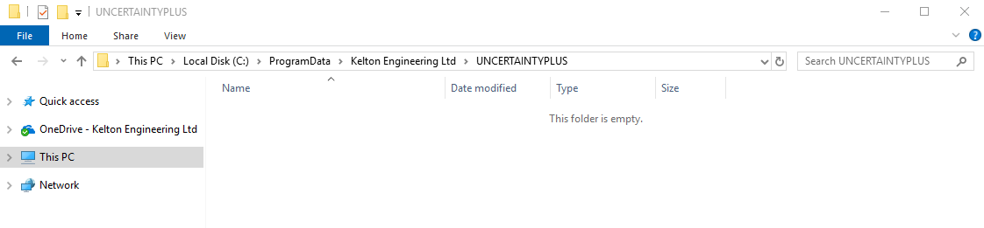

Before you copy the new file, please delete any existing *.lic files from this location.

If you experience any difficulty in copying the file into this location, please check you have the relevant permissions enabled to do this. You may need to contact your IT department if you do not have access to this folder.

If you would like any assistance with this process, please do not hesitate to contact support@kelton.co.uk

