**02 VBA HW Screenshots**

2014_stock_data:

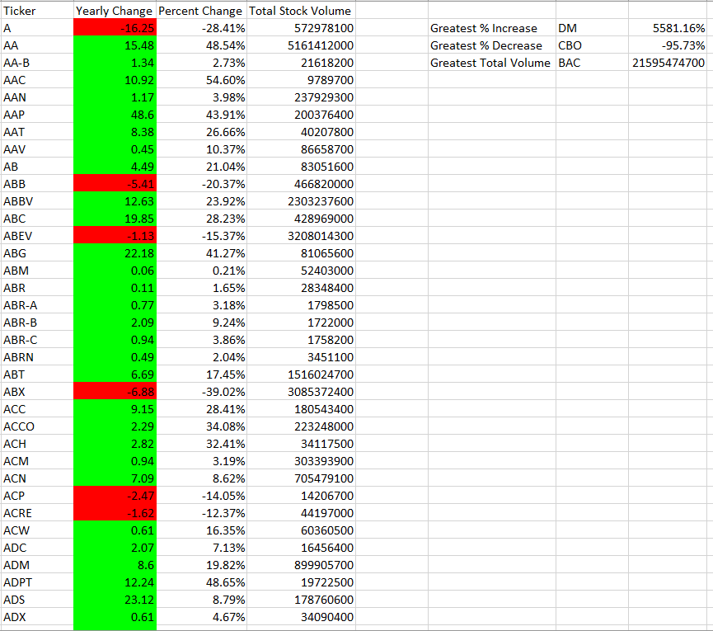

2015_stock_data:

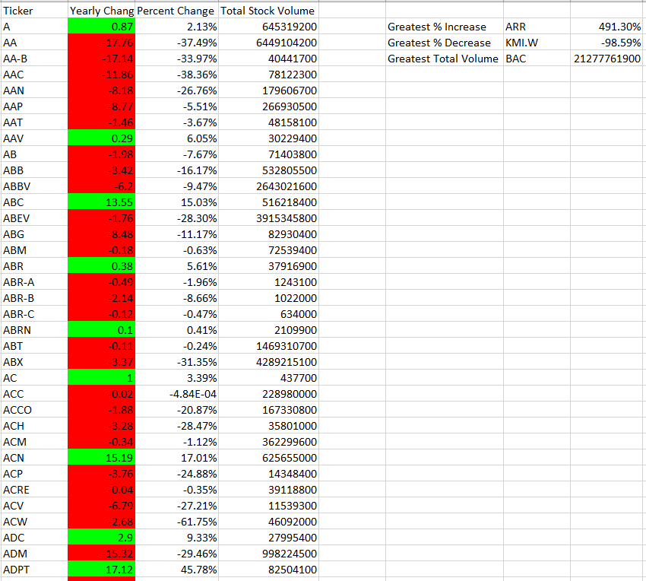

2016_stock_data:

