Regional Income Tiers

Toni Stapleton, CSM R&D, last modified February 2019

# Background

## Introduction

Household income can vary widely across the United States. Particularly when comparing income levels across regions, certain regions have a significantly higher or significantly lower median household income than the U.S. median household income. To truly get a sense of a household’s economic status, a household’s income must be measured against cost of living in the region and household size.

Currently, the Consumerview household file (sourced from Experian) includes a household income field. This field is titled “INCOME” and the values in this field are in the form of household income ranges. These ranges and current Consumerview household file distributions are seen in Table 1.

Table 1. Income ranges and household count.

|  |  |
| --- | --- |
| Income Ranges | HH Count |
| Income <$15,000 | 13,789,493 |
| Income $15,000 - $24,999 | 12,014,481 |
| Income $25,000 - $34,999 | 11,798,163 |
| Income $35,000 - $49,999 | 16,305,051 |
| Income $50,000 - $74,999 | 22,609,411 |
| Income $75,000 - $99,999 | 15,923,002 |
| Income $100,000 - $124,999 | 10,761,279 |
| Income $125,000 - $149,999 | 6,332,405 |
| Income $150,000 - $174,999 | 4,031,864 |
| Income $175,000 - $199,999 | 2,352,274 |
| Income $200,000 - $249,999 | 2,693,496 |
| Income $250,000+ | 3,909,014 |
| Unknown Income | 97 |
| *Grand Total* | ***122,520,030*** |

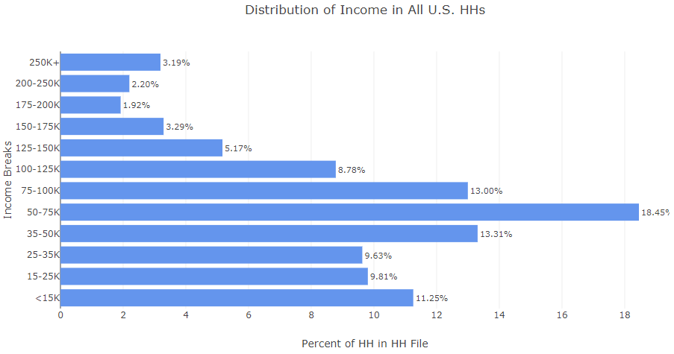

Figure 1. Distribution of income in all U.S. households.

As shown in Figure 1, 44% of households in the U.S. have a household income of less than $50,000 and 7.31% of households in the U.S. have a household income of $200,000 or more. However, would this distribution be the same if we looked at a specific region within the U.S.? Would the distributions be the same when comparing two different regions in the U.S.? In order to understand the disparities between regions, we must drill down to specific regions within the U.S.

## Metropolitan Statistical Areas

For our purposes, the geographical areas that are analyzed are Metropolitan Statistical Areas.

Metropolitan Statistical Areas are defined by the United States Office of Management and Budget (OMB) as Core Based Statistical Areas associated with at least one urbanized area that has a population of 50,000 or more.[1]

According to the U.S. Census Bureau, Core Based Statistical Areas (CBSA) consist of the county or counties or equivalent entities associated to least one core, plus adjacent counties having a high degree of social and economic integration with the core as measured through commuting ties with the counties associated with the core. The general concept of a CBSA is that of a core area containing a substantial population nucleus and adjacent communities having a high degree of economic and social integration with that core.[2] The OMB defines CBSAs to provide a nationally consistent set of geographic entities for the U.S. for use in tabulating and presenting statistical data.

The Metropolitan Statistical Area comprises the central county or counties or equivalent entities containing the core urbanized area, plus adjacent outlying counties having a high degree of social and economic integration with the central county or counties as measured through commuting.[3] As of September 2018, there are 384 Metropolitan Statistical Areas in the United States.[4] Each Metropolitan Statistical Area has an assigned CBSA code. For Metropolitan Statistical Areas, this code is five digits in length and ranges from 10000-49999.[5]

Within the Consumerview household file, 83.84% of households are in a defined Metropolitan Statistical Area (see Figure 2). The other 16.16% of households are in a nonmetropolitan area of the U.S.

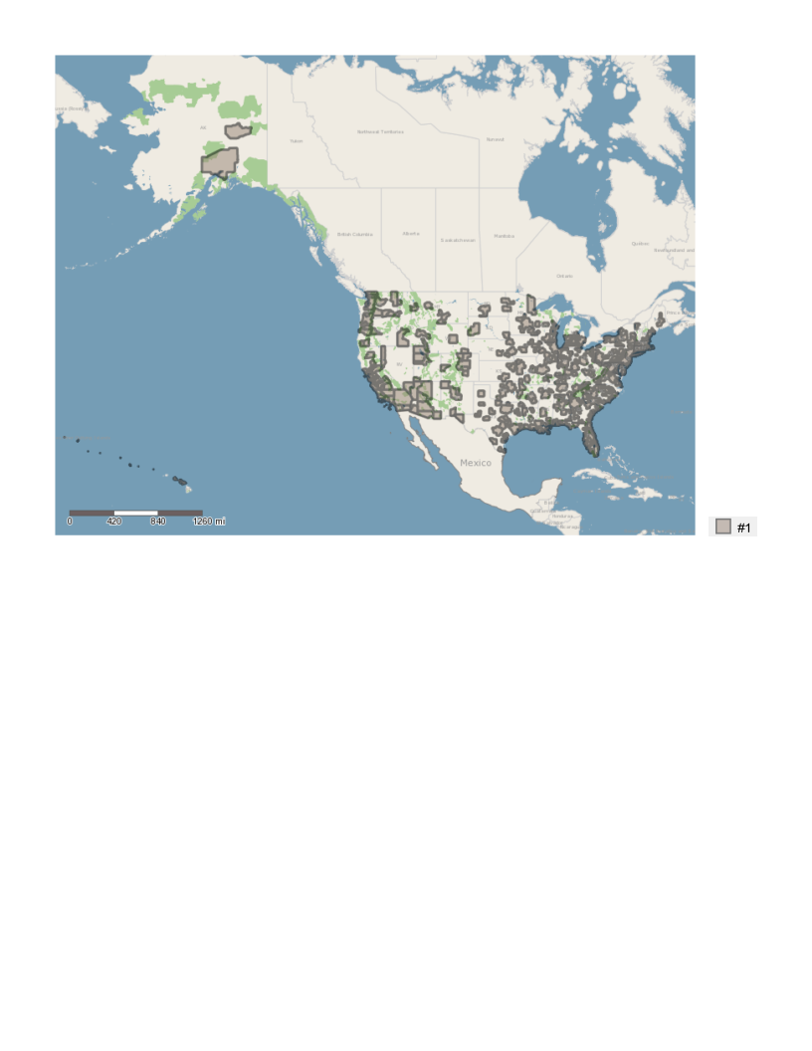

Figure 2. Metropolitan Statistical Areas in the U.S.

## Example of Metropolitan Statistical Area Income Disparities

Two examples of a Metropolitan Statistical Area (MSA) are the Jackson, TN MSA and the San Jose-Sunnyvale-Santa Clara, CA MSA. To understand the disparities across MSAs in household income, we can look at the distribution of household income levels within the Consumerview household file (see Figure 3).

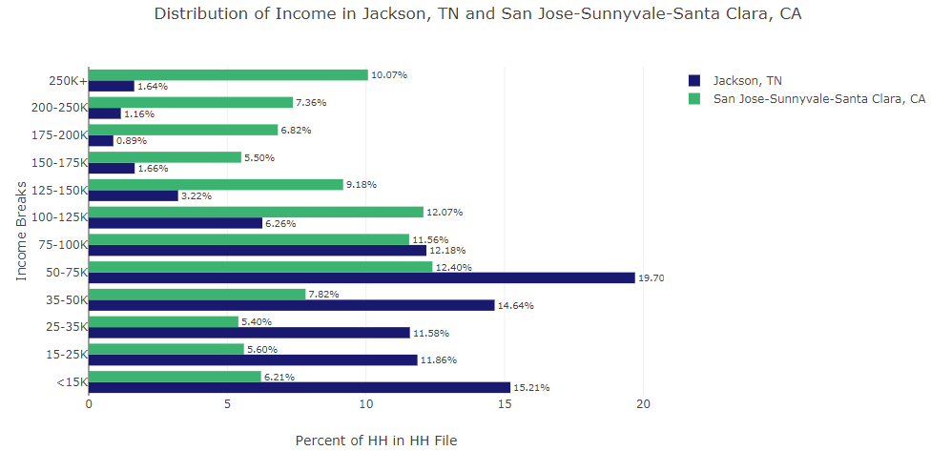

Figure 3. Comparison of household incomes in Jackson, TN and San Jose-Sunnyvale-Santa Clara, CA.

In the Jackson, TN MSA, 53.29% of households have a household income of less than $50,000 and 3.69% of households have a household income of $200,00 or more. In the San Jose-Sunnyvale-Santa Clara, CA MSA, 25.03% of household have a household income of less than $50,000 and 24.25% of household have a household income of $200,000 or more. Clearly, the average household in the Jackson, TN MSA has a very different household income than the average household in the San Jose-Sunnyvale-Santa Clara, CA MSA. Therefore, a household that would be regarded as “middle class” in Jackson, TN and a household that would be regarded as ““middle class” in San Jose-Sunnyvale-Santa Clara, CA would most likely have different household incomes.

In addition, household size also has a significant impact on a household’s economic status. More members in a household means more people that household’s income must support. A 5 member household and a 1 member household that both have the same household income would be in very different economic situations. Therefore, regional income tiers will assign economic tiers based on household income and household size relative to the household’s MSA.

# Methodology

This methodology is based on methodology from the Pew Research Center.[6] The U.S. Government does not define the “middle class”, however the widely accepted definition from the Pew Research Center is that a middle class household is any household with an income in the range of to double the U.S. median household income. According to the Pew Research Center, any household with an income below this range is in the lower economic class, while any household with an income above this range is in the upper economic class. The distribution of income class across the U.S. as found by the Pew Research Center is shown in Figure 4[7].

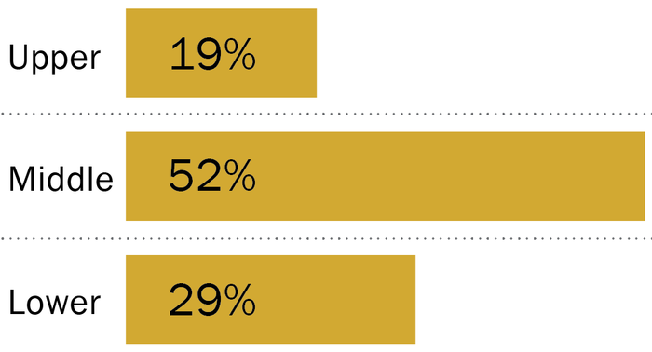

Figure 4. Distribution of economic classes in the U.S., according to the Pew Research Center.

Following the Pew Research Center’s methodology, we define the U.S. median household income to be $67,800 (2016 real dollars), and therefore any middle income household will fall in the household income range of $45,200 - $135,600.

## Adjusting for Regional Variations

To adjust for regional variations, Regional Price Parities (RPP) from the Bureau of Economic Analysis. RPPs are price indexes used to measure geographic price level differences for one period in time within the U.S. and are reported at the MSA level[8]. For example, the RPP for the San Jose-Sunnyvale-Santa Clara, CA MSA is 127.1, which means that the prices in this MSA are on average 27.1% higher than the U.S. average. On the other hand, the RPP for the Jackson, TN MSA is 82.1, and therefore the prices in this MSA are on average 17.9% lower than the U.S. average. An RPP is a weighted average of the price level of goods and services for the average consumer in one geographic area (in this case, an MSA) compared to all other regions in the U.S.[9]

The most recently released RPPs are 2016 RPPs and are available for 382 MSAs, as well as another RPP that acts as the price index for all nonmetropolitan areas of the U.S.[10] These RPPs are used to build the Regional Income Tiers by adjusting the middle income tier range. As previously cited, the middle tier for household income ranges from $45,200 - $135,600. This range is adjusted as follows. For example, the RPP for the San Jose-Sunnyvale-Santa Clara, CA MSA is 127.1. Therefore, the range is adjusted to be 27.1% higher for the San Jose-Sunnyvale-Santa Clara, CA MSA, in accordance with the RPP. This means the middle economic tier in San Jose-Sunnyvale-Santa Clara, CA MSA is a range of household income from $57,500 - $172,350. Likewise, the original middle economic tier range is adjusted to be 17.9% lower for the Jackson, TN MSA, in accordance with the RPP. Therefore, the household income range for the middle economic tier in Jackson, TN is $37,150 - $111,350. This can be applied accordingly for all MSAs which have an RPP.

## Adjusting for Household Size

To adjust for household size, an equivalence-scale adjustment is applied. Rather than simply dividing a household income directly by the number of people in the household to get the per capita income, an equivalence-scale adjustment is used to account for economies of scale in consumer expenditures.[11] For example, a two-bedroom apartment is not necessarily double the rent of a one-bedroom apartment. A widely-accepted equivalence-scale adjustment for household income that is applied here is the following[12]:

Thus, the household income is divided by the square root of household size to get the equivalent single person income. However, in order to truly compare this to an average American household, we must convert household income to a uniform household size. The average size of the American household is approximately 2.5 people, and therefore each household’s income is made equivalent to the income of a three-person household (nearest whole number).[13] Therefore, to adjust the per capita income to an equivalent three-person household income, the following equation is applied[14]:

Thus, the per capita income is multiplied by the square root of 3 to adjust the per capita income to the equivalent three-person household income.

## Examples of Assigning Households to Regional Income Tiers

Example #1: Two Member Household with Household Income of $150,000 in San Jose, CA.

We adjust for household size by adjusting to the equivalent household income for a three-person household, the average U.S. household size.

Therefore, we must determine if $183,711 falls in the range of household income for the San Jose, CA MSA middle economic tier to determine what regional income tier this household belongs to. As mentioned above, the household income range for the middle economic tier in San Jose, CA is 27.1% higher than the U.S. average, which makes the range $57,500 - $172,350. $183,711 is higher than this range, thus a two-member household with a household income of $150,000 in San Jose, CA would be considered to be in the Upper economic tier.

Example #2: Five Member Household with Household Income of $150,000 in San Jose, CA.

We adjust for household size by adjusting to the equivalent household income for a three-person household, the average U.S. household size.

Again, the range for a middle income household in San Jose, CA is $57,500 - $172,350. A household income of $116,189 is in this range, thus a five-member household with a household income of $150,000 in San Jose, CA would be considered to be in the Middle economic tier.

# Regional Income Tiers Build

## Details

### Prepare the Consumerview household file

1. There is no CBSA code for MSAs for households in the Consumerview household file. So, a lookup table must be used to merge in the CBSA codes for each household. This is done by matching each household in the Consumerview household file to a CBSAMET_KEY and CBSAMET_NAME in the ZipGeographyLookup.cydb file by matching on zip code (field [ZIP1] in the Consumerview household file, field [ZIP_KEY] in ZipGeographyLookup.cydb).
   1. All but 77 households should match. These households are fake records and have no data.
2. For all households whose CBSAMET_KEY is null after the match (In this case, the CBSAMET_NAME from the ZipGeographyLookup.cydb is “No Metro”), the CBSAMET_KEY field is assigned to be ‘999’, which designates a U.S. nonmetropolitan area and will allow a match to the RPP file for nonmetropolitan areas.
3. Summarize the results by grouping by CBSAMET_KEY (originated from the ZipGeographyLookup.cydb), CBSAMET_NAME (originated from the ZipGeographyLookup.cydb), INCOME (originated from the Consumerview household file), SIZE1 (originated from the Consumerview household file) in that order and then produce a count of households (count of INSEQNUM, which originates from the Consumerview household file).

The above process is automated in the Alteryx workflow INCOME_TIERS.yxmd.

### Build the Regional Income Tiers

1. Read in the Consumerview household file summary built in Alteryx and the Regional Price Parities.
2. Define the U.S. median household income
3. Calculate the U.S. middle class range
4. Use the U.S. lower threshold and U.S. upper threshold to build lower and upper thresholds for middle income tier for every household size in every MSA and the nonmetropolitan U.S.
5. The adjusted thresholds are then rounded to the closest break in the Consumerview household file income ranges. The INCOME field in the Consumerview household file has the following possible values:

Table 2. INCOME values.

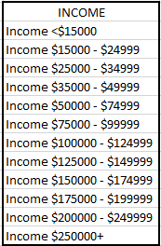

So, the adjusted lower threshold and adjusted upper threshold are rounded to 0, 15000, 25000, 35000, 50000, 75000, 100000, 125000, 150000, 175000, 200000, or 250000 based on which number they are closest too.

1. Any INCOME range that falls between the rounded adjusted lower and rounded adjusted upper threshold for that MSA and household size is labeled “Middle” income tier. Any INCOME range below the rounded adjusted lower threshold is labeled “Lower” income tier. Any INCOME range above the rounded adjusted upperer threshold is labeled “Upper” income tier.

The above process outputs a lookup table of all combinations of MSA, household size, and INCOME value in the Consumerview household file that can be then be used to map any household in the file to the appropriate income tier. This process is written up in the Assign_Income_Tiers_Final.py file and should be executed with Python.

## Relevant Programs and Files

All programs and files are in the *\Regional_Income_Tiers* folder.

### \Regional_Income_Tiers\INPUTS\ Folder Contents

#### Regional Price Parities:

*\Regional_Income_Tiers\INPUTS\Regional_Price_Parity.csv* contains the RPPs for all MSAs. The most recent file contains the 2016 RPPs. The source of this file is found at <https://www.bea.gov/data/prices-inflation/regional-price-parities-state-and-metro-area>.

To refresh the data: under ‘Interactive Data’, select ‘Interactive Data: Regional Price Parities’. In the resulting webpage, click on ‘Regional Price Parities (SARPP)’ under ‘REAL PERSONAL INCOME AND REGIONAL PRICE PARITIES’. Select the option ‘MARPP – Regional Price Parities by MSA’ and then click next step. Under Area, select ‘All Areas’ and under Statistic select ‘RPPs: All items’ and make sure the Unit of Measure is ‘Levels’, then click next step. Choose the most recent year and then click next step. Download the results and save as a CSV in the location *\Regional_Income_Tiers\INPUTS\Regional_Price_Parity.csv*.

#### HH File Counts By CBSAMET_KEY

*\Regional_Income_Tiers\INPUTS\HHFile_Counts_By_CBSAMET.csv* contains the summary of the Consumerview household file built by the Alteryx workflow *\Regional_Income_Tiers\INCOME_TIERS.yxmd*

## Steps

1. Open the workflow *\Regional_Income_Tiers\INCOME_TIERS.yxmd*. Make sure the Consumerview household file is the correct version and the input is correctly configured. Save and run the workflow.
2. Make sure the inputs in *Assign_Income_Tiers_Final.py* are correctly configured. Save and run the script. The script will product the CSV FILE *income_tier_lookup_table.csv*

# Results

## Consumerview Household File

Using the lookup table, each household in the Consumerview household file is assigned an income tier based on their MSA (as defined by the CBSAMET_KEY and CBSAMET_NAME fields, which is merged in according to the process outlined in section 3.1.1), their household income (as defined by the INCOME field in the Consumerview Household File), and their household size (as defined by the SIZE1 field in the Consumerview Household File). After assigning each household to an income tier, the distribution in the Consumerview Household File is shown in Table 3. There are 97 households in the Consumerview Household File that have a value of “Unknown Income” populated in the INCOME field. Therefore, these households cannot be assigned to an income tier.

Table 3. Regional income tier distribution in the Consumerview HH file.

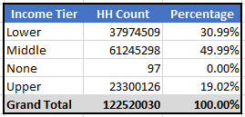

## Metropolitan Statistical Area Analysis

Continuing our analysis of the San Jose-Sunnyvale-Santa Clara, CA and Jackson TN MSAs, the distribution of income tiers in each MSA is shown in Figures 5 and 6.

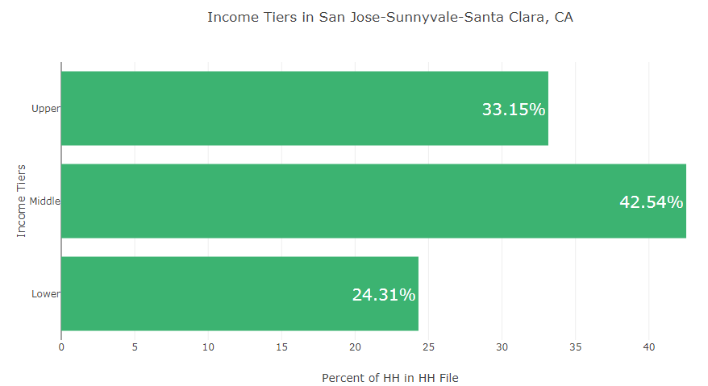

Figure 5. Distribution of income tiers in the San Jose-Sunnyvale-Santa Clara, CA MSA in the Consumerview household file.

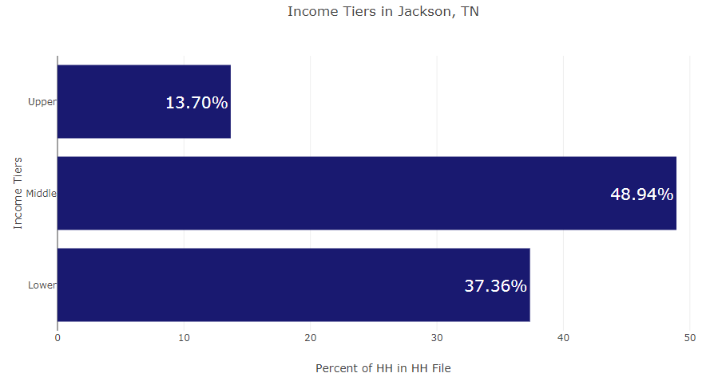

Figure 6. Distribution of income tiers in the Jackson, TN MSA in the Consumerview household file.

The middle income tier is the largest tier in both MSAs. The San Jose-Sunnyvale-Santa Clara, CA MSA has a higher percentage of upper income tier households and a lower percentage of lower income tier households than the Jackson, TN MSA.

# Conclusion

Regional income tiers allow for each household in the Consumerview household file to be assigned to an income tier based on the number of people in the household and that household’s income. Regional income tiers also account for variations in cost of goods and services and other regional price parities by calculating the household income tier based on the MSA in which that household resides.

If we compare the distribution of income tiers in the Consumerview household file to the distribution of income classes in the U.S. according to the Pew Research Center (the source on which this methodology is based), the distributions align very closely (Figure 7).

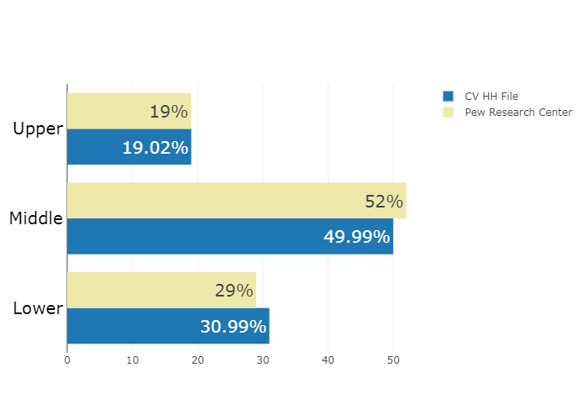

Figure 7. Comparison of income tier distributions in the U.S. according to the Consumerview HH file and the Pew Research Center.

Regional income tiers can be applied to any household in the Consumerview household file with a known household income, household size, and zip code. These income tiers allow for comparisons across MSAs and can be integrated into IRI solutions that utilize the Consumerview household file.

# Appendix

## Regional Income Tiers in ShopperSights

Regional income tiers can be used in IRI solutions that utilize the Consumerview household file. One of these solutions is ShopperSights, a proprietary targeting tool for retailers and manufacturers. Using ShopperSights Trade Areas, we can complete store level analysis of all households that are in a store’s consumer base as calculated by ShopperSights.

Store #1: Whole Foods, 4800 El Camino Real, Los Altos, CA

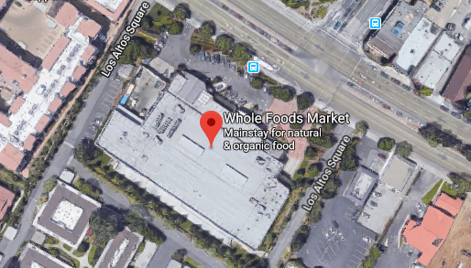

Figure 8. Whole Foods, 4800 El Camino Real, Los Altos, CA

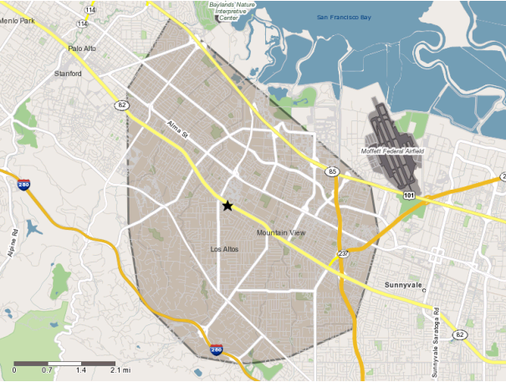For example, we can analyze the Whole Foods at 4800 El Camino Real in Los Altos, CA, which is in the ShopperSights store universe. This Whole Foods is in the San Jose-Sunnyvale-Santa Clara, CA MSA. The ShopperSights Trade Area for this store is pictured in Figure 9.

Figure 9. Whole Foods ShopperSights Trade Area

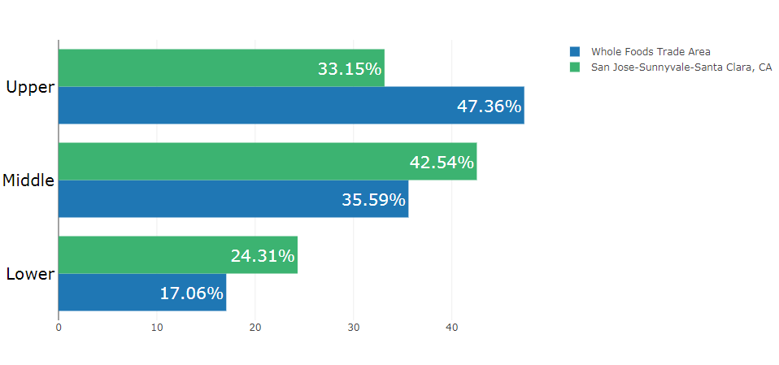The distribution of income tiers amongst the households in the Trade Area for this Whole Foods compared to the distribution of income tiers in the entire San Jose-Sunnyvale-Santa Clara, CA MSA is shown in Figure 10.

Figure 10. Whole Foods Trade Area vs. San Jose-Sunnyvale-Santa Clara, CA income tiers.

As shown, there is a much higher percentage of upper income tier households in the Trade Area for the Whole Foods as compared to the percentage of upper income tier households in the entire MSA. One could say this is aligned with the general representation of Whole Foods as an upscale grocery store.

Store #2: Kroger, 941 North Parkway, Jackson, TN



Figure 11. Kroger, 941 North Parkway, Jackson, TN

We can analyze the Kroger at 941 North Parkway in Jackson, TN, which is in the ShopperSights store universe. This Kroger is in the Jackson, TN MSA. The ShopperSights Trade Area for this store is pictured in Figure 12.

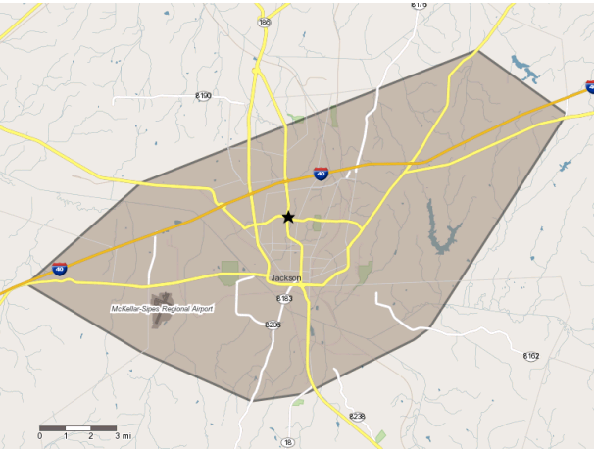

Figure 12. Kroger ShopperSights Trade Area

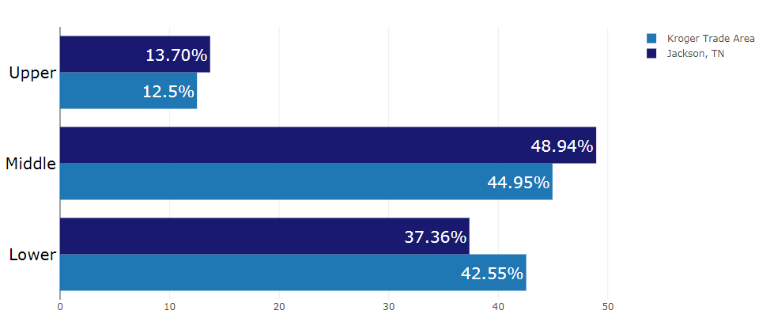The distribution of income tiers amongst the households in the Trade Area for this Kroger compared to the distribution of income tiers in the entire Jackson, TN MSA is shown in Figure 13.

Figure 13. Kroger Trade Area vs. Jackson, TN income tiers.

As shown, the income tier distribution for the Kroger ShopperSights Trade Area households a very similar to the income tier distribution of the entire Jackson, TN MSA.

1. “Geographic Terms and Concepts – Core Based Statistical Areas and Related Statistical Areas,” U.S. Census Bureau, last revised December 6 2012, https://www.census.gov/geo/reference/gtc/gtc_cbsa.html.
2. Ibid.
3. “Geographic Terms and Concepts – Core Based Statistical Areas and Related Statistical Areas,” U.S. Census Bureau, last revised December 6 2012, https://www.census.gov/geo/reference/gtc/gtc_cbsa.html.
4. “Metropolitan and Micropolitan: About,” United States Census Bureau, last revised October 18 2018, https://www.census.gov/programs-surveys/metro-micro/about.html.
5. “Geographic Terms and Concepts – Core Based Statistical Areas and Related Statistical Areas,” U.S. Census Bureau, last revised December 6 2012, https://www.census.gov/geo/reference/gtc/gtc_cbsa.html.
6. Richard Fry and Rakesh Kochhar, “Are you in the American middle class? Find out with our income calculator,” Pew Research Center, last modified September 6 2018, http://www.pewresearch.org/fact-tank/2018/09/06/are-you-in-the-american-middle-class/.
7. Ibid.
8. “Real Personal Income and Regional Price Parities,” Bureau of Economic Analysis, last modified July 2016, https://www.bea.gov/sites/default/files/methodologies/RPP2016_methodology.pdf.
9. “Real Personal Income and Regional Price Parities,” Bureau of Economic Analysis, last modified July 2016, https://www.bea.gov/sites/default/files/methodologies/RPP2016_methodology.pdf.
10. RPPs not available for Twin Falls, ID according to the Bureau of Economic Analysis.
11. Paul Taylor and Rakesh Kocchar, “Fighting Poverty in a Tough Economy, Americans Move in with Their Relatives: Appendix B: Adjusting Household Income For Household Size,” Pew Research Center, last modified October 3 2011, http://www.pewresearch.org/wp-content/uploads/sites/3/2011/10/Multigenerational-Households-Final1.pdf.
12. Ibid.
13. Richard Fry and Rakesh Kochhar, “Are you in the American middle class? Find out with our income calculator,” Pew Research Center, last modified September 6 2018, http://www.pewresearch.org/fact-tank/2018/09/06/are-you-in-the-american-middle-class/.
14. Paul Taylor and Rakesh Kocchar, “Fighting Poverty in a Tough Economy, Americans Move in with Their Relatives: Appendix B: Adjusting Household Income For Household Size,” Pew Research Center, last modified October 3 2011, http://www.pewresearch.org/wp-content/uploads/sites/3/2011/10/Multigenerational-Households-Final1.pdf.