Project Activity 4 – Automated Software Testing and Deployment

Describe your team's application:

1. Which features of the whole project did you choose to implement from the backlog? Describe your personal task (code or document processing) and expected results of your part

Adding advanced functionality, additional network checks and providing information about possible threats. In addition, create a vulnerable server on Kali Linux in advance to demonstrate the operation of a server that is not working properly. This was done for the visual operation of our application. Port scanning methods and comparison with potentially dangerous attacks on ports have also been added. A file was also created containing a list of vulnerabilities on the ports. A menu for selecting functions that a user can use has been added.

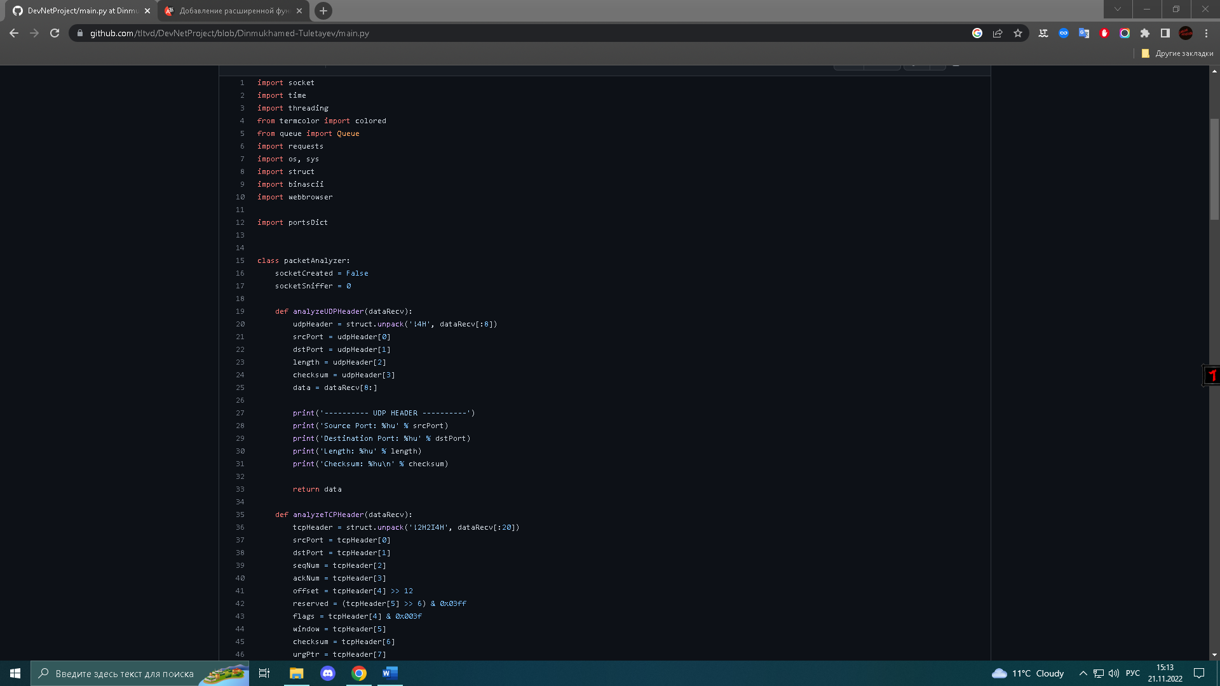

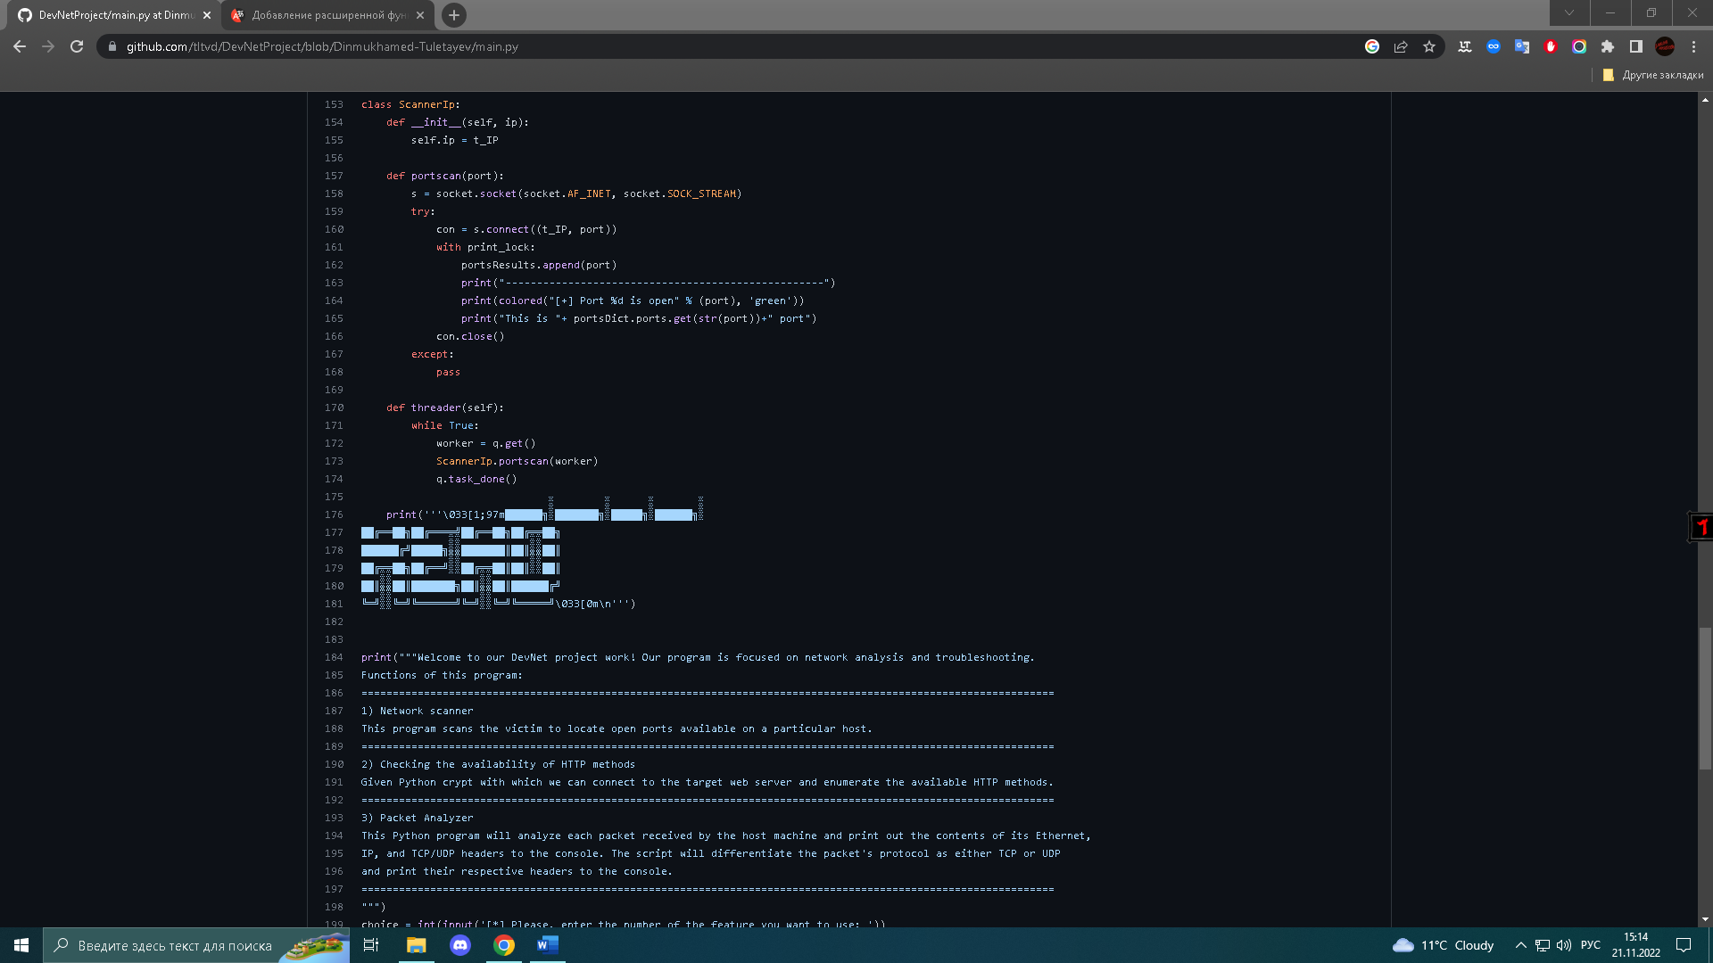

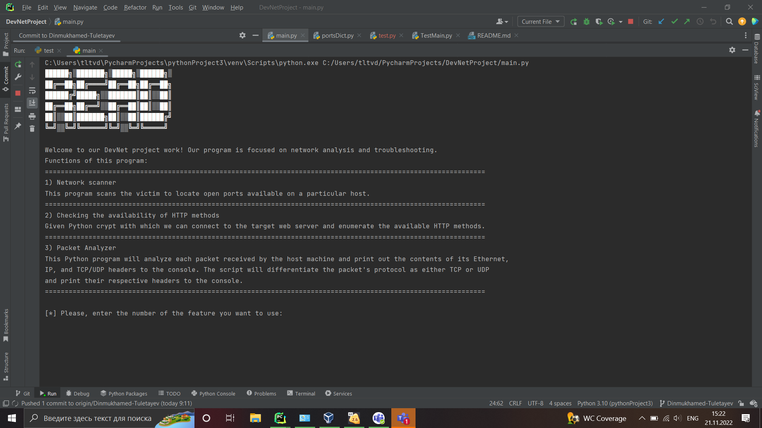

1. What are the specific objectives of your features and how do you plan to test them? Describe the methods of testing and expected results of your tests

We have 4 functions that interact with the server. The first function checks the client/server connection and outputs a positive/negative response. The second function scans ports and displays information about all open ports of the server and their protocols. The third function checks the list of open ports (if any) and compares it with the list of potentially dangerous ports that can be attacked and suggests closing them. The fourth function checks the server for XSS vulnerability. Unittest have also been made for each method to check the operability of the code.

1. Why were your inputs stored? Please apply the link to your branch on github.com or other system of version control

At the moment of the development of our application, each member of the team contributes his part of the work to his branch. Each change can be observed by clicking on our link:

<https://github.com/tltvd/DevNetProject>

Reflect on the type of issues you have faced while working on this project. How did you find solutions and what have you learned?

At the stage of development of our application, we face many problems, one of the most important is the realization that it is easier and more practical to work on this application on Linux OS than on Windows OS. This is explained by the fact that the functionality associated with networks is very reduced on Windows.