Starting a DAF Bootstrap Process

The Bootstrap class is part of the DAF classes which are located in the cmf/common-daf-v3 Subversion project.

A Bootstrap process is a small Java VM that runs on each machine that is to be part of a DAF application. The Bootstrap process is used to start and stop DAF nodes (ie. Java VMs) on local and remote machines distributed over a network. The following figure shows how a remote process can send a message to two Bootstrap processes and start two nodes.

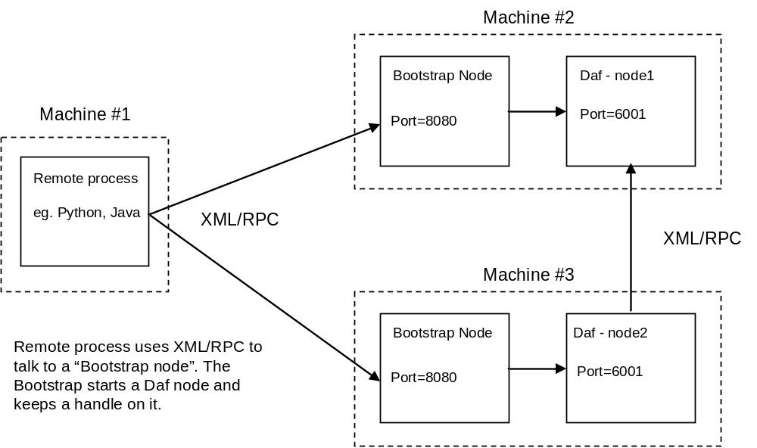

The Bootstrap node is actually a simple DAF node running a customer handler that is capable of starting and stopping a Java VM. The remote process can be any client that speaks XML-RPC. There is a Java class named “com.pb.common.rpc.BootstrapClient” which can be used from the command-line or a shell script to start and stop.

There are two steps to starting a Bootstrap process:

1. Start a DAF node using the “-bootstrap” command
2. Supply the name of command file to be run when a “start” command is run (Note, this step is only required when the client does not pass the start command parameters).

Because the Bootstrap process is essentially a DAF node, please see “Starting a DAF node” for the details around classpath configuration.

There are two ways to interact with the Bootstrap process; 1) as an XML-RPC client and 2) using the com.pb.common.rpc.BootstrapClient class (a convenience class).

Bootstrap Process Interface
The Bootstrap process exposes an XML-RPC interface that looks like:

execute.start : String
execute.stop : boolean
execute.start(Hashtable envVars, Vector args) : String
exeucte.stdout() : String
execute.stderr() : String
execute.exitValue : int

Any XML-RPC client can call these methods and interact with a running process. For example, after the process has been started, the std-console and std-error streams can be viewed by invoking the stdout and stderr method respectively.

Starting a Node with a Command File
The execute.start method call is used to start a remote process using a command file located on the remote machine. The name of the command file is supplied on the command-line when the Bootstrap node is started.

A machine specific command file is useful to account for machine dependencies or machine specific configuration.

For example, if the Bootstrap node were started using this command,

java com.pb.common.rpc.DafNode -bootstrap -command startnode.txt

then, the command file named startnode.txt located in the current directory would be used to start the DAF node. A typical startnode.txt file looks like:

set classpath=cmf\build\cmf-20060210.jar;..\cmf\common-daf-v3\lib\xmlrpc-2.0.jar

java
com.pb.common.rpc.DafNode
-node
node0
-config
testapp.groovy

Lines starting with “set” are used to set environment variables for the DAF node process.

Blank lines are ignored as are lines starting with “#”.

The following lines are used to supply the command and command arguments to the new process.

Starting a node with an XML-RPC Client
The execute.start(Hashtable envVars, Vector args) method is used to start a remote process. The environment and command args are passed from the remote client. using the standard XML-RPC protocol.

For example, if the Bootstrap node were started using this command (notice the “command” option is not used as it was in the last example),

java com.pb.common.rpc.DafNode -bootstrap

then, the following Java code could be used to start a node remotely.

Object result = null;

Hashtable env = new Hashtable();
env.put("classpath", " cmf\build\cmf-20060210.jar;..\cmf\common-daf-v3\lib\xmlrpc-2.0.jar ");

Vector args = new Vector();
args.add("java.exe");
args.add("com.pb.common.rpc.DafNode");
args.add("-node");
args.add("node0");
args.add("-config");
args.add("testapp.groovy");

Vector params = new Vector();
params.addElement( env );
params.addElement( args );

try {
//Connect to the Bootstrap node on default port
RpcClient client = new RpcClient(http://localhost:8080);
result = client.execute("execute.start", params);
logger.info("got answer back: " + result.toString() );
return;
}
catch (RpcException e) {
e.printStackTrace();
}
catch (IOException e) {
e.printStackTrace();
}
logger.info("got error back");

Starting a node using the BootstrapClient Class
The Java class “com.pb.common.rpc.BootstrapClient” is a convenience class and can be used to start/stop and get status from a Bootstrap process. It essentially provides the code that was shown in the previous example.

Executing the class with no parameters will generate a display that looks like this:

usage: java com.pb.common.rpc.BootstrapClient <arguments> [options]

arguments:
-start starts specified node
-startAll starts all nodes in the supplied config file
-stop stops the specified node
-stopAll stops all nodes in the supplied config file
-console gets the stdout and stderr output
-config name of groovy configuration file

options:
-port used with -bootstrap flag, default=8080

Starting a node:
ex 1: com.pb.common.rpc.BootstrapClient -start node1 -config testapp.groovy

Starting all nodes:
ex 2: com.pb.common.rpc.BootstrapClient -startAll -config testapp.groovy

The BootstrapClient class takes the DAF config file as a parameter. The config file supplies the BootstrapClient class with all the needed information for each node in the application. This allows node names to be passed on the command line in place of URLs.

