SWIM2 Visualization Platform
(TLUMIP WOC19 Visualization Task)
From: Ben Stabler, stabler@pbworld.com, April 21, 2010 (Revised March 5, 2014, December 16, 2014)

Overview
The Oregon Department of Transportation (ODOT) needed a platform for dynamic visualization and inspection of SWIM2 model results in order to better understand SWIM2. As a result, the SWIMVIZ Adobe Flash application was developed. The purpose of this memo is to describe the development process for the Flash application as well how to use it.

Implementation Tools
The SWIMVIZ application was developed with the following technologies:
- Adobe Flex – Adobe’s open source application development environment for Adobe Flash technology. Especially useful is Adobe’s Advanced Data Visualization library, which includes a wealth of libraries for dynamic interacting charting/visualization. Flex is a combination of two programming languages:
  - MXML (Macromedia extensible markup language) - a user interface declarative language much like HTML that was originally developed by Macromedia (before Macromedia was acquired by Adobe)
  - ActionScript – the programming/scripting language for Flash that was originally developed by Macromedia (Macromedia was acquired by Adobe)
- IBM ILOG Exilir – IBM’s visualization library for Adobe Flex. The primary components used from this library include the map components.
- SQLite – The popular open source file-based database solution for data storage. A separate process is run to create the SWIM2VIZ database for each model run. See swim_viz_db.doc for more on the database, including the database schema.

Map Creation
Performance in a dynamic interactive visualization application is very important. As a result, the solution requires an efficient version of the map geography. Thus, the map geometry was simplified and compiled ahead of time into ActionScript. The process to create the SWIM2 beta zone dynamic map was:
- Start with the current SWIM2 alpha zone shapefile
- Spatially aggregate the alpha zone polygons to beta zone polygons using ArcGIS’ Dissolve tool
- Use the free online MapShaper Flash application to simplify the polygon definitions to improve runtime. The *.shp file was simplified using the Douglas-Peucker line simplification algorithm from 7400 KB to 500KB without much noticeably degradation.
- Use ILOG’s custom map converter (included with the ILOG Exilir license) to convert the simplified shapefile export from MapShaper to compiled ActionScript. Compiling the zone geography ahead of time means the performance is significantly better than, say, loading a shapefile at runtime.

User Interface Settings
The SWIMVIZ user interface is organized into three tabbed displays:
- Scenario and Query
- Tables
- Plots and Maps

Scenario and Query
The Scenario and Query tab contains the following:
- Database Selection
  - Get the scenario SQLite database file to use by clicking the Get DB button
  - If desired, get a reference SQLite database file to use by first checking the Reference database checkbox and then click the Get DB button.
  - If using a reference database, set the difference operator (either “/” or “-“) in the drop down next to the check box.
  - Setup the SWIMVIZ year slider and primary tables via the Scenario Setup button.
  - Update the SWIMVIZ year slider to only include years in both the Scenario and Reference database via the Reference Setup button
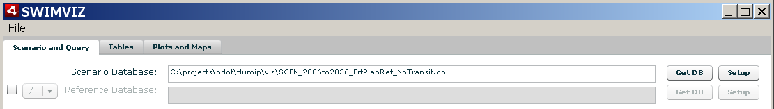
- Specify and Execute the Data Query
  - Specify the primary table to query from the table drop down.
  - A default query is loaded into the query field for each table. The default queries usually contain queries parameters of the form @[parameter]. See the query parameters below.
  - The following query parameters are allowed in the query builder:
    - @tstep – year – example: “16”. This parameter is automatically replaced with every year found in the scenario database (and in the reference database if desired).
    - @act – activity – example: “CONSTRUCTION”
    - @com – commodity – example: “1_ManPro”
    - @purp – trip purpose – example: “OTHER”
    - @mseg – market segment – example: “0-30k; Autos=0” (DC_LOGSUM table)
    - @trk – truck class – example: “TRK1”
    - @hhinc – hh income – example: “0-30k”
    - @mode – trip mode – example: “DA” (drive alone)
    - @fz – fromzone – example: 1
    - @tz – tozone –example: 1
  - The relevant table parameters are displayed for the table selected. For example, in the screenshot below, the Trips_CT table allows the user to specify commodities, the truck class, the from zone (or trip origin zone), the spatial aggregator (MPO, County, State, etc), and the spatial aggregation operator (SUM, MIN, AVG, MAX, COUNT). Click the parameter on the left and select the values on the right. Note that multiple values may be selected where applicable. The user can right click in the values list to select all.
  - The query must return the following data table format in order to be a valid data source for spatial aggregation and visualization:
    - BZONE – beta zone
    - DATADIM – basically a label
    - SPATIALAGG – spatial aggregation code
    - QUANTITY – quantity of interest; value to display
    - TSTEP – year
    - QUANT_SCEN – if difference calculated, scenario database value
    - QUANT_REF – if difference calculated, reference database value
  - Once a query has been built, execute the query for all years by clicking the Execute button. SWMIVIZ executes the query for every year (replacing the @tstep parameter each time) and returns only results from valid years.
  - The Query Log logs the queries executed in SWIMVIZ. It is often helpful to review the Query Log if a query fails.
  - The results of the query are populated in the data grids (see the next section).
  - If the query does not contain the “@tstep” parameter, then the query will be executed once and the results are returned to the Basic data grid.
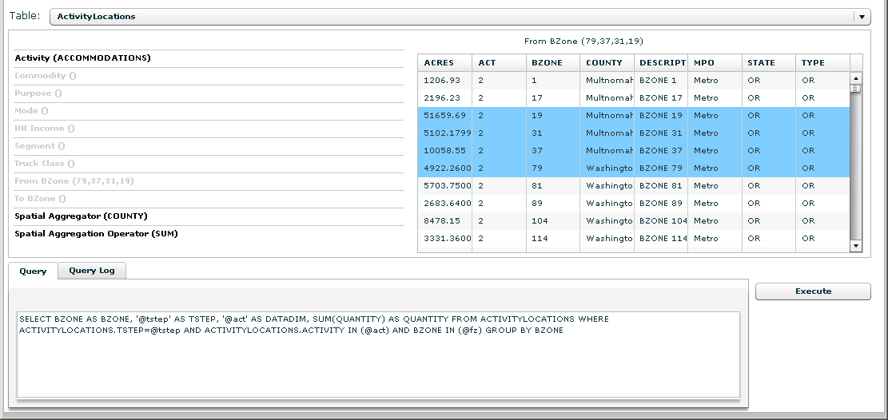

Tables
The Tables tab allows the user to review the query results. This includes the following functionality:
- The Current Year (Bzone) data grid displays the query results for the current year by bzone, as set by the year slider.
- The All Years query result is populated in the All Years (Bzone) data grid tab by bzone. This contains the query for all valid years.
- The Current Year (Spatial Aggregation) data grid displays the query results for the current year as aggregated by the spatial aggregation parameters, as set by the year slider.
- The All Years spatial aggregation query result is populated in the All Years (Spatial Aggregation) data grid tab. This contains the query for all valid years.
- The Basic Query data grid displays the results of a Basic query (no “@tstep”) if applicable.
- The user can move the slider to change the current year table.
- The user can copy the currently displayed data grid to the Windows clipboard in tab separated format via the Copy Data Table button.
- The Import Data button allows the user to select a CSV file of custom BZONE data to add to the database. The CSV file is read and the fields added to the BZONE table in the database. The format of the CSV file is: BZONE,Field1,Field2,…
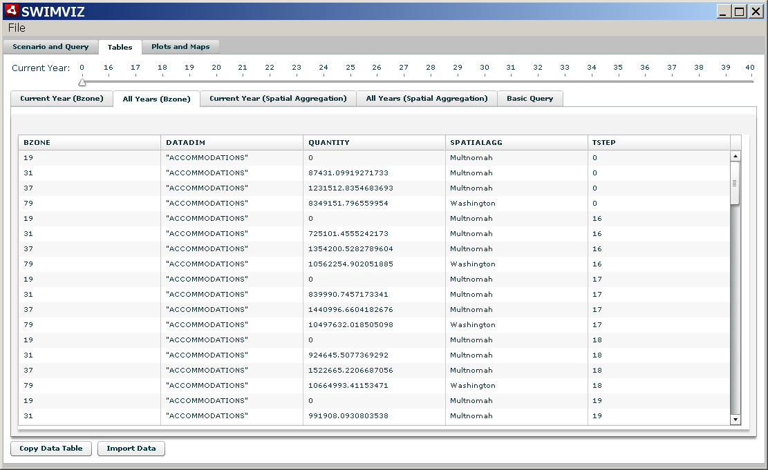

Plots and Maps
The Plots and Maps tab contains the following:
- Current Year plot  - Displays the spatial aggregation results for the current year  - The plot title is set to the DATADIM field  - The user can change the current year using the current year slider or by clicking the Play button to step through the years at a 1 second interval.  - Mouse over a chart item (dot) to highlight the spatial aggregation area on the map.  - The user can export the current year plot (as well as the all years plot and map via the Export button). The visuals will be saved to png format. | 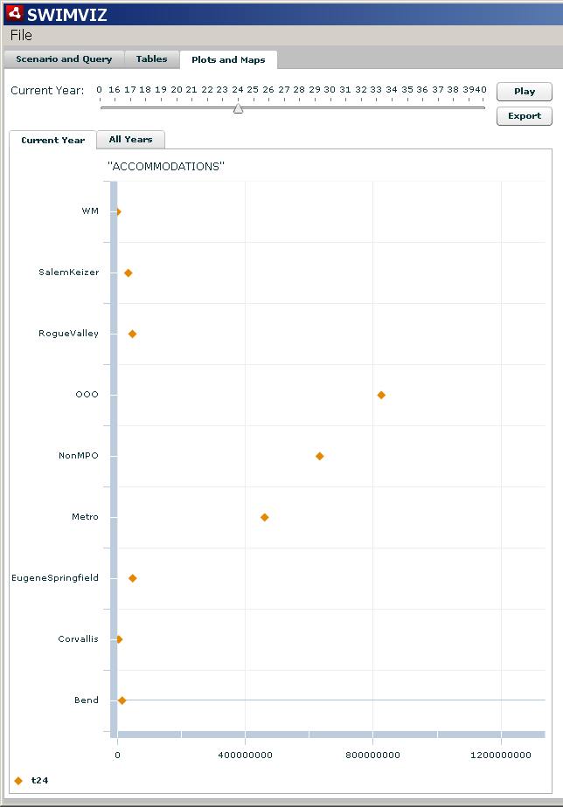
- All Years Plot  - The All Years plot shows the spatial aggregation results over time.  - The plot title is set to the DATADIM field  - The user can change the current year using the current year slider or by clicking the Play button to step through the years at a 1 second interval.  - Mouse over a chart item (dot) to highlight the spatial aggregation area on the map.  - The user can export the current year plot (as well as the all years plot and map via the Export button). The visuals will be saved to png format. | 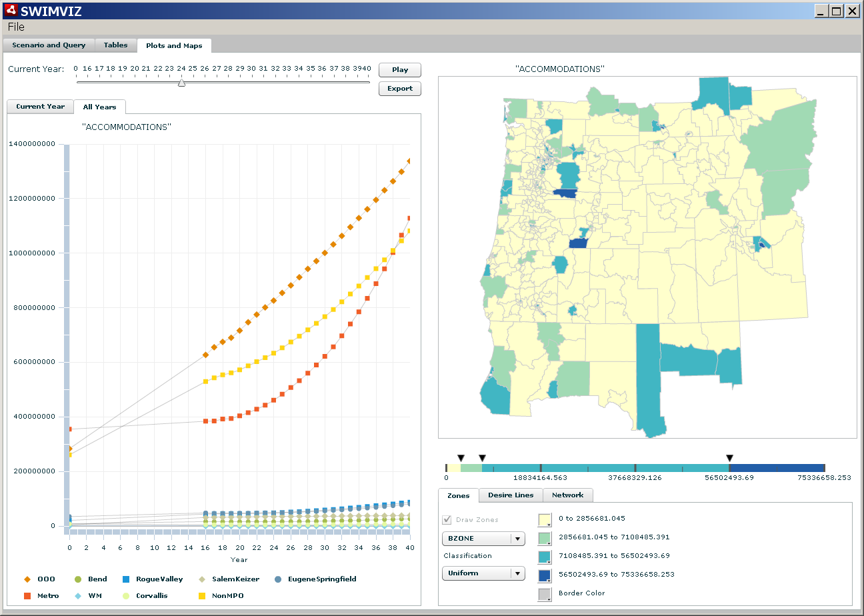
- Map (Zones)
  - The map shows the current year (Bzone) table results in spatial form.
  - The user chooses to display results as:
    - BZONE – each bzone is colored according to its value
    - SPAG – each bzone is colored according to its SPATIALAGG value
  - The user chooses one of the classification methods:
    - Percentile (quantiles)
    - Uniform (equal interval)
    - Custom (by moving the break sliders)
  - The classification scheme is not recalculated after every query. This allows the user to hold the classification scheme constant across queries.
  - The user can change the classification colors and the border color
  - Zoom in and out of the map is done with the mouse wheel
  - A mouse over tooltip displays the current query results by bzone
- Map (Desire Lines)  - Check the Desire Lines checkbox to enable the drawing of desire lines when the user single left clicks on a bzone in the map (depending on the current query).  - The desire lines are drawn at the SPATIALAGG or BZONE level depending on the setting.  - A single left click on a bzone will substitute the clicked bzone number or all the bzones in the zone’s SPAG into the From BZone and To BZone parameter dialog on the query tab and execute the current query again with the new bzone setting. This is especially useful for the OD data tables such as BuySell_Matrix and TripMatrix.  - The bar width is normalized to the current year table QUANTITY. The max bzone value (often the intrazonal) is drawn as the max bar width. The minimum value is drawn with a width of 0. All values in between are linearly scaled.  - The desire line color and max bar width can be set.  - The threshold % is the minimum bar width to draw. The default value of 0.001 means all bars with a value > 0.1% of the max bar value are drawn.  - Map (Network) - deprecated  - Check the Draw Network checkbox to draw the network for the current year (according to the current year slider). Note that the network is only available in TS model run years (usually every 3 years).  - The same settings apply for drawing lines as for Desire Lines.  - The WIDTH FIELD specifies a SQL field to use for the line width.  - The MODES specifies which modes to include in the calculation.  - The COLOR FIELD specifies a SQL field to use for the coloring of the lines.  - The three color field color selectors specify the colors for the color field ranges. The default ranges are 0 – 0.75, 0.75-1, 1+. | 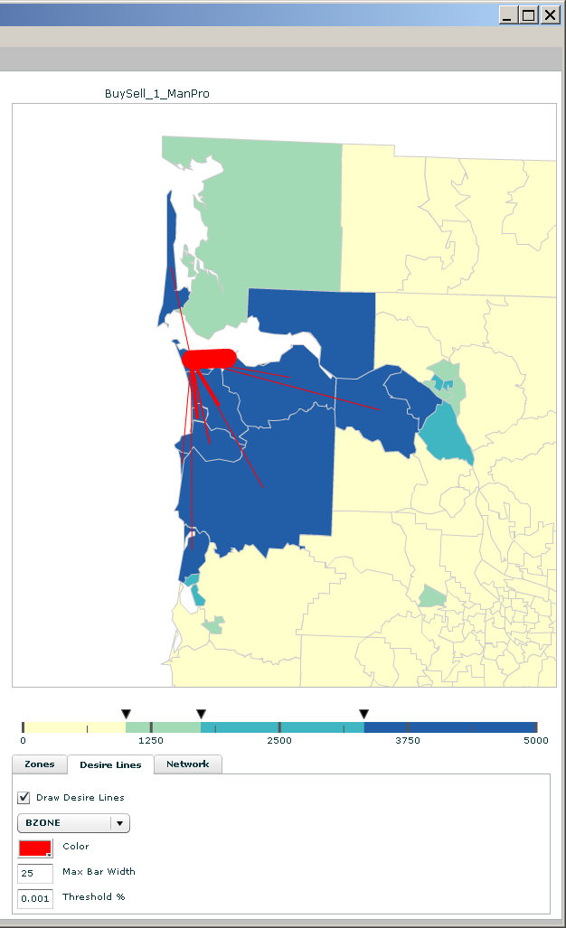  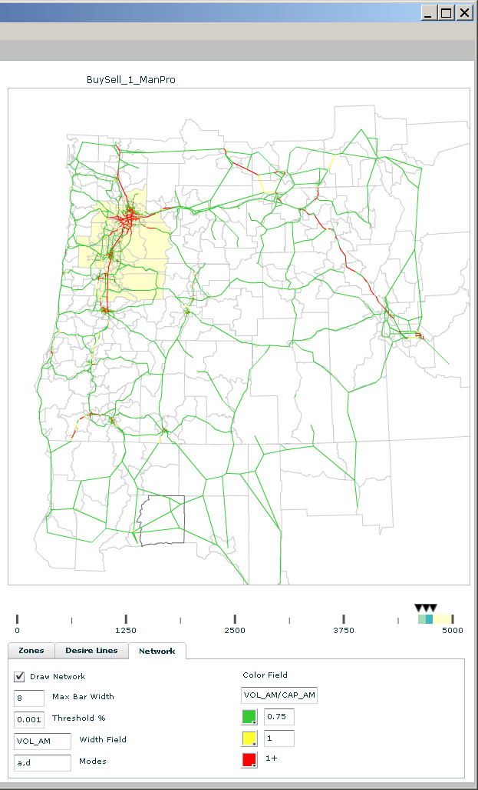
  - The current query run for the network is below. This query limits the link set to the major links in the network via the TYPE IN () clause.
"SELECT SUM(" + {WIDTH FIELD} + ") AS WIDTH, SUM(" + {COLOR FIELD} + ") AS COLORFIELD,ANODEX,ANODEY,BNODEX,BNODEY FROM LINK_DATA WHERE TSTEP=" + {TSTEP} + " AND TSYSSET LIKE ("%a%") AND TSYSSET LIKE ("%b%") AND… AND TYPE IN (1,2,3,4,11,12,13,14) GROUP BY ANODE,BNODE"

File Menu
The SWIMVIZ file menu has the following items:
- Save Settings – the save settings button will save the current GUI configuration including the query, parameter settings, map classes, map colors, etc to a binary *.set file. The scenario database name and reference database name are not saved to the file in order to allow the user to reuse settings across scenarios
- Load Settings – the load settings button will load from a *.set file a complete SWIMVIZ configuration, including filename, query, parameter settings, map classes, map colors, etc and execute the stored query against the current scenario and reference databases.
The Save and Load settings features allow the analyst to create a series of visualizations that serve as the talking point for telling a story to stakeholders.
- Exit – exit the application.

Batch Mode
SWIMVIZ can be run in batch mode from the Windows command line as well. This feature is useful for generating a series of visuals (saved as PNG files) and/or saving query results (saved to a tab delimited text file). The system call to run SWIMVIZ in batch mode is below. Note that all file references must be absolute.
C:\Program Files\SWIMVIZ\SWIMVIZ.exe {scenario DB} {settings file} {output table filename} {table ID} {output visual filename(s)} {year for table and visuals} {reference scenario DB if desired}
where for example:
{scenario DB} = C:\SCEN_2006to2036_FrtPlanRef_NoTransit.db
{settings file} = C:\swimviz.set
{output table filename} = C:\test.txt
{table ID} = 3 (0=current year bzone, 1=all years bzone, 2=current year spag, 3=all years spag, 4=simple)
{output visual filename(s)} = C:\test.png
{year for table and visuals} = 16
{reference scenario DB if desired} = C:\SCEN_2006to2036_FrtPlanRef_NoTransit_Ref.db

Deployment
The Flex application can be complied into a SWF (Flash file format) binary file or an AIR (Adobe Integrated Runtime) binary file. Both of these formats are similar to the Java jar format in that they are compiled bytecode files. The SWF file is usually then uploaded to a website and executed by the Adobe Flash player inside a web browser. The Adobe Flash player is available for free from Adobe. Adobe AIR solutions are deployed to the desktop and can read and write files locally, which is not allowed by the Flash player due to Internet security concerns. The current SWIMVIZ application is deployed as an AIR solution in order to work with the local SQLite database. If the SWIMVIZ database was ported to a web-enabled database then the SWIMVIZ application could easily be switched to a web application.

The complete SWIMVIZ installer is called SWIMVIZ.air.

Installation/Setup
To run the SWIMVIZ application on a new computer:
- Copy the SWMVIZ *.db scenario database(s) to the new computer
- Install the Adobe AIR Runtime (see the Reference section at the end for a URL)
- Install the SWIMVIZ.air application
- Start SWIMVIZ via Start + Programs + SWIMVIZ

Note that administrative rights are required to install the Adobe AIR Runtime as well as the SWIMVIZ AIR application.

Updates
The update process depends on whether or not the user has administrative rights to the computer. With administrative rights, the update steps are the same as the installation/setup process. Without administrative rights, the user can simply replace the SWIMVIZ.swf file in C:\Program Files\SWIMVIZ with a new version. This requires installing the new SWIMVIZ.air application on a computer with administrative rights and then copying the installed SWIMVIZ.swf file over to the computer without administrative rights.

References
- Map Shaper, http://www.mapshaper.org
- Adobe Flex, http://www.adobe.com/products/flex
- Adobe Data Visualization Library, http://livedocs.adobe.com/flex/3/datavis_flex3.pdf
- Adobe Flash Player, http://get.adobe.com/flashplayer
- Adobe AIR Runtime, http://get.adobe.com/air
- IBM ILOG Exilir, http://www.ilog.com/products/ilogelixir
- SQLIte, http://www.sqlite.org

