Todd Lunter  
CS3200  
HW 1

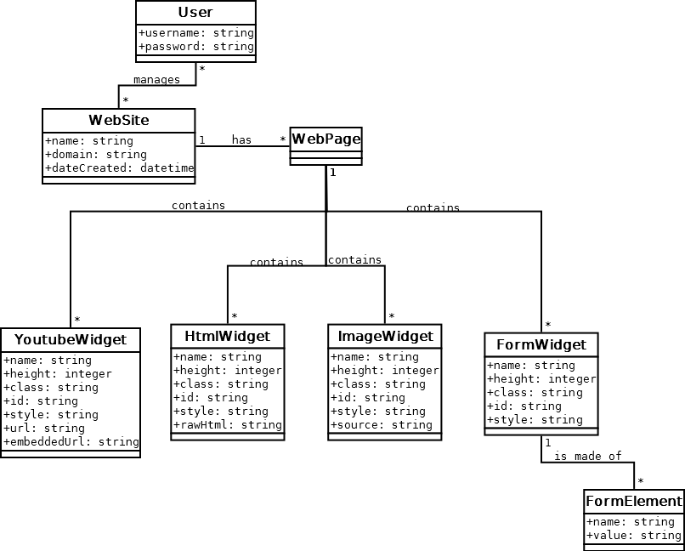

## Initial design (very inefficient)

User can manage many WebSites and many Users can manage a single WebSite (thereby creating and editing WebPages/Widgets). A WebPage is made up of many different types of Widgets

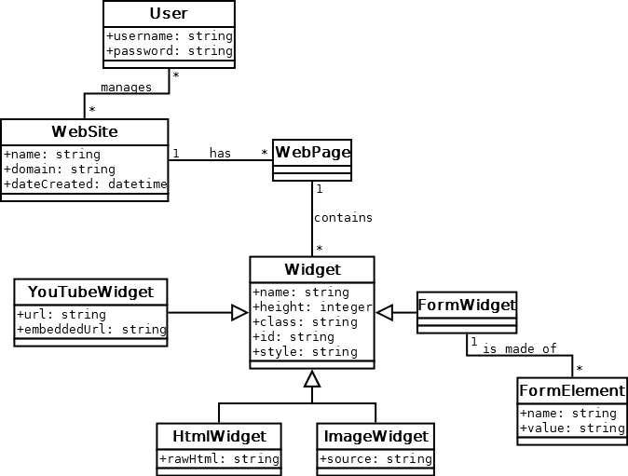

## Generalization

All widgets are generalizations of the main Widget class. This prevents duplicated tables.

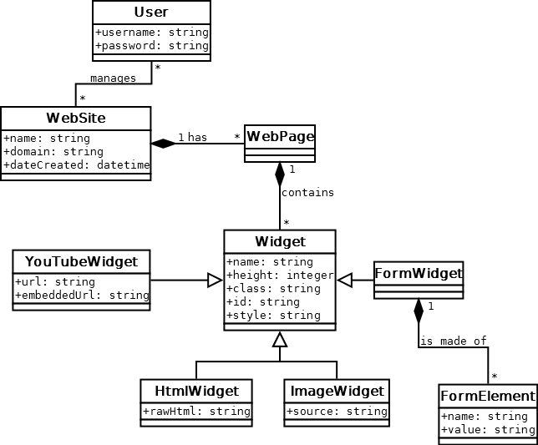

## Composition

When a FormWidget is deleted, make sure to remove all traces of its FormElements (not to be reused). Same with a WebSite and its WebPages, and WebPage and its Widgets.

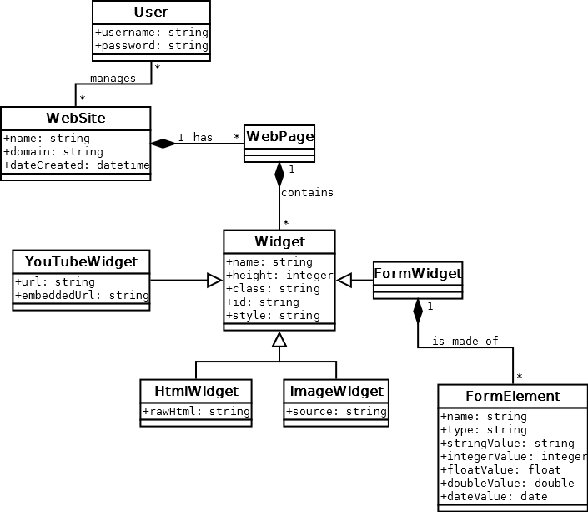

## Correct DataTypes

Since a form element can contain many different types of data, let’s not force it into a string and allow it to be any type (specified by the type field).

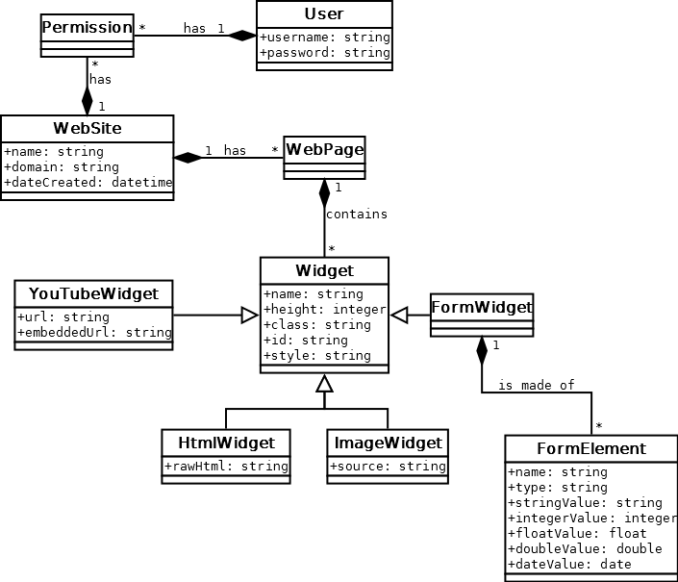

## Reify

Add Permission mapping table between User and WebSite for determining what a User can control and who can control a WebSite.