Todd Lunter
CS3200
HW 1

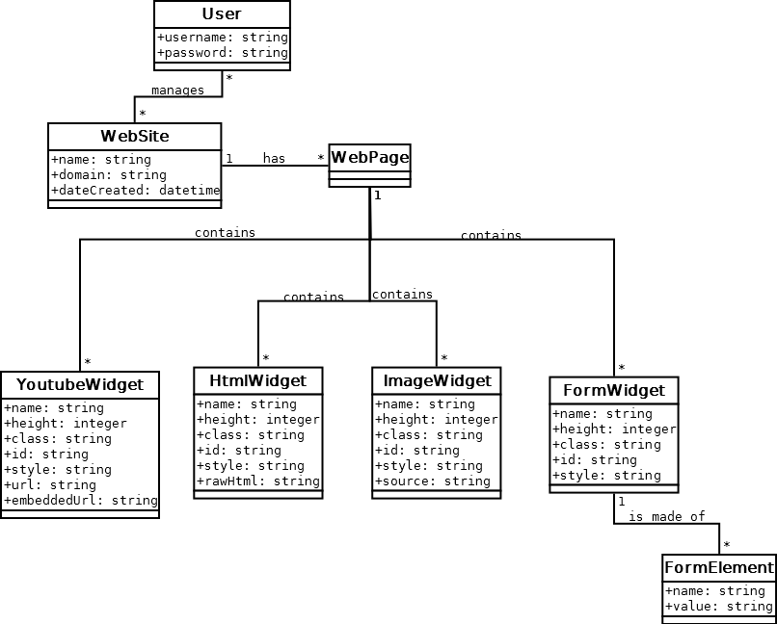

Initial design (very inefficient)
User can manage many WebSites and many Users can manage a single WebSite (thereby creating and editing WebPages/Widgets). A WebPage is made up of many different types of Widgets

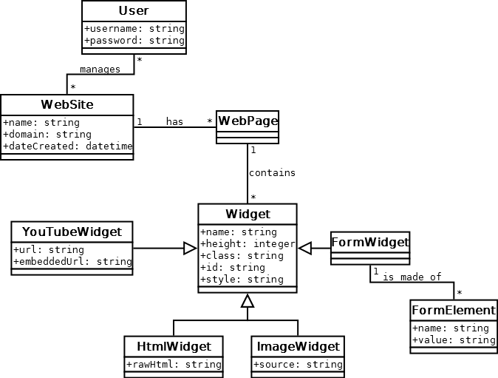

Generalization
All widgets are generalizations of the main Widget class. This prevents duplicated tables.

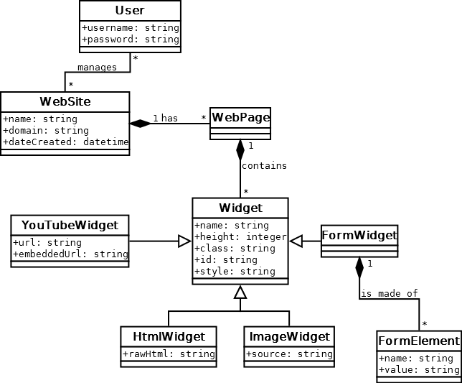

Composition
When a FormWidget is deleted, make sure to remove all traces of its FormElements (not to be reused). Same with a WebSite and its WebPages, and WebPage and its Widgets.

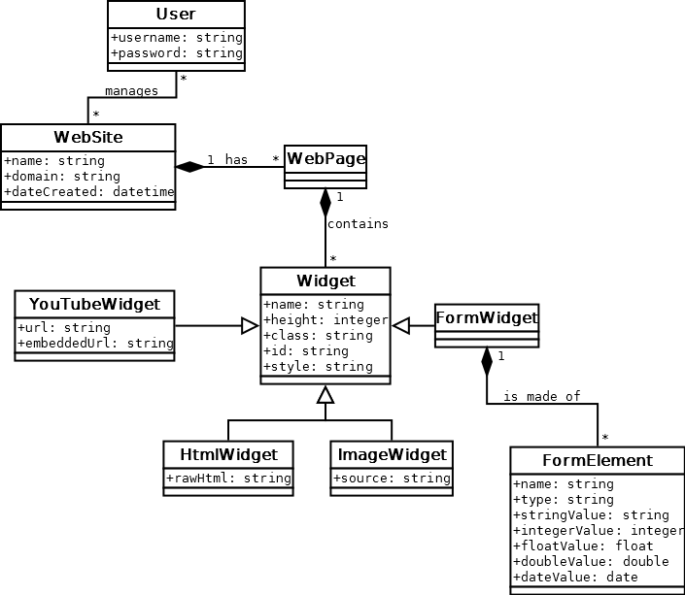

Correct DataTypes
Since a form element can contain many different types of data, let’s not force it into a string and allow it to be any type (specified by the type field).

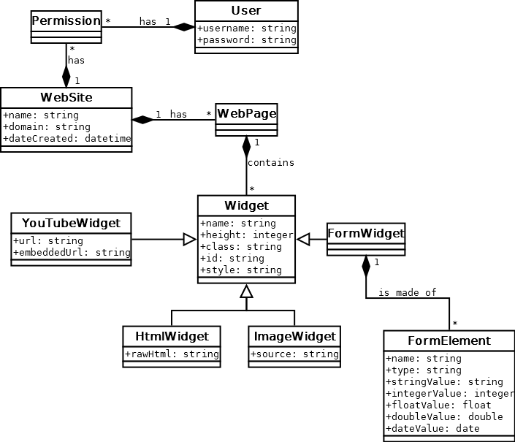

Reify
Add Permission mapping table between User and WebSite for determining what a User can control and who can control a WebSite.

