Hello everyone!

Since there were a few requests during the meetup, here is my follow-up with the how-to’s and answers. Below are the topics we did not manage to cover at the full extend:

1. Data sets
2. Core ML
3. Deploying a model
4. Besides the new Google search feature, you can also find over 27 TB of data here:

<http://academictorrents.com/>

1. You can deploy the trained model as a .mlmodel file. Additional information can be found here: <https://dataplatform.cloud.ibm.com/docs/content/analyze-data/ml-core-ml.html?context=analytics>
2. The steps required to deploy a model as an API endpoint:

I will assume that you already have a Watson Machine Learning model available in your project, it should look something like this:

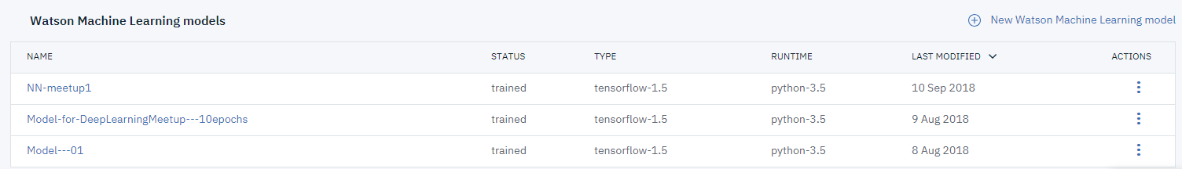

For your model click on the 3 buttons in the **Actions** column and then on **Deploy** (you can do the same thing by clicking on your model and then going to the **Deployment**s tab). Click Add Deployment and fill out the form, it should look like this:

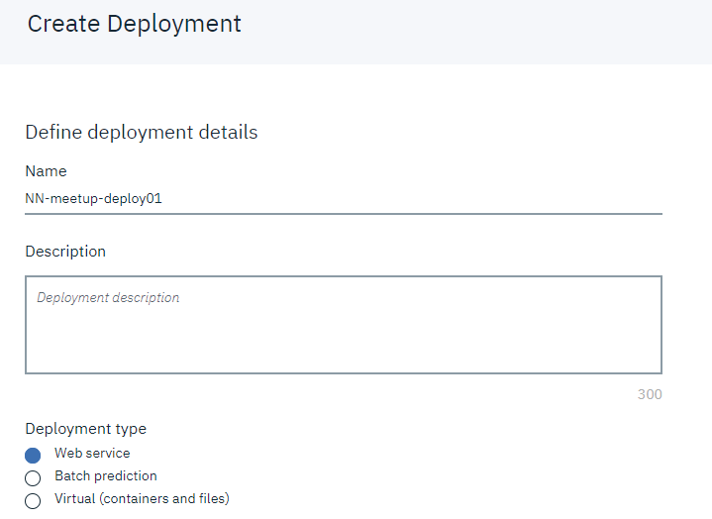

Click **Save** afterwards. If you pay attention, you will see the status of your deployment change a few times until it gets to DEPLOY_SUCCESS.

If you want to test the model, let’s assume you are here:



Click on your model, go to **Deployments** and click on the deployed model you are interested in. I the upper part of the screen you will see 3 tabs:

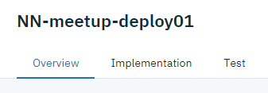

Under Implementation you will find the information to your scoring end-point as well as code snippets and API Specifications.