BHARATI VIDYAPEETH’S COLLEGE OF ENGINEERING, NEW DELHI
Department of CSE - AIML
MICRO PROJECT PROGRESS REPORT
Period of Report from 27/08/2026 to 28/09/2026
Sr. No. | Student Name | Enrollment Number
1. | Kaashvi | 01411515624
2. | Tanvi | 01611515624
3. | Khushi Choudhary | 01911515624
Attendance and Feedback By Mentor
Enrollment no. | Student Name | Attendance out of 5 | Feedback/Suggestion | Signature
1 | Kaashvi
2 | Tanvi
3 | Khushi Choudhary

Mentor Name: Dr. Kavita Bhatt
Approved Project Topic: AI-Based Respiratory Sound Screening: A Robustness-Oriented Pipeline for Noise-Aware Classification and Explainability Validation
WORK DONE DURING THE PERIOD:
Data Preparation and Preprocessing:
- Ingested the complete official ICBHI 2017 Respiratory Sound Database (~2.0 GB, 920 recordings, 6,898 extracted respiratory cycles).
- Enforced strict Patient-Independent GroupKFold cross-validation (5,401 train / 1,497 val) to prevent diagnostic leakage across splits.
- Extracted 128-band Log-Mel Spectrograms at 16 kHz (STFT window=1024, hop=512) capturing adventitious crackles and wheezes (50–8000 Hz):

Model Architecture & Imbalance Optimization:
- Engineered a 4-stage convolutional backbone with Temporal Attention Pooling to dynamically weight transient 10–20 ms crackle bursts:

- Trained using SpecAugment and Focal Loss (gamma=2.0) with inverse frequency weighting to counteract severe class imbalance (Normal: 54%, Crackle: 33%, Wheeze: 8%, Both: 4%):

Dual Explainability (XAI) & Joint Reliability Index (JRI):
- Integrated dual attributions combining coarse spatial activation (Grad-CAM) with game-theoretic pixel attributions (SHAP GradientExplainer) decomposed into Low (50–500 Hz), Mid (500–2 kHz), and High (2–8 kHz) frequency bands.
- Formulated the Joint Reliability Index as the harmonic mean of predictive robustness (R) and explanation stability (S via SSIM):

STATUS / STAGE OF THE PROJECT:
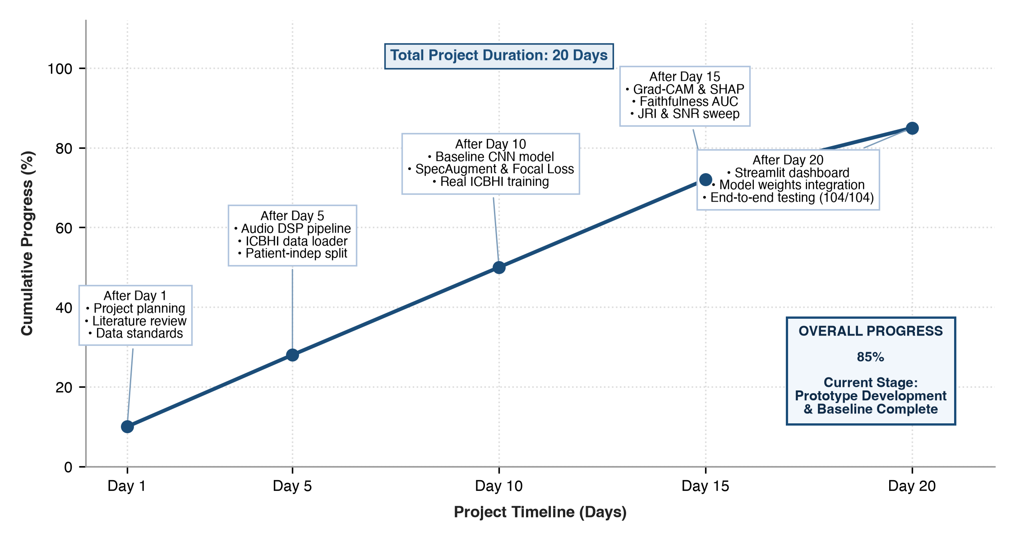

NEXT PHASE: IMPLEMENTATION AND EXPERIMENTATION
The next phase of the project will focus on expanding the validated baseline into advanced experimental validation:
1. Advanced Audio Backbones — benchmarking self-supervised foundation audio models (AST, PaSST, PANNs CNN14) to improve recall on minority classes (Wheeze & Both).
2. Supervised Contrastive Learning — incorporating SupCon loss on acoustic embeddings to improve topological boundary separation between faint wheezes and regular breathing.
3. Noise-Aware Multi-SNR Training — training with dynamic on-the-fly SNR injection to demonstrate measurable empirical improvements in the Joint Reliability Index.
4. Hospital Acoustic Artifacts — evaluating non-stationary hospital soundscapes (ICU monitors, stethoscope friction, ambient chatter) from the ESC-50 dataset.
5. Cross-Corpus Generalization — conducting zero-shot evaluations on external public databases (HF_Lung_V1) to quantify the clinical generalization gap across varying diagnostic recording hardware.
6. Point-of-Care Edge Optimization — exporting the pipeline via ONNX Runtime and TorchScript to evaluate latency and memory limits for digital stethoscope integration.
REAL SYSTEM EXPLAINABILITY OUTPUTS:
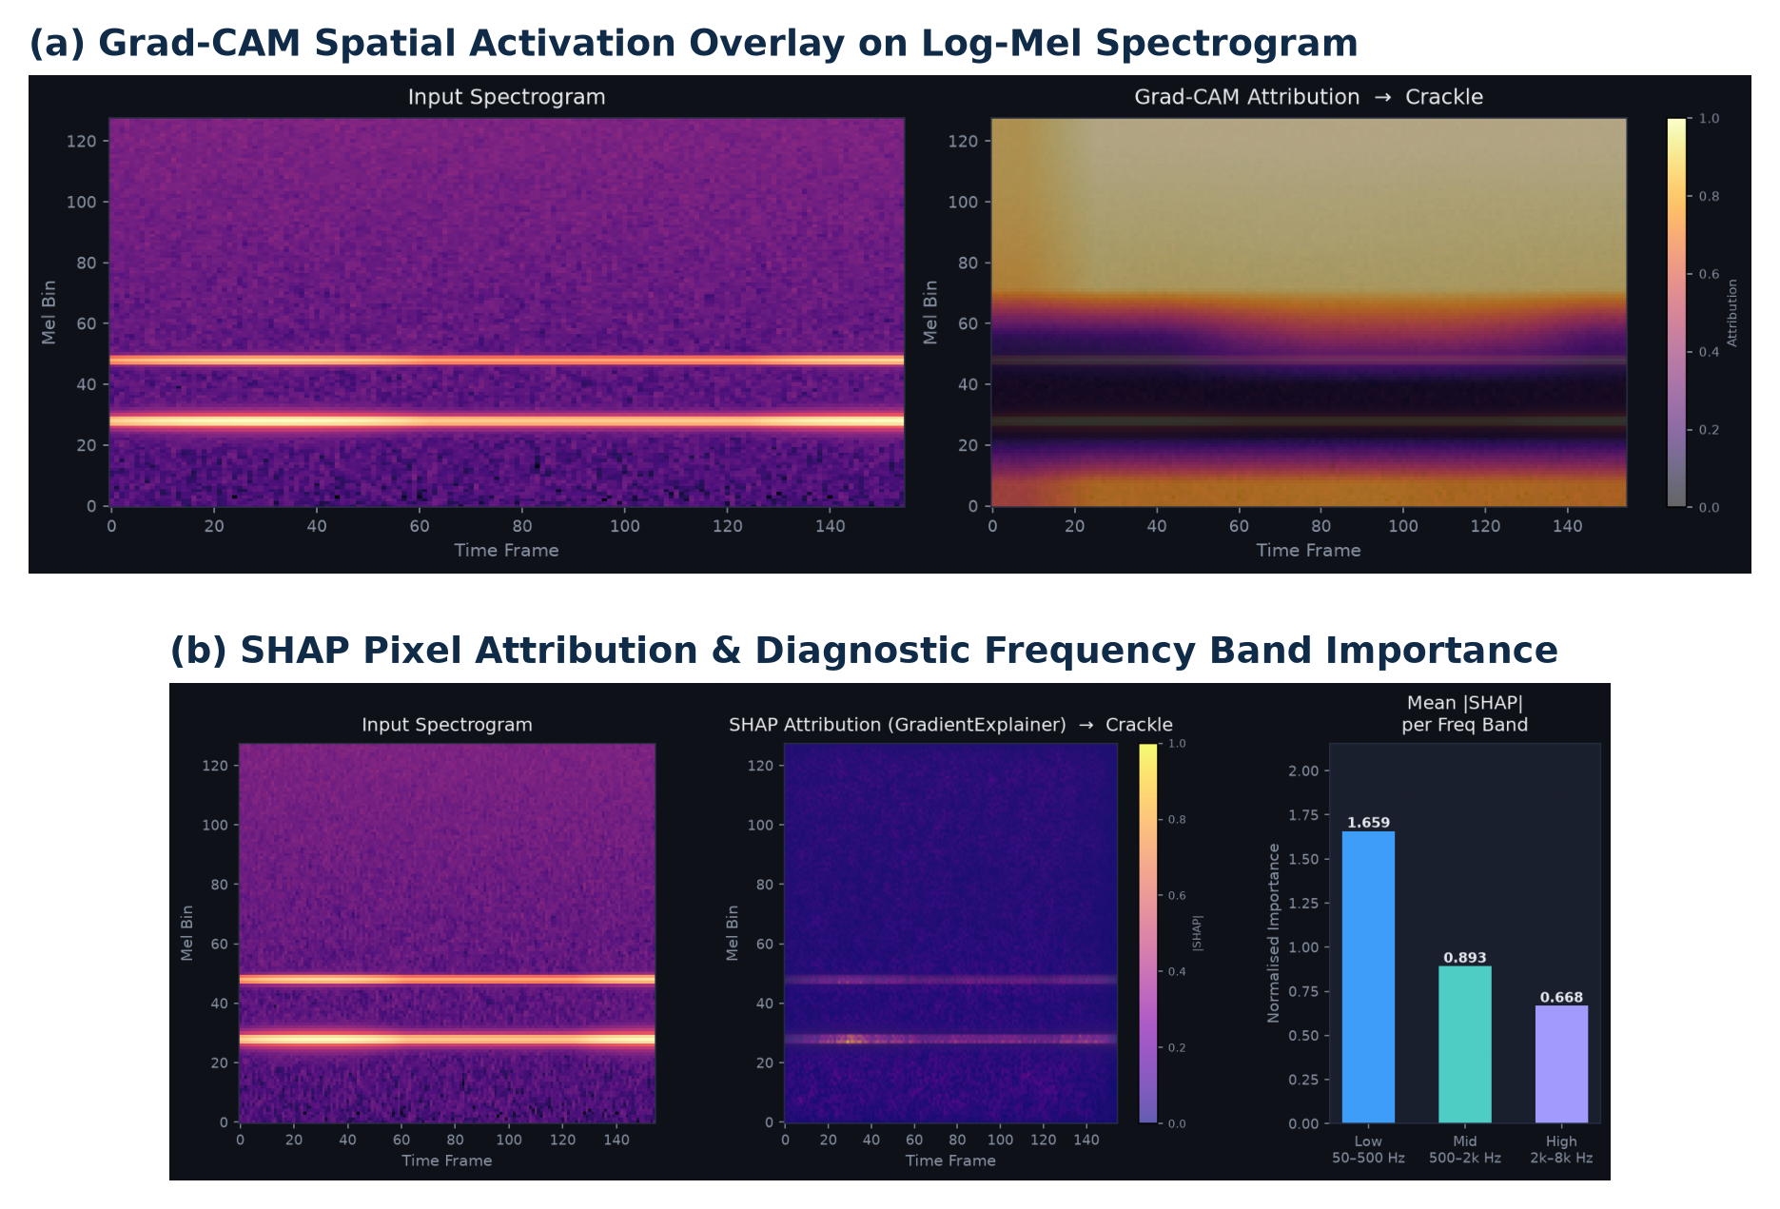

_________________________  Dr. Kavita Bhatt  Project Mentor | _________________________  Dr. Deepika Kumar  Head of Department (CSE-AIML)

