**PRACTICAS_CAPTURAS**

**INTEGRANTES: CARNET:**

**TEPAS MAZARIEGO, KENIA STEPHANNIE TM17013**

**MARTINEZ LIMA, NATALIA SOFIA ML17002**

**PRACTICA 4**

Test de ContainerTest

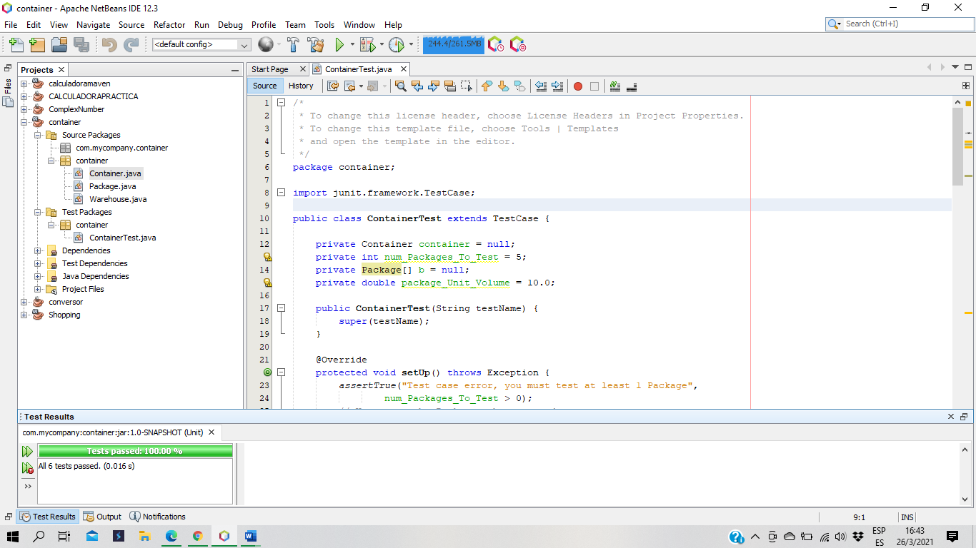

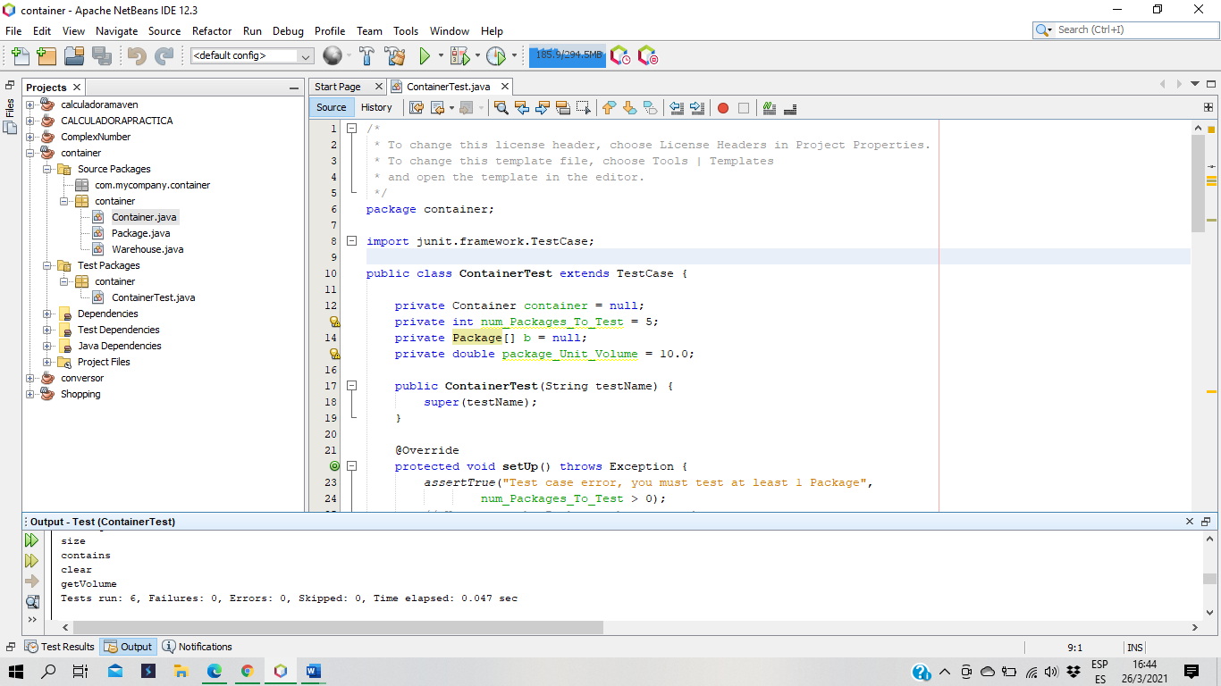

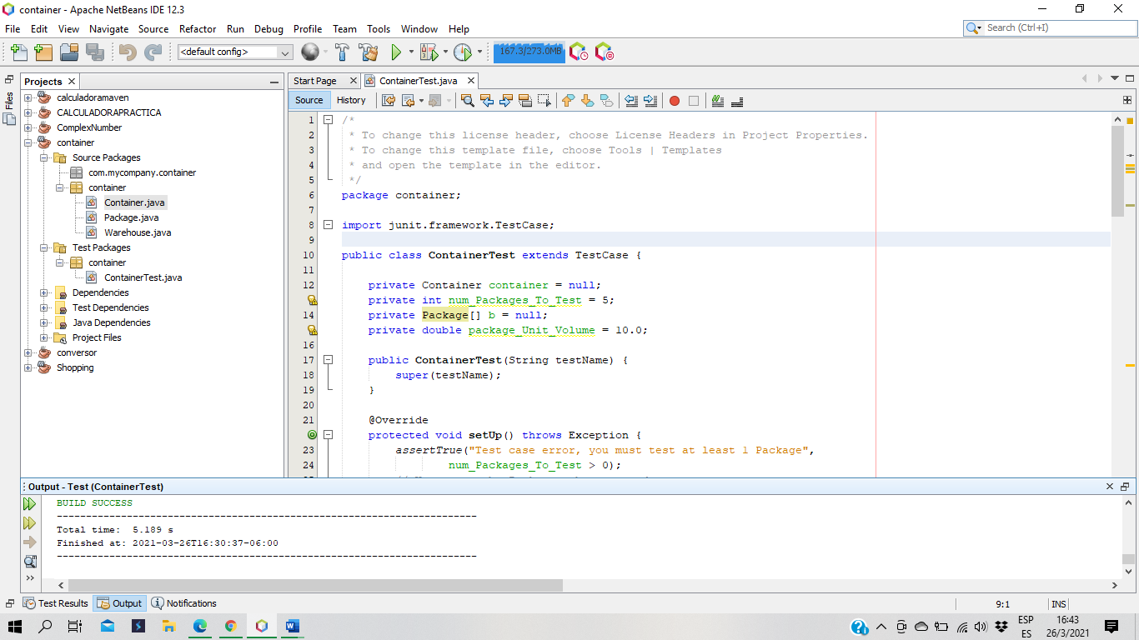

Test WarehouseTest

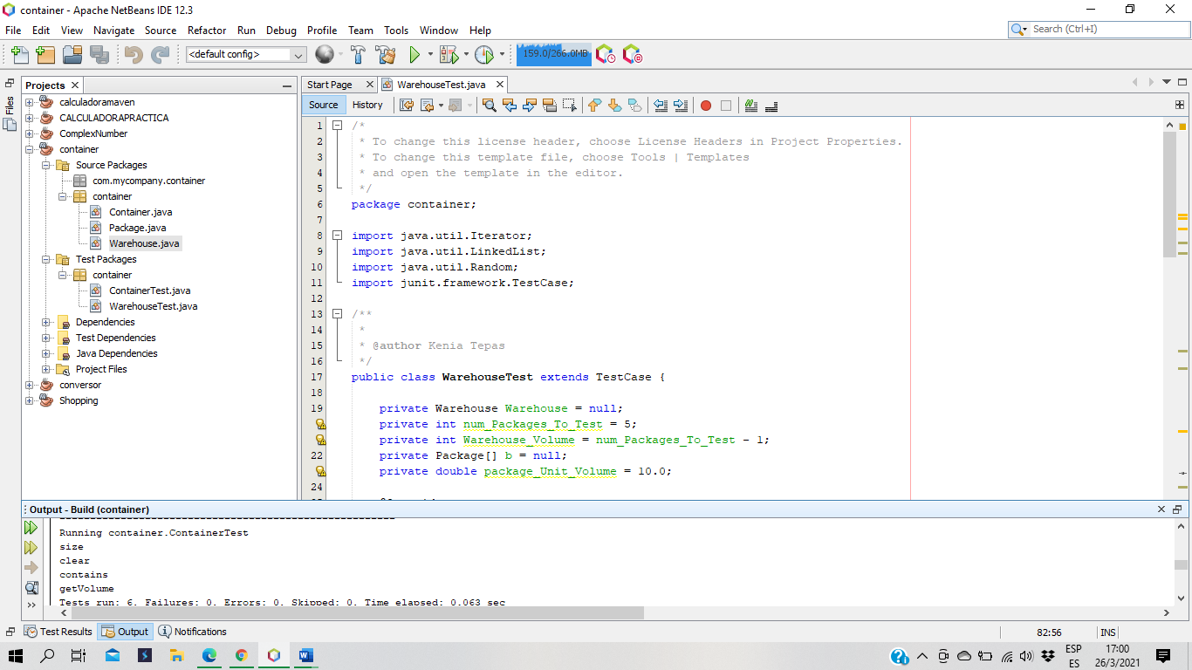

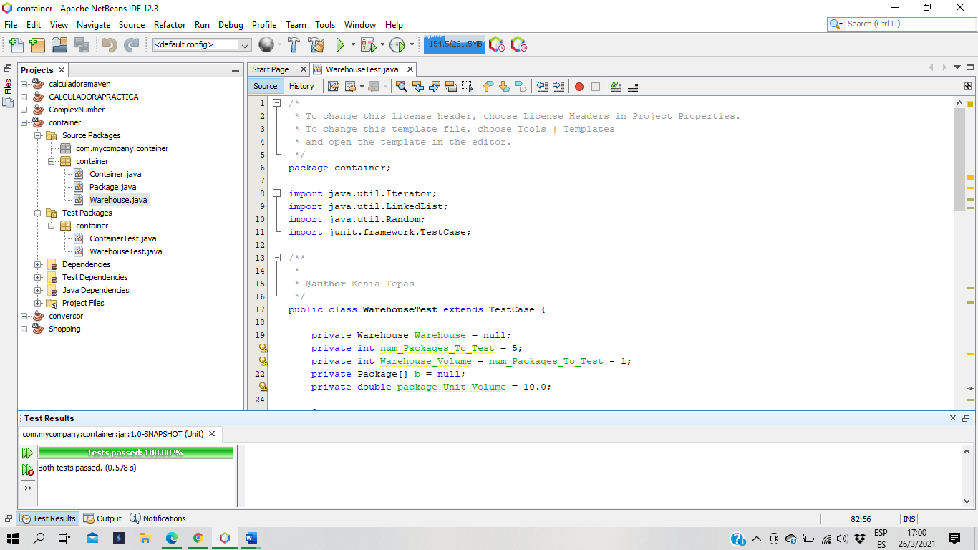

Test PackageTest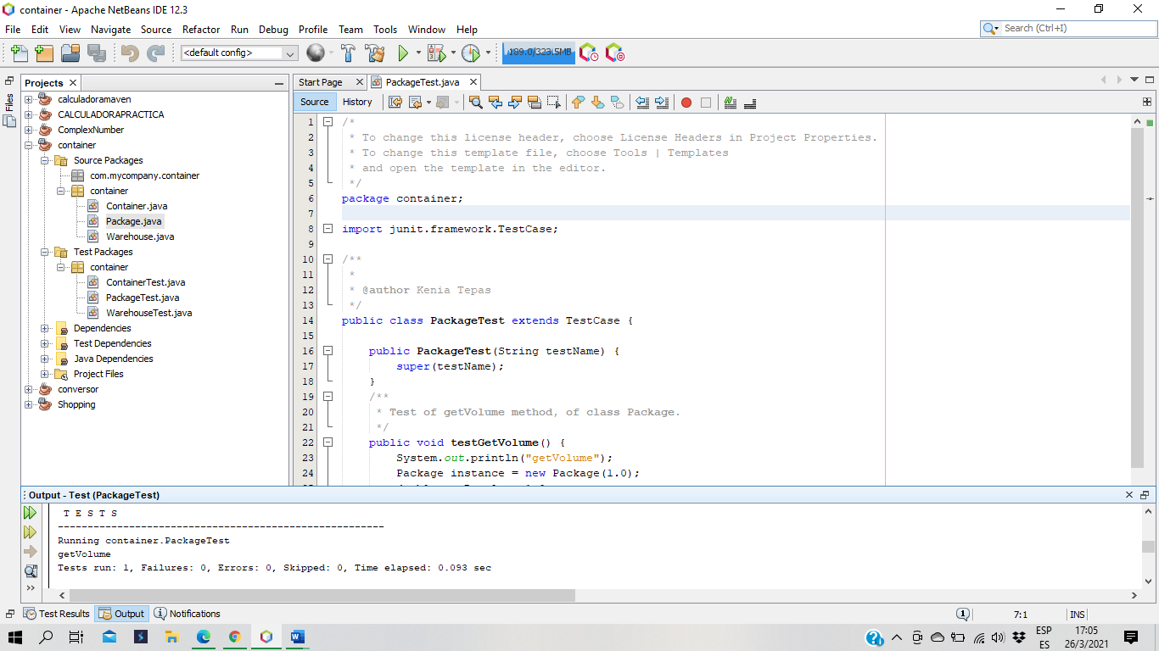

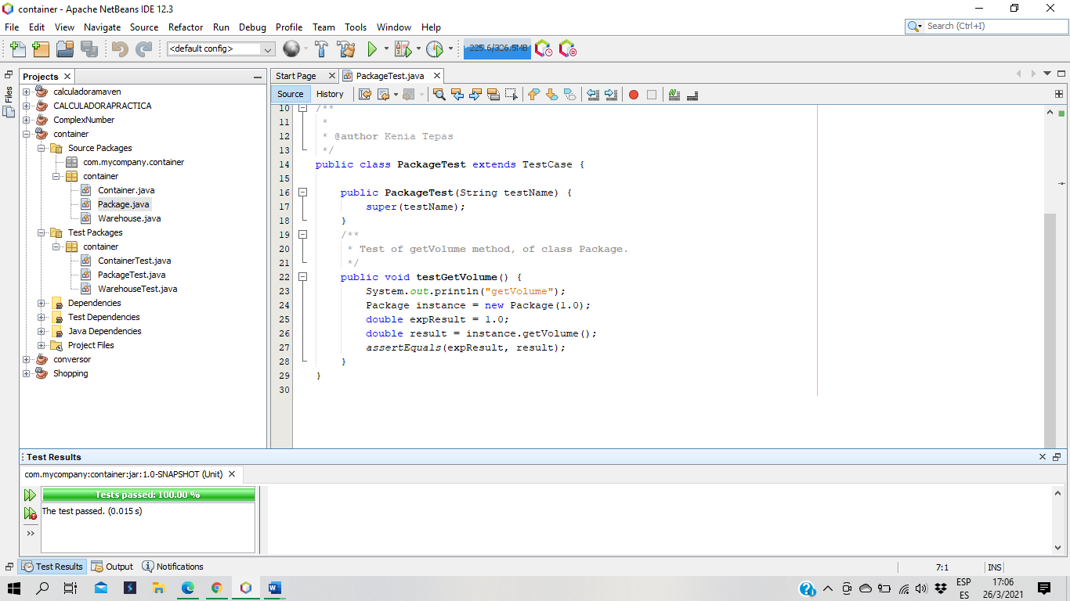

Test ContainerSuite.java

