1. Ultrasensitivity in cascades
   1. Data was estimated within Excel. Use of the best fit data solver tool was used in Excel to find the following fits for the following equations:
      1. $MEK1 (response)=\frac{{MOS}^{n}}{{a^{n}+MOS}^{n}}$, a = 63.47, n = 1.7
      2. $ERK2 (response)=\frac{{MOS}^{x}}{{c^{x}+MOS}^{x}}$, c = 35.06, x = 4.9
      3. $ERK2 (response)=\frac{{MEK1(response)}^{m}}{{b^{m}+MEK1(response)}^{m}}$ b = 0.27, m = 4.55
   2. The ultrasensitivity of the entire cascade is greater than the sensitivity of each step making sense, as each successive step creates a larger effective response from a small change in the prior step. The sensitivity of the entire cascade should be the culmination of each successive step’s sensitivity.
   3. See handed in paper for this part.
2. Chemotaxis model
   1. Signal adaptation is required for chemotaxis to compensate for when the bacteria is in high concentrations of attractant or repellant and must be able to sense a gradient effectively, amplification is necessary so that small steps in gradient are capable of altering the system even while in low concentrations of attractant, effectively that a picomolar concentration change can effectively effect a large bacteria’s chemotaxis machinery.
   2. Amplification of signals come from CheA acting as a kinase that can phosphorylate many different CheY enzymes so that a single receptor being phosphorylated will create many phosphorylated CheY proteins to induce change in the flagellar motor.
   3. Adaptation comes from the methylation of the receptor by CheR in addition to CheB modulation by the activation of CheA.
   4. Robustness of the adaptation with respect to ligand concentration because adaptation with respect to biochemical parameters allows you to return to the same steady state of the receptor even with small alterations in environment possibly due to variations in transcription/translation or microenvironment affecting enzyme kinetics.
   5. Having a fine-tuned response to adaptation time and steady state tumbling frequency allows the bacteria to control how “nervous” they are. A bacterium in a media with a lot of obstacles or repellants should be tumbling much more frequently than a bacterium that is in a free liquid. For example a bacterium in a gel filled with repellents will increase its CheR concentration to become more “nervous” or increase its stead state tumbling frequency.
3. See handed in paper for all parts of 3.
4. 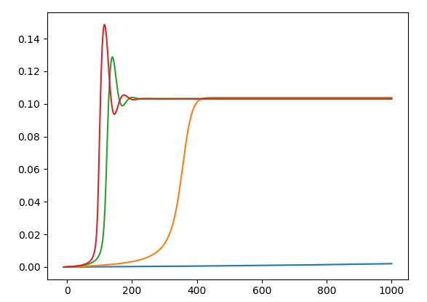
   1. The above graph shows the adaptation of the activated receptor after attractants are added. The blue line represents L = 10, orange for L = 1, green for L = .1, and red for L = .01. It’s difficult to note what is different based on what we changed from a three state model to a two state model because my code does have errors in it. We do note that the adaptation time in this model is slower than the one in the three state model, possibly due to lacking a second methylated state to make the receptor more active for ligands.
   2. The steady state activity concentrated in 3c is different from this model. In 3c I have 1.02E-4 but my graphs show about 1.02 E -1. Changing the model to take away CheB acting as an inhibitor results in the following graph:

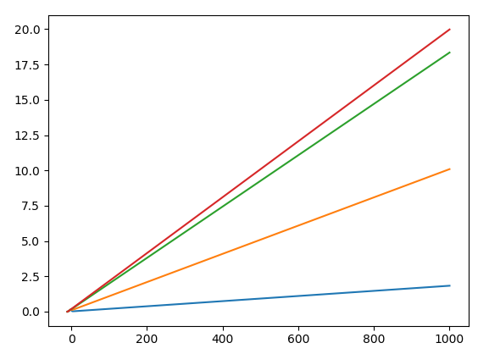

Each line still representing the same ligand concentrations as in 4a

* 1. CheY must be tuned to attain zero order response in order to get signal amplification. By getting to zero order response the change in CheY becomes massive for the slightest change in CheA’s phosphorylation state. In order to attain zero order response the CheY levels.