Chapter 1 - Digital Geography

1.1 Introduction:
Maps and models of the earth have been produced since antiquity. They describe the geography of the land, the political boundaries of countries, and are used for navigation. History shows that maps and models of the earth were important for trade, exploration, and military uses. One of the earliest models of the earth was developed in the 8th century BC by the Greek philosopher Homer. In this model, Homer described the earth as a flat disk. Anaximenes, in the 6th century BC, then modeled the earth as a rectangle. But Pythagoras (also in the 6th century BC) described the earth as a sphere since he believed that all perfect objects must be based on a sphere. Plato, Aristotle, and Archimedes all supported the idea of modeling the earth as a sphere. Plato calculated the circumference of the earth to be 40,000 miles while Archimedes' calculations resulted in a circumference of 30,000 miles. Then, in the 3rd century BC, the Greek mathematician Eratosthenes used physical measurements near Alexandria, Egypt and calculated the circumference of the earth to be 25,000 miles. This is remarkable since the accepted average circumference of the earth today is 24,901 miles [12].
The Greek mathematician Ptolemy (127-151 AD) developed maps that had influence through the Middle Ages and up to the beginning of the Renaissance. But he erroneously calculated the circumference of the earth to be 18K miles. Some historians speculate that Columbus used maps derived from Ptolemy that led him (Columbus) to erroneously believe that Asia was only 3,000 or 4,000 miles west of Europe. The Flemish cartographer Gerardus Mercator (1512-1594) began developing more accurate maps based on the information gathered by the 15th and 16th century explorers [12].
By the 17th century, it was internationally accepted that the earth was a flattened sphere (i.e. an ellipsoid). This agreement was reached after a long debate between French and English geodesists. The French (Cassini, et.al.) believed the semi-major axis of the ellipsoid ran from the North Pole to the South Pole. However, the English (Newton, et.al.) believed that the semi-major axis was perpendicular to the North/South-pole line and were proved correct by a series of geodetic experiments [12].
Accurate maps and models of the earth are perhaps more important today than in the past. Maps are important for accurate navigation (both naval and air), civil engineering, military planning, and oil and mineral explorations. Other uses include agriculture, cadastre (i.e. property taxation), environment and urban planning, surveillance, forestry, and geology [16].
With the advent of the computer, the earth can be modeled using computer graphics. Maps can now be quickly rendered and manipulated to provide users with needed information. Geographic data and the computer programs that display maps graphically are called Geographic Information Systems (GIS). Also, GIS programs must perform analytic functions (such as line-of-sight calculations) for an operator [17].
This project/thesis is a study of the technology used to process a digital database of geographic data and also to graphically display that data. A software product, called the Geographic Map System has been developed in support of this study.
1.2 Types of Digital Maps:
At a high level, databases of digital maps can be divided into three categories:
Vector Map Systems
Digitized Raster Systems
Terrain Elevation Systems
Vector Map Systems are databases in which the geographic information is stored as tuples of [latitude, longitude, altitude]. Map images are generated by manipulating these position tuples. For example, borders of countries and continents are defined as an array of [latitude, longitude] pairs. Such information can be used to generate wire-framed maps.
Digitized Raster Systems, the second category, are essentially a digitization of "paper maps". These databases consist of raster images of the paper maps. The paper maps are usually classified by the resolution that in turn determines their use. Maps of lower resolution are likely to be used by pilots at high altitudes and maps of higher resolution are used for low-level flying. A digital database of the maps is created by scanning the paper maps. A computer system can then generate raster images from the digitized data. Not many manipulations of the digital map data are possible since it is a raster image. Sometimes, vector data is overlaid on an image of a paper map to augment the image. This is similar to using acetate overlays on a desktop map. Also, satellite imagery is considered a Digitized Raster System. These systems are databases of digital images generated by satellites.
Terrain Elevation Systems (the third category) are used to generate detailed three-dimensional displays of regions of the earth. Such systems show differences in elevation of the terrain (in some cases to a high degree of accuracy) and can be used to generate images of mountains, valleys, etc. One example of such a system is called Digital Terrain Elevation Data (DTED) and is produced by the US Government. Each datum in a DTED database represents the elevation at a particular point on the earth. There are three types of DTED databases each differing in the resolution of the data. Level 0 DTED is the lowest resolution at 1000 meters (horizontally) between each datum. Level 1 DTED is more accurate at 100 meters between each datum. The highest resolution of DTED is Level 2 at 30 meters between each datum. Level 0 is the only publicly available database. The other two (Level 1 and Level 2) remain classified by the US Government.
Note that Terrain Elevation Systems are distinguished from Vector Systems because the data is eventually used to generate only raster images. For example, even though DTED data is a series of tuples of [longitude, latitude, altitude], a GIS program cannot generate the political boundaries of a country. Furthermore, Terrain Elevation
Systems are distinguished from Digitized Raster Systems because the source data is not a series of pure pixel values. A GIS program must read the tuples of [longitude, latitude, altitude] and apply a coloring scheme to render an image. Also, three-dimensional transformations can be applied to the terrain elevation data to generate different projections and images (of the same data). This is opposed to Digitized Raster Systems that contain only pixel information. Applying transformations without a frame of reference will generate an undefined image.
It should be noted that the format of digital map systems can vary significantly. This can occur because the developer/vendor of a GIS product also defined the format of the data. This was typically done independently from other map developers and users. This usually rendered the data useless to anyone except the vendor ... and to whomever purchased the GIS product. However, in more recent years, an effort has been made to develop digital map data that is independent of any specific GIS product. Such a database is said to be of neutral format. GIS products are then developed to use these databases of neutral format [17].
Also, Map projection schemes are important in classifying map systems. A projection scheme is used to solve the age-old paradox of how to display the spherical/ellipsoid earth onto a flat piece of paper. Some typical projection schemes are:
The Mercator Projection:
This scheme places the globe in a cylinder. The equator of the globe is tangent with the walls of the cylinder. Thus, the radius of the cylinder is said to be the same as that of the globe. Every point on the globe is then projected onto the walls of the cylinder. This is analogous to placing a light bulb in the middle of the globe and then observing the shadow/image that is projected onto the walls of the cylinder. The cylinder is then unrolled and laid flat. The disadvantage to this scheme is that accuracy is lost at the poles. Actually, accuracy of the image is progressively worse as the projection moves away from the equator (north and south). Accuracy is often said to be tolerable (for many applications) up to 70° North Latitude and down to 70° South Latitude [3]. More details of the Mercator Projection are presented in chapter 4.
Lambert Conformal:
This scheme places a cone on the globe. The image of the globe is then projected onto the walls of the cone. The cone is then unraveled and laid flat. This scheme gives a more accurate projection at the poles than the Mercator Projection. Accuracy is greatest where the edge of the cone is tangent to the globe. Actually, different images can be generated by orienting the cone at different points on the globe. For example, the edges of the cone could be set to be tangent with the North/South poles as opposed to the equator [3].
Transverse Mercator:
This scheme is a variation on the Mercator Projection. It simply rotates the globe inside the cylinder such that the North/South poles are now tangent to the walls of the cylinder. This gives an accurate projection for the points at the poles while reducing accuracy for most points at the equator [3].
Projection schemes are described in more detail in Chapter 4. Some database systems are produced using more than one projection scheme [10].
Another important characteristic used to categorize map systems is called the scale of the map. It is also sometimes referred to as the resolution of the map data. The scale of a map is usually stated as the ratio 1:X where the 1 refers to one unit of measure "on the map" and the X refers to the same unit of measure but "in the real world". For example, a scale of 1:10,000 means that 1 centimeter on the map corresponds to 10,000 centimeters (0.1 Km) on the earth. Another method used to specify resolution is the ratio meters-per-pixel. This ratio is applied to raster images and photographs. The ratio indicates how many square meters of an object/region has been compressed into one pixel of the image. A small ratio indicates an image of high resolution.
1.3 Sources of Digital Maps:
There are several institutions that generate digitized geographic data. One source of maps is the United States Government. In particular, two federal agencies are producers of several types of digital databases of geographic data. The first is the U.S. Geological Survey (USGS) (a bureau of the US Department of the Interior). This agency (http://www.usgs.gov) provides maps for geography, geology, mining, etc. Second, the National Imagery and Mapping Agency (NIMA) provides maps in support of the US Department of Defense (DoD) but has recently made some maps publicly available (http://www.nima.mil).
The U.S. Geological Survey (USGS): The USGS maintains an extensive series of different types of digital map systems. Examples of some of their maps systems are:
Digital Orthophoto Quadrangle (DOQ)
This system is a database of digitized aerial photographs. Resolution is high at 1:12K. This is an example of a Digitized Raster System [6].
Digital Line Graph (DLG)
These databases contain vector files of line data (e.g. roads, rivers, borders of US states, etc.). The USGS provides two scales for this map type, one at 1:100K scale, and another at 1:2M scale [6].
Digital Raster Graphics (DRG)
These maps are scanned images of USGS paper maps. Often, these DRG systems are combined with DLG and DOG images [6].
Digital Elevation Model (DEM)
This system is similar to the Digital Terrain Elevation Data (DTED) system. The DEM system is a database of terrain elevations at regularly spaced (horizontal) points on the earth [6].

The National Imagery and Mapping Agency (NIMA): This agency also maintains an extensive library of digital map systems. Often, map data is available from NIMA for regions of the world that are not covered by map systems from the USGS. For example, the DTED system is produced and managed by NIMA while the DEM system is produced and managed by the USGS. Although DTED and DEM are similar (i.e. both Terrain Elevation Systems) the USGS does not have data available for parts of Europe since that is not part of their mission.
NIMA manages several Vector Map Systems. One such system is called the Digital Chart of the World (DCW). It was developed in the early 1990's and contains over 1600 mega-bytes of data for the entire globe [9].
NIMA also manages a large library of paper maps of various regions of the world and to varying degrees of resolution. NIMA implemented a series of projects to digitally scan these paper maps, thereby converting the "paper" library to a "digital" library. These systems are called ARC Digitized Raster Graphics (ADRG). The term ARC means Equal Arc-second Raster Chart/Map. ARC is a coordinate scheme to identify regions of the globe where errors in resolution of a given map-sheet due to changes in latitude are negligible [17]. Some examples of these databases (and the corresponding scale) are:
GNC - Global Navigation Chart - 1:5M
JNC - Jet Navigation Chart - 1:2M
ONC - Operational Navigation Chart - 1:1M
TPC - Tactical Pilotage Charts - 1:500K
JOG - Joint Operations Graphics - 1:250K
ATC - Series 200 Air Target Chart - 1:200K
TLM (1) - Topographic Line Map - 1:100K
TLM (2) - Topographic Line Map - 1:50K
CG - City Graphics - scale varies
Different projection schemes were applied when these maps were created. For example, the ONC series was constructed using the Lambert Conformal Projection. However, the ONC series does not contain information at the North/South poles. Alternatively, the JNC series was constructed using the Transverse Mercator Projection because it contains map data at the North/South poles [9].
There are other sources (besides NIMA and the USGS) of satellite imagery. Consider the following:
Spot Earth Observation System:
The French organization CNES (Centre National d'Etudes Spatiales), with support from Sweden and Belgium, maintain a series of satellites and ground stations called Spot. This organization (http://www.spot.com) generates raster imagery of the earth and then sells it to the public. A customer is able to specify the region of interest.
SPIN-2:
In an ironic twist to the end of the cold-war, Aerial Images, Inc. (Raleigh, NC), and Central Trading Systems, Inc, (Huntington Bay, NY) joined with the organization called Interbranch Association: SOVINFORMSPUTNIK (Moscow, Russia) to sell imagery from a network of Russian satellites (http://www.spin-2.com). This system was once classified and part of the Soviet military's surveillance system. The imagery from this system is high resolution (e.g. 1.56 meters-per-pixel).
UK Perspectives:
The British government began the National Remote Sensing Centre (NRSC) to produce and manage satellite imagery. This organization then became public in 1991 and joined with two other companies to provide satellite imagery to the public. (http://www.ukperspectives.com).
Terraserver:
This organization (Aerial Images, Inc., Microsoft, the USGS, and Compaq) manages a database of satellite imagery and aerial photographs (http://www.terraserver.com). The sources of the imagery are the USGS, SPIN-2, and UK Perspectives systems. Customers can request imagery for specific areas of the earth. Some imagery is available via the Internet as JPEG or TIFF files.

1.4 The Geographic Map System
The focus of this project/thesis was to investigate how Geographic Information Systems (GIS) are developed. There are several mapping systems currently available from various vendors. However, the details of the implementation are always hidden from the user/customer. Therefore, this is an investigation of existing technology, rather than a development of new technology.
Given a computer and a database of (raw) geographic information, the basic software components of a GIS product (i.e. the application software) are:
File Management - this component reads the geographic information from the database.
Graphics/Data Operations - this component manipulates the data from the first component and prepares it to be displayed graphically. It also performs analytic functions (e.g. line-of-sight calculations).
User Interface - this component graphically displays the data to an operator. Also, this component reacts to requests from the operator.
The interaction of these components is illustrated in Figure 1.1.

Figure 1.1 : Basic Architecture of GIS Products
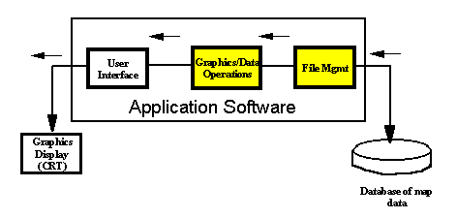
Often, developers of GIS products will purchase the first two components (the shaded components in Figure 1.1) and then write the third component based on the needs of a particular customer. The focus of this graduate project was the converse of this approach. The objective was to study and then develop the first two components. The results are a software product called the Geographic Map System (GMS).
For this thesis the vector map system called Digital Chart of the World (DCW) was chosen. For this type of database, two software toolkits were produced. The first is called the GMS Extabula Toolkit (Extabula, Latin for "from the map/chart"). This toolkit corresponds to the File Management component (of Figure 1.1). It is used to read the information from the DCW database and prepare it so it can be manipulated by client software. The second toolkit is called the GMS DCW Graphics Toolkit and corresponds to the Graphics/Data Operations component (of Figure 1.1). Its function is to prepare the data from the first toolkit in such a way that it can easily be displayed by the user interface component of the GIS.
In addition to these two toolkits, a series of applications were developed to demonstrate the functionality of the GMS toolkits. Although not overly sophisticated (compared to GIS products available on the market), these applications exercise some of the core capabilities of the two toolkits.

Chapter 2 - The DCW Database

2.1 Introduction:
The Digital Chart of the World (DCW) is a database of geographic information. The information is stored on 4 CD-ROMs and covers the entire earth. The DCW database was developed in the early 1990's by the National Imagery and Mapping Agency (NIMA). Other agencies that supplied source maps were [9]:
Australian Army Survey
Canadian Directorate of Geographic Operations
United Kingdom Military Survey.
US Geological Survey
At the time of the DCW project, NIMA was called the Defense Mapping Agency.
NIMA (http://www.nima.mil) is part of the US Department of Defense (DoD). Its function is to provide geographic information to other members of the Department of Defense. The purpose of the DCW product is to provide a database of neutral format that can be used by several different types of geographic information systems (GIS). The objective was to support GIS products in the military, scientific, and educational communities.
As mentioned in Chapter 1, the DCW database is a vector map system. The data is organized as tuples of longitude, latitude. For example, the political borders of a country are specified as an array of latitude/longitude pairs. The DCW database actually conforms to a rigorous definition that is called the Vector Product Format (VPF) and is specified in the document Mil-Std-2407. The VPF is a protocol of how certain types of vector map data are to be organized. A vector map system that conforms to the VPF standard is said to be VPF compliant. The DCW database is VPF compliant.
The DCW database was constructed using several types of paper maps. Specifically, the Operational Navigation Chart (ONC) map series and the Jet Navigation Chart (JNC) series were used. Rather than scanning these paper maps into raster images (as was done for the ADRG systems), the data from the ONC and JNC maps were further processed into vector data. The DCW database was constructed using 270 sheets of ONC map data (whose resolution is 1:1,000,000). The ONC map series was developed for the military and is typically used by pilots and planners. The DCW database was augmented using the JNC map series because the ONC series does not cover the region of Antarctica. The JNC series is also used for navigational purposes, but its resolution is less (than ONC) at 1:2,000,000 [9].
The DCW database contains supplemental information to the ONC and JNC maps. Information about airports was added using data called Digital Aeronautical Flight Information File (DAFIF). Also, the US Geological Survey provided information called
Advanced Very High Resolution Radiometer (AVHRR) that describes vegetation. Two other map types were used to provide details about 355 world cities. These maps were the Joint Operations Graphic (JOG) and the Tactical Pilotage Chart (TPC) [9].
2.2 Architecture of the DCW Database:
As mentioned, the DCW database consists of 4 CD-ROMs. On each CD is a series of directories (readable on DOS, UNIX, etc. systems) that are called libraries. Each library further contains sub-directories and eventually files of geographic data. Therefore, the term library is synonymous with directory.
The DCW is not a relational database in the way that Oracle ® and Sybase ® are constructed. However, the DCW does contain relational information. Furthermore, an effort was made to reduce the amount of duplicate information which is another characteristic of a relational database. However, in its simplest view, the DCW is a hierarchy of flat files.

Figure 2.1 : Organization of DCW Database
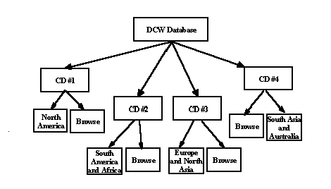
First, consider the highest-level libraries. The DCW database is divided into 5 such libraries:
NOAMER - North America
EURNASIA - Europe and North Asia
SOAMAFR - South America and Africa (and Antarctica)
SASAUS - South Asia and Australia
BROWSE - whole Earth
The first four libraries (NOAMER, EURNASIA, SOAMAFR, and SASAUS) are called regional libraries and contain detailed geographic information about a specific area of the world. The BROWSE library contains high-level geographic information about the entire earth. Each of the first 4 regional libraries is installed on one CD-ROM (i.e. one regional library per CD). The Browse library is duplicated on each of the 4 CDs. This is illustrated in Figure 2.1 above.
At the root of each CD-ROM are two directories. One is the regional library (i.e. a directory called NOAMER, or SOAMAFR, etc.). The other is the Browse library (i.e. a directory called BROWSE). Recall that the browse library is duplicated on each CD.
Themes (Coverages) in the DCW Database: Each library (on a given CD) is further divided into what are called themes (also called coverages). These are categories of geographical information such as transportation, hydrology, and cities. A theme is also equivalent to a directory. Therefore, each theme is a sub-directory of a regional library. Each regional library contains 17 themes. The themes of a regional-library are summarized in Table 2.1 below:
Table 2.1 : Regional Themes of DCW Database (non-Browse)
- Aeronautical Information
Directory Name : AE
This directory contains details about civil and military airports.
- Cultural Landmarks
Directory Name : CL
This directory contains data about landmarks of significance for a specified region.
- Data Quality
Directory Name : DQ
This directory contains data about the resolution and accuracy of the geographic data in a specified region.
- Drainage Information
Directory Name : DN
This directory contains data about such geographic entities as glaciers, canals, aqueducts, wells, reservoirs, and dams.
- Drainage (supplemental)
Directory Name : DS
This directory contains additional drainage information about small lakes, and small islands of inland waters.
- Hypsographic Information
Directory Name : HY
This directory contains elevation data. Regions of equal elevation are specified. This data can be used to draw elevation contours on a map.

- Hyspsographic (supplemental)
Directory Name : HS
This directory contains additional elevation data that was made available from different sources. For example, this directory typically contains information called spot elevation.
- Land Cover Information
Directory Name : LC
This directory contains data about geographic entities such as rock quarries, strip mines, and oil fields.
- Ocean Features
Directory Name : OF
This directory contains data about exposed ship wrecks, lighthouses, and reefs.
- Physiography
Directory Name : PH
This directory contains data about physical geography. This is information about tectonic plates, fault-lines, etc.
- Political/Oceans
Directory Name : PO
This directory contains data about the boundaries of the continents and countries.
- Populated Places
Directory Name : PP
This directory contains details of cities, towns, villages, and built-up areas.
- Railroads
Directory Name : RR
This directory contains data about single and multi-track railroad systems.
- Roads
Directory Name : RD
This directory contains data about highways, dual and single lane roads, etc.
- Transportation Structures
Directory Name : TS
This directory contains data about commuter stations, highway overpasses, etc.
- Utilities
Directory Name : UT
This directory contains data about electrical power plants, and other utility systems.
- Vegetation Directory Name : VG
This directory contains data about forests, fields, agricultural crops, etc

The Browse library is likewise divided into themes. However, there are 8 such themes. Some themes are the same as the regional libraries and some are unique to the Browse library. In any case, there is less detail and resolution than in the regional libraries. The 8 themes of the Browse-library are summarized in Table 2.2.

Table 2.2 : Browse Themes of DCW Database
- ONC Compilation Date
Directory Name : CO
This directory contains data about the dates of ONC charts used in the DCW database.
- Data Volume
Directory Name : DV
This directory contains information about the storage and memory requirements of the DCW database.
- Drainage
Directory Name : DN
This directory contains data about lakes, rivers, and inland water ways.
- Geographic Reference
Directory Name : GR
Describes the limits/boundaries of the browse data.
- Availability of Hypsographic Data
Directory Name : DA
This directory specifies the regions on the globe for which hypsographic data is defined (i.e. contained in the database).
- ONC Index
Directory Name : IN
Reference/Index to the ONC charts used in the DCW database.
- Political/Oceans
Directory Name : PO
This directory contains data about the boundaries of the continents, countries, etc.
- Populated Places
Directory Name : PP
This directory contains general information about cities and towns.

Before describing the architecture of the themes (i.e. sub-directories), it will be helpful to first describe what is called the Geographic Reference System.
The Geographic Reference System (GEOREF): The GEOREF system is a coordinate scheme that partitions the earth into equal sized regions. This system uses a flat-earth model and then divides regions into equal sized areas called tiles. Each tile is a 15° by 15° cell as shown in Figure 2.2.

Figure 2.2 : GEOREF Tiling Scheme
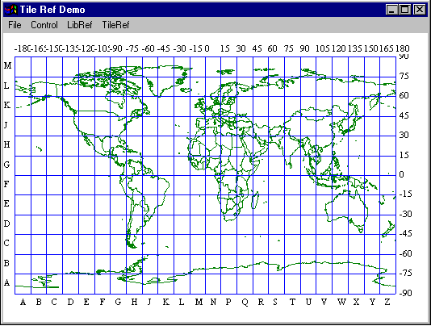

There are 24 longitude zones identified by the letters A through Z (except the letters I and O). The longitude zones start at -180° and move to 180° in 15° increments. Also, there are 12 latitude zones identified by the letters A through M (skipping I). The latitude zones start at -90° and move to 90° in 15° increments. A tile is identified by the tuple XY where X is the longitude zone and Y is the latitude zone. For example, the tile GJ is the area -90° .. -75° longitude and 30° .. 45° latitude (i.e. much of the eastern United States) [10].
Each tile is then further divided into smaller 5° by 5° sub-tiles. The longitude sub-tiles are numbered column-wise 1 through 3 and the latitude sub-tiles are numbered row-wise 1 through 3. The first sub-tile is 11 and is in the lower left corner of the outer tile [10]. See Figure 2.3 below. For example, much of the country of Spain is contained in the tiles MJ22, MJ23, MJ32, and MJ33.

Tiling Scheme of DCW Database: Now, back to the DCW database. Data within a particular theme from a DCW library is partitioned into a directory scheme based on the Geographic Reference System. The first series of sub-directories of a theme are the longitude-zones from the GEOREF system. Thus, there are one or more sub-directories named A, B, ... Z. Going into one of these sub-directories shows one or more directories that correspond to the latitude-zones (i.e. directories with names A, B, ... M). Continuing into the latitude sub-directories yields one or more sub-directories whose names correspond to the sub-tiles of the GEOREF system (i.e. directories with the names 11, 12, ... 33). Going into one of these sub-tile directories finally yields a series of files of raw geographic data (which will be described shortly). Therefore, certain data for a given

Figure 2.3 : GEOREF Sub-Tiling Scheme

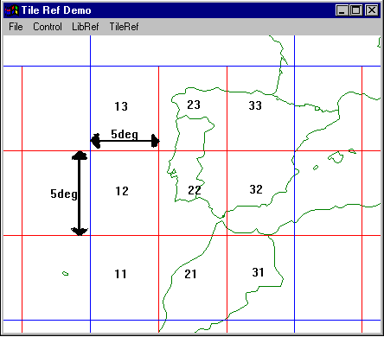

region can be accessed by specifying the tiles. This directory hierarchy of the themes of the DCW database is shown in Figure 2.4 below.
This essentially describes the "skeleton" of the DCW database. It is how geographic information is distributed in the database.
Exceptions to the Rule: For a given regional library, there are 3 directories that are different. These directories are at the same level as the theme sub-directories. However, each directory simply contains files of raw geographic data. There is no
application of the GEOREF tiling scheme to these directories. Table 2.3 summarizes the contents of these 3 directories.
Table 2.3 Other Directories (Non-Browse)
Gazetteer
Directory Name : GAZETTE
This directory is a geographic dictionary.
Library Reference
Directory Name : LIBREF
This directory contains high level boundary data for a particular library. It specifies the general area of coverage for that library.

Tile Reference
Directory Name : TILEREF
This directory contains a list of all the GEOREF sub-tiles for a given library. The names of the sub-tiles and the area covered by each sub-tile is specified.

Figure 2.4 : Directory Hierarchy of DCW Themes
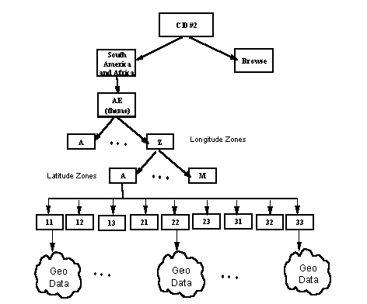
Hence, in addition to the 17 thematic directories, each regional library contains these 3 sub-directories for a total of 20. The TILEREF directory is interesting because it contains the data that describes which GEOREF tiles that are defined for the whole library. Hence, an application can use the data from the TILEREF directory to access data from any of the 17 themes. For example, the data from the TILEREF directory was used to construct the image of Figure 2.3 (above).
The Browse library also has a LIBREF directory. It specifies the boundaries of continents and countries for the whole globe (whereas the LIBREF of a regional library specifies only the geography of that particular region of the globe). For example, data from the LIBREF directory of the Browse library was used to construct the image of Figure 2.2 (above). Hence, in addition to the 8 thematic directories, each Browse library contains this LIBREF sub-directory for a total of 9. Now it is time to describe the files in this DCW architecture that contain geographic information.

2.3 Basic File-Types in DCW Database
The previous section described how the DCW database is organized (i.e. its architecture). However, it is the files within that architecture that contain the raw geographic information. This section describes the types of files found within that architecture. The files of the DCW database are classified into the following four categories:
Database Tables
Library Tables
Primitive Tables
Coverage Tables

Note that the term table is equivalent to file. The database tables contain general information about the whole DCW database (i.e. are not specific to a particular library). The library tables contain information about a specific library (i.e. NOAMER, SOAMAFR, EURNASIA, SASAUS, or BROWSE). The primitive tables contain low-level geographic information (such as borders of countries, outlines of continents, etc.) for a given library. The coverage tables contain descriptive information about a given region (such as soil conditions, maximum elevations, reefs, etc.).

The Database Tables: As mentioned, the Database Tables give a general description of the whole DCW database. These files are duplicated on each CD-ROM and reside at the root directory. There are two database files:
Table 2.4 : Database Tables
Database Header Table
File Name : DHT
Library Attribute Table
File Name : LAT

The Database Header Table contains general information of the DCW database such as its name, the mailing address of NIMA, and date of creation. It is essentially the title page of the database. The Library Attribute Table contains records that define the boundaries of each of the libraries.
The Library Tables: These files are placed in each of the library directories (e.g. SOAMAFR). These files give descriptions of the specified library (regional or browse). Each library directory consists of one copy of the files listed in Table 2.5.
Table 2.5 : Library Tables
- Library Header Table
File Name : LHT
- Coverage Attribute Table
File Name : CAT
- Geographic Reference Table
File Name : GRT
- Data Quality Table
File Name : DQT
- Lineage Narrative Table
File Name : LINEAGE.DOC

The Library Header Table gives a general description of the particular library. It is like a title-page for that library. The Coverage Attribute Table lists each of the themes contained in the library. The names of the directories for each theme are also specified. It is like a table-of-contents for the library. The Geographic Reference Table contains information about the earth-model used to construct the data. For example, it specifies if the earth-model is ellipsoid and what the lengths are of the semi-major and semi-minor axes. The Data Quality Table lists attributes about the accuracy of the information in the database. For example, it specifies the absolute horizontal accuracy between points. The Lineage Narrative Table gives supplemental quality and accuracy information about the database and is written in a prose format. The Browse library does not contain a LINEAGE.DOC file.

The Primitive Tables: These files contain low-level geographic information. First consider the following types of tables referred to here as core primitive tables. There are 4 types of these core tables and are described in Table 2.6.

Table 2.6 : Core Primitive Tables
- Edge Tables (File Name : EDG)
An edge table contains information that defines borders of geographic items. Because edge tables contain variant-length records each EDG table is matched with a file called an index table. The index table is simply a list of offsets. There is one offset value for each edge record in the matching edge table. The offset specifies the start of the corresponding edge record. All edge index files are named: EDX.
- Text Tables (File Name : TXT)
A text table contains the names of geographic regions (e.g. the name "Pacific Ocean"). A text record specifies the text/string and the [longitude, latitude] where the string is to be written on a map. Text tables are files with variant-length records (e.g. "Ohio" vs "Indian Ocean"). Therefore, text tables are matched with a text index table. Similar to the edge index table, the records of the text index specify the offsets to the start of each text record. All text index tables are named: TXX.
- Face Tables (File Name : FAC)
These tables are used to define a join relationship between a set of edges (from an edge table) and a feature table (which is described below). A region that is enclosed by a series of edges is called a face. Often, it is necessary to determine the features (i.e. characteristics) of that region. Such characteristics are defined in a feature table. The face table connects the region to those features.
- (Entity) Node Tables (File Name : END)
These tables define a geographic object that is a single point (e.g. A water-tower). Each (entity) node record contains a foreign key to a feature table (described below). This pointer (i.e. foreign key) identifies what kind of geographic object the node is. For example, it identifies the node as a water-tower as opposed to an oil-well. Cities, towns, and villages are sometimes defined as (entity) nodes.

There are 3 other types of primitive files. These files are used to support query functionality to the database. Often, a GIS product will allow an operator to specify a geographic region to be studied. These files allow applications to access data more
quickly than by searching edge and node tables directly. These files are described in Table 2.7.
Table 2.7 : Query Primitive Tables
Bounding Rectangles
These files define the boundaries of many sets of edges and faces. Edge bounding rectangles (file name : EBR) define regions that enclose a set of edges (e.g. all the edges of the continent Australia). Face bounding rectangles (File Name : FBR) define regions that enclose a set of faces.
Ring Tables
File Name : RNG
These tables define a series of concentric faces (i.e. a face inside a face, etc.). Each record in a ring table references one face record (from a face table) and also one edge record (from an edge table). The edge record defines the first edge of the face. The first ring record defines the outer face. The next ring record defines the inner face, etc.
Spatial Indexes
Each spatial record defines a geographic region as well as a file offset into either an EDGE, TEXT, FACE, or NODE table. Thus, there are 4 types of spatial index files (Edge - ESI, Text - TSI, Face - FSI, and Node - NSI). For example, if an operator is allowed to ask, "what are all the nodes within a specified region", a node spatial index file is searched to find a "matching region".

The Coverage Tables: These tables contain descriptive information about a particular geographic entity. Also, these files are used in a relational method with respect to the primitive tables. These files allow GIS applications to implement functionality to allow an operator to query the DCW database, or to apply filtering of what information is displayed on a map.
As with the primitive tables, there are many instances of the coverage tables for each library. A theme will likely have several coverage tables, each of the same name, but located in different tiles (i.e. directories).

The coverage tables are further categorized into five subtypes. This hierarchy is described in Table 2.8.

Table 2.8 : Coverage Tables
Value Description Table: A VDT is a list of text strings that describes (or names) geographic entities that were defined from a given core primitive table. VDTs and core primitive tables are related to each other. Feature tables
(described below) are used to define the join relationship between a VDT and a primitive table. There are two types of value description tables:
Integer: (File Name: INT.VDT)
The records from an INT.VDT contain a unique ID and a string. The string is used to describe a geographic entity. For example, a given INT.VDT may be a list that describes geographic points as water-towers, or oil-wells, or railroad stations.
Character: (Name: CHAR.VDT)
A CHAR.VDT (also) contains records of IDs and strings. However, instead of describing a geographic feature, these records give the name of it. Actually, each library in the DCW database has only one CHAR.VDT table, located in the PO theme. It lists the names of countries and their abbreviations (e.g. "Albania" is "AL").
The rationale behind VDTs is to prevent duplication of data (in primitive tables).
Feature Tables: A feature table is used to associate value description tables with core primitive tables. Feature tables establish a join relationship between VDTs and core primitive tables. Thus, there are four types of feature tables described as follows. Note that the "*" in the file names that follow represent one of the themes of a library (e.g. AE, PO, RD, RR, etc.):
Point: (Name: *POINT.PFT)
Each record from a point-feature-table contains IDs (i.e. keys) that join records from node tables to records in value description tables. For example, given a node record that defines a populated point (i.e. from the PP theme). Along with the node table is a corresponding feature table called PPPOINT.PFT. Each record from this feature table specifies the ID of a node record and the ID of a record from a value description table. Thus, the node record is matched to a value-description record that might specify the point to be a "village".
Text (File Name: *TEXT.TFT)
Text feature tables join records from primitive text tables to records in value description tables. For example, given a text record from the drainage (DN) theme in which the text string is "stream". Along with the text table is the feature table called DNTEXT.TFT. Each record from this feature table specifies the ID of a text record (from the text table) and the ID of a record from a value description table. Thus, the text record is joined to a value-description record that might describe the text string as a "running stream".
Area (File Name: *AREA.AFT)
Each record from an area-feature-table contains IDs (i.e. keys) that join records from face tables to records in value description tables. For example, given a face record that defines a geographic region (e.g. from the PO theme). Along with the face table is a corresponding feature table
called POAREA.AFT. Each record from this feature table specifies the ID of a face record and the ID of a record from a value description table. Thus, the face record might be identified as "polar ice" from the "Antarctic Area".
Line (File Name: *LINE.LFT)
Each record from a line-feature-table contains IDs (i.e. keys) that join records from edge tables to records in value description tables. For example, given an edge record that defines a railroad (i.e. from the RR theme). Along with the node table is a corresponding feature table called RRLINE.LFT. Each record from this feature table specifies the ID of an edge record and the ID of a record from a value description table. Thus, the edge record can be identified as a "single track" railway and its current status is "functional".
Note that a theme has one or more feature tables based on the kind of primitive information contained in that theme. Consider the theme vegetation (VG). In this theme there are only area feature tables since the theme describes areas of vegetation. A "corn field" is described as an area and can not be described as a line on a map. Also, consider the theme populated places (PP). This theme contains points since some populated locations are small enough to be represented as a point on a map (e.g. a village). Also, the theme contains areas that describe larger population centers (e.g. New York City). However, the theme does not contain line features since a population center can not be described as a line.
Feature Class Schema Tables (File Name : FCS)
There is one feature class schema table in each theme. The table describes what feature tables exist in a theme and what join relationships exists to the core primitive tables. The FCS table identifies the foreign keys between the primitive tables and the feature tables (and vice-versa).
Narrative Tables (File Name : *.DOC)
These tables describe each of the features (point, line, area, and/or text) within a given theme (VG, AE, RR, etc.). The description is in a prose format so it is readable by an operator. This information augments the value description tables.
Winged Edge Topology: The DCW database was constructed to support many types of GIS products. Therefore, the DCW database was meant to be used for more than just drawing images on a computer screen. It was constructed to also support query capabilities. Consider the case where an operator wants to study the geography of the country Spain. As Figure 2.3 shows, the tiles MJ22, MJ23, MJ32, and MJ33 all contain information about this region of the globe. It would be the responsibility of a GIS product to retrieve all the geographic information from this region.
Winged-Edge Topology is an algorithm that allows information to be retrieved about geographic entities that are separated across tiles. A better name would probably be Cross Tile Retrieval System, but Mil-Std-600006 defines it otherwise.
A given edge table can be read from top to bottom and the points used to display lines of an image. However, this does not define the "areas" of a map. If regions are to be distinguished by shading/coloring, it is necessary to know the "areas" defined in the edge table. Furthermore, many "areas" cross from one sub-tile to another. The Winged-Edge Topology Algorithm uses additional information in each edge record to determine which edge records are "connected" to a given edge record. Also, if the "neighbors" of an edge record reside in another edge table, that edge table can be "interpreted" from the current edge record. Thus, the Winged-Edge Topology Algorithm provides a means to concatenate edge records into a polygon that represents a geographic area.

2.4 Basic Data-types of the DCW Database:
Any file in the DCW database consists of one or more records. Each record is constructed from a primitive data type such as a 32-bit integer, or 32-bit floating point value. Table 2.9 lists each of the primitive data types used in the DCW database.
Table 2.9 : Primitive Data Types
Data Symbol | Description
T | String of n characters
F | 32-bit floating point
R | 64-bit floating point
S | 16-bit integer (i.e. short)
I | 32-bit integer
C | Two dimensional coordinate (x, y) (two 32-bit floats)
B | Two dimensional coordinate (x, y) (two 64-bit floats)
Z | Three dimensional coord (x, y, z) (three 32-bit floats)
Y | Three dimensional coord (x, y, z) (three 64-bit floats)
D | Date - 20 character string "YYYYMMDDhhmmss.xxxxx"
X | NULL field (i.e. will be defined in future releases)
K | Triplet-ID record (see below)

Except for the triplet-id record, each of the data types listed corresponds to data types that are directly supported by programming languages. But for some reason, the designers of the DCW database decided to be unnecessarily complex with respect to the triplet-id as a data type.
The Triplet ID Record: This data type is found in edge records and is used in support of the Winged-Edge-Topology Algorithm. It is a way to specify the locations of the Left Face, Right Face, Left Edge, and Right Edge of a given edge record. Three values are specified in a triplet-id record:
Primitive ID
Tile ID
External Primitive ID
The Primitive ID specifies the ID of a joining record (face or edge) within the current sub-tile. The Tile ID specifies the ID of a joining record (face or edge) that is outside of the current tile (i.e. the edge or face record resides in a table that is in a different sub-tile). The External Primitive ID specifies the ID of the record from that external table.
A triplet-id record is a sequence of bytes. The first byte, called the type byte, is used to specify a syntax that defines the values for the Primitive ID, the Tile ID, and the External Primitive ID. The type byte is divided into four 2-bit sections. The first two 2-bit section indicates how many bytes are used to define the value of the Primitive ID. The second 2-bit section indicates how many bytes are used to define the Tile ID. The third 2-bit section indicates how many bytes are used to define the value of the External Primitive ID. The fourth 2-bit section is not used. Each 2-bit section will have a value of 0, 1, 2 or 3 that indicates how many bytes follow the type byte. The number of bytes for each value is shown in Table 2.10.
Table 2.10 : Length of Triplet-Id Values
2-bit Value | Number of Bytes
0 | 0
1 | 1
2 | 2
3 | 4
For example, if the type byte is 01_00_00_00, then there is one byte following the type byte and it is used to define the value of the Primitive ID. Furthermore, no values are specified for the Tile ID nor the External Primitive ID. If the type byte is 00_11_10_00, then there are 4 + 2 bytes following the type byte. The first four bytes are used to define the value for the Tile ID and the last two bytes are used to define the External Primitive ID. Note that there is no value for the Primitive Id for this case.
Although there are 64 different combinations possible with a triplet-id record, the actual number encountered is fewer. This is because if a Primitive ID is specified, then the corresponding record is in a file that is co-resident in the tile. Thus, the Tile ID and the External Primitve ID are not applicable. Also, if the record is in another tile, then the Primitive ID value will not be specified but both the Tile ID and the External Primitive ID must be specified.

2.5 Basic Format of DCW Files

Each file in the DCW database consists of two sections, the header and the body. The first four bytes of the header are an integer specifying the size (in bytes) of the header section. Then, the header describes the format of the records in the body of the file. The body is one or more records of geographic or relational data. The Data Symbol column in Table 2.9 (above) is important because those symbols are used in the header section of each file. The data type of each attribute of a record is defined using one of those symbols.
As an example of a header, consider the definition of an entity node record (from the PO theme).
Table 2.11 : Example Header (END Table)
xxxx;
Entity Node Primitives;-;
ID=I, 1,P,Row Identifier,-,-,:
POPOINT.PFT_ID=I, 1,F,Foreign Key to Point Feature Table,-,-,:
CONTAINING_FACE=I, 1,F,Foreign Key to Face Table,-,-,:
FIRST_EDGE=X, 1,N,Foreign Key to Edge Table (null),-,-,:
COORDINATE=C, 1,N,Coordinates of Node,-,-,:;
A bit of "doctoring" has been done here for readability purposes. For example, the carriage returns are not present in any of the DCW files. The xxxx symbolizes the 4-byte integer that defines the size of the header section. The next item is the name of the record, Entity Node Primitives. If a narrative table (*.doc) had been associated with this node table, then the name would have been specified after the name of the record. Next, the format of the record is defined. The general syntax is:

[attribute]=[data-type],[num-elements],[key-type],[vdt],[theme-index]:
For example, the attribute:
CONTAINING_FACE=I, 1,F,Foreign Key to Face Table,-,-,:
specifies an attribute with the name "CONTAINING_FACE" whose data type is Integer (32-bit). The attribute is one integer long. The F indicates that the attribute is a foreign key and the description indicates how the key is used. The fifth specifier is simply a - and indicates that no Value Description Table (VDT) applies. The sixth specifier is also a - and indicates that no thematic-index table applies. Attributes that are of varying length would be indicated by the symbol * for [num-elements] (third specifier). For example, character strings and arrays of latitude/longitude coordinates are specified this way. All definitions of attributes are terminated by the symbol :. The end of the header section is indicated by the consecutive symbols :;.
As an example, the above record would have the following C struct:
typedef struct
{
int ID;
int fgnKeyToPntFeatureTbl;
int fgnKeyToFaceTbl;
float coordLongitude;
float coordLatitude;
} nodeRecType;

where the attribute FIRST_EDGE is not included since (as Table 2.11 shows) the attribute does not exist for this version of the DCW database and is reserved for future versions.
Chapter 3 - The GMS Extabula Toolkit

3.1 - Objectives and Requirements

Fundamentally, any GIS product needs the ability to read geographic data from a given database. This is the purpose of the GMS Extabula Toolkit (Extabula, Latin for "from the map/chart"). The general objective is for the toolkit to read each of the types of files from the DCW database and to build data structures that can be manipulated by client software. Figure 3.1 illustrates the overall system.

Figure 3.1 : GMS System Architecture
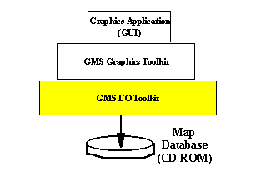
The GMS Extabula Toolkit corresponds to the shaded component of Figure 1.1. The toolkit essentially provides an interface to the DCW database for higher level clients. To achieve this objective the following requirements are specified:
Table 3.1 : Requirements of GMS Extabula Toolkit
- A series of utilities shall be developed to read the data from the files of the DCW database.
- Access to the following types of files shall be provided:
- Database Level Tables
- Database Header Table
- Library Attribute Table
- Library Level Tables
- Library Header Table
- Coverage Attribute Table
- Geographic Reference Table
- Data Quality Table
- Primitive Tables
- Edge Tables
- Face Tables
- Text Tables
- Node Tables
- Index Tables
- Bounding Rectangles (both Edge and Face)
- Ring Tables
- Coverage Tables
- Value Description Tables (Integer and Character)
- Feature Tables (Area, Point, Text, and Line)
- Feature Class Schema Tables
- Thematic Index Tables
- Spatial Index Tables
- Data structures that correspond to each of the types of files shall be defined to allow client software to process/manipulate the data.
- The utilities shall be written in ANSI C.
- The utilities shall be compilable by ANSI C and ANSI C++.
- The utilities shall be portable to the following platforms:
- MS Windows 98
- MS NT
- HPUX UNIX (Hewlett-Packard)
- Sun-Solaris UNIX

3.2 - Architecture and Design
The GMS Extabula Toolkit consists of a series of components. A component is a C header file and a C source-file. The header file defines the interface for the client and the source-file is the implementation. Each component provides the ability to read a file from the DCW database. A data structure is also defined in the header file. It defines the C language format of the file for the client. There is no coupling between components that access a particular kind of DCW file.
Two common/global components are defined. The first is a header file of type declarations and useful constants. It is called gmsTypesAndConstants.h. The second component is a series of utilities that are used by the other components. It is called gmsUtilities.h/c. For example, a type that defines a record of latitude and longitude are defined as well as a function to read one such record given a file descriptor.
Coupling between components is minimized because each component is dependent only on the two common components and the ANSI Standard C Library.
The interface of each component (i.e. its header file) is fairly simple. A data structure type is defined along with two functions. The first is a get routine. This function reads a DCW file and builds a data structure based on the contents of the specified file. The file to be read is specified using a string. It is the full path to the DCW file. Memory is allocated from the heap and a pointer to the data structure is returned to the caller. The second routine is a free routine. It de-allocates the memory of the object by returning it to the heap. The client calls this function when the data is no longer needed. Each component also contained a function to print the contents of the data structure to standard output (stdout). These were built only to support debugging and testing. Clients will likely be graphics based so output to the console will probably not be useful (especially for Windows GDI applications for which no console output is defined).
The components were designed to be archived into static libraries. Since the toolkit is really only useful by higher-level client software, it is easier to present as simple an interface (i.e. the header files) as possible and allow the client to link against a static library.

3.3 - Implementation
As mentioned, there are two common components of the toolkit. The remaining components are categorized based on the types of DCW files they process.
Common Types and Utilities: As mentioned, two common components were defined to support the other components of the toolkit. They are listed in Table 3.2.
Table 3.2 : Basic Types and Support Utilities
Header | Source (Implementation)
GmsTypesAndConstants.h | N/A
gmsUtilities.h | gmsUtilities.cpp

The gmsUtilities.h/c essentially simplifies accessing data from a DCW file. Several functions exist to read data that is based on the primitive data types of the DCW database (see Table 2.9). For example, there is a routine
twoDimCoordType gmsReadTwoDimCoord (FILE *theFd);
that returns a record of latitude and longitude to the caller. This is useful for reading coordinate values. It saves the caller from having to deal with reading two float values each time a coordinate record is to be read.
Also, portability is abstracted away from the client by using the gmsUtilities.h interface. For example, reading an integer is typically not complex. But this becomes more involved in the presence of different machine architectures (i.e. the old big-endian vs little-endian problem). The routine
int gmsReadInteger(FILE *fd);
returns an integer from the DCW file being read. Swapping of bytes is done internally if required by the machine architecture. Although not dynamic, a pre-processor option called BIG_ENDIAN is used to compile the required section of code. Thus, the software can be compiled/linked on a HP-PARISC machine (big-endian) or on an Intel x86 based machine (little-endian) without having to modify code.
Also, there is a utility that reads a triplet-id record. A client that uses the function
idTripletType gmsReadIdTripletRecord (FILE *theFd);
is freed from the complexity of reading this data type (as described in Chpt 2, section 2.4) as well as the details of big-endian vs little-endian.
Database Tables: Since there are two database-level tables (DHT and LAT), there are two components to access these tables. These components are listed in Table 3.3:
Table 3.3 : Database Table Utilites
Header | Source (Implementation)
gmsDbHeaderTable.h | GmsDbHeaderTable.cpp
gmsLibAttribTable.h | GmsLibAttribTable.cpp

The gmsDbHeaderTable.h/c reads the contents of the DHT file and the gmsLibAttributeTable.h/c reads the contents of the LAT file.
Library Tables: Table 3.4 lists the components used to access the Library Tables:
Table 3.4 : Library Table Utilities
Header | Source (Implementation)
gmsGeoReferenceTable.h | GmsGeoReferenceTable.cpp
gmsLibHeaderTable.h | GmsLibHeaderTable.cpp
gmsCoverageAttribTable.h | GmsCoverageAttribTable.cpp
gmsDataQualityTable.h | GmsDataQualityTable.cpp
These utilities can be used to read library files from regional libraries as well as the browse library. For example, there are two library header tables (LHT) on each CD. The first is from the regional library and the second is from the browse library. There are two Geographic Reference tables on each CD-ROM. The first is from the regional library and the second is from the browse library.
Primitive Tables: There are four components used to access core primitive tables (edge, text, node, and face tables). Also included is a component to access index files that are used to access core primitive files. These components are listed in Table 3.5.
Table 3.5 : Core Primitive Utilities
Header | Source (Implementation)
gmsEdgeTable.h | gmsEdgeTable.cpp
gmsTextTable.h | gmsTextTable.cpp
gmsNodeTable.h | gmsNodeTable.cpp
gmsFaceTable.h | gmsFaceTable.cpp
gmsIndexFile.h | gmsIndexFile.cpp

Client applications will not need to access an index file directly. Rather, when the client specifies a core primitive file (edge, text, node, or face), the component determines the index file that is to be used. The object of the primitive data is constructed while access to the index file is hidden from the client.
There are three primitive support utilities to access ring tables, bounding rectangles, and spatial index tables. These are listed in Table 3.6
Table 3.6 : Primitive Support Utilities
Header | Source (Implementation)
gmsRingTable.h | gmsRingTable.cpp
gmsMinBoundRectTable.h | gmsMinBoundRectTable.cpp
gmsSpatialIndex.h | gmsSpatialIndex.cpp

The gmsMinimumBoundingRectangle component is used to read both Edge Bounding Rectangles and Face Bounding Rectangles. These two types of files are often called minimum bounding rectangles in the DCW documentation.
Implementation Issues: Construction of edge tables proved to be complex. One problem is that the records of edge tables are variant-records. This means that the format of the record was different for tables in different themes. Consider the generalized definition of an edge record shown in Table 3.7:
Table 3.7 General Format of Edge Records
ID =I,1,P,Row Identifier – Mandatory
*LINE.LFT_ID =I,1,F,Fgn Key to Line Feature Tbl – variant
START_NODE =I,1,F,Start/Left Node – Mandatory
END_NODE =I,1,F,End/Right Node – Mandatory
RIGHT_FACE =K,1,F,Right Face – variant
LEFT_FACE =K,1,F,Left Face – variant
RIGHT_EDGE =K,1,F,Right Edge from End Node – Mandatory
LEFT_EDGE =K,1,F,Left Edge from Start Node – Mandatory
[num-coords] =I,1,N,Number of coords in array – Mandatory
COORDINATES =C,*,N,Coordinates of Edge – Mandatory
Table 3.7 shows that edge records are variant records because some of the attributes (*LINE.LTF_ID, RIGHT_FACE, and LEFT_FACE) are not present in some edge tables. These attributes are implemented for some themes and not for others. Furthermore, for some edge records, one or two of the variant attributes are present while another is not.
It turns out that there are four variants to the edge record. The first variant is described in table 3.8.
Table 3.8 : First Variant of Edge Record
ID =I,1,P,Row ID,-,-,:
START_NODE =I,1,N,"Start/Left Node",-,-,:
END_NODE =I,1,N,"End/Right Node",-,-,:
RIGHT_FACE =K,1,F,Right Face,-,-,:
LEFT_FACE =K,1,F,Left Face,-,-,:
RIGHT_EDGE =K,1,F,Right Edge from End Node,-,-,:
LEFT_EDGE =K,1,F,Left Edge from Start Node,-,-,:
[num-coords] =I,1,N,Number of coords in array
COORDINATES =C,*,N,Edge Coordinates,-,-,:;
The format from Table 3.8 describes the edge records from the following regional themes
VG, TileRef, PP, LC.
Also, this format applies to edge records from the browse library.
The second variant is described in table 3.9.
Table 3.9 : Second Variant of Edge Record
ID =I,1,P,Row Identifier,-,-,:
*LINE.LFT_ID =I,1,F,Foreign Key to Line Feature Table,-,-,:
START_NODE =I,1,F,Start/Left Node,-,-,:
END_NODE =I,1,F,End/Right Node,-,-,:
RIGHT_EDGE =K,1,F,Right Edge from End Node,-,-,:
LEFT_EDGE =K,1,F,Left Edge from Start Node,-,-,:
[num-coords] =I,1,N,Number of coords in array
COORDINATES =C,*,N,Coordinates of Edge,-,-,:;
Note that in Table 3.9 the * for the foreign key to the line-feature table indicates the theme. The format of Table 3.9 applies to the edge records from the following regional themes:
UT, TS, RR, RD, PH, OF, HS
The third format is described in Table 3.10.
Table 3.10 : Third Variant of Edge Record
ID =I,1,P,Row Identifier,-,-,:
*LINE.LFT_ID =I,1,F,Foreign Key to Line Feature Table,-,-,:
START_NODE =I,1,F,Start/Left Node,-,-,:
END_NODE =I,1,F,End/Right Node,-,-,:
RIGHT_FACE =K,1,F,Right Face,-,-,:
LEFT_FACE =K,1,F,Left Face,-,-,:
RIGHT_EDGE =K,1,F,Right Edge from End Node,-,-,:
LEFT_EDGE =K,1,F,Left Edge from Start Node,-,-,:
[num-coords] =I,1,N,Number of coords in array
COORDINATES =C,*,N,Coordinates of Edge,-,-,:;
The format described in Table 3.10 applies to the following regional themes:
PO, HY, DQ, DN, CL.
The fourth format is described in Table 3.11. It applies only to edge tables from the LIBREF directory of regional libraries.
Table 3.11 : LibRef Edge Record
ID =I,1,P,Row Identifier,-,-,:
START_NODE =I,1,F,Start/Left Node,-,-,:
END_NODE =I,1,F,End/Right Node,-,-,:
RIGHT_EDGE =K,1,F,Right Edge from End Node,-,-,:
LEFT_EDGE =K,1,F,Left Edge from Start Node,-,-,:
[num-coords] =I,1,N,Number of coords in array
COORDINATES =C,*,N,Coordinates of Edge,-,-,:;
The next problem with implementing the edge table component was that edge records are variant-length records. Again consider the generalized format of edge records shown in Table 3.7. The COORDINATES attribute is an array of coordinate tuples whose length is different for each record. The attribute [num-coords] is not defined in Mil-D-89009, nor in Mil-Std-600006, nor in Mil-Std-2407. Now, by using the index file the software can determine where the start of each edge record is located. Thus, the number of coordinates could be calculated for each record (total-length - size of fixed
components). When this was done, the software was always off by 4 bytes. It turns out that the extra 4 bytes is an integer that indicates the length of the coordinate array. The actual implementation (i.e. the data written on the CD-ROM) includes this extra attribute that was discovered by accident (by trial and error).
Futhermore, it was discovered that all variant-length attributes were preceded by an integer that indicated the length of the array (e.g. strings from text tables).
The component gmsTextTextTable is used to access text tables. There are two variants handled by this component. One is for the browse library and the other is for the regional libraries. The string that is read from the text table is appended with the ASCII null character for easier use by the client.
The component gmsFaceTable is used to access face tables. Like the text tables there are two variants for the face tables; one for the browse library and the other for regional libraries.
The component gmsNodeTable is used to access (entity) node tables. There are three variants for the node tables; one for the Browse library, one for the gazette directory, and the third for themes of regional libraries.
Coverage Tables: There are six components used to access coverage tables. These are listed in Table 3.12
Table 3.12 : Coverage-Level Utilities
Header | Source (Implementation)
gmsFeatureTypes.h  gmsFeatureTable.h | gmsFeatureTable.cpp
gmsBrowseFeatureTypes.h  gmsBrowseFeatureTable.h | gmsBrowseFeatureTable.cpp
gmsValueDescriptionTable.h | gmsValueDescriptionTable.cpp
gmsNarrativeTable.h | gmsNarrativeTable.cpp
gmsFeatureClassSchemaTable.h | gmsFeatureClassSchemaTable.cpp
gmsThematicIndex.h | gmsThematicIndex.cpp
There are two components for accessing feature tables. One is for feature tables from the regional libraries and the other is for the Browse library. Implementation of these components was not trivial because there are several variants. First is the distinction between records from point, line, area, and text feature tables. Then, much like the case for the edge records, there were variations in the records depending upon the theme. It turns out that there are 8 variants to records from point feature tables, there are 5 variants to the area feature records, and there are 4 variants for the line feature records. The text feature record was easiest to implement because there was only one format for these
tables. Furthermore, for the Browse library, there are two variants for the area feature table.
The gmsValueDescriptionTable component is used to access both integer and character VDTs. Actually, there are two sub-types of CHAR.VDTs. One is specific to the browse library and the other is used for the regional libraries. The component determines which type of data structure to build based on the location of the CHAR.VDT that is specified.
The gmsThematicIndex component is used to access thematic index files. For some reason, the designers of the database decided that thematic index files could have offset values as byte, short-int (16-bit), or integer (32-bit). Therefore, the thematic index structure is constructed based on the size of the offset value encountered in the file.
Implementation of the narrative table and feature class schema table components was not as complicated.

3.4 - Testing
Testing of the components was performed before beginning development of the graphics toolkit (described in Chapter 4). The test drivers that were developed to test the GMS Extabula Toolkit were console-based applications. No graphics programming was developed since this was not necessary to verify the functionality of these components.
Test drivers were developed to exercise each of the components of Tables 3.3, 3.4, 3.5, 3.6, and 3.12. Some test drivers exercised more than one component. Some were targeted to exercise one component. For example, the test driver po_test was designed to exercise each of the types of files in the Political/Oceans (PO) theme of a library. On the other hand, the test driver feature_test was designed to test only feature tables from any theme.
The output from the test drivers was generated using the print utilities provided with each component. These utilities used the data structure and converted the records to an ASCII readable format. The output was sent to standard output (stdout) of the console. Often, the output was captured to a text file. Success of testing was based on the following criteria. First the output was read to see if it made any sense. For example, were latitude values between -90.0° and 90.0°? Were longitude values between -180.0° and 180.0°? Were the names of countries and cities in text strings valid? Second, the output was then compared the values from a set of known tables. These known tables were provided from the documents Mil-D-89009, Mil-Std-600006, and Mil-Std-2407. This was particularly useful in verifying the output from testing the feature tables.
Part of the testing scheme included building static libraries of the GMS Extabula Toolkit and then linking test drivers against the static libraries. Most of the development of the toolkit was done on a Windows 98 platform using Microsoft Visual C++ (v 6.0). However, the toolkit and test drivers were eventually ported to UNIX platforms (HPUX and SUN Solaris) and built using an ANSI C compiler. Testing was simplified by
building and linking against static libraries on these platforms. More details of this are given below.
Portability: One of the requirements was to develop the toolkit so that it is portable to more than one platform. Initial testing was performed using Windows 98. After successful testing was achieved, the tests were ported to a Microsoft NT computer. All of the tests were re-executed on the NT system.
Next, the software was transferred (File-Transfer-Protocol) to an HPUX platform. The GMS Extabula Toolkit was built into a static library and the test drivers were compiled and linked against the static library. Also, the SOAMAFR portion of the DCW database was transferred to the test site. The tests were successfully repeated.

Next, the software was transferred to a Sun-Solaris platform. The build process used for testing on the HPUX platform was duplicated on the SUN-Solaris platform. The tests were then successfully repeated.
Conclusion: Testing showed a stable toolkit on all platforms. At this point, development shifted to the next toolkit called the GMS DCW Graphics Toolkit.
Chapter 4 - The GMS DCW Graphics Toolkit

4.1 - Objectives and Requirements
The second main component of GIS products is the Graphics/Data Operations. The objective of this module is to provide a set of utilities that manipulate the geographic data so it can be presented to an operator. Also, most GIS products include functions that perform analytic services for an operator [17]. The Graphics/Data Operations component is sandwiched between the utilities that directly access the database and the user interface. This is illustrated in Figure 4.1.
Figure 4.1 : Architecture
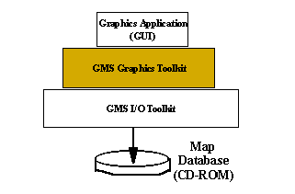

The objective of GMS DCW Graphics Toolkit is to manipulate the data structures from the GMS Extabula Toolkit in such a way as to be useful to several types of user-interface applications. To achieve this the requirements of Table 4.1 were defined. Several of the requirements make reference to earth models (e.g. Flat-earth, and WGS84). These will be described in more detail in section 4.2.
Table 4.1 : Requirements of GMS DCW Graphics Toolkit
- The GMS DCW Graphics Toolkit shall provide a series of utilities to convert a given [Longitude, Latitude] coordinate to coordinates based on each of the following grid systems:

Flat-earth model
Spherical model : Earth-Centered-Earth-Fixed (ECEF)
Ellipsoid (WGS-84) model
- Utilities to generate ECEF coordinates based on a spherical earth model and the WGS84 ellipsoid model shall be provided. The radius of the spherical model shall be 6,378,137.0 meters.
- Utilities to rotate an ECEF coordinate around the x, y and z axes shall be provided.
- An abstract screen coordinate system shall be used. This coordinate system shall only assume the client software to be a raster graphics system (i.e. pixel based). No other assumption about the graphics package of the client shall be assumed. In other words, it shall not be assumed that the graphics toolkit of the client is GKS, nor MS Windows GDI, nor X Window System, etc.
- A utility to convert a given ECEF coordinate to a 3D screen coordinate shall be provided.
- Utilities to project a given 3D screen coordinate into a 2D screen coordinate shall be defined.
- Utilities to translate 2D and 3D screen coordinates shall be provided.
- Utilities to rotate 3D screen coordinates about the x, y and z axes shall be provided.
- Utilities to generate a grid of lat/long lines shall be provided. These utilities shall:
- allow the client to specify the number of latitude (i.e. parallel) and longitude (i.e. meridian) lines the grid is to contain,
- allow the client to specify which earth model (i.e. flat vs. ellipsoid) is used to generate the grid lines.
- Utilities to zoom in/out the screen coordinates shall be provided.
- The utilities shall be written in ANSI C++.
- The utilities shall be portable to the following platforms:
- MS Windows 98
- MS NT
- Hewlett-Packard HPUX (UNIX)
- Sun-Solaris UNIX

4.2 - Algorithms
One of the important functions of this toolkit is to convert a given [longitude, latitude] coordinate into a corresponding two dimensional (x, y) or three-dimensional (x, y, z) coordinate. The two and three-dimensional coordinates are much easier to manipulate for computer graphics operations. To support this, requirements were specified to develop utilities that support three types of coordinate systems. These three
coordinate systems are the flat earth model, the spherical earth model, and the ellipsoid model. These systems are described as follows.
Flat Earth: This model is useful to applications that display the earth as a flat map. This model is essentially an application of the Mercator Projection.

A sphere (i.e. the earth) is placed in the middle of a cylinder. All points on the sphere are projected onto the wall of the cylinder [3]. This is illustrated in Figure 4.2.

Figure 4.2 : Cylindrical Projection
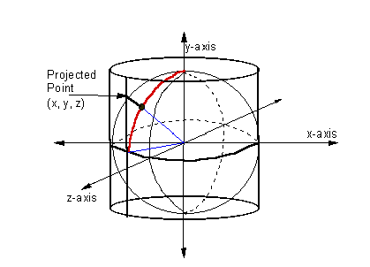
The cylinder is then unraveled and laid flat, thereby giving a flat earth. The circumference of the cylinder is the same as the sphere. The range of the x-coordinate is:
- Π * Re .. Π * Re
where Re is the radius of the earth. The value of x is therefore calculated from:
x = longitude * (Π * Re / 180)
Now, the y-coordinate is a function of the latitude. At 0° latitude the value of y is 0. However, at 90° the value of y is infinity. Therefore, the y projection needs to be limited. The height of the cylinder is chosen as the limit. Since the height of the cylinder is twice the radius of the sphere (2 * Re) the range of the y-coordinate is therefore limited to:
- Re .. Re
Furthermore, the sine function is chosen as the y projection function so that all latitude values are mapped onto some height of the cylinder. Hence, the value of y is calculated from:
y = Re * sin(latitude)
The unfortunate aspect of this equation is that accuracy decreases as the latitude moves towards the poles even though all points of the globe are mapped onto the cylinder. Such maps typically show severe distortions at the poles. For example, Antarctica is exceptionally large because it sweeps across the bottom of the map. Also, countries like Greenland are shown excessively large [1].
Spherical Earth: This model considers the earth to be a perfect sphere. Although not as accurate as the ellipsoid model (described below), it is sufficient for many applications. For this model, it is necessary to define a common frame of reference. Hence, the earth is centered in a right-handed orthogonal coordinate grid. The center of the earth is the origin of this coordinate grid. The y-axis is the line between the North and South poles running through the center of the earth. Positive y values are on the hemisphere of the North Pole. The prime meridian is the arc from the North Pole, passing through Greenwich, England, and concluding at the South Pole. The z-axis is the line that intersects both the prime meridian and the center of the earth, and is perpendicular to the y-axis. Positive z values are on the hemisphere of the prime meridian. The x-axis completes the right-handed coordinate system [11]. This is illustrated in Figure 4.3.

Figure 4.3 : Spherical Model
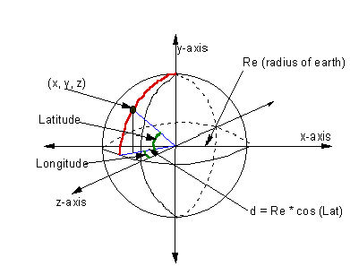

Using Figure 4.3 as reference, the derivation of any (x, y, z) from a given [longitude, latitude] value is straightforward. Therefore:
x = Re * cos(PHI) * sin(LAMBDA)
y = Re * sin(PHI)
z = Re * cos(PHI) * cos(LAMBDA)
where Re is the radius of the earth, PHI is latitude and LAMBDA is longitude.
The World Geodetic System - 1984: Before describing the third coordinate model it will be helpful to describe an earth reference system called the World Geodetic System - 1984 (WGS84) [11]. For some applications, modeling the earth as a flat rectangle, or a sphere, or an ellipsoid is not sufficient. Some systems need a highly accurate model. The WGS-84 was developed for these systems.
The WGS-84 system begins by modeling the earth as an ellipsoid. Like the spherical model described above, there is a reference coordinate system. However, it is based on a coordinate system defined by the International Earth Rotation Service (IERS). It is essentially the same as the grid described above, except the names of the axes are exchanged (e.g. the z-axis in the IERS system is the y-axis in the spherical model). The WGS-84 ellipsoid is centered in the IERS coordinate system [11].
Coordinates in the WGS-84 system are given in tuples of [longitude, latitude]. However, the values specified are called geodetic coordinates because they are generated by making what are called geodetic measurements from selected regions on the earth. A geodetic measurement is obtained by selecting a central reference point within a region on the earth (also called a station frame). The longitude and latitude of that point is calculated by defining a line perpendicular to the earth that passes through the center of a reference ellipsoid. Measurements of distance from the central point are used to calculate all other points within the region. The position measurements are performed using satellites and variations in gravity. All points within that region are said to comprise a geodetic datum. The WGS-84 system is actually a database of many hundreds of geodetic datums from areas all over the earth [11].
Now, lat/long coordinate values from a geodetic datum are highly accurate. However, these values are with respect to an ellipsoid that perfectly coincides with that region. Moving to another geodetic datum causes another reference ellipsoid to be used. Thus, in the WGS-84 system, there are actually two types of coordinates. The first is the previously mentioned geodetic and the other is called geocentric. The geodetic coordinates are the values for a particular geodetic datum. The geocentric coordinates are values from the IERS reference ellipsoid. The difference between these two types of coordinates is illustrated in Figure 4.4 [11].

Figure 4.4 : WGS-84 Latitudes
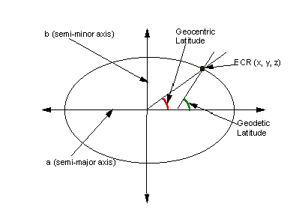
Thus, it is necessary to convert geodetic coordinates to geocentric coordinates. This permits the use of a common reference ellipsoid for geographic systems. The WGS-84 reference ellipsoid is illustrated in Figure 4.5. Note that for consistency with the spherical model (described above), the x, y, and z axes of Figure 4.5 were made to coincide with the axes of Figure 4.3. This is different from how the IERS labels the axes.
Figure 4.5 : WGS-84 Reference Ellipsoid
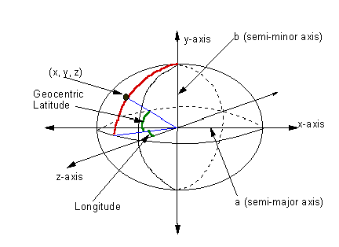

The equations to convert a given geodetic coordinate to an (x, y, z) geocentric coordinate are given in Figure 4.6 [11].
Figure 4.6 : Geodetic to Geocentric Coordinates
x = (N + h) * cos(PHI) * sin(LAMBDA)

y = ( (b²/a²) * N + h) * sin(PHI)

z = (N + h) * cos(PHI) * cos(LAMBDA)
where:
PHI = geodetic latitude
LAMBDA = geodetic longitude
h = altitude
a = semi-major axis = 6378137.0 meters
b = semi-minor axis = 6356752.0 meters
N = a / sqrt( 1 - e² * sin²(PHI) )
e = first eccentricity = sqrt(2 * f - f²)
f = earth-flattening = (a - b) / a

Thus, the input values are PHI and LAMBDA. For the toolkit being developed, the value of h (altitude) will be zero for all cases. The values of a (semi-major axis) and b (semi-minor axis) are fixed based on the reference ellipsoid. The remaining values are derived. Some, such as flattening are constants since they are derived from other constants [11] [3].
Ellipsoid Earth: The [longitude, latitude] values from the DCW database are geodetic coordinates based on the WGS-84 model. Thus, the equations described in Figure 4.6 are used for the toolkit.

The following should be noted. Although the [long, lat] coordinates from the DCW database are geodetic coordinates, the conversion to geocentric coordinates is overkill in some cases. Depending on the zoom factor and considering the highest scale of the DCW database is 1:1M, it can be hard to distinguish between the spherical model and the ellipsoid model.

Figure 4.7 : Screen Projection
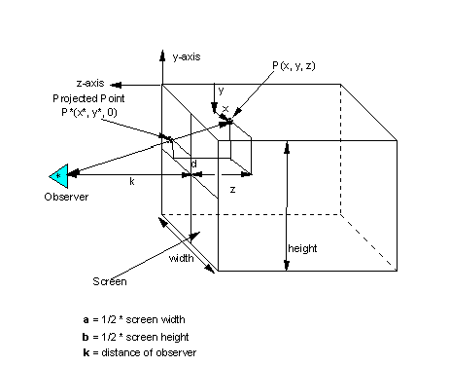
Screen Projection: For the spherical and ellipsoid models, the 3 dimensional points must then be projected onto the 2 dimensional screen. To support this a projection algorithm was implemented in the toolkit. The projection of any arbitrary 3D point P(x,y,z) onto a 2D screen gives the point P*(x*, y*). This scheme is illustrated in Figure 4.7 (above) [5].
Manipulating the following ratios,

| a - x | | a - x* |
----------- = ------------
k + z k

| y - b | | y* - b |
----------- = ------------

k + z k

yields the following projection equations [5]:
Figure 4.8 : Perspective Projection
a z + k x
x* = ------------
k + z

b z + k y
y* = ------------
k + z

4.3 - Architecture and Design
A mix of objected oriented and structured methods were used to develop the DCW Graphics Toolkit. Several components were designed as utilities and maintained little or no state information. For example, the software to manipulate coordinates and perform screen projection were implemented as utilities. Other components were designed as object oriented classes. For example, a class called gmsMapClass treats regions of data as a map object. The client would instantiate one or more map objects depending on how much area was of interest.
A core component of the DCW Graphics Toolkit is the gmsMapStateMgr. Its purpose is to record any changes to the state of a map requested by the client application. These include changes in zoom factor and orientation of the map. This keeps all maps in the same state for presentation to an operator. This component was designed as an abstract state machine since it maintains the current state of the map.
One of the design objectives was to keep coupling between components to a minimum. The components of the DCW Graphics Toolkit depend on the components of the Extabula Toolkit, but this is to be expected. Also, there are dependencies of components within the DCW Graphics Toolkit. For example, most components use the coordinate utilities. As with the Extabula Toolkit, the DCW Graphics Toolkit was also designed for portability. Thus the only other dependencies are on functions from the ANSI C++ library.
Another design objective was to implement simple interfaces to the components and to use the principle of information hiding. Since the objective of the DCW Graphics Toolkit is to simplify how a client application displays maps, it is best to provide an easy to use interface and not to overwhelm the client with unnecessary details. The DCW Graphics Toolkit is to provide as much platform-independent functionality as will be useful. Overly complicated interfaces will likely cause the client to bypass the DCW Graphics Toolkit, use the Extabula Toolkit, and perform its own graphics operations. The DCW Graphics Toolkit is provided to try and alleviate that work.

4.4 - Implementation

Utilities: A series of components were developed that provide various functions for the client application. These components are listed in Table 4.2.

Table 4.2 : Coordinate Utilities
Header | Source
gmsDcwTypesAndConstants.h
gmsWorldCoordUtils.h | gmsWorldCoordUtils.cpp
gmsScreenCoordUtils.h | gmsScreenCoordUtils.cpp
gmsTransformationUtils.h | gmsTransformationUtils.cpp
gmsDcwUtilities.h | gmsDcwUtilities.cpp
gmsPolygonUtilities.h | gmsPolygonUtilities.cpp

gmsDcwTypesAndConstants: This component simply defines a series of type declarations and constants that are useful throughout the toolkit. No functionality is defined for this component.
gmsWorldCoordUtils: These utilities are for converting from [longitude, latitude] values to world-coordinates. The data from the DCW database is in geodetic coordinates (latitude, longitude). These values are converted to either 2D world coordinates (flat-earth model) or 3D world coordinates (spherical, ellipsoid models). The dimensions of the world coordinates are meters. As suggested, the client is allowed to specify which earth model is to be used (flat-earth, spherical, or ellipsoid-WGS-84). Furthermore, functions are defined to construct polylines of latitude and longitude in world coordinates. These functions can be used to construct a grid of latitude and longitude lines on a map.
gmsScreenCoordUtils: These functions are defined to convert world coordinates to screen coordinates. Once a world coordinate value is constructed, it is necessary to convert it to a coordinate that is relative to a raster graphics system. These functions apply the current zoom factor to generate the screen coordinates. For 3D world coordinates, a 3D screen coordinate is generated. For 2D world coordinates, a 2D screen coordinate is generated. Also, for convenience, there are functions that operate on polylines of coordinates.
gmsTransformationUtils: These functions are defined to perform standard graphics operations on screen points. This includes projection of 3D screen coordinates to 2D screen coordinates (see Figure 4.7 above). Also, functions to perform translation and rotation of points and polylines are defined.
gmsDcwUtilities: This component contains a series of general purpose functions. Most functions provide heap allocation and de-allocations based on data structures of coordinate values. Other functions simplify access to raw DCW files.
gmsPolygonUtilities: This component defines a series of utilities to build polygons from DCW edge tables. Edges can be organized to define polygons that represent closed geographic regions such as countries, islands, and bodies of water. The polygons can be used by an application/client to define "fill-areas" to graphically enhance the image of a map.

Map Objects: The next series of components were developed as map objects. These components are listed in Table 4.3.

Table 4.3 : Map Classes
Header | Source
gmsMapClass.h | gmsMapClass.cpp
gmsBrowseMapClass.h | gmsBrowseMapClass.cpp
gmsMbrClass.h | gmsMbrClass.cpp
gmsNodeClass.h | gmsNodeClass.cpp
gmsTextClass.h | gmsTextClass.cpp
gmsLatLongGridClass.h | gmsLatLongGridClass.cpp
gmsLibRefClass.h | gmsLibRefClass.cpp
gmsTileRefClass.h | gmsTileRefClass.cpp
gmsThemeTileClass.h | gmsThemeTileClass.cpp
gms_PO_PolygonMapClass.h | gms_PO_PolygonMapClass.cpp
gms_DN_PolygonMapClass.h | gms_DN_PolygonMapClass.cpp
gmsDataTablesClass.h | gmsDataTablesClass.cpp
gmsNamesOfFilesClass.h | gmsNamesOfFilesClass.cpp
gmsMapStateMgr.h | gmsMapStateMgr.cpp

gmsMapClass: This class is used to abstract a given edge table into a map object. This map object is presented to the client as a screen image. The map object consists of the lines/edges of the map as well as the nodes (e.g. cities, towns) within that map. A map object can be instantiated as a "raw" image or as a "filtered" image. A filtered image contains no tile boundary information.
gmsBrowseMapClass: This class is used to abstract the edge tables of the Browse library into a map object. Edge tables from any browse theme can be converted to 2D screen images for the client. Also, a grid of latitude and longitude lines can be generated. Nodes (e.g. cities, towns) and text (i.e. names of countries) can also be obtained from a browse map object. The object also provides access to the data tables (i.e. the library attribute table, coverage attribute table, etc.).
gmsMbrClass: This class abstracts minimum bounding rectangles into an object that can be displayed on the screen. Although not very interesting graphically, this information can be used to determine regions of coverage in a given DCW library. As mentioned in chapter 2, there are two types of minimum bounding rectangles: face and edge.
gmsNodeClass: This class abstracts node tables into screen displayable objects. Nodes from the DCW database are essentially points on a given map. They are typically used to define entities such as towns and villages.
gmsTextClass: This class abstracts text tables into displayable objects. Text items are the names of countries, cities, bodies of water, etc. A text object specifies a text string as well as the coordinates where the string is to be displayed.
gmsLatLongGridClass: This class defines a map object that contains a grid of lat/long reference lines. One method is provided to retrieve a screen image of a latitude grid and another method is provided for a longitude grid.
gmsLibRefClass: This class defines a "Library Reference" object. The LibRef theme is unique in that it contains high level data for a whole region (i.e. one of the DCW regions NOAMER, SOAMAFR, EURNASIA, SASAUS). The client need only specify the earth model to be used.
gmsTileRefClass: This class abstracts the "Tile Reference" data from a DCW library into an object. The client may retrieve (from the object) an image of all the GEOREF tiles contained in the library. Also, a method is provided to convert a given tile ID into its corresponding name. For example, the tile whose id is 25 (from the SOAMAFR library) has the name "MJ22".
gmsThemeTileClass: This class abstracts a GEOREF tile into a map object. A GEOREF tile consists of 9 subtiles. This class uses the gmsMapClass, the gmsTextClass, and gmsNodeClass to generate a map of a single GEOREF tile.
gms_PO_PolygonMapClass: This class abstracts a given edge table from the Political/Oceans (PO) theme into a series of polygons in screen coordinates. The polygons represent closed geographic regions. Instantiated objects can be used to display differently shaded regions on a map.

gms_DN_PolygonMapClass: This class is similar to the gms_PO_PolygonMapClass except that it is specific to the Drainage (DN) theme. These polygons represent waterways and inland bodies of water.
gmsDataTablesClass: This class abstracts the data tables of the DCW database. Specifically, an object of this class contains the following tables of information:
Database Level Data:

1) DHT - Database Header Table
2) LAT - Library Attribute Table

Library Level Data:
1) CAT - Coverage Attribute Table

2) DQT - Data Quality Table
3) GRT - Geographic Reference Table
4) LHT - Library Header Table
The "library" tables apply to both REGIONAL and BROWSE libraries. The client is allowed to retrieve a buffer of ASCII characters for a specified data table.
gmsNamesOfFilesClass: This class defines an object that is a list of all the files of a given DCW library . An object allows a client application to retrieve the full path to any file in the current library. This class actually implements a singleton in order to prevent duplication of data. The list of files is dynamically created upon request. An offline text file points to the root of the DCW database. This is powerful in that the DCW database can be relocated and no rebuild of the application is necessary. However, the run-time performance of this component at instantiation is rather poor. But, there is no performance penalty after instantiation.
gmsMapStateMgr: This component is an abstract state machine that maintains the state of a currently displayed map. It is a very central component in that the coordinate utilities use this component extensively which, in turn, are used by higher level components/classes. A client application writes/updates the map state manager usually in response to requests from an operator.

4.5 - Testing
A series of unit tests were developed to exercise the DCW Graphics Toolkit. Except for the gmsDcwUtilities component, all components of the toolkit were tested using graphics applications. The gmsDcwUtilities component was tested using a console application. Verification of the graphics test drivers was done by visual inspection.
The first test drivers were used to verify the functionality of the utilities. For these tests, map data was minimal since the focus was to verify proper conversion from geodetic coordinates to world coordinates and eventually to screen coordinates. Also,
projection functionality was tested. Test drivers also exercised the zoom function as well as rotations and translations.
Testing then shifted to displaying various kinds of data from the DCW database. These tests exercised the class components of the toolkit (i.e. gmsMapClass, gms_PO_PolygonMapClass, etc.).
Portability: As mentioned, one of the objectives for the GMS toolkits is to allow for portability. The toolkits use no platform specific functions. Tests were initially developed on a MS Windows 98 platform using the Windows GDI interface. The same test drivers were then constructed and executed on a MS NT platform. This was a rather trivial port but nonetheless verified that dependency on the ANSI C++ library was transparent (16-bit vs. 32-bit).
The toolkits were then ported to a SUN Solaris (UNIX) platform and test drivers were developed using the X Window System and the Motif Toolkit. New applications had to be developed since X/Motif and the MS Windows GDI systems are completely different. The toolkits were then ported to a Hewlett-Packard HPUX (UNIX) platform. The toolkits and X/Motif test drivers were constructed and executed on this platform.
Conclusion: Testing showed a stable toolkit on all platforms. Chapter 5 describes applications that were developed on the MS Windows platform. Chapter 6 describes the applications that were developed to use the X/Motif system.
Chapter 5 -
MS Windows Applications Using GMS Toolkits

5.1 - Objectives
Several applications were developed to demonstrate the features of GMS toolkits. These applications were developed on an MS Windows platform using the GDI graphics package.

5.2 - Browse Library - Flat Earth Model

An application was developed that utilizes some of the map data from the Browse library. At start up, a window containing a map of the globe is presented to the operator. This is illustrated in Figure 5.1.

Figure 5.1 : Flat Browse - Initial Window
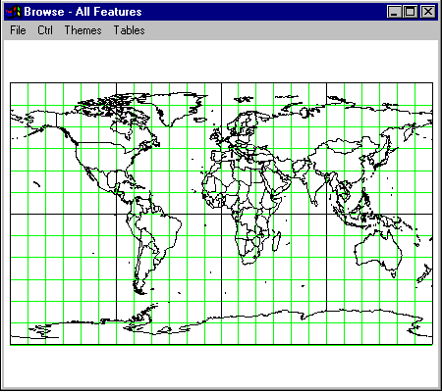

This application makes use of the component gmsBrowseMapClass. One map object is instantiated and then used to display the data. The initial map shows the data from the LibRef portion of the Browse library. Also shown is a grid of lat/long lines that were constructed using the component gmsLatLongGridClass. For this application, the flat-earth model was chosen to instantiate the map object. As mentioned in chapter 3, distortion of the map occurs in the higher latitudes. As is shown, the continent of Antarctica is severely distorted.
This application provided the operator with the ability to zoom-in/pan-out and also to re-center the map. The results of changing the zoom and re-centering the map are illustrated in Figure 5.2.
Figure 5.2 : Flat Browse - Zoom and Move
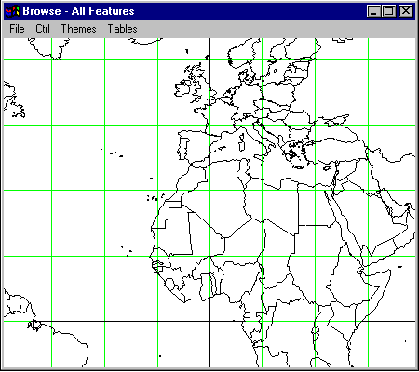

The application would also display data from several of the Browse themes. For example, Figure 5.3 shows data from the Drainage (DN) theme which is actually rivers and outlines of large inland bodies of water.
Also, data from the Political/Oceans (PO) and the Populated Places (PP) are available for operator selection. Figure 5.4 illustrates some of this information. Cities are represented as small squares on the map.

Figure 5.3 : Flat Browse - Rivers/Lakes
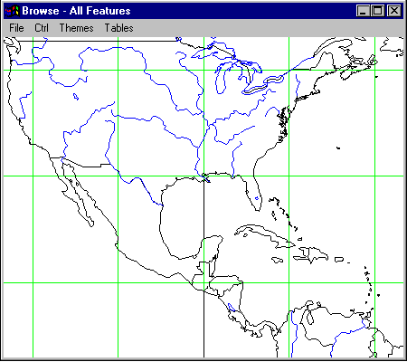
Figure 5.4 : Flat Browse - Text and Cities
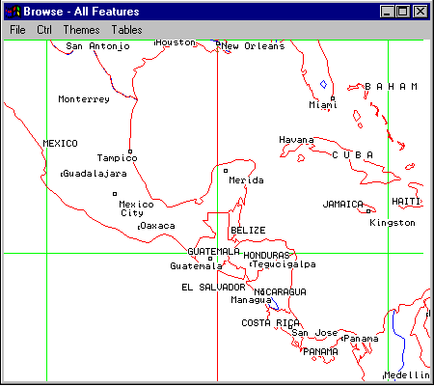

5.2 - Browse Library - Ellipsoid (WGS-84) Earth Model
A second application, which also accessed the data from the Browse library, was developed. However, it instantiated the gmsBrowseMapClass object using the ellipsoid-earth model. As shown in Figure 5.5, the start up window shows an ellipsoid for the earth.
Figure 5.5 : Ellipsoid Browse - Initial Window
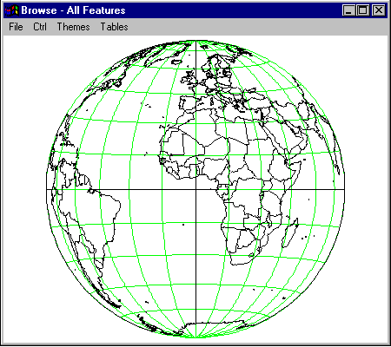
In contrast to the flat map projection, the continent of Antarctica is shown in its proper proportion.
Like the flat-earth application, zoom and move functions are available to the operator. However, a move for the ellipsoid model is actually a rotation. Figure 5.6 shows the map reoriented to display the North Pole.

Similar to the flat-earth application, this application implemented functionality to display data from the themes of the Browse library (e.g. DN, PO, PP, etc.).
Also, this application provided access to the data tables of the DCW database. The two database-level files are the Database Header Table and the Library Attribute Table. These items are illustrated in Figure 5.7 and Figure 5.8 (respectively).

Figure 5. 6 : Ellipsoid Browse - Zoom/Rotation
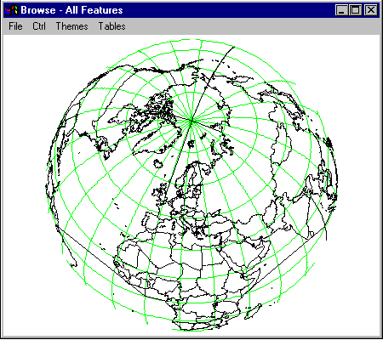

Figure 5.7 : Database Header Table
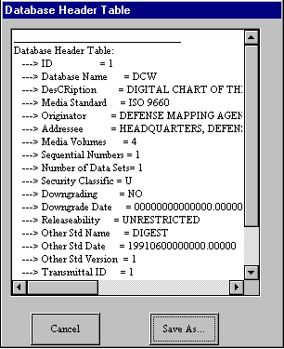
Figure 5.8 : Library Attribute Table
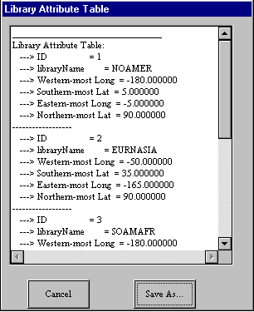
In addition, each library contains 4 data tables. These items are illustrated for the Browse library in Figures 5.9, 5.10, 5.11, and 5.12.
Figure 5.9 : Coverage Attribute Table
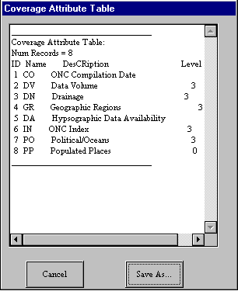
Figure 5.10 : Data Quality Table
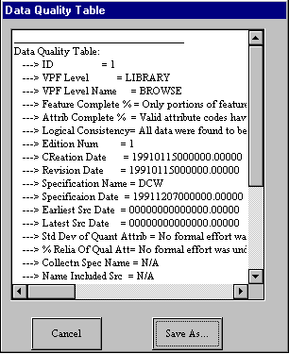
Figure 5.11 : Geographic Reference Table
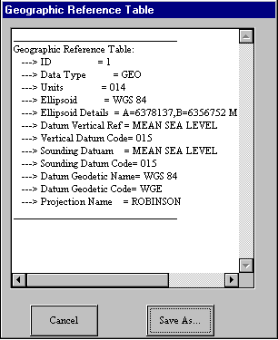
Figure 5.12 : Library Header Table
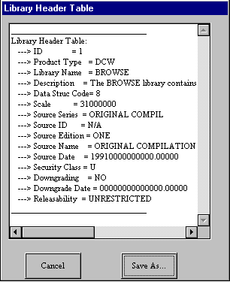

5.3 - The SOAMAFR LibRef Application
To illustrate how the DCW database is divided into libraries, an application was
Figure 5.13 : SOAMAFR LibRef
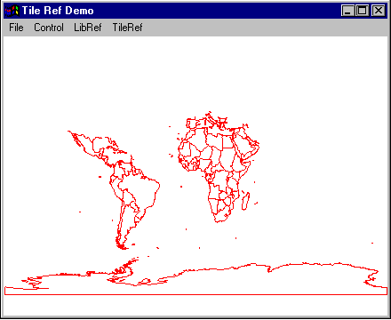
developed to display the LibRef data for the South America and Africa (SOAMAFR) library. Figure 5.13 illustrates the region of the world covered by this part of the DCW database.

5.4 - The SOAMAFR Demo
This application was developed to demonstrate some of the thematic information from the SOAMAFR library. The first map, shown in Figure 5.14, shows the west-central coast of Africa, at the countries of Nigeria and Cameroon. The map shows the political boundaries of the countries as well as the coastline. This information was obtained from the Political/Oceans (PO) theme of the SOAMAFR library. Also shown are text labels naming the countries and geographically significant items. Admittedly, the text functions of the DCW Graphics Toolkit are limited. The map shows overlap of text items, etc. These conditions are due to the simplicity of the DCW Graphics Toolkit rather than the availability of the information from the DCW database. For the case of these text items, information is being filtered by the DCW Graphics Toolkit. Direct access to the text data via the Extabula Toolkit is still possible and a client application would be able to display the text items in a more user-freindly manner.
Figure 5.14 : SOAMAFR - Nigeria and Cameroon
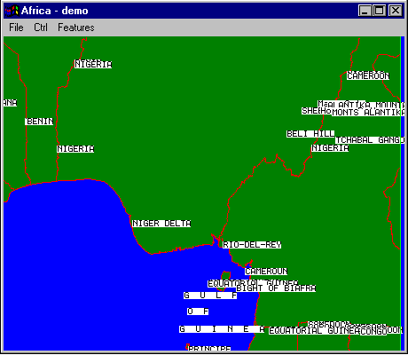
The next map, shown in Figure 5.15, shows lakes, rivers, and streams for the region. This information was obtained from the Drainage (DN) theme of the SOAMAFR library. The current zoom factor distorts the amount of area covered by water, but it nonetheless shows a region with many inland bodies of water.
Figure 5.15 : SOAMAFR Lakes/Rivers
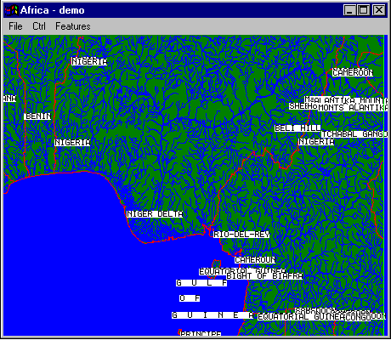
The third map, shown in Figure 5.16, shows the portion of the DN theme that contained areas (i.e. polygons) of bodies of water. This information demonstrates lakes and rivers of significant width. In particular, the Niger River and its tributaries are shown as polygons. Also, the very large Niger River Delta is shown. Accuracy can be lost if such bodies of water are shown simply as a line of constant width.
The fourth map, shown in Figure 5.17, shows a few towns and villages in the country of Cameroon. Also, the map shows a close up of the island of Bioko. The island's capital city is Malabo. This information was obtained from the Populated Places (PP) theme of the SOAMAFR library.

Figure 5.16 : SOAMAFR - Niger River and Delta
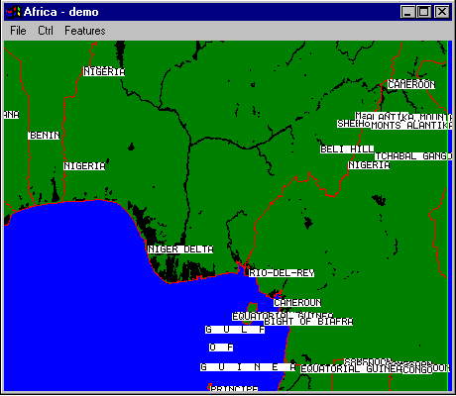
Figure 5.17 : SOAMAFR - Towns/Villages (PP theme)
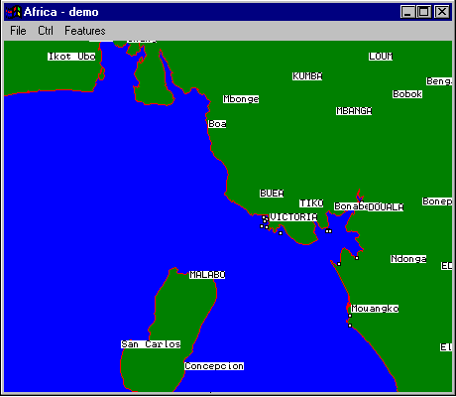

The fifth map, shown in Figure 5.18, shows elevation data for the region. This data was obtained from the Hypsographic (HY) theme of the SOAMAFR library. Areas of elevation between sea level and 1000 feet are shaded green. Areas above 1000 feet are shaded yellow. Admittedly, this is a poor representation of the elevation data since finer granularity is available from the DCW database. A more accurate map would show varying shades with changes in elevation. The highest peak in Nigeria is 7000 feet, yet this is not distinguishable as shown. However, this accuracy is available via the Extabula Toolkit by directly accessing the hypsographic data. The DCW database distinguishes elevations at 1000-foot intervals up to 29000 feet.

Figure 5.18 : SOAMAFR : Hypsographic Data
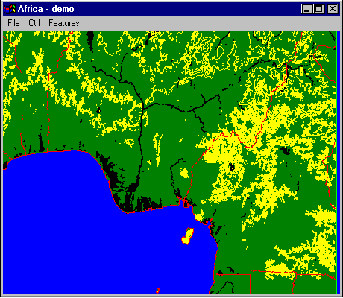

5.5 - Conclusions
As this chapter shows, some applications were developed to exercise the functionality of the DCW Graphics Toolkit and Extabula Toolkit on an MS Windows platform. These demonstration programs are not meant to be exhaustive since there are many other features available from either toolkit. A client application could use the DCW Graphics Toolkit for some functionality and then use the Extabula Toolkit directly for many other functions.
Chapter 6 -
X/Motif Applications Using GMS Toolkits
6.1 - Introduction:
Applications were developed to demonstrate the portability of the GMS toolkits. These applications were similar in functionality to the applications developed for Chapter 5. The difference being that the X Window System was used for graphics operations and the Motif Toolkit was used to define the user interface.
Two different UNIX based platforms were used to demonstrate this portability. First, the GMS toolkits were ported to a Hewlett-Packard HPUX platform (Apollo 712 PA-RISC workstation). The two toolkits (Extabula and DCW Graphics) were compiled and archived. Then, several applications were developed and linked against the two toolkits. Secondly, the toolkits were then ported to a SUN Solaris platform (SPARC 4 workstation) and the testing was repeated. This chapter describes some of the testing performed on the SUN Solaris environment.
6.2 - Browse Library - Flat Earth Model:
The first application used the Browse library and the flat-earth model. The behavior of this application is similar to the one developed in Chapter 5. The startup window is shown in Figure 6.1. This Motif application used a menuBar widget to define a series of control buttons. A drawingArea widget is used as the canvas for the map. The map shows the data from the LibRef portion of the Browse library. The GMS component gmsBrowseMapClass was instantiated using the LibRef data. The lines from this object were then displayed using the XDrawLine utility. Also, a lat/long grid is shown for reference. This was generated using the GMS component gmsLatLongGridClass.

Figure 6.1 : X/Motif Browse/Flat-Earth : Startup Window
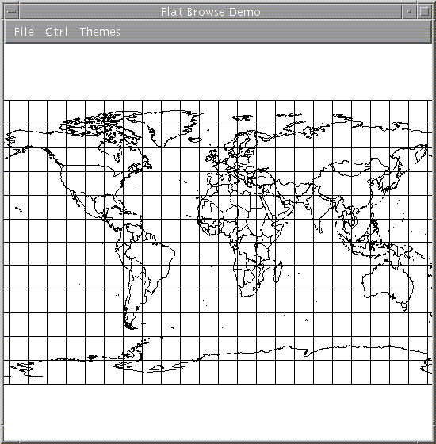
The application would allow the operator to display data from several of the Browse themes. For example, Figure 6.2 shows data from the Drainage (DN) theme which is indicated by major rivers and inland bodies of water.

Figure 6.2 : Data From the DN Theme
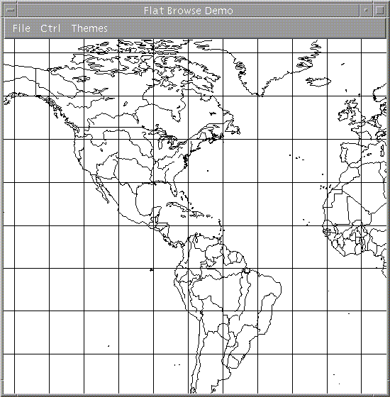

The application also provided the operator with the ability to zoom-in/pan-out and also to re-center the map. The results of changing the zoom and re-centering the map are illustrated in Figure 6.3.

Figure 6.3 : Zoom-in and Re-center Functions
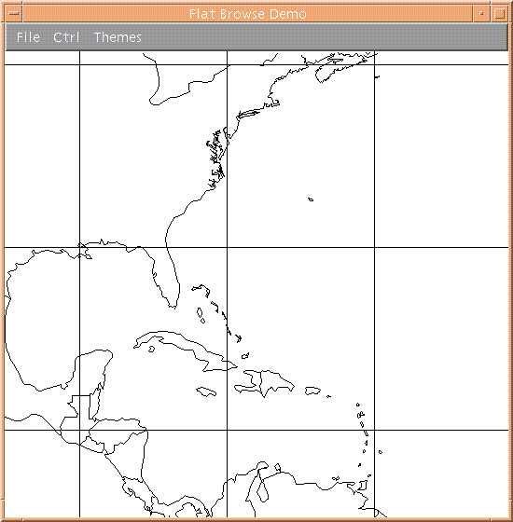

6.3 - Browse Library - Ellipsoid (WGS-84) Earth Model:
A second application was developed to demonstrate the ellipsoid model and using the Browse library (similar to chapter 5). The start map is illustrated in Figure 6.4. The components gmsBrowseMapClass and gmsLatLongGridClass were again used, except that the corresponding objects were instantiated using the ellipsoid model.

Figure 6.4 : Browse-Ellipsoid-Model
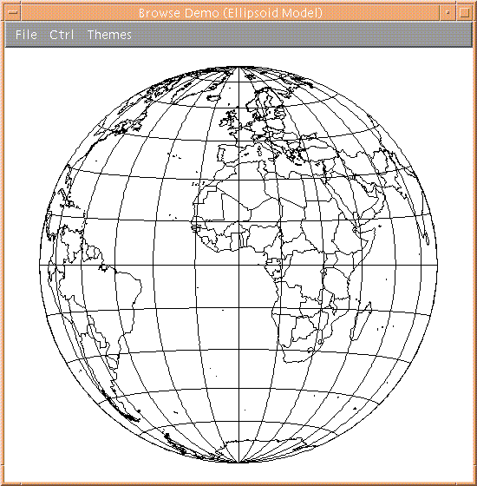
This application also implemented zoom/pan functionality. Map movement was performed by using the GMS rotation utilities. Figure 6.5 shows the map after a series of zoom-in and rotation operations. The map also gives a rather accurate picture of the continent of Antarctica (in contrast to the flat-earth model, i.e. Mercator Projection).

Figure 6.5 : Zoom and Rotate Functionality
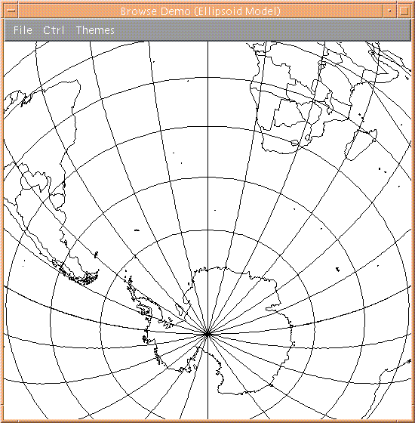

This application also allowed the operator to display data from the other Browse themes. Figure 6.6 shows data from the Browse DN (Drainage) theme for the continent of South America. This was done by instantiating another map object from the gmsMapClass and specifying the DN theme and the ellipsoid model.

Figure 6.6 : Drainage Data - Ellipsoid Model
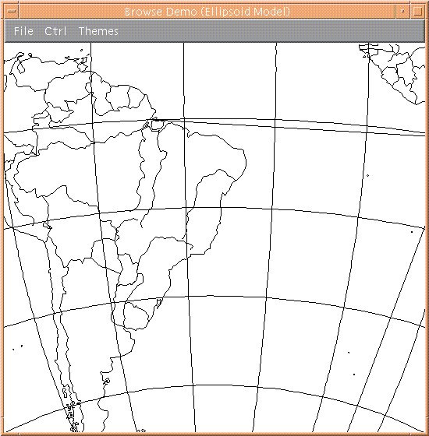

6.5 - Conclusions:
As this chapter shows, applications were developed that demonstrated the portability of the GMS toolkits. This chapter illustrates that the toolkits work on UNIX based platforms. Furthermore, it illustrates that the GMS toolkits are compatible with the X Window System. Often, it is necessary to develop GIS applications for more than one environment. Having to develop the user-interface portion of a GIS product for two different graphics systems (e.g. Windows GDI vs X/Motif) is usually a very difficult task. However, having file management functionality and Graphics/Data Operations that are portable to several platforms simplifies development of GIS products.
Chapter 7 -
General Conclusions

The Geographic Map System is a set of powerful and useful utilities that simplify the development of Geographic Information Systems.
There are many different kinds of software systems that need to display maps for an operator. Each system utilizes maps in a different way. An air traffic controller will want to see a certain type of map to help manage an air corridor. However, a Navy SEAL will want to see another kind of map while performing mission planning. The functions provided “on top” of the map vary from system to system since each system is meant for a different audience. Implementation of these systems is difficult enough without having to worry about the inadequacies of the map component.
As a software engineer, I have worked on several projects that utilize maps as part of the user interface. For each project, a mapping component was purchased from a third party vendor as a Computer-Off-The-Shelf (COTS) product. An API was provided to implement what the customer required. For each case, the COTS products always lacked some set of functions that made development of the final product more difficult. Often this was the result of a business decision. The vendor would always offer to implement new functionality for an additional cost.
The Geographic Map System is the result of a wish list of functionality for mapping toolkits. While developing user interfaces, co-workers and I would always say things such as, “wouldn’t it be great if the map tool had a function to do X.” But most often, when it was realized that function X was not available, it would be beneficial if access to the raw geographic data was available via the map tool. Most map tools do not provide such functionality. It would be similar to giving away the family jewels. The GMS is different in this regard since the Extabula Toolkit allows applications to directly access raw geographic data. If a particular function is not provided via the toolkit, the client still has the power to access the raw geographic data. At this point, the number of functions that the client is able to implement becomes almost infinite.
Also, the GMS product is designed so that it is expandable. As mentioned in Chapter 2, there are many different kinds of digital map systems available. The GMS can be expanded to access these other map systems (e.g. the ADRG series). As a matter of fact, DCW maps can be overlaid on maps from the ADRG series to display more useful information. Thus, these two map types complement each other when implementing new map functions.
The GMS toolkit could be expanded to process Digital Terrain Elevation Data (see also, Chapter 1, section 1.2). Highly specialized maps can be rendered by overlaying DCW map data onto a 3D image of DTED data. Although the current DTED database does not cover as much area of the earth as the DCW system, this is changing. A recent mission by the NASA Space Shuttle was to make continuous sweeps of the earth to generate DTED map data. It will take about 2 years to prepare the data from the Space Shuttle, but once available, practically every region of the globe can be rendered as a 3D image. The GMS API could be expanded to access this type of map data, thereby further increasing its power and usefulness.
References

1. P. W. McDonnel Jr.,Introduction to Map Projections, Marcel Dekker Inc., New York, 1979

2. C. Petzold, Programming Windows - 5th Ed., Microsoft Press, Redmond Washington, 1999. Library Call Num: QA76.76.O63P533
(http://www.mspress.com)

3. P. Richardus, R. Adler, Map Projections for Geodesists, Cartographers and Geographers, North Holland/American Elsevier, New York, 1972, pg 13-17. Library Call Num: GA110R52

4. D. F. Rogers, J. A. Adams, Mathematical Elements for Computer Graphics, McGraw-Hill Inc., 1976. Library Call Num: T385.R6

5. D. Salomon, Computer Graphics and Geometric Modeling, Springer-Verlag New York Inc., New York, 1999. Library Call Num: T385.S243 1999

6. Earth Science Information Center, U.S. Geological Survey, P.O. Box 25046, MS504, Fed. Center, Denver, CO, 80225, http://www.usgs.gov.

7. Mil-Std 2401 Department of Defense World Geodetic System, National Imagery and Mapping Agency, 8613 Lee Highway, Fairfax, VA, 22031-2137, 11-Jan-94
http://www.nima.mil
(from : http://www.nima.mil/publications/specs/printed/wgs84/wgs84.html)

8. MIL-STD-2407, Vector Product Format, National Imagery and Mapping Agency, 8613 Lee Highway, Fairfax, VA, 22031-2137, 11-Jan-94
http://www.nima.mil

9. MIL-D-89009, Digital Chart of the World Database, National Imagery and Mapping Agency, 8613 Lee Highway, Fairfax, VA, 22031-2137, 11-Jan-94
http://www.nima.mil
10. MIL-STD-600006, Military Standard - Vector Product Format, National Imagery and Mapping Agency, 8613 Lee Highway, Fairfax, VA, 22031-2137, 11-Jan-94
http://www.nima.mil
11. Department of Defense World Geodetic System 1984, Its Definition and Relationships with Local Geodetic Systems (NIMA TR 8350.2 - 3rd Ed), National Imagery and Mapping Agency : Systems and Technology, 4600 Sangamore Rd., Bethesda, Maryland, 20816-5003, 04-Jul-97
http://www.nima.mil
12. Geodesy for the Layman (DMA TR 80-003), National Imagery and Mapping Agency : Geosciences Division DMAASC/GDG Geospatial Department, Aerospace Center, St. Louis AFS, MO, 653118, December 1983
http://www.nima.mil

13. How to Obtain Specifications and Standards from the Departments of Defense Single Stock Point, Defense Printing Service, 700 Robins Ave. (Bldg 4D), Philadelphia, PA, 19111-5094.

14. Webster's Encyclopedic Unabridged Dictionary of the English Language, Portland House, New York, 1989
Library Call Num: PE1625.W46 1989

15. VPFVIEW 1.0 Users Manual for the Digital Chart of the World, Defense Mapping Agency, Fairfax, VA, July, 1992.

16. Spot Eath Observation System, Centre National d'Etudes Spatiales (CNES), http://www.spot.com.

17. National Imagery and Mapping Agency (NIMA), http://www.nima.mil

18. Map-Projections - A Working Manual, USGS Professional Paper 1395, 1987.
Appendix - Acronyms

ADRG - Arc Digitized Raster Graphic
ANSI - American National Standards Institute
API - Application Programming Interface
ASCII - American Standard Code for Information Interchange
ARC - Equal Arc-second Raster Chart/Map
AVHRR - Advanced Very High Resolution Radiometer
CD-ROM - Compact Disk - Read Only Memory
COTS - Computer-Of-The-Shelf (product)
C3I - Command, Control, Communications, and Intelligence
DAFIF - Digital Aeronautical Flight Information File
DCW - Digital Chart of the World
GDI - Graphics Device Interface (via Microsoft Windows)
GEOREF - Geographic Reference System (tiling scheme)
GIS - Geographic Information System
JNC - Joint Navigation Chart
JOG - Joint Operations Graphic
JPEG - Joint Photographic Experts Group - image compression technique
NIMA - National Imagery and Mapping Agency
ONC - Operational Navigational Chart
TIFF - Tagged Image File Format...
TPC - Tactical Pilotage Chart
USGS - United States Geological Survey
VPF - Vector Product Format
WGS84 - World Geodetic System - 1984

