California State University
Northridge

Department of Computer Science

Project : Implementation of a Geographic Map System

- MacAndrew

File No: 952-1580

Date: 16-Apr-98

Approved:____________________________

Committee Chair: Dr. Salomon

1.0 Objective

This project will be an implementation a geographic mapping system. Geographic data will be obtained from the “U.S. Geological Survey” and the “National Imagery and Mapping Agency”. This data will be used to generate and display maps. In general, the objective is to gain insight into “how” map data can be graphically presented to an end-user. The objective is to also study some known graphics techniques for drawing two-dimensional images and three-dimensional surfaces.

2.0 Introduction

The U.S. Geological Survey (USGS) and the National Imagery and Mapping Agency (NIMA) have developed a library of geographic mapping data. This data is available on CD-ROMs. The format of the data is defined rigorously. It is not targeted to any specific application but rather, the format is such that any application can be developed to use it.

This project is a study of how to implement a mapping system using some of the map data defined by the USGS and NIMA.

I’ve had an interest in mapping toolkits and how they work for several years. Since my first exposure to mapping toolkits, I’ve been developing applications which utilize the functions/capabilities provided by a particular toolkit. There’s usually an application programming interface (API) which allows the developer to invoke utilities in order to implement some “value-added” function. However, the internals of the mapping toolkit have always been a black box. It has always begged the question “how is that done?” The focus of this project is to answer that question.

An analogy would be an application which makes use of UNIX system calls. The application developer follows the specification of a particular system call. The developer will then expect a certain behavior, but how that function is implemented is sometimes unknown.

This project will develop a mapping toolkit using some of the databases of map-types provides by the USGS and the NIMA. This toolkit can be essentially divided into three main layers.
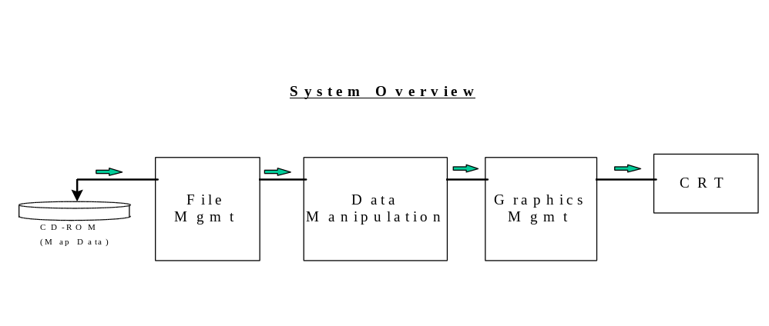
The first layer deals with processing to read the files of map-data according to the protocol defined by the NIMA. The data-type is generic (i.e. not targeted to a specific machine) so such things as big-endian vs little-endian protocols must be observed. The second layer will manipulate the data from the file-management layer so as to be useful to the third layer. The third layer will utilize the data from the second layer to perform graphics operations. This layer will use graphics algorithms to display the map data as two dimensional or three dimensional images.

There are already several mapping systems currently available for various computer platforms. Each of these systems uses map data provided by the USGS and/or NIMA to generate displays for various types of end-users. Some map systems are commercially available and some are designed to support military end-users.

For example, a system called “Multi-Sensor Data Display Workstation” is a UNIX based product developed by “System Planning Corporation”. It is used by military services to manage and interpret radar and other electronic information. It’s basic “desktop” is a map. Images are then displayed on the map for the end user to interpret.

Another example is a system called “Maptech”. This system uses maps from the USGS so hikers, hunters, and outdoors enthusiasts can plan trips. It allows the user to plan and navigate without having to use a paper map.

The U.S. Government generates several kinds of map data. At a high level, these map types can be divided into three categories: (1) vector map systems, (2) Arc Digitized Raster Graphics (ADRG), and (3) three dimensional map systems.

The first category, vector map systems, are used to generate wire-frame like displays. An example of such a system is called “World Vector Shoreline”. Another system (which is available from the USGS) is called “Digital Chart of the World”.

The second category, Arc Digitized Raster Graphics (ADRG), is used to generate “paper-maps” on the computer screen. The data for these maps were generated by digitizing the paper maps used by the U.S. Department of Defense. There are several subclasses of ADRG maps. Some are:

JNC - Jet Navigational Chart
ONC - Operational Navigational Chart
TPC - Tactical Pilotage Chart
JOG - Joint Operations Graphic
TLM - Tactical Line Map
City Graphic

Each map-type has varying degrees of accuracy. Some map-types are used by aviators and other are used by surveyors, etc.

The third category, three dimensional map systems, are used to generate detailed displays of terrain. Such systems show differences in terrain elevation to a high degree of accuracy. An example of one such system is called “Arc Digitized Raster Imagery”. This data-type is generated by digitizing photographs from satellites. Another example is called “Digital Terrain Elevation Data”. This system is useful for displaying mountains, valleys, etc.

For this project, one map-type from each of the three (above mentioned categories) will be studied and implemented. Specifically, an application will be developed which will display the following three types of maps:

- Digital Chart of the World (DCW)
- one of the ADRG map-types (e.g. ONC)
- Digital Terrain Elevation Data (DTED)

The first two map-types are two-dimensional systems and the third is a three-dimensional system.

The technology being studied here is important to several end users. The U.S. Military has always made extensive use of maps. Mapping toolkits provide an electronic way to manage maps and to aid in making decisions. Civil engineers and geologists have also needed maps to assist them in their work. One way the USGS supports its clients is by providing electronic maps to them.

3.0 Technical Approach

The development environment for this project will be based on the UNIX operating system. The graphics system will be the X Window System and the Motif Toolkit. Any computer system which supports these items will be used for development. In general, however, the Hewlett-Packard workstations available from the CSUN Computer Science Department will be used.

Development will proceed in four main phases. The first phase will be used to obtain the CD-ROMs of map data. Also, the documentation which describes the format of the map-data will be obtained and researched. The primary sources of these items are the USGS and NIMA. However, secondary sources of this data (such as universities and companies) may be used.

The remaining three phases will be used to develop the map system. These three phases will be similar to the Spiral Model of software development. Each phase will consist of a requirements analysis, high-level design, etc. Phase 3 will build on the results of Phase 2, and Phase 4 will build on the results of Phase 3.

3.1 Work Breakdown Structure

The project will consist of the following 4 main phases.

Phase A - Study/System-Analysis:
The three types of map-data will be obtained. It is critical that all three types be obtained at the start of the project … before Phases B, C and D. The “Digital Chart of the World” data-set is readily available from the USGS. However, dealings with the NIMA can be more “bureaucratic” so there might be some difficulty in obtaining the “Arc Digitized Raster Graphics” maps and the “Digital Terrain Elevation Data” maps. Which ADRG map-type obtained from NIMA will dictate which one gets implemented (i.e. it will be based on availability). Phases C and D will depend on obtaining these map-types. Hence, it is critical to obtain these items early.

The documentation which formally describes the format of each map-type will be obtained. These items are defined as “Military-Standards”. For example, Mil-Std-600006 is the specification which describes the format of the DCW map-type. Again, it is important to obtain this documentation early in the project since the success of the subsequent phases depends on these items.

A study of currently available mapping systems will be performed. The focus of this project is “how” a mapping system is implemented. Many applications have already been developed which use the chosen map-types and it may prove helpful to obtain insights and/or caveats about developing a mapping-system.

A study of software packages for coordinates systems will be made. Map systems may be based on different coordinate systems. For example, some map systems are based on the “Universal Transverse Mercator System” and others are based on obscure systems developed by the U.S. military. Such systems can be extremely complex. This may be an area where software “reuse” may be helpful to the success of the project.

Phase B - Map Type I - Digital Chart of the World

B.1 - System Analysis
A study of the documentation which describes the format of the “Digital Chart of the World” will be performed. A study of graphics algorithms and coordinate-system algorithms will be performed to determine which would be helpful for development of the application.

B.2 - Requirements Development
A set of requirements (specific for this map-type) will be developed These requirements will describe what the application will be able to perform for the end user. An initial user-interface will be defined. A minimal set of map features (from the DCW database) will be described as being displayable to the end-user.

B.3 - High Level Design
A high-level design of the initial system will be developed. This will address how map data is to be “read” and “processed” by the application. It will describe the algorithms (coordinate systems and graphics) used to display the map-data to the end user.

B.4 - Detailed Design
Software modules will be defined. Interfaces and interaction between these components will be defined. A prototype may be developed.

B.5 - Coding/Implementation
The software components will be implemented.

B.6 - Testing
The system will be tested based on the requirements developed in phase B.2

Phase C - Map Type II - One of the ADRG Map-types

C.1 - System Analysis
A study of the documentation which describes the format of the (chosen) “Arc Digitized Raster Graphics” will be performed. A study of what components developed from Phase B can be “reused” for this map-type will be performed. A study of how to incorporate the components from this phase into the existing system will be performed.

C.2 - Requirements Development
A set of requirements (specific for this map-type) will be developed These requirements will describe what the application will be able to perform for the end user. The user-interface will be expanded to include this map-type. A minimal set of map features (from the ADRG database) will be defined as being displayable to the end-user.

C.3 - High Level Design
The high-level design of the system will be expanded to incorporate the requirements of the ADRG map-type. This will address how map data is to be “read” and “processed” by the application. It will describe the algorithms (coordinate systems and graphics) used to display the ADRG map-data to the end user.

C.4 - Detailed Design
Software modules will be defined. Interfaces and interaction between these components and previously defined components will be defined.

C.5 - Coding/Implementation
The software components will be implemented.

C.6 - Testing
The system will be tested based on the requirements developed in Phase B.2 and Phase C.2

Phase D - Map Type III - Digital Terrain Elevation Data

D.1 - System Analysis
A study of the documentation which describes the format of “Digital Terrain Elevation Data” will be performed. A study of what components developed from Phases B and C can be “reused” for this map-type will be performed. A study of how to incorporate the components from this phase into the existing system will be performed.

D.2 - Requirements Development
A set of requirements (specific for the DTED map-type) will be developed These requirements will describe what the application will be able to perform for the end user. The user-interface will be expanded to include this map-type. A minimal set of map features (from the DTED database) will be defined as being displayable to the end-user.

D.3 - High Level Design
The high-level design of the system will be expanded to incorporate the requirements of the DTED map-type. This will address how map data is to be “read” and “processed” by the application. It will describe the algorithms (coordinate systems and graphics) used to display the DTED map-data to the end user.

D.4 - Detailed Design
Software modules will be defined. Interfaces and interaction between these components and previously defined components will be defined. A couple of components may be incorporated into the existing system as proof of concept.

D.5 - Coding/Implementation
The software components will be implemented.

D.6 - Testing
The system will be tested based on the requirements developed in all phases (B.2, C.2 and D.2).

- Schedule

The schedule for the project is 13 months. The diagrams below shows the amount of time (in months) allocated to each phase and sub-phase.

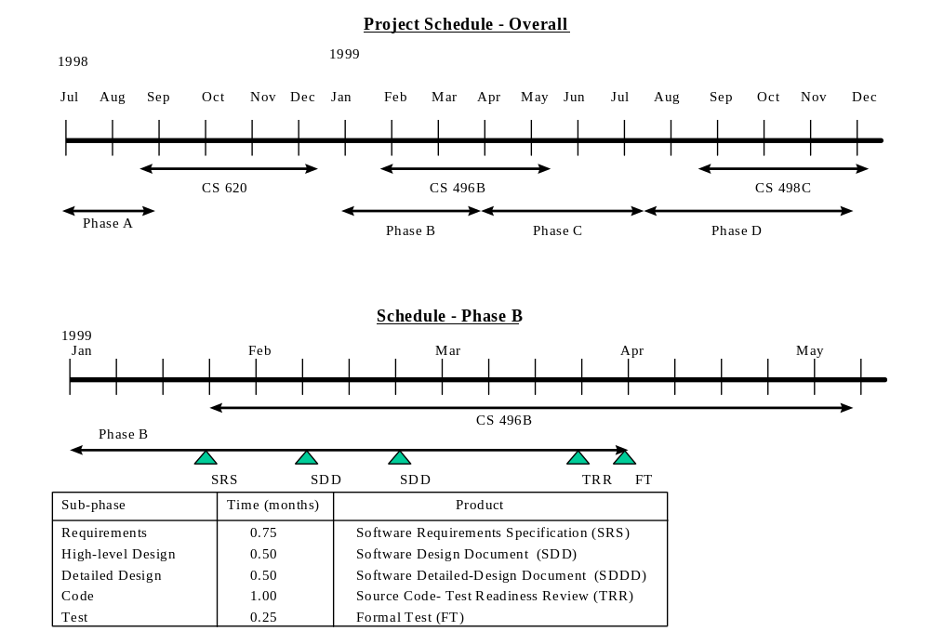
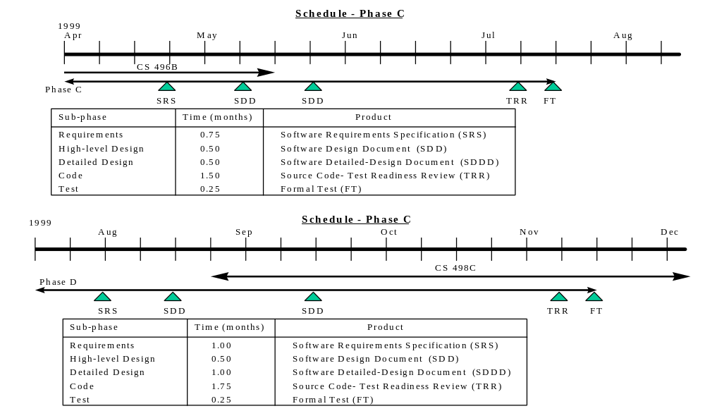

5.0 Criteria for Success

In order for Phase A to be successful, the three databases of map-types must be obtained (DCW, one ADRG, and DTED). An entire database of map data is not needed. A sample-set will suffice. For example, an ADRG-JOG map of California will suffice as opposed to trying to obtain the entire ADRG-ONC database of the world. Also, for Phase A to be successful, all standards and specifications for each of the three map-types must be obtained.

Successful completion of Phases B, C and D will be marked by generation of the following documents: Software Requirements Specification, Software Design Document, Software Detailed Design Document, and (of course) the source code. A comprehensive test of the software will be performed at the end of each phase.

At a high level, the following must be realized:

- A software application which displays a map based on the map-type called “Digital Chart of the World”.
- A software application which displays a map based on one of the “Arc Digitized Raster Graphics” map-types.
- A software application which displays a map of “Digital Terrain Elevation Data”.

- Reference

“VPFVIEW 1.0 Users Manual for the Digital Chart of the World”, Defense Mapping Agency, Fairfax, VA, July, 1992.

Earth Science Information Center, U.S. Geological Survey, P.O. Box 25046, MS504, Fed. Center, Denver, CO, 80225.

“MIL-STD-600006, Military Standard - Vector Product Format”, Defense Printing Service, 700 Robins Ave. (Bldg 4D), Philadelphia, PA, 19111-5094.

“Map-Projections - A Working Manual”, USGS Professional Paper 1395, 1987.

“MIL-D-89009, Digital Chart of the World Database”, Defense Printing Service, 700 Robins Ave. (Bldg 4D), Philadelphia, PA, 19111-5094.

“How to Obtain Specifications and Standards from the Departments of Defense Single Stock Point”, Defense Printing Service, 700 Robins Ave. (Bldg 4D), Philadelphia, PA, 19111-5094.

“MIL-STD-2407, Vector Product Format”, Defense Printing Service, 700 Robins Ave. (Bldg 4D), Philadelphia, PA, 19111-5094.

“Multi-Sensor Data Display Workstation”, System Planning Corp., 1000 Wilson Blvd., Arlington, VA, 22207.

