In this assignment you will use the Robcor database as described in Exercise 4 on page 642.

Part 0. Use the given Access database to create the Robcor database on SQL Server. Then define the PKs and create the relationships. Save a copy of the ERD in SQL Server and name it A10P0.jpeg.

Part 1. Design a star schema database in Crow's Foot. Make sure you have all the appropriate dimensions, attributes, and facts. Consider only the facts fuel used, distance, and revenue. Revenue is defined as char_fuel_gallons * mod_chg_mile. Save the ERD in the file named A10P1.

Part 2. Create a database to implement the design in Part 1 above. You must use Create table statements with Alter table statements to add all the constraints. Save the script in a file named A10P2.sql.

Part 3. Write a stored procedure to populate the star schema database with the transaction data in the provided database. Save the stored procedure in a file named A10P3.sql. The stored procedure should be such that it can be rerun/tested whether or not the star schema database is populated.

Part 4. Write a query for each of the following and save the queries in A10P4.sql.

List the names of pilots who have flown the most miles.

List the revenue by model and month in ascending order.

Submit all the files on Blackboard and a printed copy in class.

0)

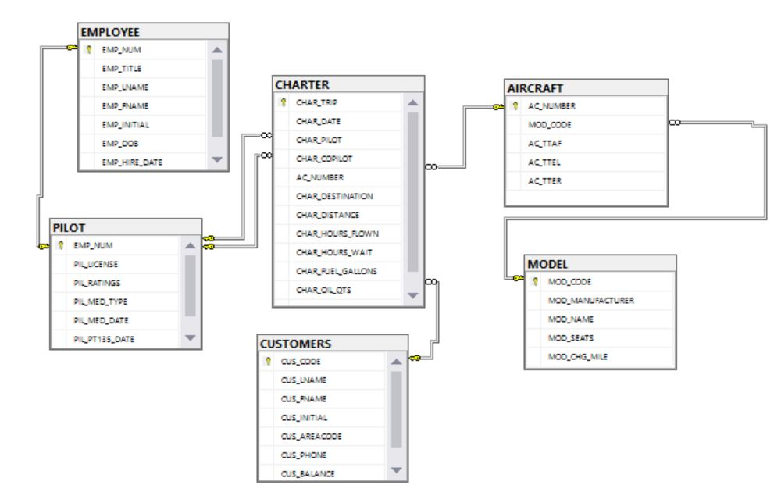

1)

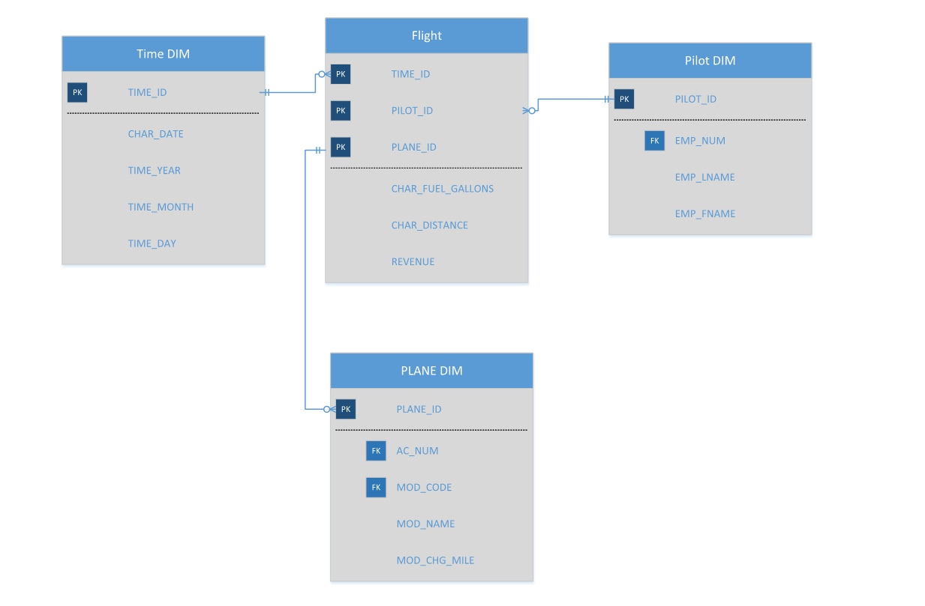

2)

CREATE TABLE PILOT_DIM

(

PILOT_ID INT IDENTITY NOT NULL,

EMP_NUM CHAR(3),

EMP_LNAME VARCHAR (20),

EMP_FNAME VARCHAR(20)

);

CREATE TABLE PLANE_DIM

(

PLANE_ID INT IDENTITY NOT NULL,

AC_NUM NVARCHAR(5),

MOD_CODE VARCHAR(10),

MOD_NAME VARCHAR (30),

MOD_CHG_MILE DECIMAL

);

CREATE TABLE TIME_DIM

(

TIME_ID INT IDENTITY NOT NULL,

CHAR_DATE DATE,

TIME_YEAR CHAR(4),

TIME_MONTH CHAR(2),

TIME_DAY CHAR(2)

);

CREATE TABLE FLIGHT

(

TIME_ID INT NOT NULL,

PILOT_ID INT NOT NULL,

PLANE_ID INT NOT NULL,

CHAR_FUEL_GALLONS DECIMAL,

CHAR_DISTANCE DECIMAL,

REVENUE DECIMAL

);

CREATE TABLE STAGING

(

TIME_ID INT NOT NULL,

PILOT_ID INT NOT NULL,

PLANE_ID INT NOT NULL,

EMP_NUM CHAR(3),

EMP_LNAME VARCHAR (20),

EMP_FNAME VARCHAR(20),

CHAR_DATE DATE,

TIME_YEAR CHAR(4),

TIME_MONTH CHAR(2),

TIME_DAY CHAR(2),

MOD_CODE VARCHAR(10),

MOD_NAME VARCHAR (30),

CHAR_FUEL_GALLONS DECIMAL,

CHAR_DISTANCE DECIMAL,

MOD_CHG_MILE DECIMAL,

AC_NUMBER NVARCHAR(5)

);

ALTER TABLE PILOT_DIM

ADD CONSTRAINT PK_PILOTDIM PRIMARY KEY (PILOT_ID)

ALTER TABLE PLANE_DIM

ADD CONSTRAINT PK_PLANEDIM PRIMARY KEY (PLANE_ID)

ALTER TABLE TIME_DIM

ADD CONSTRAINT PK_TIMEDIM PRIMARY KEY (TIME_ID)

ALTER TABLE FLIGHT

ADD CONSTRAINT PK_FLIGHT PRIMARY KEY (PILOT_ID,PLANE_ID,TIME_ID),

CONSTRAINT FK_FLIGHTTIME FOREIGN KEY (TIME_ID) REFERENCES TIME_DIM,

CONSTRAINT FK_FLIGHTPLANE FOREIGN KEY (PLANE_ID) REFERENCES PLANE_DIM,

CONSTRAINT FK_FLIGHTPILOT FOREIGN KEY (PILOT_ID) REFERENCES PILOT_DIM

3) USE [CIS31030]

GO

/****** Object: StoredProcedure [dbo].[A10P3.SQL] Script Date: 12/4/2016 10:42:34 PM ******/

SET ANSI_NULLS ON

GO

SET QUOTED_IDENTIFIER ON

GO

-- =============================================

-- Author: TIM MAHAN

-- Create date: <Create Date,,>

-- Description: <Description,,>

-- =============================================

ALTER PROCEDURE [dbo].[A10P3.SQL]

AS

BEGIN

ALTER TABLE FLIGHT

DROP CONSTRAINT PK_FLIGHT,

CONSTRAINT FK_FLIGHTTIME,

CONSTRAINT FK_FLIGHTPLANE,

CONSTRAINT FK_FLIGHTPILOT

ALTER TABLE PILOT_DIM

DROP CONSTRAINT PK_PILOTDIM

ALTER TABLE PLANE_DIM

DROP CONSTRAINT PK_PLANEDIM

ALTER TABLE TIME_DIM

DROP CONSTRAINT PK_TIMEDIM

TRUNCATE TABLE FLIGHT

TRUNCATE TABLE PILOT_DIM

TRUNCATE TABLE PLANE_DIM

TRUNCATE TABLE TIME_DIM

TRUNCATE TABLE STAGING

ALTER TABLE PILOT_DIM

ADD CONSTRAINT PK_PILOTDIM PRIMARY KEY (PILOT_ID)

ALTER TABLE PLANE_DIM

ADD CONSTRAINT PK_PLANEDIM PRIMARY KEY (PLANE_ID)

ALTER TABLE TIME_DIM

ADD CONSTRAINT PK_TIMEDIM PRIMARY KEY (TIME_ID)

ALTER TABLE FLIGHT

ADD CONSTRAINT PK_FLIGHT PRIMARY KEY (PILOT_ID,PLANE_ID,TIME_ID),

CONSTRAINT FK_FLIGHTTIME FOREIGN KEY (TIME_ID) REFERENCES TIME_DIM,

CONSTRAINT FK_FLIGHTPLANE FOREIGN KEY (PLANE_ID) REFERENCES PLANE_DIM,

CONSTRAINT FK_FLIGHTPILOT FOREIGN KEY (PILOT_ID) REFERENCES PILOT_DIM

INSERT INTO PILOT_DIM

SELECT DISTINCT E.EMP_NUM, E.EMP_LNAME, E.EMP_FNAME

FROM EMPLOYEE E

INNER JOIN PILOT P ON P.EMP_NUM = E.EMP_NUM

INNER JOIN CHARTER C ON P.EMP_NUM = C.CHAR_PILOT

INSERT INTO PLANE_DIM

SELECT A.AC_NUMBER, M.MOD_CODE, M.MOD_NAME, M.MOD_CHG_MILE

FROM MODEL M INNER JOIN AIRCRAFT A ON A.MOD_CODE = M.MOD_CODE

INSERT INTO TIME_DIM

SELECT DISTINCT CHAR_DATE, YEAR(CHAR_DATE), MONTH(CHAR_DATE), DAY(CHAR_DATE)

FROM CHARTER

INSERT INTO STAGING

SELECT T.TIME_ID, PILOT_ID, PLANE_ID, EMP_NUM, EMP_LNAME, EMP_FNAME, T.CHAR_DATE, T.TIME_YEAR, T.TIME_MONTH ,

T.TIME_DAY, PD.MOD_CODE, PD.MOD_NAME, CHAR_FUEL_GALLONS, CHAR_DISTANCE, PD.MOD_CHG_MILE, PD.AC_NUM

FROM PILOT_DIM P

INNER JOIN CHARTER C ON P.EMP_NUM = C.CHAR_PILOT

INNER JOIN TIME_DIM T ON T.CHAR_DATE = C.CHAR_DATE

INNER JOIN PLANE_DIM PD ON PD.AC_NUM = C.AC_NUMBER

UPDATE STAGING

SET STAGING.TIME_ID = TIME_DIM.TIME_ID

FROM STAGING INNER JOIN TIME_DIM

ON STAGING.TIME_ID = TIME_DIM.TIME_ID

UPDATE STAGING

SET STAGING.PLANE_ID = PLANE_DIM.PLANE_ID

FROM STAGING INNER JOIN PLANE_DIM

ON STAGING.PLANE_ID = PLANE_DIM.PLANE_ID

UPDATE STAGING

SET STAGING.PILOT_ID = PILOT_DIM.PILOT_ID

FROM STAGING INNER JOIN PILOT_DIM

ON STAGING.PILOT_ID = PILOT_DIM.PILOT_ID

INSERT INTO FLIGHT

SELECT TIME_ID, PILOT_ID, PLANE_ID, CHAR_FUEL_GALLONS, CHAR_DISTANCE, (MOD_CHG_MILE * CHAR_FUEL_GALLONS) AS 'REVENUE'

FROM STAGING

END

4)

--QUERY 1

SELECT PD.EMP_FNAME, PD.EMP_LNAME

FROM FLIGHT F INNER JOIN PILOT_DIM PD

ON F.PILOT_ID = PD.PILOT_ID

GROUP BY PD.EMP_FNAME, PD.EMP_LNAME

HAVING SUM(CHAR_DISTANCE) = (SELECT TOP 1 SUM(CHAR_DISTANCE)

FROM FLIGHT F INNER JOIN PILOT_DIM PD

ON F.PILOT_ID = PD.PILOT_ID

GROUP BY PD.EMP_FNAME, PD.EMP_LNAME

ORDER BY SUM(CHAR_DISTANCE) DESC )

--QUERY 2

SELECT PD.MOD_NAME, TD.TIME_MONTH AS 'MONTH', SUM(F.REVENUE) AS 'MODEL_REVENUE'

FROM PLANE_DIM PD

INNER JOIN FLIGHT F ON PD.PLANE_ID = F.PLANE_ID

INNER JOIN TIME_DIM TD ON TD.TIME_ID = F.TIME_ID

GROUP BY PD.MOD_NAME, TD.TIME_MONTH

ORDER BY TD.TIME_MONTH ASC, MOD_NAME