Part 1: Upload the given Access database into your SQL Server account. Create all the PKs and the relationships. Screen capture the ERD in SQL Server and save it as A7.jpeg.

Finish Exercises 103 through 122 on pages 334-338. Save the SQL statements in the file A7.sql.

You must submit the following:  A7.jpeg and A7.sql before the due date and time on Blackboard. Also submit a stapled printed copy in class on the due date. A late assignment will be assessed a penalty of 10% of the assigned points per calendar day up to 7 days. After 7 days no late assignment will be accepted.

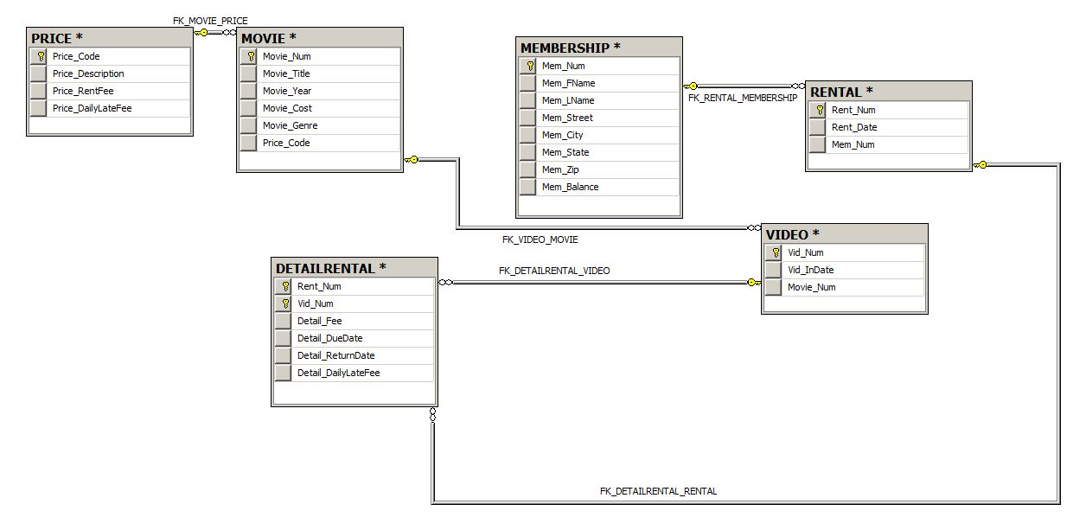

SQL Statements:

--Query 103

SELECT MOVIE_TITLE, MOVIE_YEAR, MOVIE_GENRE

FROM MOVIE

--Query 104

SELECT MOVIE_YEAR, MOVIE_TITLE, MOVIE_COST

FROM MOVIE

ORDER BY -MOVIE_YEAR

--Query 105

SELECT MOVIE_TITLE, MOVIE_YEAR, MOVIE_GENRE

FROM MOVIE

ORDER BY MOVIE_GENRE, -MOVIE_YEAR

--Query 106

SELECT MOVIE_NUM, MOVIE_TITLE, PRICE_CODE

FROM MOVIE

WHERE MOVIE_TITLE LIKE 'R%'

--Query 107

SELECT MOVIE_TITLE, MOVIE_YEAR, MOVIE_COST

FROM MOVIE

WHERE MOVIE_TITLE LIKE '%HOPE%'

--Query 108

SELECT MOVIE_TITLE, MOVIE_YEAR, MOVIE_GENRE

FROM MOVIE

WHERE MOVIE_GENRE = 'ACTION'

--Query 109

SELECT MOVIE_NUM, MOVIE_TITLE, MOVIE_COST

FROM MOVIE

WHERE MOVIE_COST > 40

--Query 110

SELECT MOVIE_NUM, MOVIE_TITLE, MOVIE_COST, MOVIE_GENRE

FROM MOVIE

WHERE MOVIE_GENRE IN ('ACTION','COMEDY') AND MOVIE_COST < 50

--Query 111

SELECT MEM_NUM, MEM_FNAME, MEM_LNAME, MEM_STREET, MEM_BALANCE

FROM MEMBERSHIP

WHERE MEM_BALANCE < 5 AND MEM_STREET LIKE '%AVENUE'

--Query 112

SELECT MOVIE_GENRE, COUNT(MOVIE_GENRE)

FROM MOVIE

GROUP BY MOVIE_GENRE

--Query 113

SELECT AVG(MOVIE_COST)

FROM MOVIE

--Query 114

SELECT MOVIE_GENRE, AVG(MOVIE_COST) AS 'AVG PRICE'

FROM MOVIE

GROUP BY MOVIE_GENRE

--Query 115

SELECT M.MOVIE_TITLE, M.MOVIE_GENRE, P.PRICE_DESCRIPTION, P.PRICE_RENTFEE

FROM MOVIE M INNER JOIN PRICE P

ON M.PRICE_CODE = P.PRICE_CODE

--Query 116

SELECT M.MOVIE_GENRE, AVG(P.PRICE_RENTFEE) AS 'AVG RENT FEE'

FROM MOVIE M INNER JOIN PRICE P

ON M.PRICE_CODE = P.PRICE_CODE

GROUP BY MOVIE_GENRE

--Query 117

SELECT M.MOVIE_TITLE, M.MOVIE_COST/P.PRICE_RENTFEE AS 'BREAKEVEN RENTALS'

FROM MOVIE M INNER JOIN PRICE P

ON M.PRICE_CODE = P.PRICE_CODE

--Query 118

SELECT MOVIE_TITLE, MOVIE_YEAR

FROM MOVIE

WHERE PRICE_CODE IS NOT NULL

--Query 119

SELECT MOVIE_TITLE, MOVIE_GENRE, MOVIE_COST

FROM MOVIE

WHERE MOVIE_COST BETWEEN 44.99 AND 49.99

--Query 120

SELECT M.MOVIE_TITLE, P.PRICE_DESCRIPTION, P.PRICE_RENTFEE, M.MOVIE_GENRE

FROM MOVIE M INNER JOIN PRICE P

ON M.PRICE_CODE = P.PRICE_CODE

WHERE M.MOVIE_GENRE IN ('FAMILY','COMEDY','DRAMA')

--Query 121

SELECT M.MEM_NUM, M.MEM_FNAME,M.MEM_LNAME, M.MEM_BALANCE

FROM MEMBERSHIP M INNER JOIN RENTAL R

ON M.MEM_NUM = R.MEM_NUM

--Query 122 (LAST ONE)

SELECT MIN(M.MEM_BALANCE) AS 'MINIMUM BALANCE', MAX(M.MEM_BALANCE) AS 'MAXIMUM BALANCE', AVG(M.MEM_BALANCE) AS 'AVERAGE BALANCE'

FROM MEMBERSHIP M INNER JOIN RENTAL R

ON M.MEM_NUM = R.MEM_NUM