**CIS 481 – Intro to Information Security**

**IN-CLASS EXERCISE # 1**

Names of team members:

Logistics

A. Get into your regular team

B. Discuss and complete the assignment together. Don’t just assign different problems to each teammate! That defeats the purpose of team-based learning.

C. Choose a recorder to prepare the final copy to submit to instructor in Blackboard.

**Problem 1**

The CIA triad presents three essential characteristics of information that must be protected. However, most agree that these three characteristics are not the only ones that need to be protected. Other characteristics include authenticity, accuracy, possession, timeliness and utility. If you were tasked with creating an information security *rectangle*, instead presenting FOUR characteristics of information, which would you choose and why? (8 pts.)

If tasked with creating an information security rectangle, the four characteristics we would choose would be Confidentiality, Integrity, Availability, and Accountability. Accountability allows us to implement the human element to the CIA triad. In regard to information security, the information is able to be handled by the internal manpower directly manipulating the data. Policies and procedures put in place have no value if there is no willingness to adhere to the standards set in place. Availability is paramount to the CIA triad. Without information being available to the populace that interacts with it, that violates the balance needed between security and access. Confidentiality as it pertains to information security is the confidence attributed to institutions span of control and trust with your personal information. Integrity is crucial in information security for maintaining consistent and correct information

**Problem 2**

In 1991, John McCumber proposed a model for Information Security that uses a 3-D cube, as below. Describe the three dimensions of the McCumber cube. (9 pts.)

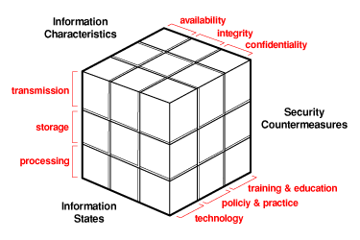

The availability of data would be different from when it’s being processed to when it’s being stored. Data while being processed cannot be immediately accessed while the processor transforms the data, where data in storage is generally more easily accessible as it is not currently in use.

The technology used for transmission can also vary, depending on the environment, you may need to use a weaker encryption method to make the data more easily available to other users.

**Problem 3**

How can the practice of information security be described as both an art and a science? How does security as a social science influence its practice? (8 pts.)

Information security as an art-form is an elegant balance between availability and the security restrictions of the data. The science however, is more cut and dry. It has a universal application to cover a broad scope of practices. The social aspect comes into play with the human element affecting the integrity of information. Data is always going to be handled by people at some point and that person is then responsible with the security of the information.