# Lab 1 – Testing Kali Linux

|  |
| --- |
| * This is an individual assignment, and worth 20 points. * The due date and time is 4:00 Thur, September 7 (Sec 01) / 7:00 Thur, September 7 (Sec 76). * You need to provide your answers to the “Lab1-Outcome.docx.” Change the file name following the naming convention suggested below. * Naming convention is as follows: homework, hypen, last name, first initial, and extension (e.g., Lab1-Outcome-ImG.docx). If you do not follow the convention, I will deduct 1. * Make screenshots small so that you can save space. |

# Tasks

* (Task 1) For this task, you should read the file “Basic Linux Commands for Linux Terminal Beginners (pcsteps.com).pdf” on posted the Blackboard.
* Open a terminal.
* On root, create a directory with your first name.
* Within the directory you created, create an empty file named “cis480.txt”.
* Using “echo” command, add the text “test1” to the text file.
* Using “echo” command, append the text “test2” to the text file.
* Using “cat” command, display the content in the “cis480.txt”.
* Using “grep” command, search for “test1”.
* On root, using “tar” command, compress everything in your directory.
* Delete the compressed file.
* Show the commands you executed and outcomes in one or two screenshots.
* (Task 1) Take screenshots of the outcome.

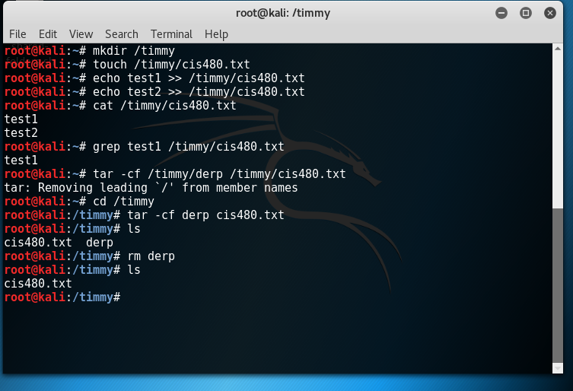

* (Task 2) Let’s try **ifconfig** command. The Windows equivalent is ipconfig. The commands you can use are:
* ifconfig --help (for help)
* ifconfig (to get the IP address of your system)
* Run a **ifconfig** command to display the IP address, netmask, broadcast associated with the Kali. Take a screenshot of the outcome.
* (Task 2) Take a screenshot of the outcome. 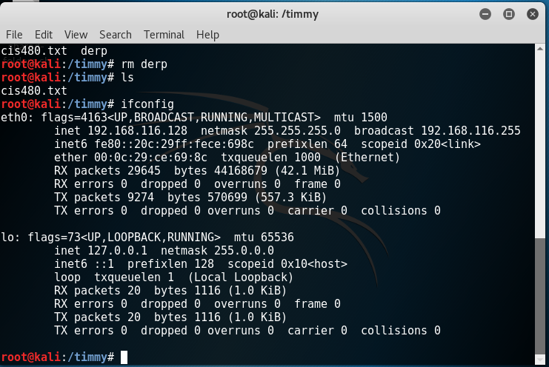

(Task 3) Let’s next try **netstat** to display the ports that are open in your system. The state of each port can be listening, waiting, or connected. **netstat** by default does not tell which service is leading a port to be open.

* Run a **netstat** command to display the listening server sockets. Take a screenshot of the outcome. If the screen displays too many entries, you can resize the screen after zooming in/out (View > Zoom In/Out).

(Task 3) Take a screenshot of the outcome. 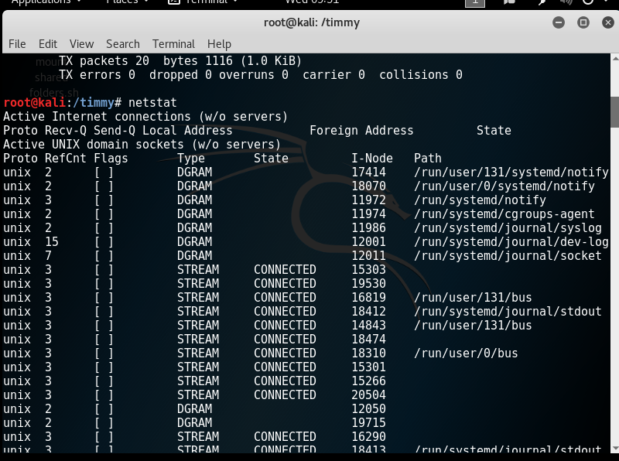

* (Task 4) Next, let’s try **traceroute** (tracert in Windows) to trace the route to the destination by sending ICMP Echo Request messages.
* traceroute (for options)
* traceroute www.louisville.edu
* Run a **traceroute** command to trace the route to [www.louisvilleky.gov](http://www.louisvilleky.gov). Take a screenshot of the outcome.
* (Task 4) Take a screenshot of the outcome. 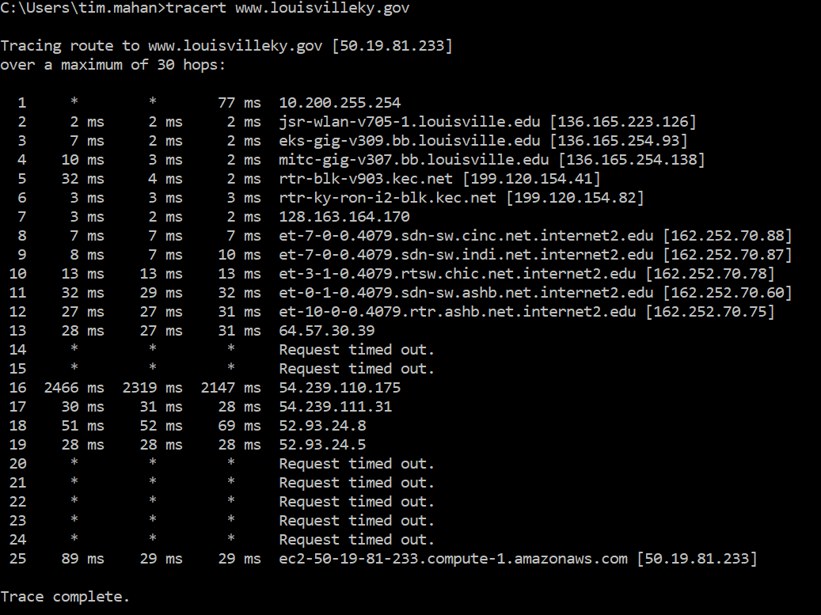
* (Task 5) Let’s try **ping** to test the connection to a host.

Run a **ping** command to test the connection to [www.louisvilleky.gov](http://www.louisvilleky.gov). Send the ECHO REQUEST message five times only. For this, you have to use count option (-c). Take a screenshot of the outcome.

(Task 5) Take a screenshot of the outcome. 