# Tim Mahan

# Lab Exercise – Setting up a VPN client

|  |
| --- |
| * This is an individual lab exercise, and not graded. * The due date and time is tonight. * Change the file name following the usual naming convention. |

# Part 1 – Background on OpenVPN

* Go to the following site for the details about OpenVPN.
  + <https://openvpn.net/>
* “OpenVPN is an open-source software application that implements virtual private network (VPN) techniques for creating secure point-to-point or site-to-site connections in routed or bridged configurations and remote access facilities. It uses a custom security protocol that utilizes SSL/TLS for key exchange. It is capable of traversing network address translators (NATs) and firewalls. It was written by James Yonan and is published under the GNU General Public License (GPL).”[1]

# Part 2 – Background on VPNBook

* Go to the following site for the details about VPNBook.
  + [https://www.vpnbook.com/](%20https://www.vpnbook.com/)
* “VPNBook is a virtual private network provider that uses encrypted connection to alternate the original IP address. Although it is unknown who is behind this service and how it receives it funding, it is free to use and it was reviewed in a special article of the PC Magazine, where its said that the service "has certain functionality flaws, but is good for a free VPN service". It was also reviewed by BestVPN portal. The service connects to a VPN via OpenVPN client or a PPTP connection. There are minimal variety of geographic locations. Available servers include the United States, Canada and Romania. VPNBook can be used to bypass some governmental restrictions.”[2]

# Part 3 – Establishing a VPN client

* Set up OpenVPN on Windows 10 / Mac OS X. Take a screenshot of the webpage that shows the IP address of the host.
* <https://www.vpnbook.com/howto/>

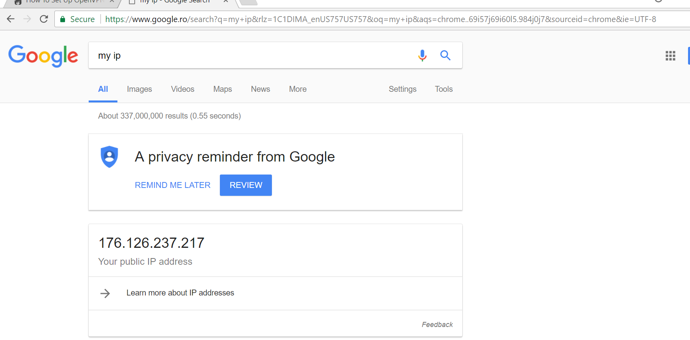

* Set up OpenVPN on Kali. For this, follow the instructions on “How to set up OpenVPN on Ubuntu.” Take a screenshot of the webpage that shows the IP address of the host.
* <https://www.vpnbook.com/howto/>

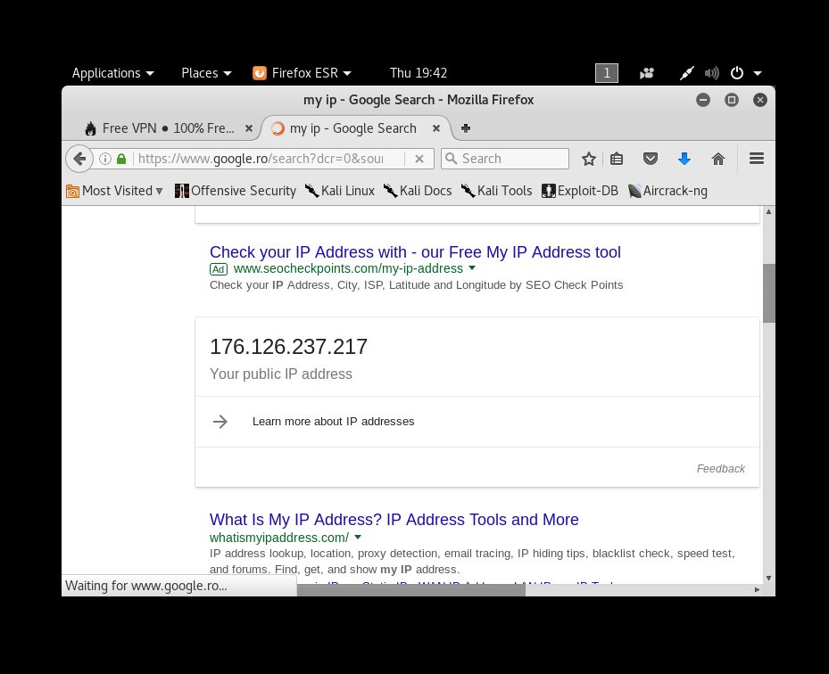

* After this, make sure you uninstall the VPN client. Otherwise, it may interrupt your web surfing.

1. https://en.wikipedia.org/wiki/OpenVPN
2. https://en.wikipedia.org/wiki/VPNBook#cite_note-pc_mag-3