Class Diagram

This is a visual representation of all the classes our system will include. A class is essentially the blueprint for an object (objects would be things like students, professors, admissions applications and so on). This blueprint lists every attribute an object can have, and is used directly to create objects when the system is running. The classes within a class diagram list the class name at the top, followed by the attributes in the next section, and in the last section each class lists the methods (actions) available to each object of a particular class. The following is the class diagram we have put together for the SONAR system:



ERD

An Entity Relationship Diagram represent all the tables that will be present within the database of our system. Each table in the diagram contains the table name, as well as the attributes for each class. The difference between an ERD and a Class Diagram is that an ERD does not list the actions an object of a certain class will be able to take, but rather the keys (primary and foreign) within each table of the database. A primary key (denoted with PK) is the unique identifier for a specific table. A foreign key (denoted with FK) is a unique identifier (primary key) in another table. By giving each table a uniquely identifiable attribute, and placing the same attribute in other tables, we create relationships among the tables. The relationships created with these keys can vary. If you look at a table, and follow a line coming out of it (representing the relationship with another table) to the connecting table, you will see one of several things:

* 
* This represent a zero to many relationship, think of it this way, a professor may teach zero to many students in a semester depending on what they are doing.
* 
* This represent a 1 and only 1 relationship, think of it this way, a student can be one, and only one, kind of student (an example would be a lower division student, a student cannot be both an upper division student AND a lower division student at the same time.)

The following is our ERD for the SONAR system.



WND

The Window Navigation Diagram is a simple layout of the navigation options possible for a user of the system. Our diagram shows forms, which would be actual web pages (see the prototypes section for examples) that accept input, and the act on it. The outputs are the results of users such as advisors using the forms within the system. The following is a simple Window Navigation Diagram for the different kinds of users of out SONAR system:















Data Dictionaries

Data dictionaries are simply used to list the fields (columns) a table will have as well as the information regarding each field. In the following dictionaries, we include the field name, a brief description of what the field represents, the size of the field (for calculating storage requirements), and finally whether a field is the unique identifier (primary key, or PK) in the table and/or whether the field is a unique identifier (foreign key, or FK) in another table.

Admissions Application

|  |  |  |  |  |
| --- | --- | --- | --- | --- |
| Attribute Type | Definition | Type of Attribute | Size | PK/FK |
| Application Number | Unique identifier for admissions application submitted | int | 4 | Pk |
| StudentID | Identifier to identify individual students saved in the database. | uint | 4 | FK |
| First Name | Common Name for the user | varchar | 10 |  |
| MI | Middle initial of user. Can be used to identify users who might have the same first and last name. | varchar | 1 |  |
| Last Name | Surname of the user | varchar | 10 |  |
| Email | Primary email that can be used for sending out notifications | varchar | 30 |  |
| Address | Physical address of the user for mailing purposes. | varchar | 30 |  |
| City | City in which the donor resides. | varchar | 20 |  |
| State | 2 letter abbreviation for the state that user resides in. | varchar | 2 |  |
| Zipcode | Zip code for the physical address of the user | uint | 4 |  |
| Phone Number | Primary phone number where student can be reached. | uint | 4 |  |
| GPA | Grade point average for the student that will be used in the decision making process. | decimal | 16 |  |
| ACT Score | ACT score for the student | short | 2 |  |
| SAT Score | SAT score for student | short | 2 |  |
| Notes | Field to enter details on anything else not listed in the preceeding attributes. | varchar | 500 |  |

|  |  |  |  |  |
| --- | --- | --- | --- | --- |
| Scholarship Application | |  |  |  |
| Attribute Type | Definition | Type of Attribute | Size | PK/FK |
| ScholarshipAppID | Identifier for each application submitted by the student | int | 4 | PK |
| StudentID | Identifier to identify individual students saved in the database. | uint | 4 | FK |
| First Name | Common Name for the user | varchar | 10 |  |
| MI | Middle initial of user. Can be used to identify users who might have the same first and last name. | varchar | 1 |  |
| Last Name | Surname of the user | varchar | 10 |  |
| Email | Primary email that can be used for sending out notifications | varchar | 30 |  |
| Address | Physical address of the user for mailing purposes. | varchar | 30 |  |
| City | City in which the donor resides. | varchar | 20 |  |
| State | 2 letter abbreviation for the state that user resides in. | varchar | 2 |  |
| Zipcode | Zip code for the physical address of the user | uint | 4 |  |
| Phone Number | Primary phone number where student can be reached. | uint | 4 |  |
| GPA | Grade point average for the student that will be used in the decision-making process. | decimal | 16 |  |
| Expected Graduation | Expected graduation date for the student | date | 4 |  |
| Notes | Field to enter details on anything else not listed in the preceding attributes. | varchar | 500 |  |

|  |  |  |  |  |
| --- | --- | --- | --- | --- |
| Marketing type |  |  |  |  |
|  |  |  |  |  |
| Attribute Type | Definition | Type of Attribute | Size | PK/FK |
| MarketingTypeID | Unique number to identify each marketing type | Short | 2 | PK |
| TypeName | Descriptive name of each marketing type. | varchar | 15 |  |

|  |  |  |  |  |
| --- | --- | --- | --- | --- |
| Student Type |  |  |  |  |
|  |  |  |  |  |
| Attribute Type | Definition | Type of Attribute | Size | PK/FK |
| Student Type ID | Unique number to identify each student type | Short | 2 | PK |
| Student type name | Name of the student type | varchar | 15 |  |
| Description | Brief description of the Student type | varchar | 100 |  |

|  |  |  |  |  |
| --- | --- | --- | --- | --- |
| Courses |  |  |  |  |
|  |  |  |  |  |
| Attribute Type | Definition | Type of Attribute | Size | PK/FK |
| CourseID | Unique number to identify each course | Short | 2 | PK |
| Course Name | Descriptive Name of the course | varchar | 15 |  |
| Department | Name of the department the course will be listed under | varchar | 15 |  |

|  |  |  |  |  |
| --- | --- | --- | --- | --- |
| Email template Type | |  |  |  |
|  |  |  |  |  |
| Attribute Type | Definition | Type of Attribute | Size | PK/FK |
| EmailTemplateID | Unique number to identify each email template | Short | 2 | PK |
| Email Template Namee | Name of the email template | varchar | 15 |  |
| Description | Brief description of the email template and possible use scenarios. | varchar | 100 |  |

Alumni Member

|  |  |  |  |  |
| --- | --- | --- | --- | --- |
| Attribute Type | Definition | Type of Attribute | Size | PK/FK |
| Username  Password  Email Address  Firstname  Lastname  Phone number  Street Address  City  State  Zip Code  Place of Work  Current Position  StudentID | This is the identifier used to log users in to the system  This is the key used to log users in to the system  Used to contact he Donor in the future  The common name of the user  Surname of the user  Telephone/cellphone contact of the user  The physical address of the users residence  City in which the donor  State in which the donor currently resides  Zip code where the donor currently resides  Helps University keep track of where their student go to work after graduating  Title of the current position held by the alumni  Identifier to uniquely identify student in the system | Varchar  Varchar  Varchar  Varchar  Varchar  Varchar  Varchar  Varchar  Char  Char  Varchar  Varchar  Int | 20  20  30  20  25  15  30  15  2  5  20  15  4 | PK  FK |

Committee Member

|  |  |  |  |  |
| --- | --- | --- | --- | --- |
| Attribute Type | Definition | Type of Attribute | Size | PK/FK |
| Username  Password  EmployeeID  Email Address  Firstname  Middle Initial  Lastname  Primary Phone number  Secondary Phone number  Street Address  City  State  Zip Code  CreatedByID | This is the identifier used to log users in to the system  This is the key used to log users in to the system  Identifier for each employee  Used to contact he Member in the future  The common name of the user  Middle name intial for the committee member  Surname of the user  Telephone/cellphone contact of the user  Telephone/cellphone contact of the user  The physical address of the users residence  City in which the member  State in which the member currently resides  Zip code where the member currently resides  Information about the admin responsible for creating the user | Varchar  Varchar  int  Varchar  Varchar  Char  Varchar  Varchar  varchar  Varchar  Varchar  Char  Char  Varchar | 20  20  4  30  20  1  25  10  10  30  15  2  5  15 | PK  FK |

Donor Class

|  |  |  |  |  |
| --- | --- | --- | --- | --- |
| Attribute Type | Definition | Type of Attribute | Size | PK/FK |
| Username  Password  Email Address  Firstname  Lastname  Phone number  Street Address  City  State  Zip Code | This is the identifier used to log users in to the system  This is the key used to log users in to the system  Used to contact he Donor in the future  The common name of the user  Surname of the user  Telephone/cellphone contact of the user  The physical address of the users residence  City in which the donor  State in which the donor currently resides  Zip code where the donor currently resides | Varchar  Varchar  Varchar  Varchar  Varchar  Varchar  Varchar  Varchar  Char  Char | 20  20  30  20  25  15  30  15  2  5 | PK |

Professor

|  |  |  |  |  |
| --- | --- | --- | --- | --- |
| Attribute Type | Definition | Type of Attribute | Size | PK/FK |
| Username  Password  EmployeeID  Email Address  Firstname  Middle Initial  Lastname  Primary Phone number  Secondary Phone number  Street Address  City  State  Zip Code  CreatedByID | This is the identifier used to log users in to the system  This is the key used to log users in to the system  Identifier for each employee  Used to contact he professor in the future  The common name of the user  Middle name intial for the professor  Surname of the user  Telephone/cellphone contact of the user  Telephone/cellphone contact of the user  The physical address of the users residence  City in which the professor resides  State in which the professor currently resides  Zip code where the professor currently resides  Information about the admin responsible for creating the user | Varchar  Varchar  int  Varchar  Varchar  Char  Varchar  Varchar  varchar  Varchar  Varchar  Char  Char  Varchar | 20  20  4  30  20  1  25  10  10  30  15  2  5  15 | PK  FK |

Prospective Students

|  |  |  |  |  |
| --- | --- | --- | --- | --- |
| Attribute Type | Definition | Type of Attribute | Size | PK/FK |
| Username  Password  Email Address  Firstname  Lastname  Phone number  Street Address  City  State  Zip Code  MarketingTypeID | This is the identifier used to log users in to the system  This is the key used to log users in to the system  Used to contact he Student in the future  The common name of the user  Surname of the user  Telephone/cellphone contact of the user  The physical address of the users residence  City in which the student  State in which the student currently resides  Zip code where the student currently resides  Form of marketing responsible for bringing in prospective student | Varchar  Varchar  Varchar  Varchar  Varchar  Varchar  Varchar  Varchar  Char  Char  Varchar | 20  20  30  20  25  15  30  15  2  5  10 | PK  FK |

Semester

|  |  |  |  |  |
| --- | --- | --- | --- | --- |
| Attribute Type | Definition | Type of Attribute | Size | PK/FK |
| SemesterName  Year  Season | This identifies which semester we’re talking about, it will be denoted by a scheme similar to F16 for Fall 2016, or SU17 for Summer 2017  Year the Semester takes place  Season the semester will take place in. | Varchar  Char  Varchar | 4  4  6 | PK |

Certs Check List

|  |  |  |  |  |
| --- | --- | --- | --- | --- |
| Attribute Type | Definition | Type of Attribute | Size | PK/FK |
| CertID | Unique Identifer for specific instances of certifications tracked in the database | Int | 4 | PK |
| CertExpiration | Date the Certification Expires | Date/time |  |  |
| StudentID (username) | Unique identifier for tying students to the certifications they upload |  |  | FK |
| CertTypeID | Unique Identifier that indicates the type of certificate a student has uploaded. |  |  | FK |

Advisor

|  |  |  |  |  |
| --- | --- | --- | --- | --- |
| Attribute Type | Definition | Type of Attribute | Size | PK/FK |
| UserName | This is the identifier used to log users in to the system | Varchar | 20 | PK |
| Password | Used to authenticate users when they log into the system | Varchar | 20 |  |
| Firstname | The common name of the user | Varchar | 20 |  |
| Lastname | Surname of the user | Varchar | 20 |  |
| EmployeeID | Identifier for each employee | Int | 4 |  |
| Email | Used to log users in and contact them when necessary | Varchar | 30 |  |
| MiddleInitial | Middle name intiial for the advisor | Char | 1 |  |
| Address | The physical address of the users residence | Varchar | 30 |  |
| City | City in which the student | Varchar | 15 |  |
| State | State in which the student currently resides | Char | 2 |  |
| Zip | Zip code where the student currently resides | Uint | 4 |  |
| PrimaryPhone | Telephone/cellphone contact of the user | Varchar | 15 |  |
| SecondaryPhone | Secondary telephone/cellphone contact of the user | Varchar | 15 |  |
| CreatedByID | Administrator that created the advisor | Varchar | 30 | FK |

FinancialAidCheckList

|  |  |  |  |  |
| --- | --- | --- | --- | --- |
| Attribute Type | Definition | Type of Attribute | Size (Bytes) | PK/FK |
| AidID  AidName  SchoolYear  StudentID | Identifier of the the specific type of aid  Descriptive name of financial aid  Year that aid is offered  Unique identifier given by university | Char  Varchar  Char  Char | 8  36  8  14 | PK  FK |

Prospective Student Visits

|  |  |  |  |  |
| --- | --- | --- | --- | --- |
| Attribute Type | Definition | Type of Attribute | Size (Bytes) | PK/FK |
| VisitID  VisitDate  VisitTime  ProspectiveStudentUsename | 6 digit code of that will uniquely identify date  Date that the visit will take place  Time that the visit will take place  User name of the prospective student that will be vistiting | Char  Date  Time  Varchar | 12  3  5  36 | PK  FK |

Classes Enrollment

|  |  |  |  |  |
| --- | --- | --- | --- | --- |
| Attribute Type | Definition | Type of Attribute | Size (Bytes) | PK/FK |
| ClassID  CourseID  CreditHours  Section  StudentID  ProfessorID  Buidling  RoomNumber  StartTime  SemesterName | 4 character ID that is used on the ‘Schedule of Classes’ in ULINK  Code that is used to describe course type, ex: CIS300  Number of hours that the course is worth  Number of the section as used in ULINK and Blackboard  University ID given to student  ID assigned to professor  Building the class takes place  Room number where class takes place  Time class starts  The semester that the class will take place, ex: Fal2017 | Char  Varchar  Int  Char  Char  Char  Varchar  Varchar  Time  Varchar | 8  14  4  8  14  14  45  15  8  14 | PK  FK  FK  FK  FK |

Administrator

|  |  |  |  |  |
| --- | --- | --- | --- | --- |
| Attribute Type | Definition | Type of Attribute | Size (Bytes) | PK/FK |
| CreatedByID  UserName  Password  FirstName  MiddleInitial  LastName  EmployeeID  Email  Address  City  State  Zip  PrimaryPhone  SecondaryPhone | ID created to uniquely identify each administrator  Unique identifier created so each admin can log in  Unique password created so each admin can log in  Admin’s first name  Admin’s middle initial  Admin’s last name  Admin’s UofL employee ID  Admin’s email address  Admin’s address  Admin’s city  Admin’s state  Admin’s zip code  Admin’s phone number  Admin’s secondary phone number | Char  Varchar  Varchar  Varchar  Char  Varchar  Char  Varchar  Varchar  Varchar  Char  Char  Char  Char | 12  36  36  36  2  36  14  90  90  45  4  10  20  20 | PK  FK |

CertType

|  |  |  |  |  |
| --- | --- | --- | --- | --- |
| Attribute Type | Definition | Type of Attribute | Size (Bytes) | PK/FK |
| CertTypeID  CertTypeName | Identifies category that certification falls under  Name of the type of certification | Char  Varchar | 4  30 | PK |

Students

|  |  |  |  |  |
| --- | --- | --- | --- | --- |
| Attribute Type | Definition | Type of Attribute | Size | PK/FK |
| Username  Password  Email Address  Firstname  Lastname  Phone number  Street Address  City  State  Zip Code  Student Type  Advisor | This is the identifier used to log users in to the system  This is the key used to log users in to the system  Used to contact he Student in the future  The common name of the user  Surname of the user  Telephone/cellphone contact of the user  The physical address of the users residence  City in which the student  State in which the student currently resides  Zip code where the student currently resides  Options like Upper division, lower division, etc. that help determine the program of study  Assigns student to a particular advisor | Varchar  Varchar  Varchar  Varchar  Varchar  Varchar  Varchar  Varchar  Char  Char  Varchar  Varchar | 20  20  30  20  25  15  30  15  2  5  20 | PK  FK  FK |

Prototypes

1-4 Login

This prototype is a simply mock-up of how the SONAR system’s login page will appear for all users. Users will simply enter their university email (as that will be the standard username for ALL users) along with the password unique to this system.

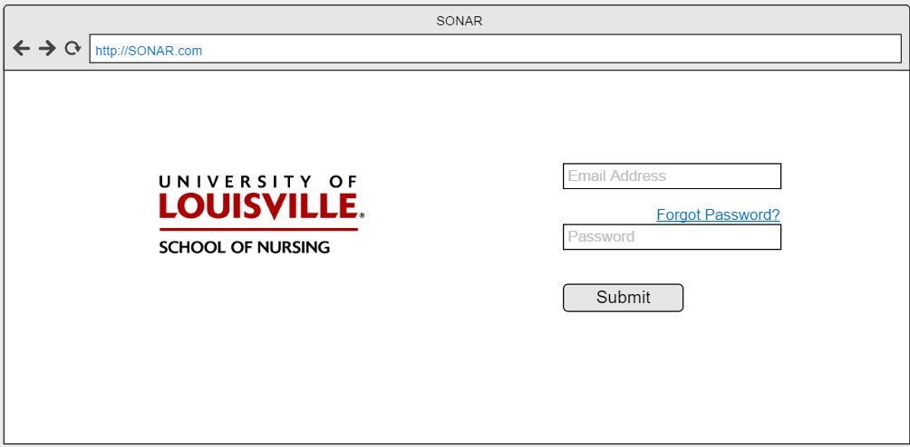

5) Submit Grades

The Professor will submit the grades of each student in each class they teach in a given semester. After successfully logging on to the system, Professors will be able to select the class from a list of classes assigned to them for the current semester, and then manually go through and select the grade of each student. Once this has been completed for a class, the professor will submit the grades. If the professor needs to clear the data entered for some reason, they will have the option to do so.

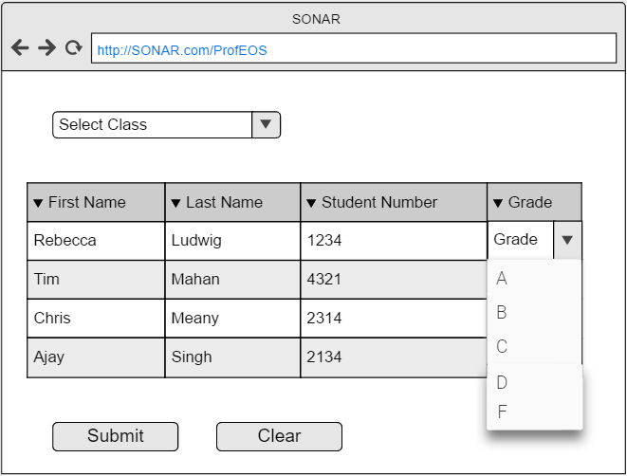

6-7 Queries

The user will run many searches (queries) against the database in order to gain information about not just individual students, but groups of students that participate in the programs offered by the School of Nursing. These searches will be used to generate reports about students, and with these reports advisors will be able to reach out to students who may have decided to not enroll in a particular semester without graduating, or reach out to students that may be on academic probation or failed a course. This will also allow Advisors to track the progress of individual students for advising appointments, with an easy-to-view report generated from a simple query.

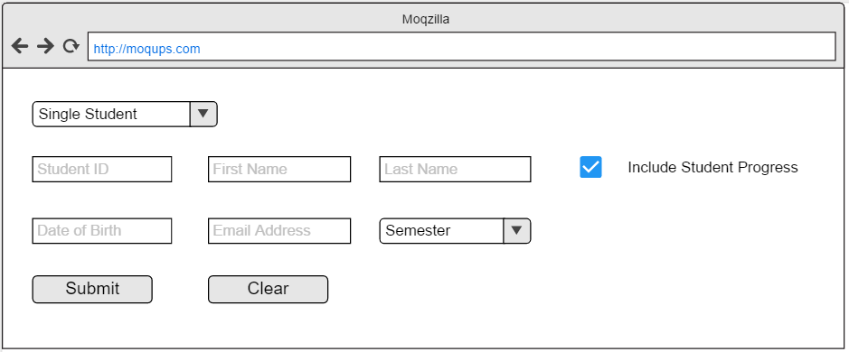

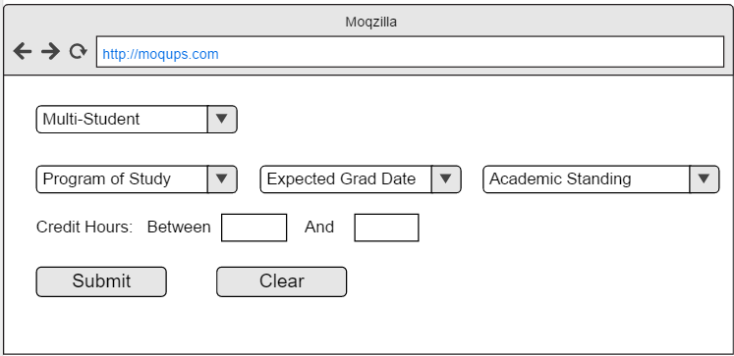

8) Document Upload

Students will have the ability to submit documentation for the review of advisors. The system will provide student users with an easy to use page that simply allows them to submit PDFs, PNGs, and JPEGs to the system so that Advisors may review and approve, not edit the documentation. When the Student selects the Document type, it lets the Advisor know what they’re looking at for approval. When the Document is selected, students can select Clear to remove it, or Submit to send it to the Advisors.

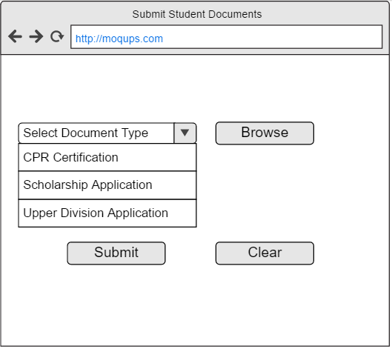

9) Import from CSV

If the need should ever arise a need for data to be imported into the database, the system administrator will have the ability to do so. This allows the system to have more robust functionality, while limiting this privilege to a group that also has the ability to restore the system from a backup should anything go wrong. These excel files (in csv format) can be used to populate the database with information it previously did not contain in a quick, efficient manner. All an Administrator would need to do is Arrange the CSV file columns according to how the Import Student Data link specifies, browse to the file, and hit submit.

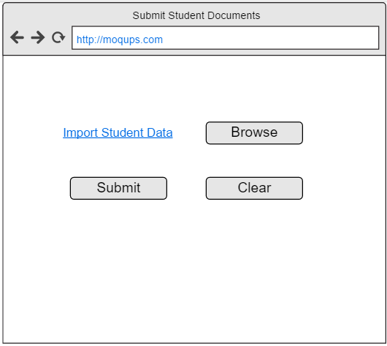

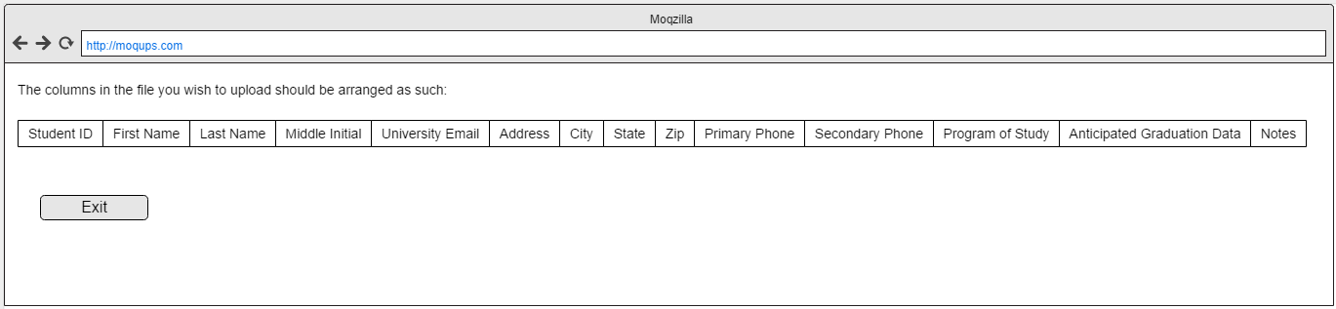

10-11 Reports

Some users such as Advisors and Committee Members would benefit greatly from having the ability to run reports and export those reports to files that they can manipulate on their computers individually, without making any changes to the data stored on the system. To provide this functionality, we’ll have premade reports for advisors and committee members to select from, as well as the division of student should they wish to be so specific. They will then be able to export the data to excel file types or in PDF format to meet their manipulation/viewing needs.

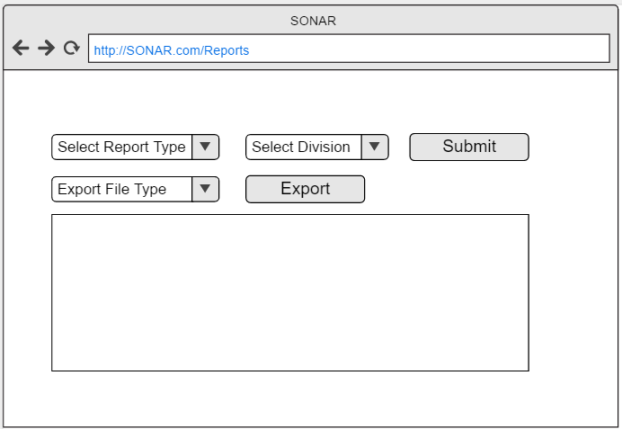

12) Automatic Reporting

Some reports can be generated and delivered automatically. On this page, users will be able to sign up for weekly, monthly, or semester reports. These will be the built in reports that are available on the reports page for users to export. All an Advisor would need to do is check the box next to the report they wish to receive on regular intervals. Once this is complete, they only need hit Save and the changes will take effect.

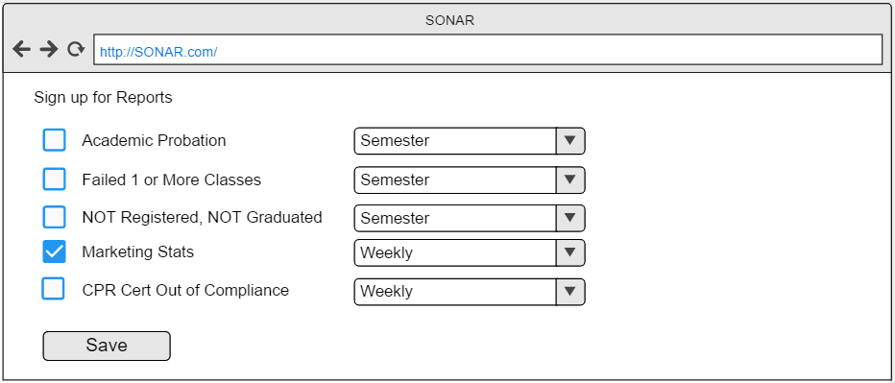

13) Reset password via email

This prototype will allow any user to reset their password. They will select reset password button and enter their email address. An email with a link will be sent to them to allow them to enter their old password followed by entering a new password twice to confirm that it’s the same and meets the standards for the program.

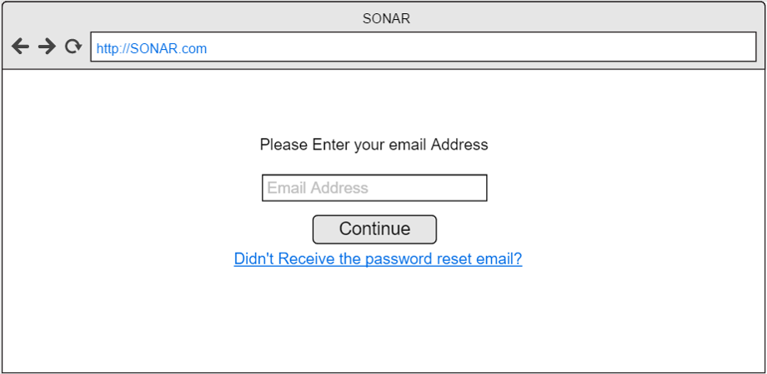

14) Generate automatic email templates

This will allow professors, advisors and committee members to choose a pre written template to send as an email to save them time. They will log in with their username and password then select the email tab. They will be brought to a blank email with pre-loaded email templates they can click on to be automatically dropped into a blank email. This will cut down on the time spent to type emails.

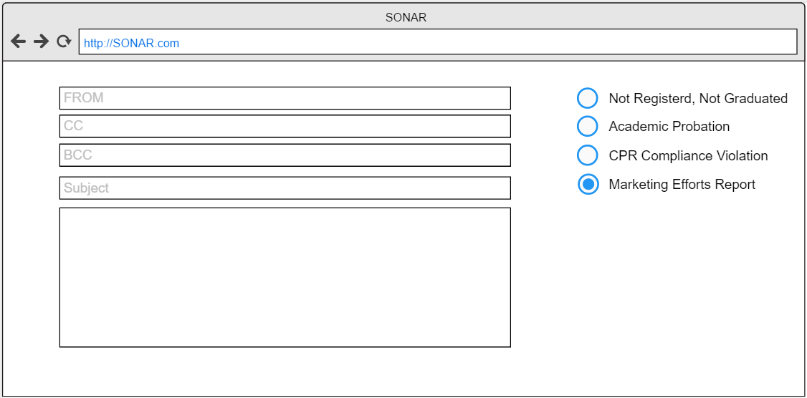

15 Track Students progress

This prototype will allow an advisor to track a student’s progress through the program by running a simple query or report.

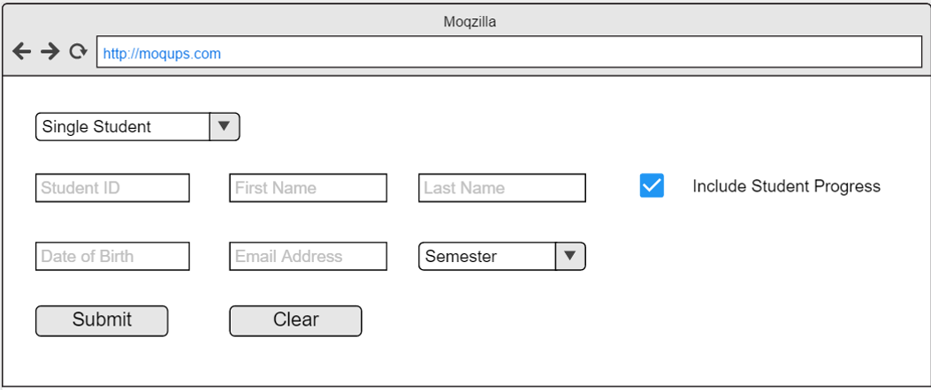

16) Track graduation progress of student

Here, advisors will be able to view a student’s completed classes and classes that need to be taken that are required to graduate. They will enter their credentials and select the student tab. From here they will search the student they want and be able to look at what classes they have finished and still need to finish.

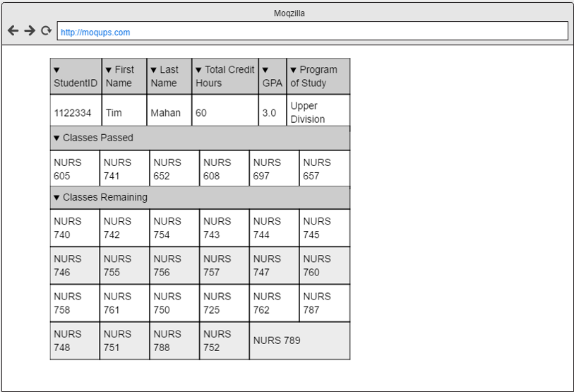

25. Submission of application to school of nursing.

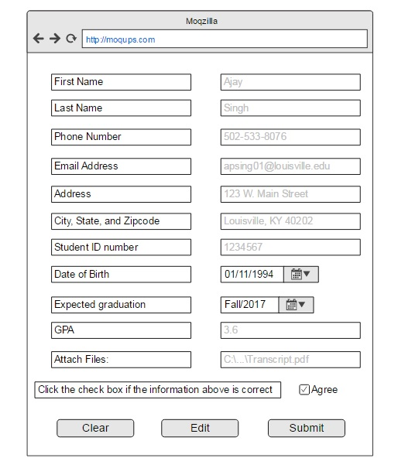

26. Track Received scholarships

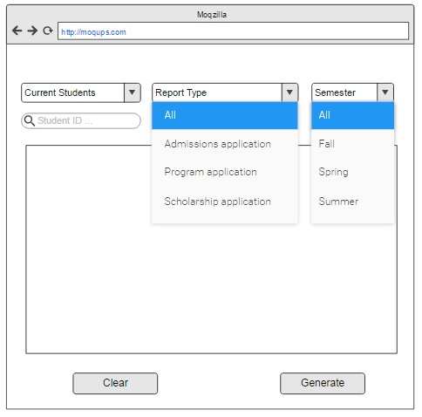

27. submit scholarships



29. Track Marketing Efforts

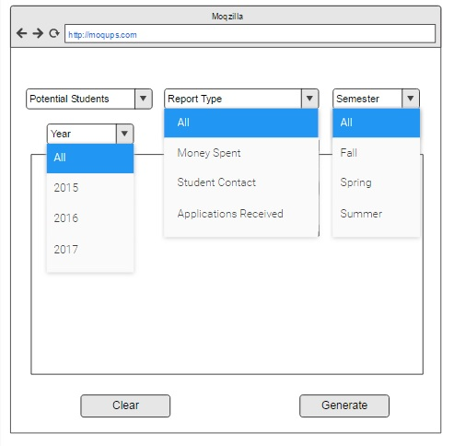

30. View reports for admissions decisions



31. Submission of application for program of study



32. Add to database storage

**System admin would physically add storage to system server**

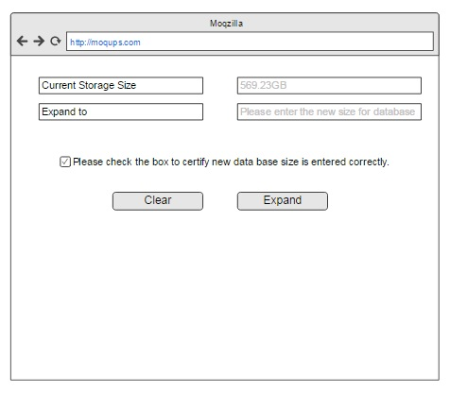

33. Add Graduated students to alumni list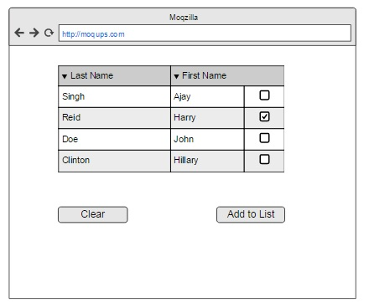

34. Generate email list



35. Edit contact information for alumni

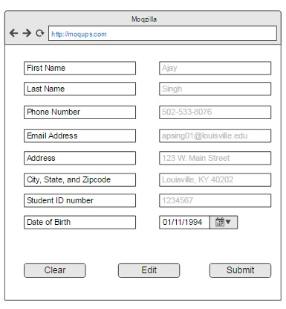

1. Generate email list to ask alumni for donations

