Intro to Data Science – Miniproject

# Variations in bicycle data

Besides weather conditions, there are three rather obvious factors causing variations in bicycle data:

* Time of year/seasonal/monthly variation based on the seasonality of Finnish climate
* Time of day variation based on the day-night cycle
* Weekday variation based on the more common working days Monday to Friday and weekends

These three variations are presented in following examples

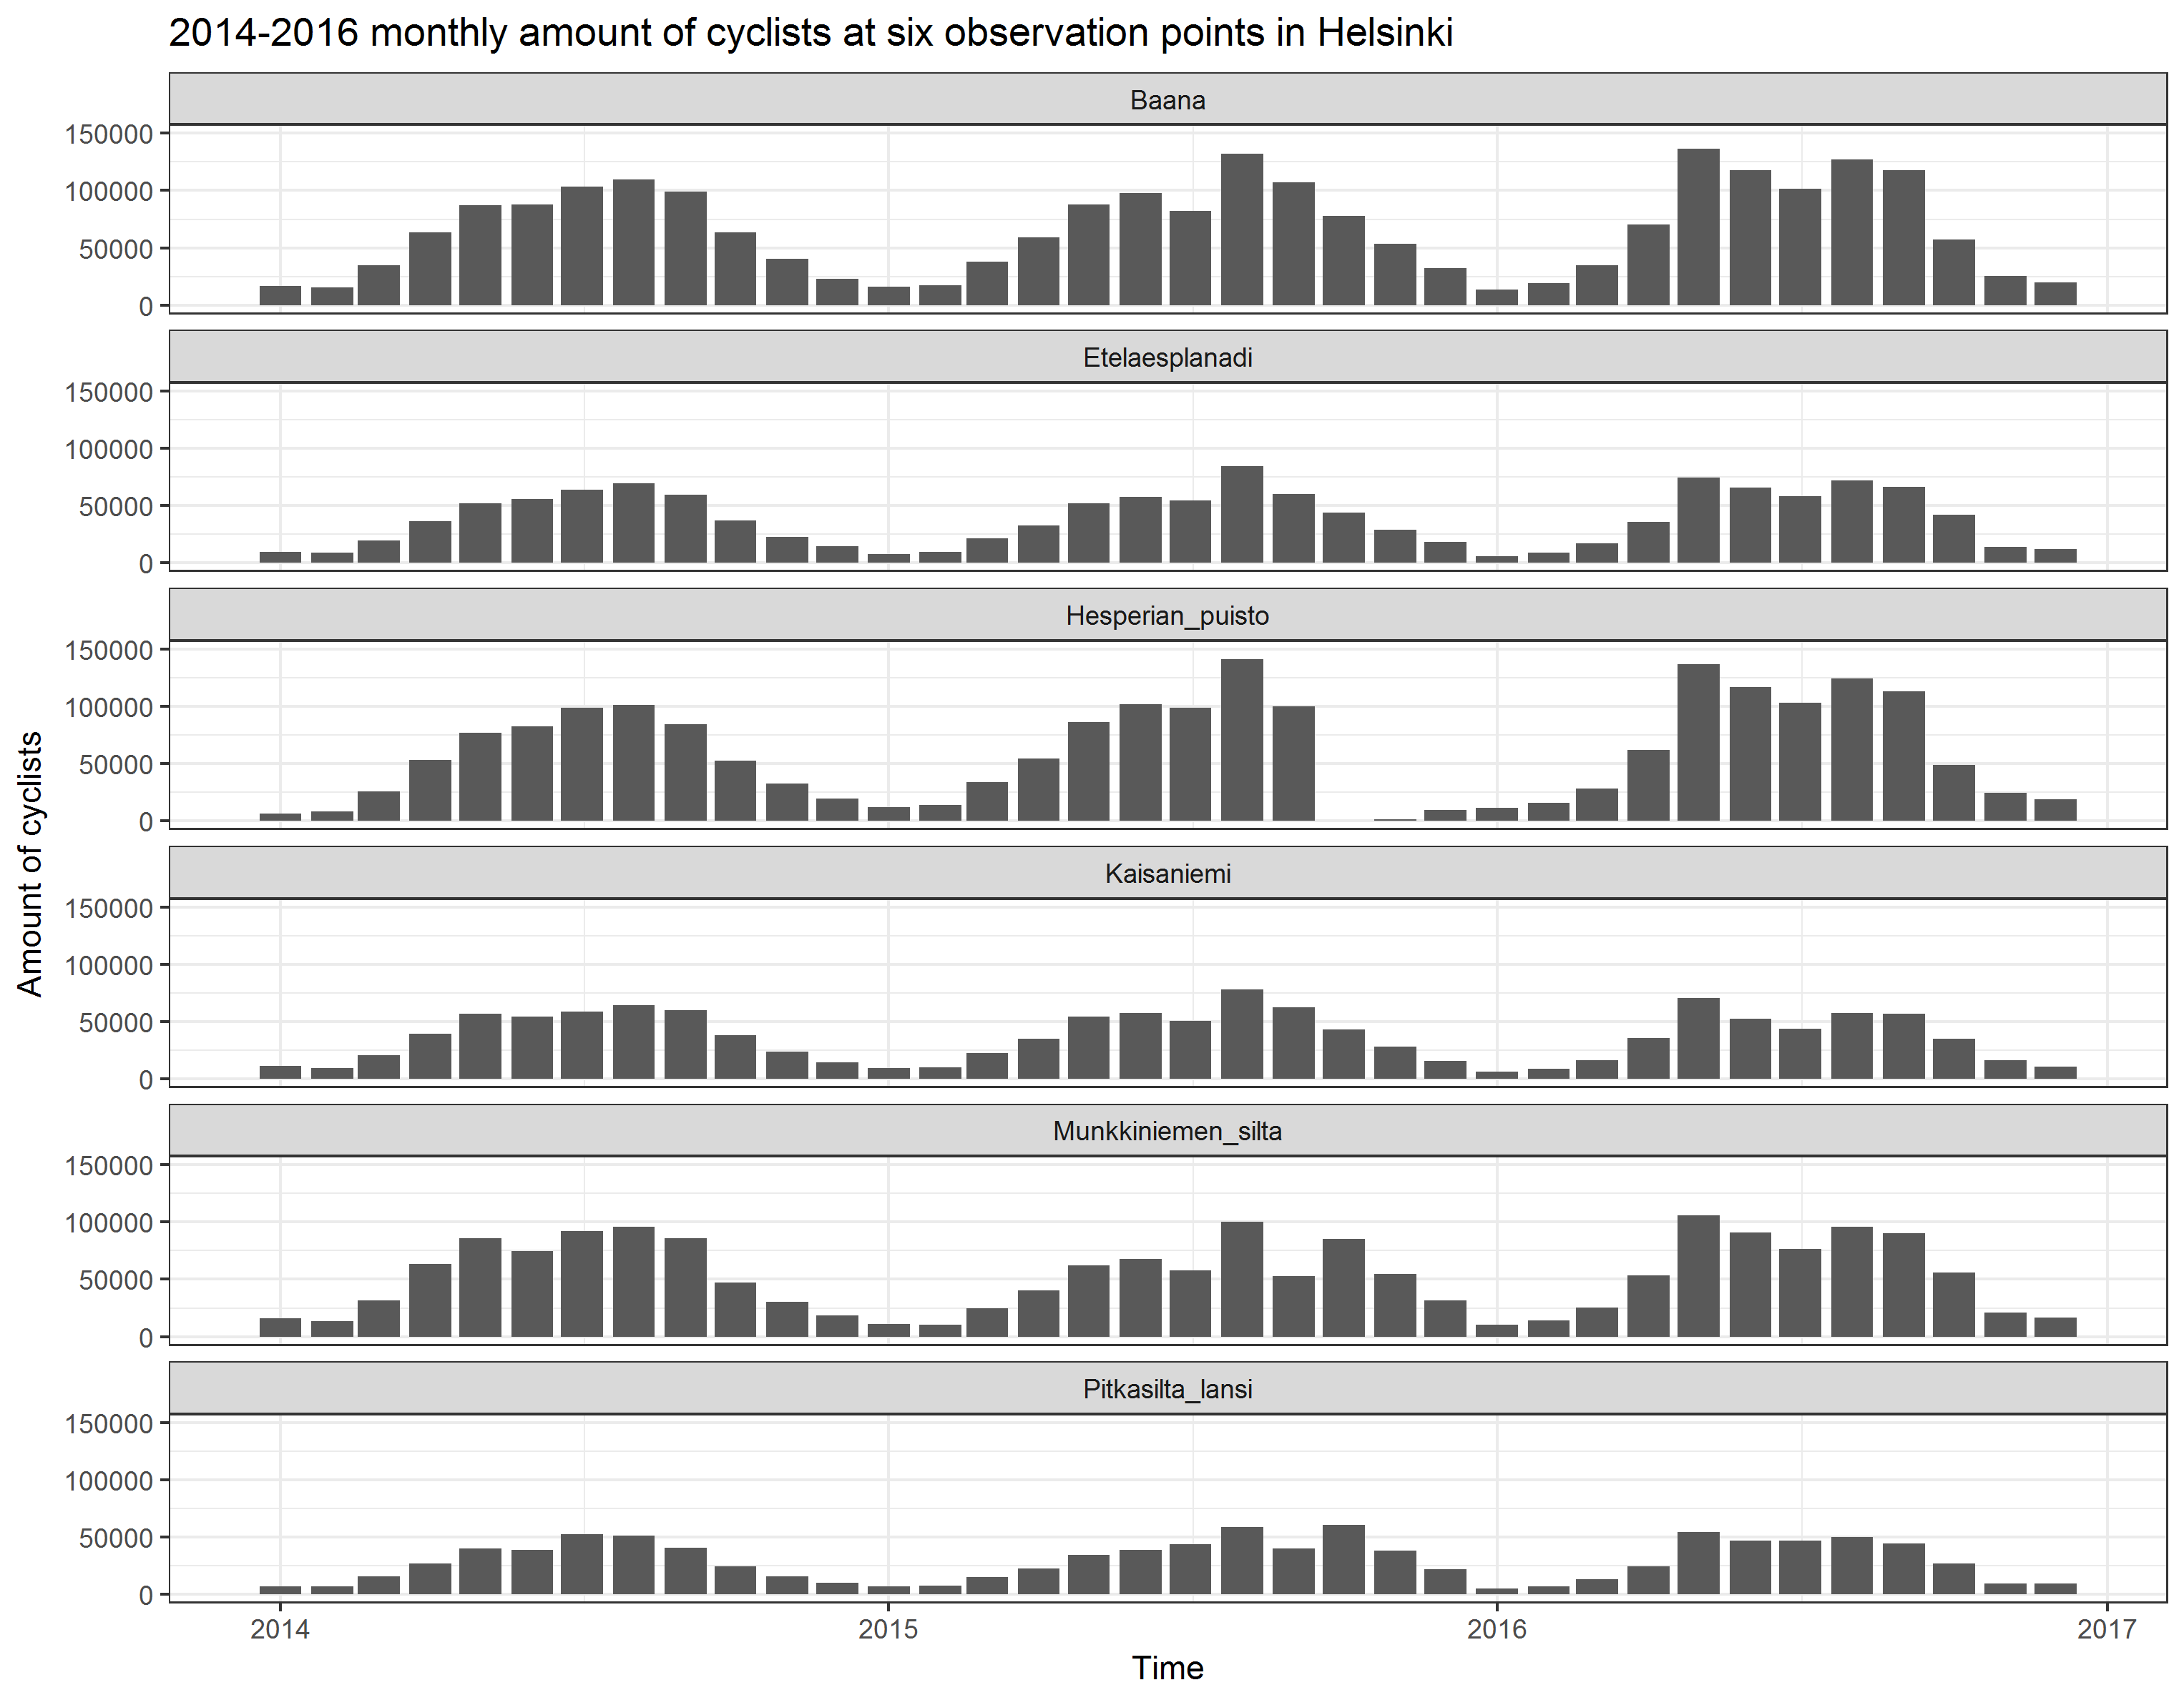

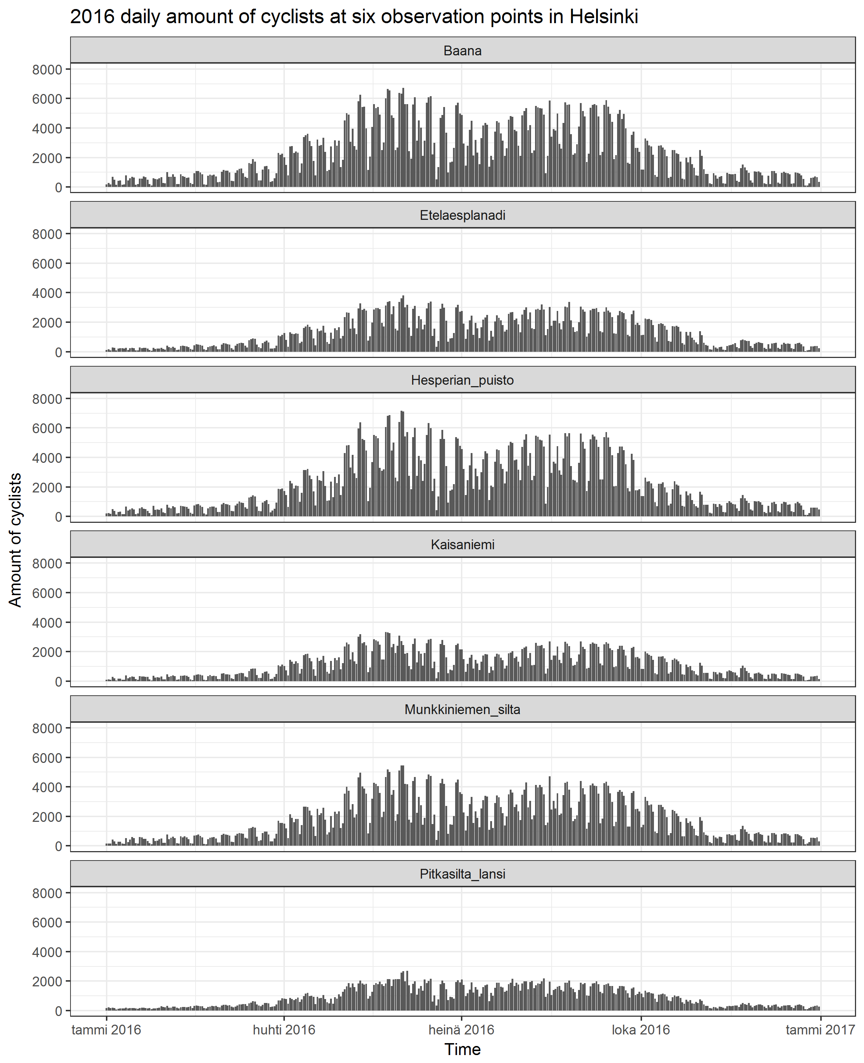

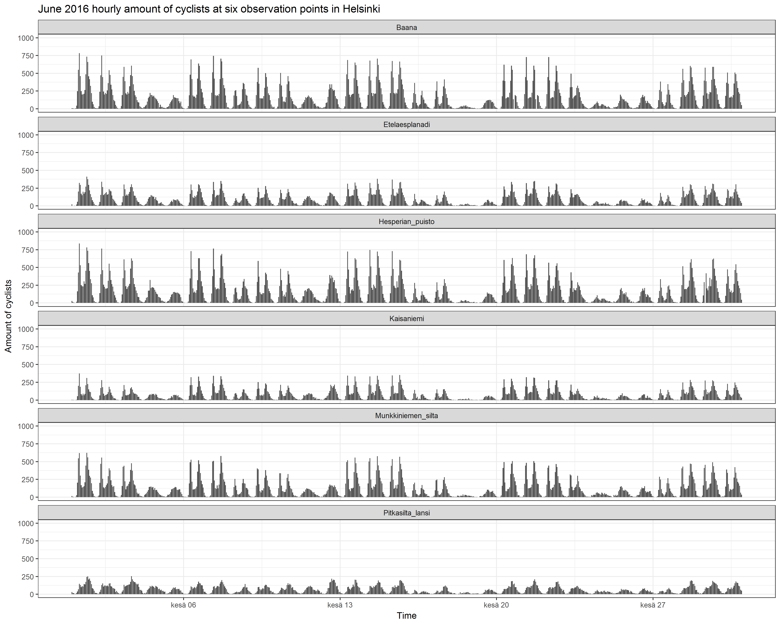

Some observations:

* At hourly level, there’s two maxima during work commute hours
* At daily level work week weekend cycle is clear. People commuting to work not necessarily cycle during weekends.
* July as the most common summer holiday month shows in the data.
* Indeed, Helsinki is empty during Midsummer festivities.

# Relationship between weather variables and amount of cyclists

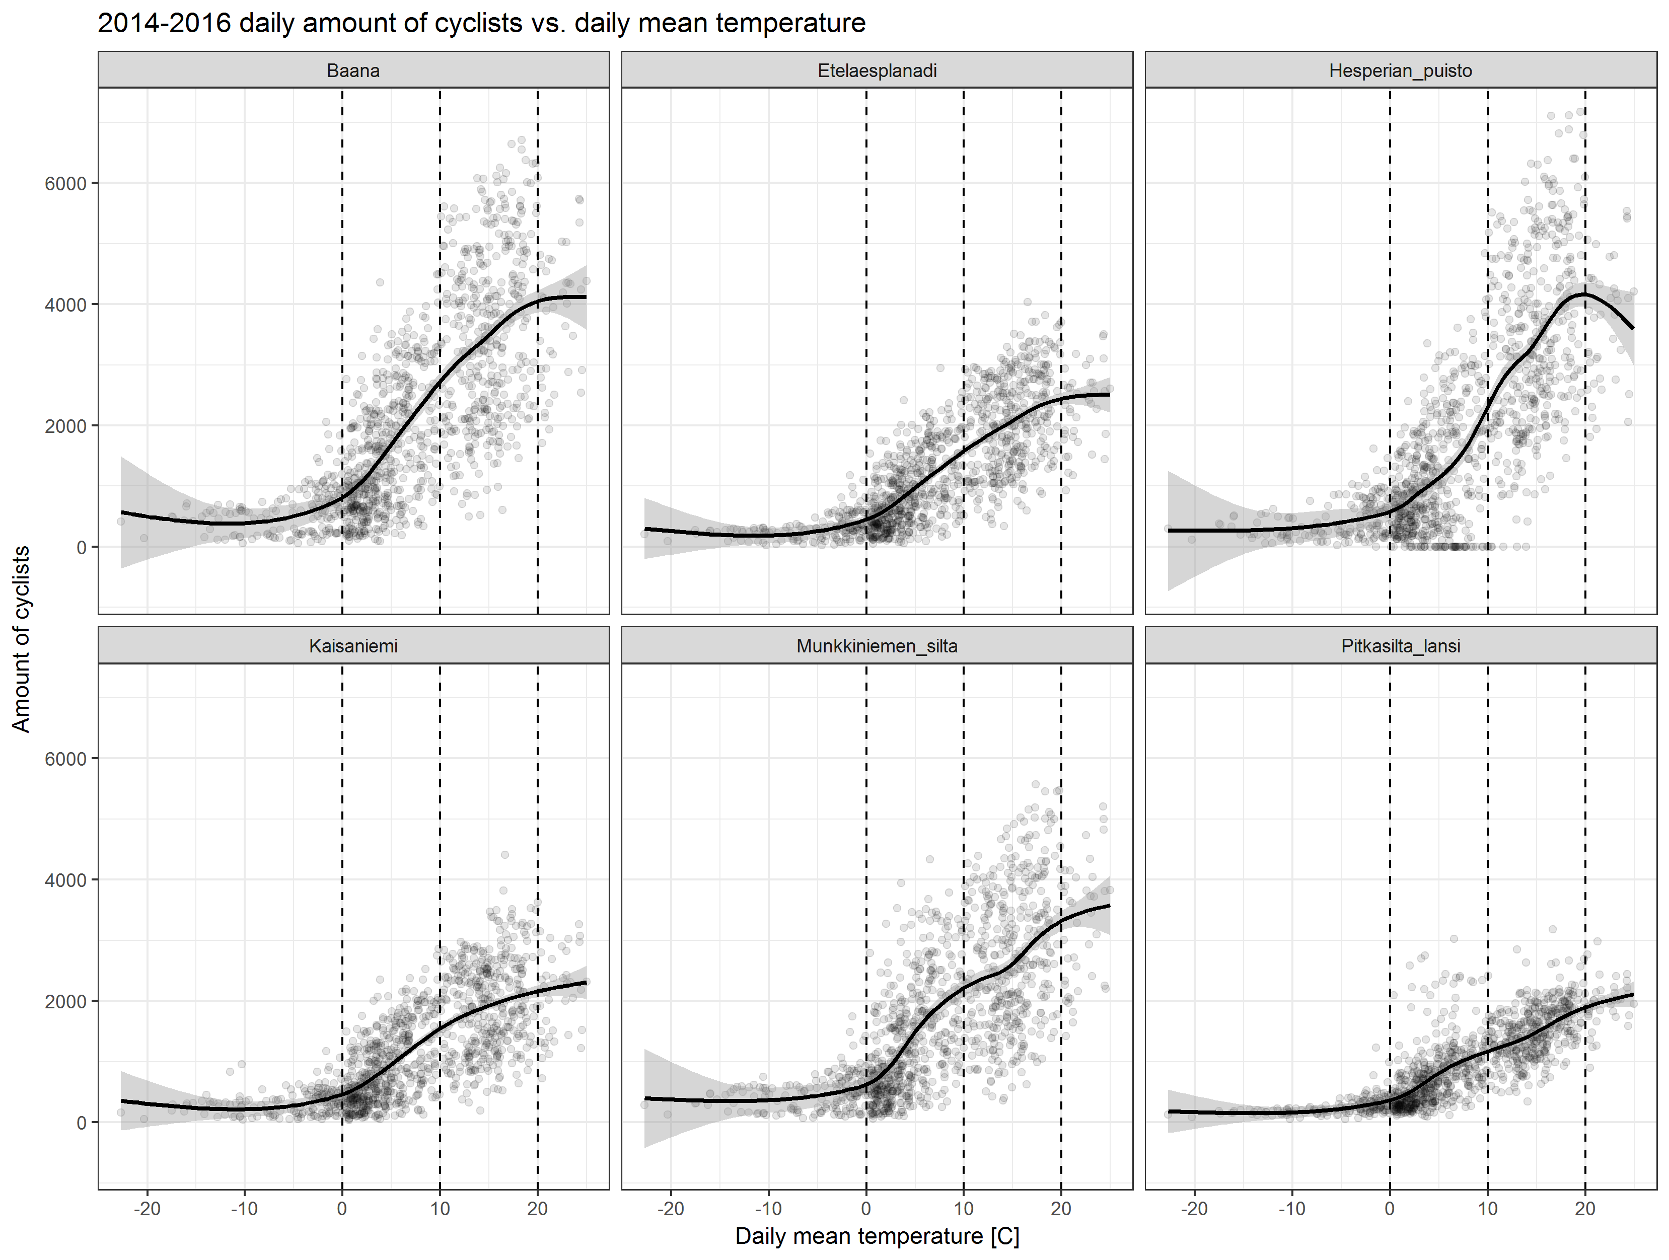

* Drastic drop in cyclists when temperature drops below zero
* Thresholds at 0, 10 and 20 degrees?
* When daily mean temperature is over 20, it is starting to be too hot for cycling?

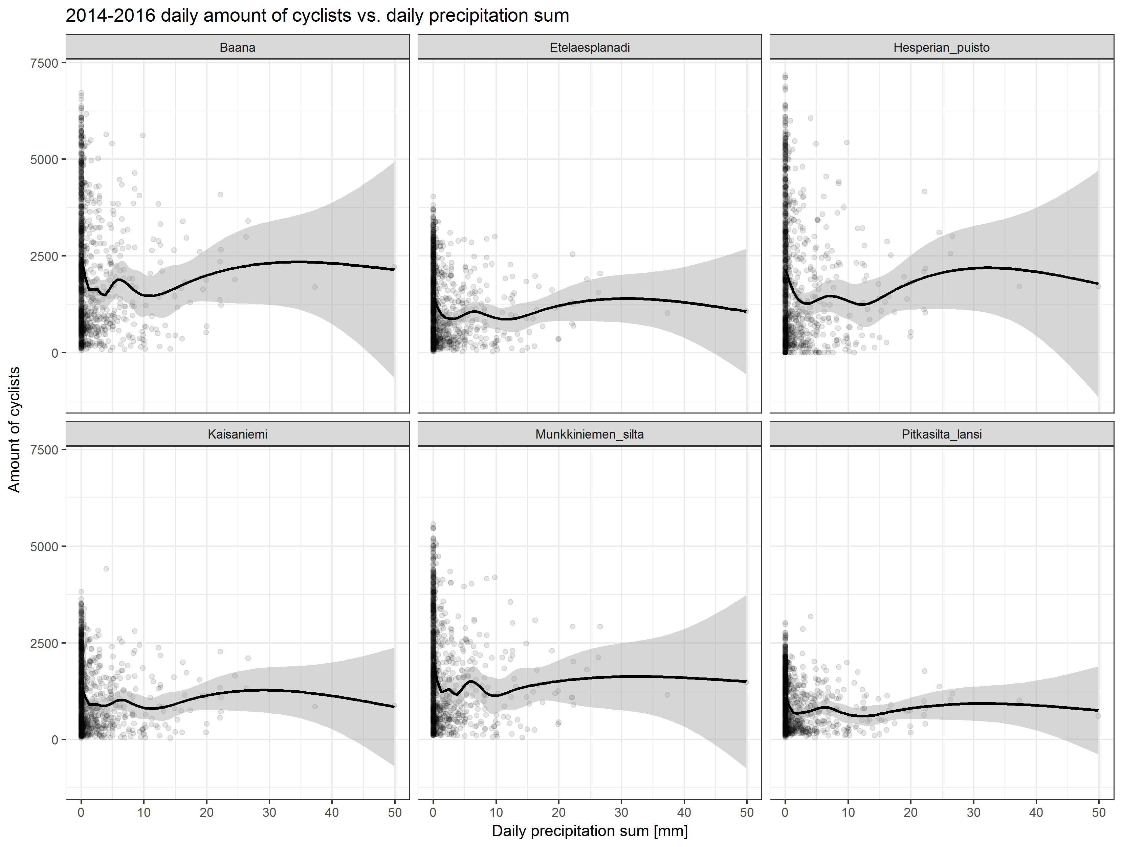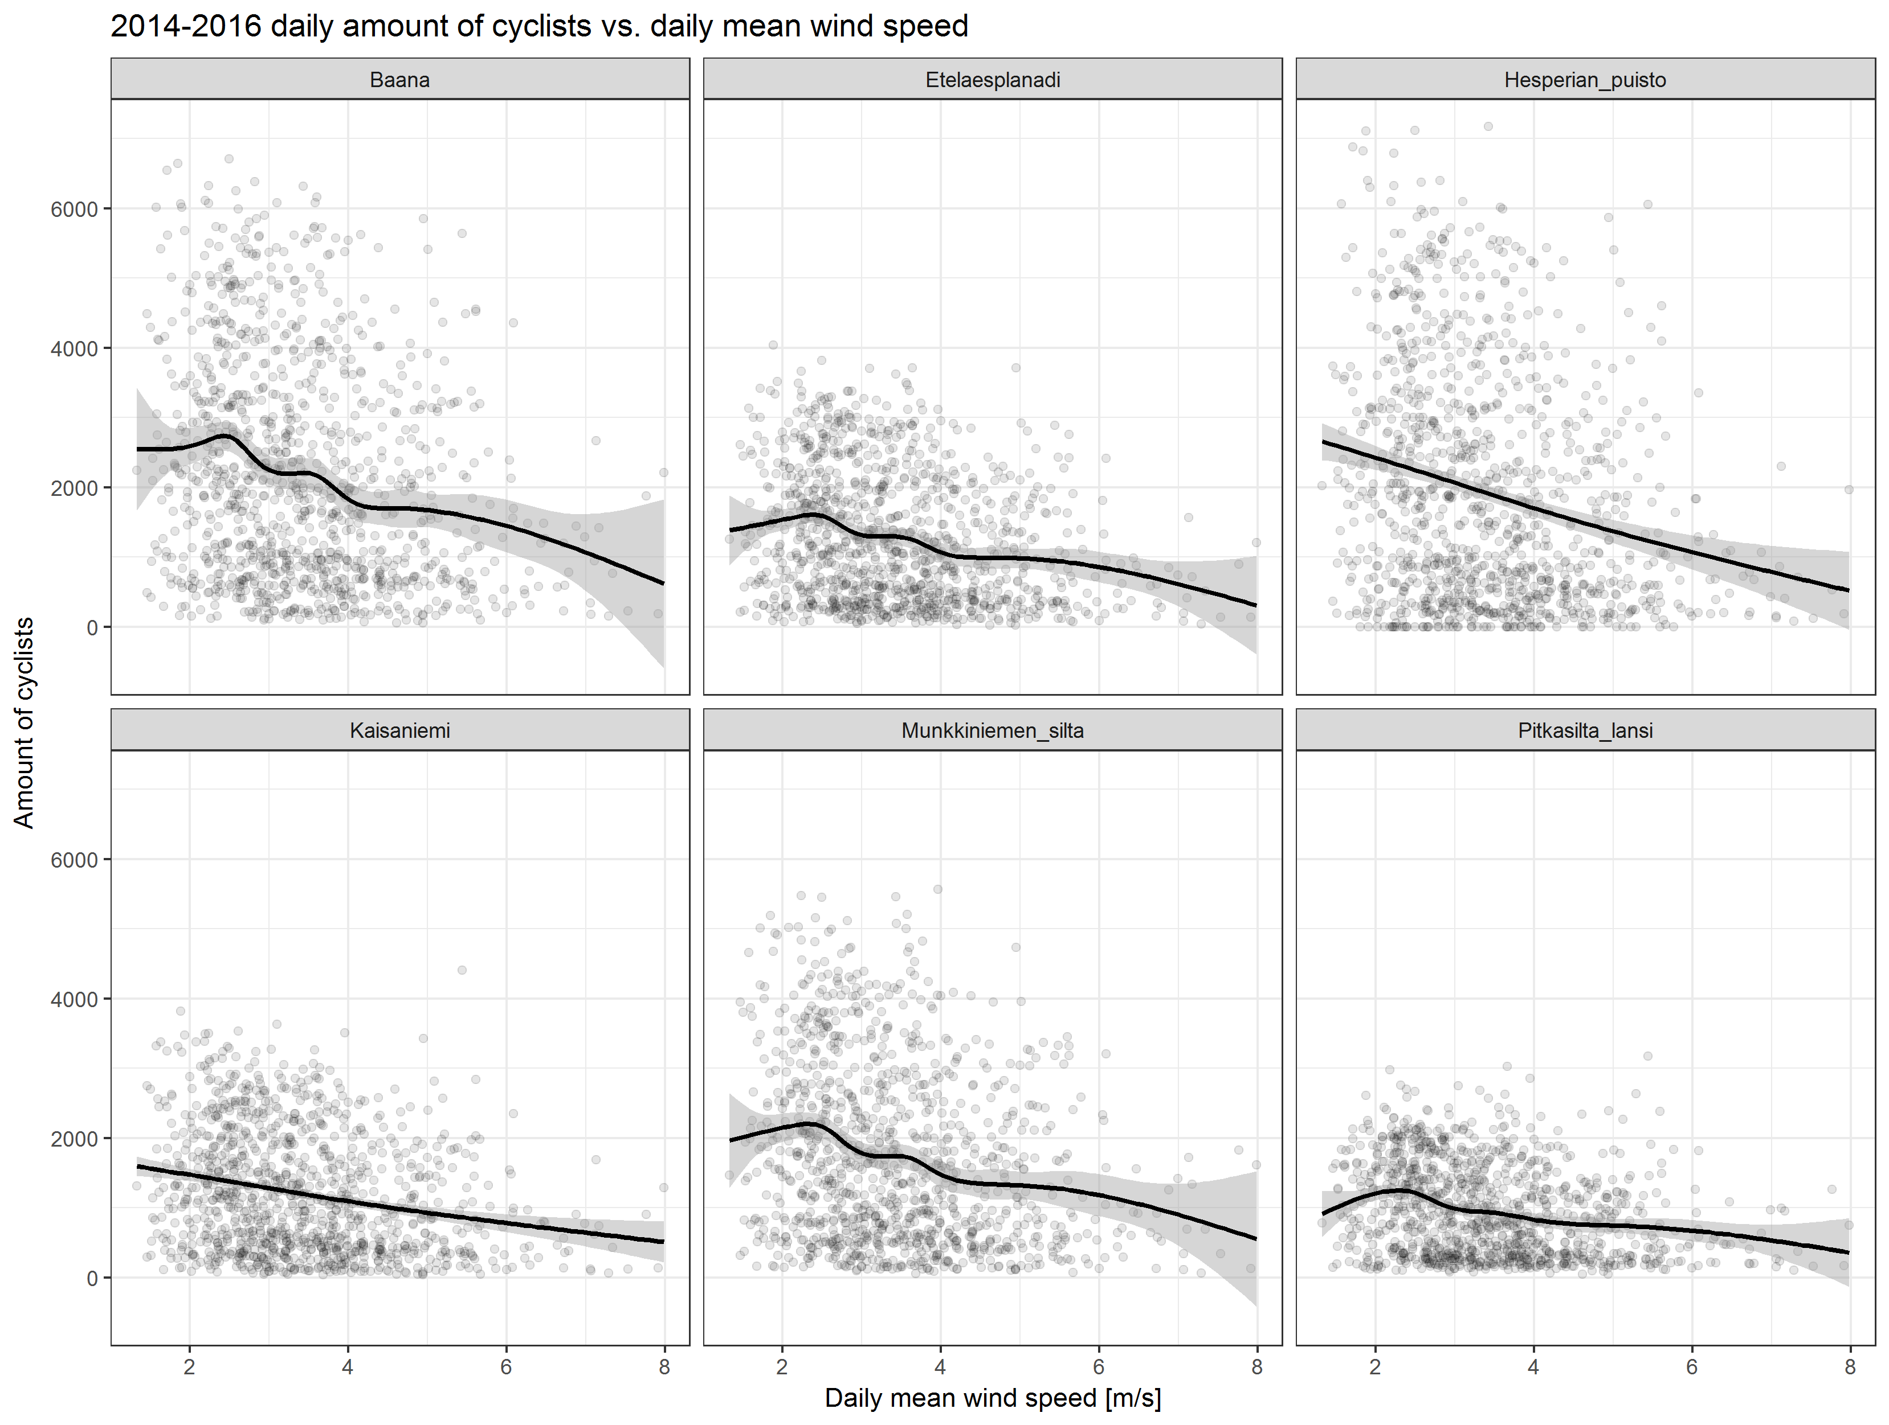

* Daily precipitation and windiness seems also to have effect:
  + Most cyclists during non-rainy days
  + Amount of cyclists decline during windy days