

**Software Modeling and Design**

**Travel Services**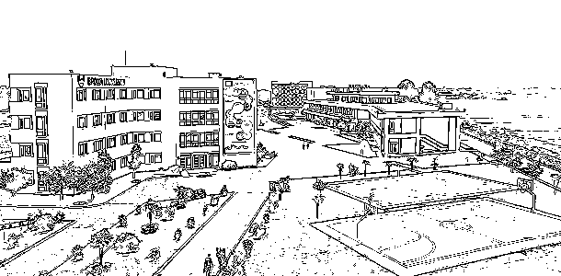

**Team members:**

**Alesia Bitri**

**Antea Toska**

**Iglis Kociu**

**Kevin Llaca**

**Tea Malasi**

**Xhesi Baze**

***Preface***

Welcome to our travel service software documentation project! With the help of this document,our objective is to provide an in-depth overview of the software's features, functionalities, and technical requirements for all the individuals who might be interested in learning more about it.

This document is meant for system administrators,system agents, software engineers, and software testers who are in charge of developing and maintaining the functionality of the product. It offers thorough information about the architecture, design patterns and data structures of the product.Understanding the software's core codebase with the aid of this documentation will make it simpler for the parties involved to add new features, correct errors, and enhance performance.

This documentation is organized with a table of contents, glossary, and index to make it simpler to find the information needed. In order to clarify important ideas, examples, graphs, and code samples are also included.

We hope that this documentation serves as a useful tool for anyone interested in learning more about our project and enables them to use our software to its full potential.

We appreciate your interest in our product and welcome any critiques to help it grow and succeed.

***1.Executive Summary***

***1.1 Project overview***

This application is an interactive platform made to help people and travel companies manage their travel plans.Below,you will find listed some of the application’s key features and major benefits.

***Key features:***

1. ***Car rental and hotel booking:*** Our application allows you to hire a driver, rent a car or book your hotels all in one place,making the process of booking much easier and convenient.
2. ***Travel tips and advice:*** Our application provides useful travel tips and advice to help you make the most of your trip.
3. ***24/7 support:*** Our application provides 24/7 support to ensure that you have assistance whenever you need it.
4. ***Reviews and ratings:*** Our application allows you to read reviews and ratings from other users of the platform, helping you make informed decisions about your trip.
5. ***Customized alerts:*** Our application sends customized alerts about your traveling plans and booking arrangements.
6. ***“Thank you” benefits:*** Our application offers rewards to frequent travelers, allowing them to earn points and discounts on their bookings.

***Benefits:***

1. ***Time-saving:*** Our application saves you time by providing a space that contains everything you might need for all your travel needs.
2. ***Cost-effective:*** Our application offers exclusive deals along with various payment methods.
3. ***Convenience:*** Our application allows you to manage all your travel details in one place.
4. ***Safety and security:*** Our application ensures that each customer stays informed and ***protected during their trip.***
5. ***User-friendly:*** Our application is designed with user-friendliness in mind, ensuring that every user can easily navigate and use all its features.

In conclusion,our travel software offers the best solution for each customer who seeks to plan,reserve and relish their trip. With a variety of features and benefits, our application ensures a worry-free and effortless travel experience.

***1.2 Scope and Purpose***

The purpose of this software is to simplify the process of booking and managing travel arrangements. It is designed to provide an intuitive and user-friendly interface that allows users to navigate the system quickly and efficiently.

The scope of the application includes providing a user-friendly platform for managing travel arrangements and reporting features to help car rentals and hotels monitor bookings, track payments, and generate reports.

***In scope:***

***1.Resources***

* Team (6 people)
* Car rental owners,hotel owners and clients
* IT review and testers

***2.Deliverables***

* Travel services application delivered by June 2023

***3.Project roadmap and timeline***

* March 16,2023 : Creation of the team
* March 18-20,2023: Defining the requirements of the application
* March 21-30,2023: Documentation of the software
* April 1-20,2023 : First phase of creating the software
* April 21-30,2023 : Optimization of the first piece of the software
* May 1-15,2023: Finishing the creation of the software
* May 16-30,2023 : Final touches of the software and its documentation
* June 2023: Presentation of the software

***Out of scope:***

* New features included in the software

***2.Product/service description***

***2.1 Product context***

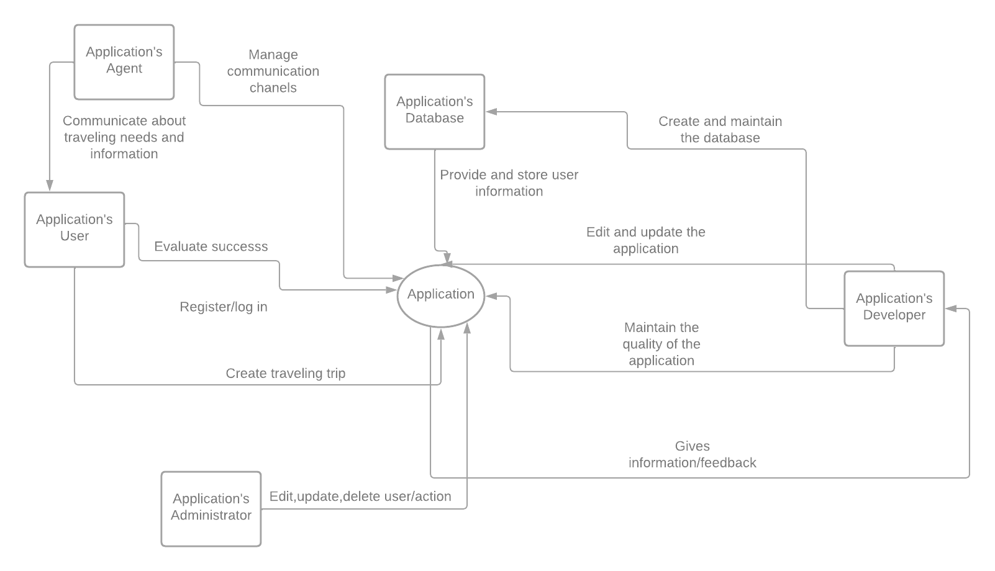

***2.2 User characteristics***

***Customer profile:*** *Every individual*

*Our software can be used by every person who is in need to make traveling arrangements. There is no age,gender,racial limit to the use of this software. It is created for everyone. Every person has the ability to express their thoughts and give reviews,in order for the software to get better and more useful for them.*

***2.3 Assumptions***

* *Resources*

1. *Meetings will be held frequently,with each member being present*
2. *Each member,despite their role,will be able to participate in the software’s creation and documentation*
3. *All facilities will be available when needed*
4. *End users will have access to the software , as well as, the possibility to test it in their desired date*

* *Delivery*

1. *The software will be delivered and presented on time*
2. *The software will be delivered with all the requested features*

* *Budget-estimated cost of the project*

1. *Project costs will stay the same as the initially budgeted cost (moderate expenses).*

* *Scope*

1. *The project scope will not change*

* *Schedule*

1. *Materials will arrive as planned within the project schedule.*

* *Methodology*

1. *Project will follow the parallel process flow type.*
2. *Project will follow the unified process model.*

***2.4 Constraints***

●***Technology limitations*** : The IDE used,access of the needed amount of devices such as computers,mobile phones,iPads etc.

● ***Scheduling limitations***: Planned meetings and their scheduled times need to be favorable for all the included members.

●***Adaptability limitations***: Members of the team have to be able to compromise and make changes to their personal schedules when needed.

●***Construction and design limitations***: A good understanding of the programming language used and well-defined knowledge of its libraries,functions and features it provides.

●***Delivery limitations***: The application needs to be delivered in the appointed time.

● ***Testing limitations***: The scheme/method used for testing the application needs to be efficient.

***2.5 Dependencies***

*● This new product presents the need to download distinct features on the IDE such as specific libraries and extensions to be executed.*

*●This new product presents the need to have access to all kinds of technological devices.*

*● This new product presents the need to have access to all needed resources mentioned above.*

.