Server Usage ;

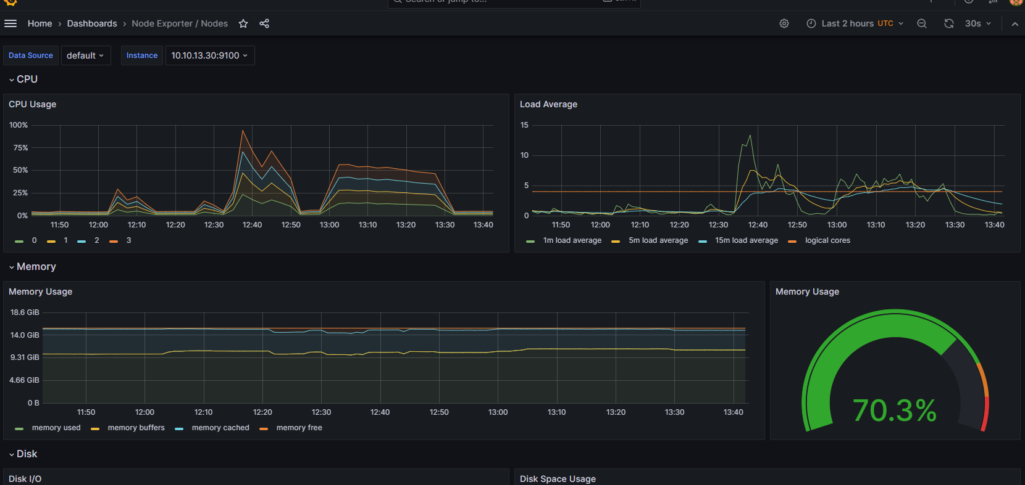

Registration service usage ;

Gateway service ;

