**Instructions for installing exam marking software**

Step1: Download the exam marking software to your computer

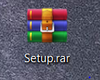

Step2: Unzip and open the folder containing the installation file

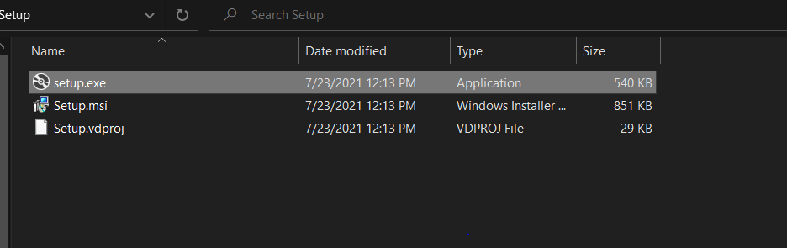

Step3: Run the setup.exe file

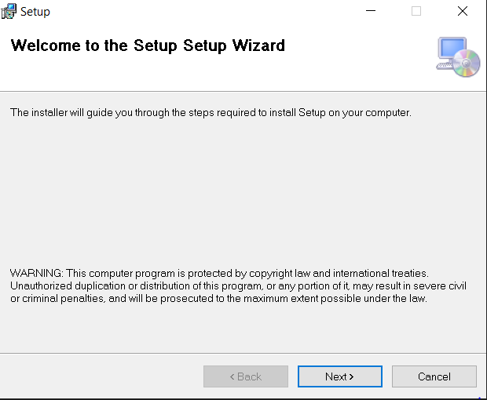

You will then click **Next**

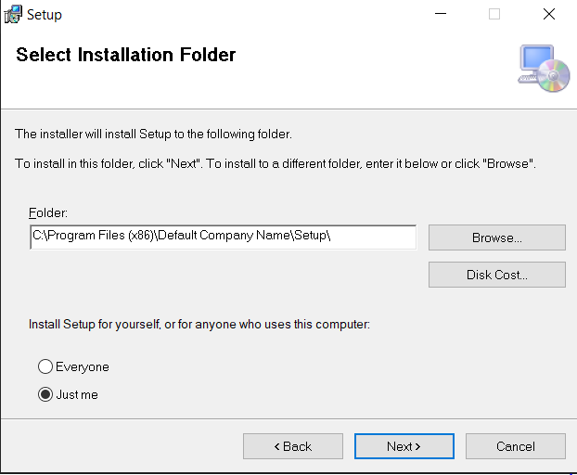

if you want to change the installation place

Here you can choose where to install the software. The initial default will be drive C, you can choose **Browse** to choose another place if you want

Step4: After that I will click Next and it will install itself and will notify the installation window successfully. Select close to close the settings window

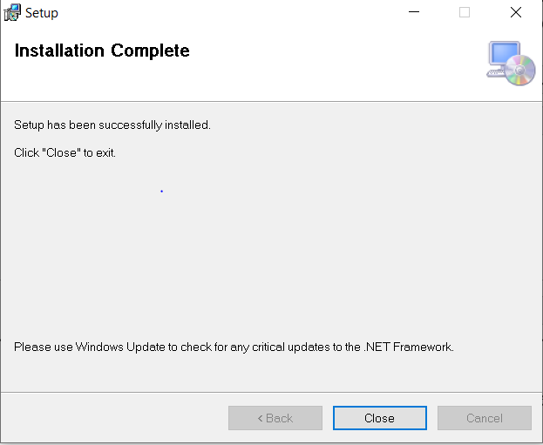

Step5: Then it will go to the desktop and open the marking software and use it

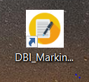

**Software require to use program**

**Microsoft .Net Framework 3.5 or higher,**

**SQL Server or higher**

**Instructions on how to use the marking software**

Step1: Open the exam marking software



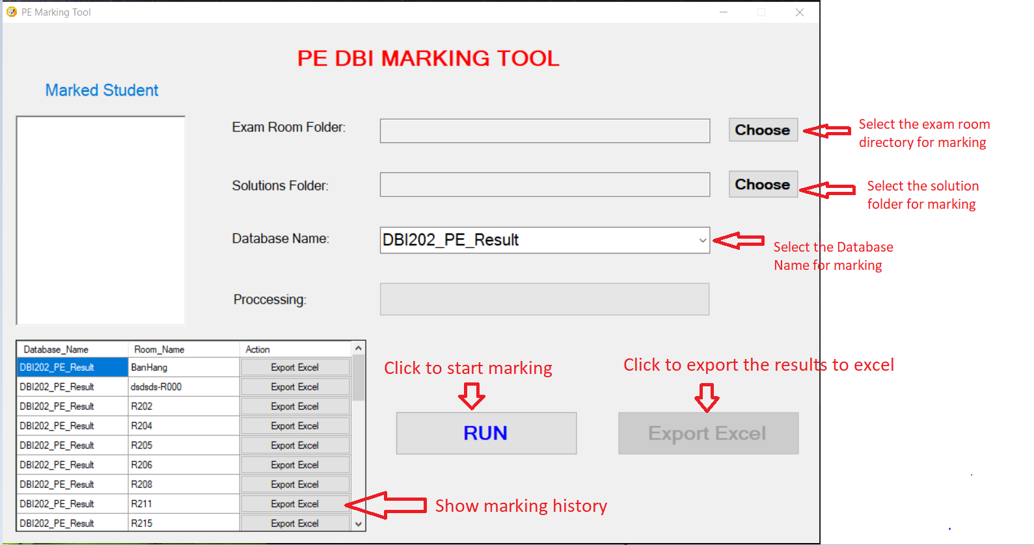

Step2: Choose Exam Room Folder, Solutions Folder and database name solution

Ex:

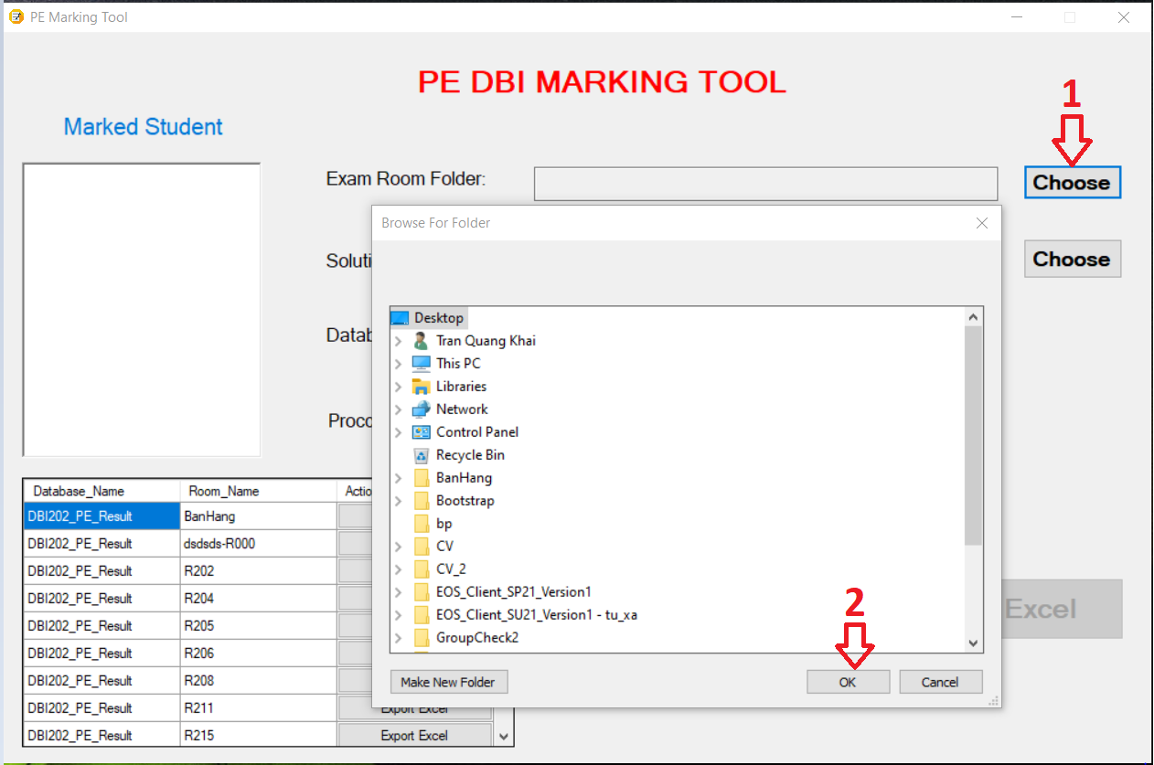

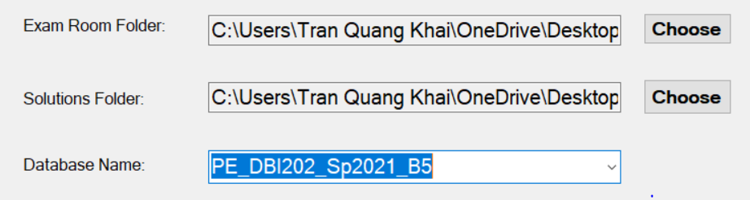

Step3: Click the Run button to marking the test

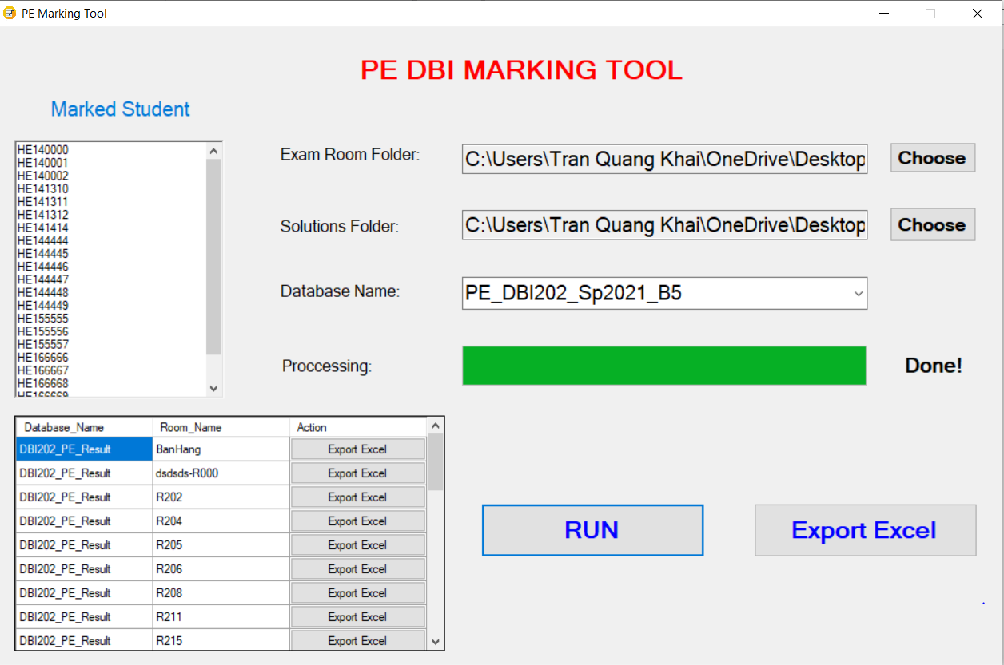

Step4: Click the Export Excel button to export the results to excel

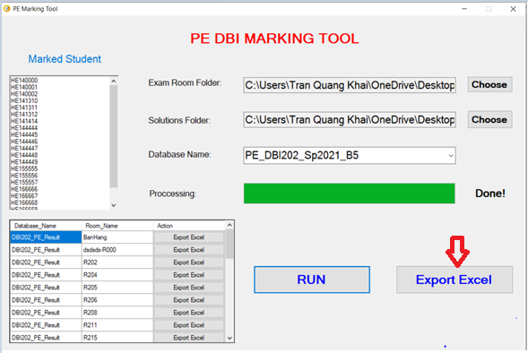

After that, you can custom excel file name, it’s location and click Save to save file.

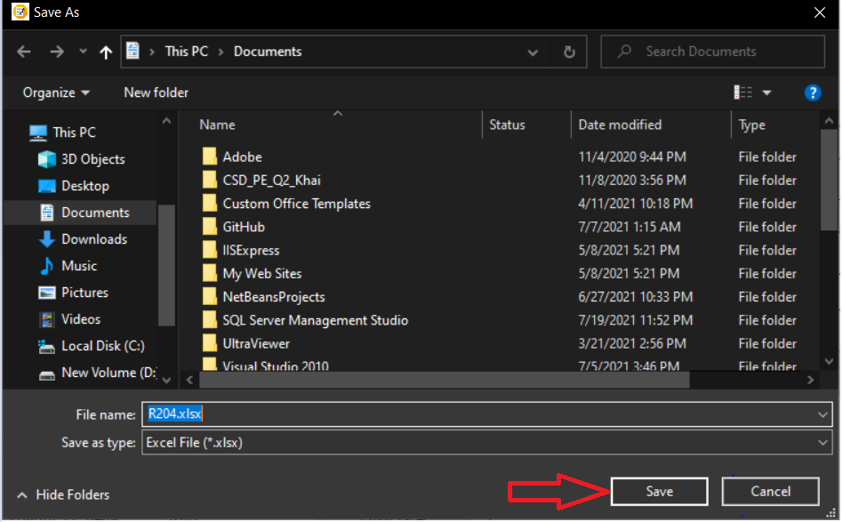

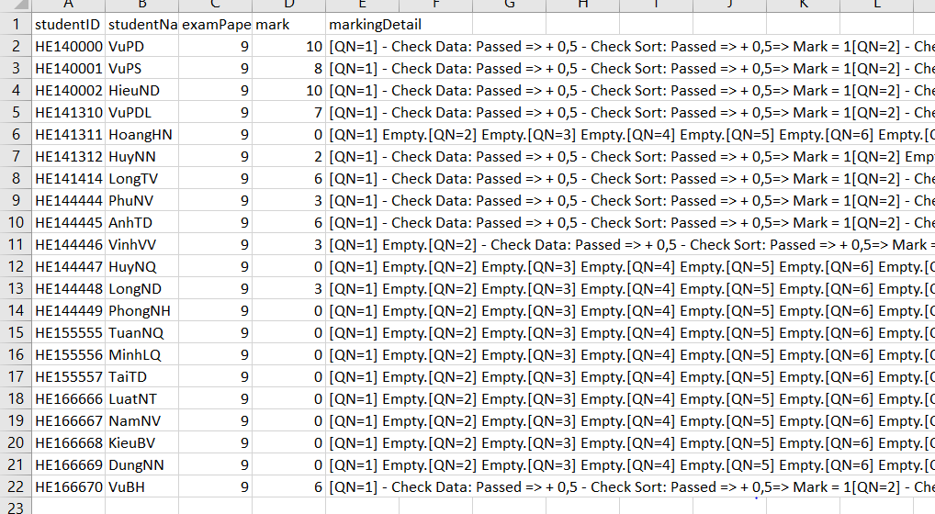

You can choose Export Excel in table to export pre-specified results

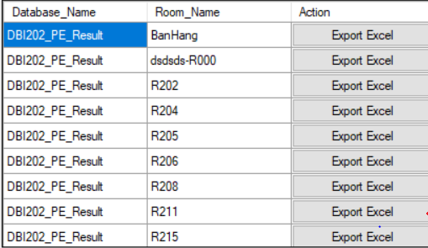

Step5: Click X to close the software

