In LINK protocol, the users are punished when they are found to be malicious (even if they are acting just as malicious verifiers). The figure 1 shows the NS2 simulation results while comparing the cases, when verifiers are punished in LINK protocol with the case when they are not punished. We observe small increase in False positive rate (the percentage of truthful claims denied by LCA) while punishing the verifiers, because few good verifiers are also punished at times. This can happen, in case of close family or a few colleagues at work who verify the legitimate user very often. So, the good users claims are also rejected due to punishing good verifiers. But, this is the cost LINK have to pay to detect colluding verifiers eventually.
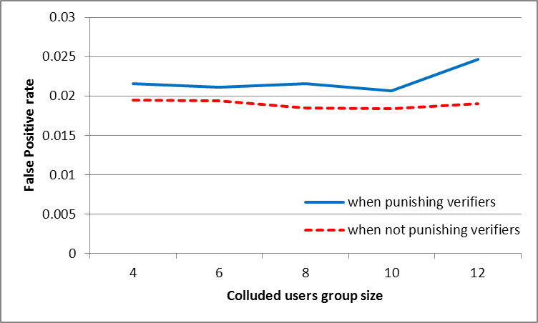
Figure1: False Positive rate
The figure 2 shows the False Negative Rate while comparing simulations with and without punishing the verifiers in case of colluding malicious users.
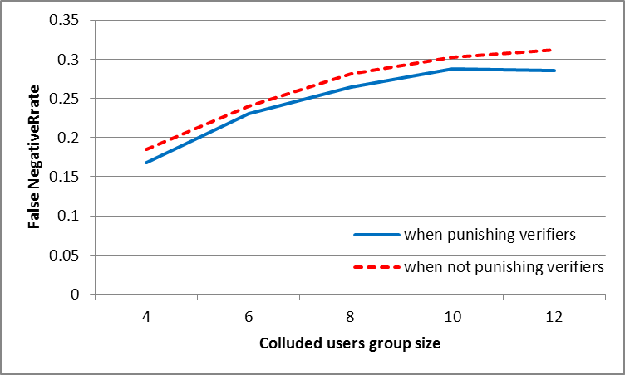
Figure2: False Negative rate

