This figure highlights the accuracy of the radiation model. It plots the nonzero pair-wise movement between counties in the contiguous United States. The data is drawn from the 2000 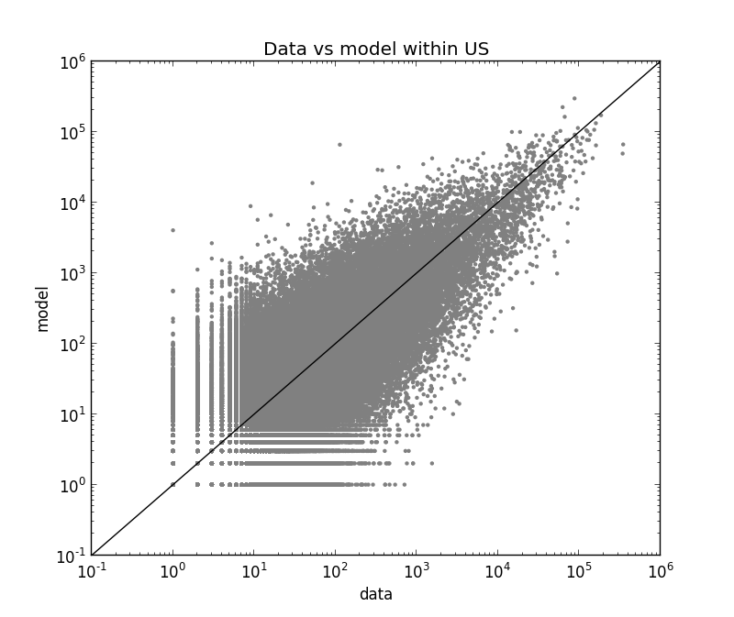US Census County-to-County worker flow data while the model is the output of the radiation model using population data from the 2000 US Census.

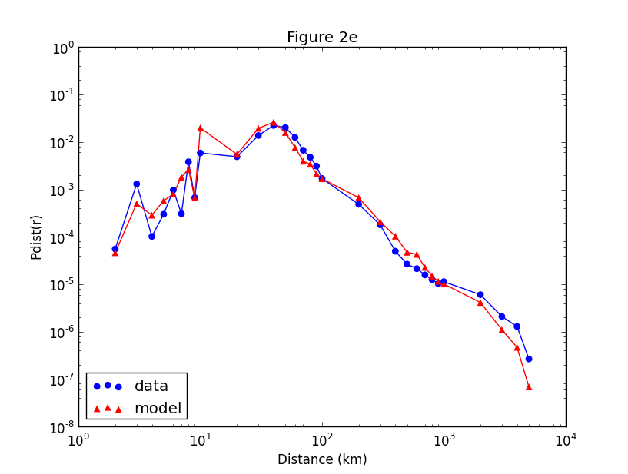

To further confirm the accuracy of the radiation model, we plotted the probability of a trip between two counties that are at distance r from each other using both the data and the model. Based on this figure, it is clear that the model closely aligns with the data.

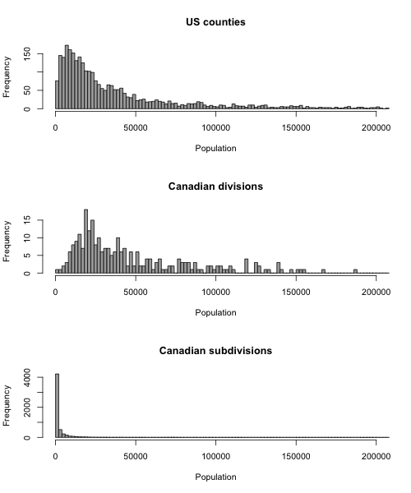

The Canadian Census collects data at the levels subdivision and larger division. To determine which organizational level to use, we examined which level's population distribution most closely resembled that of US counties'. The mean populations are 89353, 104191, and 5359 and the standard deviations are 292350, 251202, and 45910 for US counties, Canadian divisions, and Canadian subdivisions, respectively. Based on this data and the figure, we determined that Canadian divisions most closely resemble US counties.

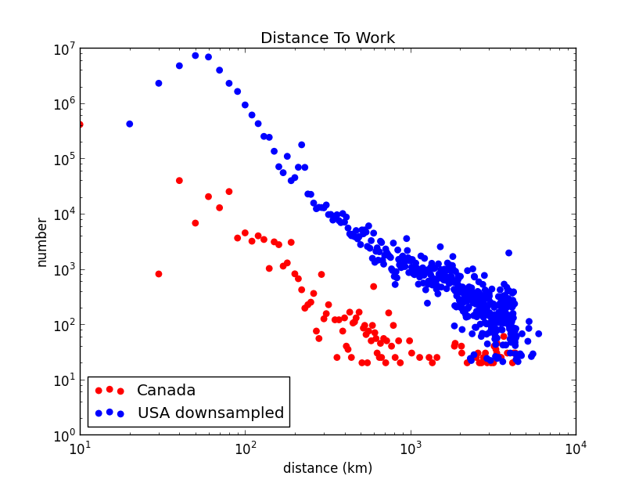

\*\*\* I'm not sure what we learned from this figure. Maybe I need to scale the Canadian data differently?

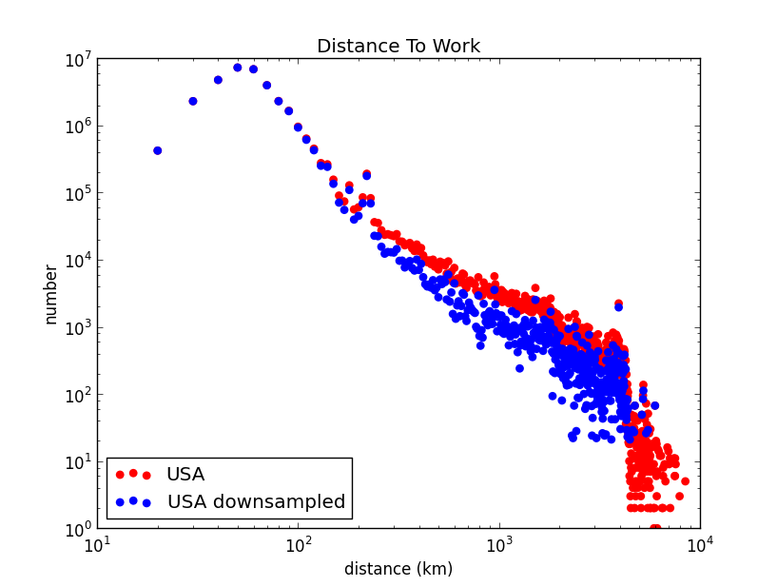

Because the Canadian movement data is a 20 over 20 sample, we created a 20 over 20 sample of the US movement data. The downsample had the most profound effect on the tail of this graph, indicating that further movements, because they occur less frequently, are more undersampled.

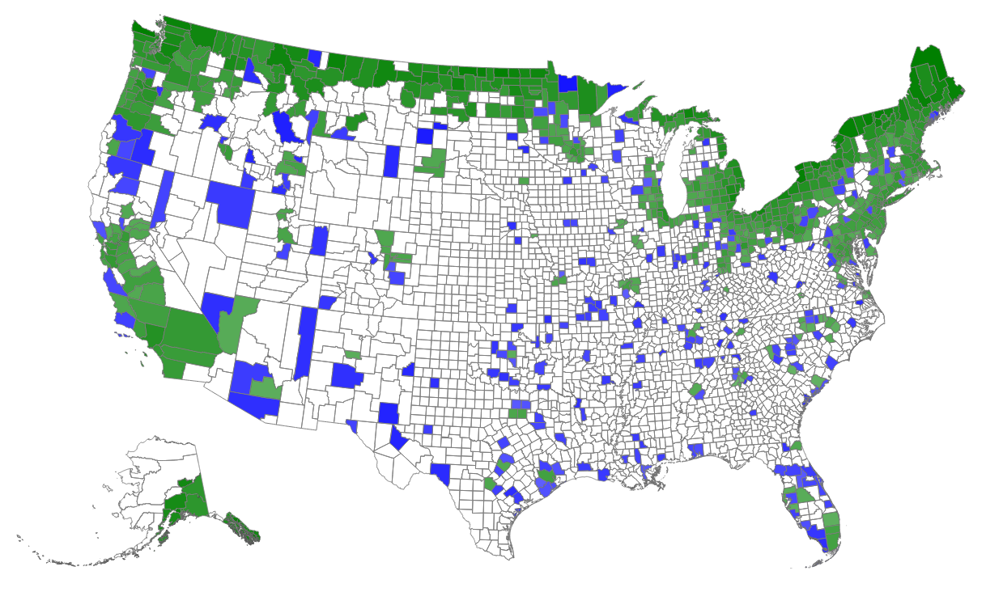

This figure visualizes the error in the radiation model when it is used to estimate movement across an international border. In this case, we looked at the degree to which the radiation model over or under-predicted the movement from each US county to Canada. Movement from green counties was over-predicted by the model, while movement from blue counties was under-predicted. This figure makes clear that most over-prediction occurs in cities closer to the Canadian border.

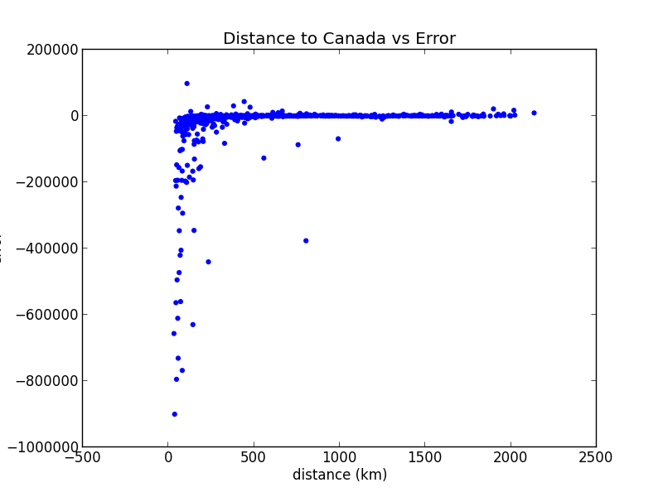

This figure plots the error of a county's radiation model movement prediction against that county's distance from Canada. Negative error values indicate that model has over-predicted the amount of movement while positive values indicate under-prediction. This figure, again, demonstrates that the radiation model over-predicts movement from counties closer to the border. It also demonstrates a lack of under-prediction in the model.