BLOOM ENERGY CORPORATION
  - NYSE: BE
Analysis Report
Sector: Industrials | Industry: Electrical Equipment & Parts
Date of Report 5/10/2026
INVESTMENT RECOMMENDATION:
SELL / AVOID
Intrinsic Value $9.52 | Target $8.40 | Current Price $260
Downside -96%

Investment Thesis
My recommendation is to avoid Bloom Energy entirely. With Market price today sitting roughly around $260 and Intrinsic Value is sitting at $9.53 using a base case DCF scenario spanning the next five years into 2030. While the environment regarding Artificial intelligence infrastructure is rapidly expanding, there is good reason to believe Bloom Energy is already massively over valued with little evidence supporting conviction on future growth. Purchasing shares at this price level would be extremely risky with extreme downside potential.

- Bloom Energy is already massively overvalued. After running a DCF model ranging from 2026-2030 with a WACC of 13% and Terminal value of 2.5% an intrinsic value of $9.53 was pulled. Bloom Energy’s WACC is naturally high, coming in around 25% due to its high beta, which is common in emerging AI Companies as of recent. Bringing it down to 13% was a conservative but still realistic number regarding the specific industry. Factoring in some key ratios such as ROA, ROE, and ROIC, all of which are negative, it is obvious Bloom Energy’s current price is heavily based on speculation.

- Cash Flow and Financial Health can be a bit of a nightmare. While arguable FCF numbers alongside sketchy ratios is common in emerging businesses, it usually doesn’t accompany a $260 price tag. Bloom Energy has pumped out negative cash flows from 2021-2023. Total debt has rapidly increased alongside its Debt/Equity ratio which is currently sitting at 3.79 as of 2025. The icing on top is a consistent return in the negative millions.

- Relying on changing the system entirely to be impactful. Currently Bloom Energy is relying on customers who are willing to look for alternate sources of power for their data centers. It still isn’t the industry norm; most data centers are on the waitlist or have already tapped into a main power grid. With data centers being projected to consume as high as 9% of all U.S. electricity by 2030. While possibly not being the most efficient, tapping directly into the grid tends to be the most cost effective.

- Heavily relies on construction of current and new data centers. About half of data centers planned to open in the U.S. by 2026 have been delayed or fully cancelled. With most data centers planned for 2028-2032 not even breaking ground yet. There’s been a massive supply and demand issue for parts to run these massive data centers, with tariffs and other political events further restraining the supply chain. Longer lead times and geo-political events causing economic tensions has caused most companies to delay these data centers or outright cancel them. Furthering pushing down demand for Bloom Energy’s services and hardware.

Key Risks: The biggest worry is increase in demand, or lack thereof. There’s not a doubt on whether Bloom Energy provides a solid product, if data centers continued to be delayed or cancelled however there will be a large price disparity between actual value and what expectations currently are. Besides market demand risk, there’s geopolitical issues to stress as the United States gets involved with conflicts and economic battles with countries.

Company Overview
Bloom Energy Corporation (NYSE: BE) is a clean power technology company that designs, manufactures, and sells solid oxide fuel cell systems. The company’s systems generate on-site electricity without relying on the Traditional electric grid. Founded by KR Sridhar in 2001, CEO Sridhar has described the company as being “At the forefront of a once-in-a generation opportunity to become the global standard for onsite power”.

The business plan is simple, large users of electricity need reliable systems. Bloom has become that reliability in a time when electrical grids have failed to keep up with the everchanging environment. Bloom has become more relevant as of recent due to AI data centers, industrial companies, and utilities look for faster and more reliable ways to secure power.

Bloom Energy sells their main product, The Bloom Energy Server. A modular fuel-cell system that converts a variety of fuel into electricity through an electrochemical process rather than combustion. Helping hedge against rises in a specific fuel source while also protecting the environment. The company’s revenue is mainly tied to the Energy Server while also having maintenance/service contracts in place as well. Recently they’ve had large strategic partnerships with companies such as Oracle and Brookfield Asset Management.

Sector & Industry Analysis
- AI Infrastructure is rapidly expanding. With the introduction and consistent upgrades in Artificial Intelligence the need for data centers is constantly growing. However, around the world current infrastructure systems aren’t setup to support such a large cast of centers. Bloom Energy has an opportunity to be one of the first in markets to provide alternate power solutions to Data Centers. They’re provided with first access to an Industry not yet explored. This can be both very rewarding and very dangerous.

- Industry Longevity and Competition. I believe Bloom Energy has potential to power more than Data centers. Acting as a secondary power source to important buildings such as hospitals, factories, or even military bases. The expansion power they have is unlimited, especially with an ever-increasing electricity crisis. Bloom Energy serves a genuinely beneficial product; however current valuations are heavily banking on specifically AI data centers. Competitors of Bloom Energy include Cummins Inc, Plug, and Fuel Cell. Plug is mainly focusing on hydrogen fuel cells and infrastructure. This will put them at a huge advantage if hydrogen economy scales, for now there’s very little build out on the infrastructure required for it. Bloom Energy provides an immediate solution, with a variety of fuel sources. Fuel cell is on a similar wavelength of Bloom Energy but has a much smaller track record and relationship with clients. Fuel Cell follows along with the technology power theme but is financially smaller and not yet on the commercial scale. The Final and Major competitor to Bloom Energy is going to be Cummins. Cummins isn’t just a pure fuel-cell peer, it’s a pre-established company that sells a variety of products from engines, generators, to full power systems. Cummins is highly needed for data centers due to their backup power and distributed generation abilities. Cummins provides the biggest threat to Bloom Energy Longevity, a pre-established company with manufacturing and client relationships ready. Where Bloom Energy stands out is its ability to stand out without relying specifically on diesel or gasoline, providing for alternate solutions and a healthier emissions track record.

- Possible bubble waiting to implode. Heavy reliance on data centers could burst the expectations of Bloom Energy if too overly reliant. There’s been conversation as of recent discussing whether AI is a large bubble waiting to pop, like the .com bubble of the early 2000s. Bloom Energy has the business model to be able to avoid that in partial, it’s important to position themselves as more than just an AI Data center power option. Potentially attempt to market themselves to other highly valuable buildings that rely on consistent power for success.

Financial Analysis
- Historical Performance

Appendices

- Historical Financial Statements Cleaned Up 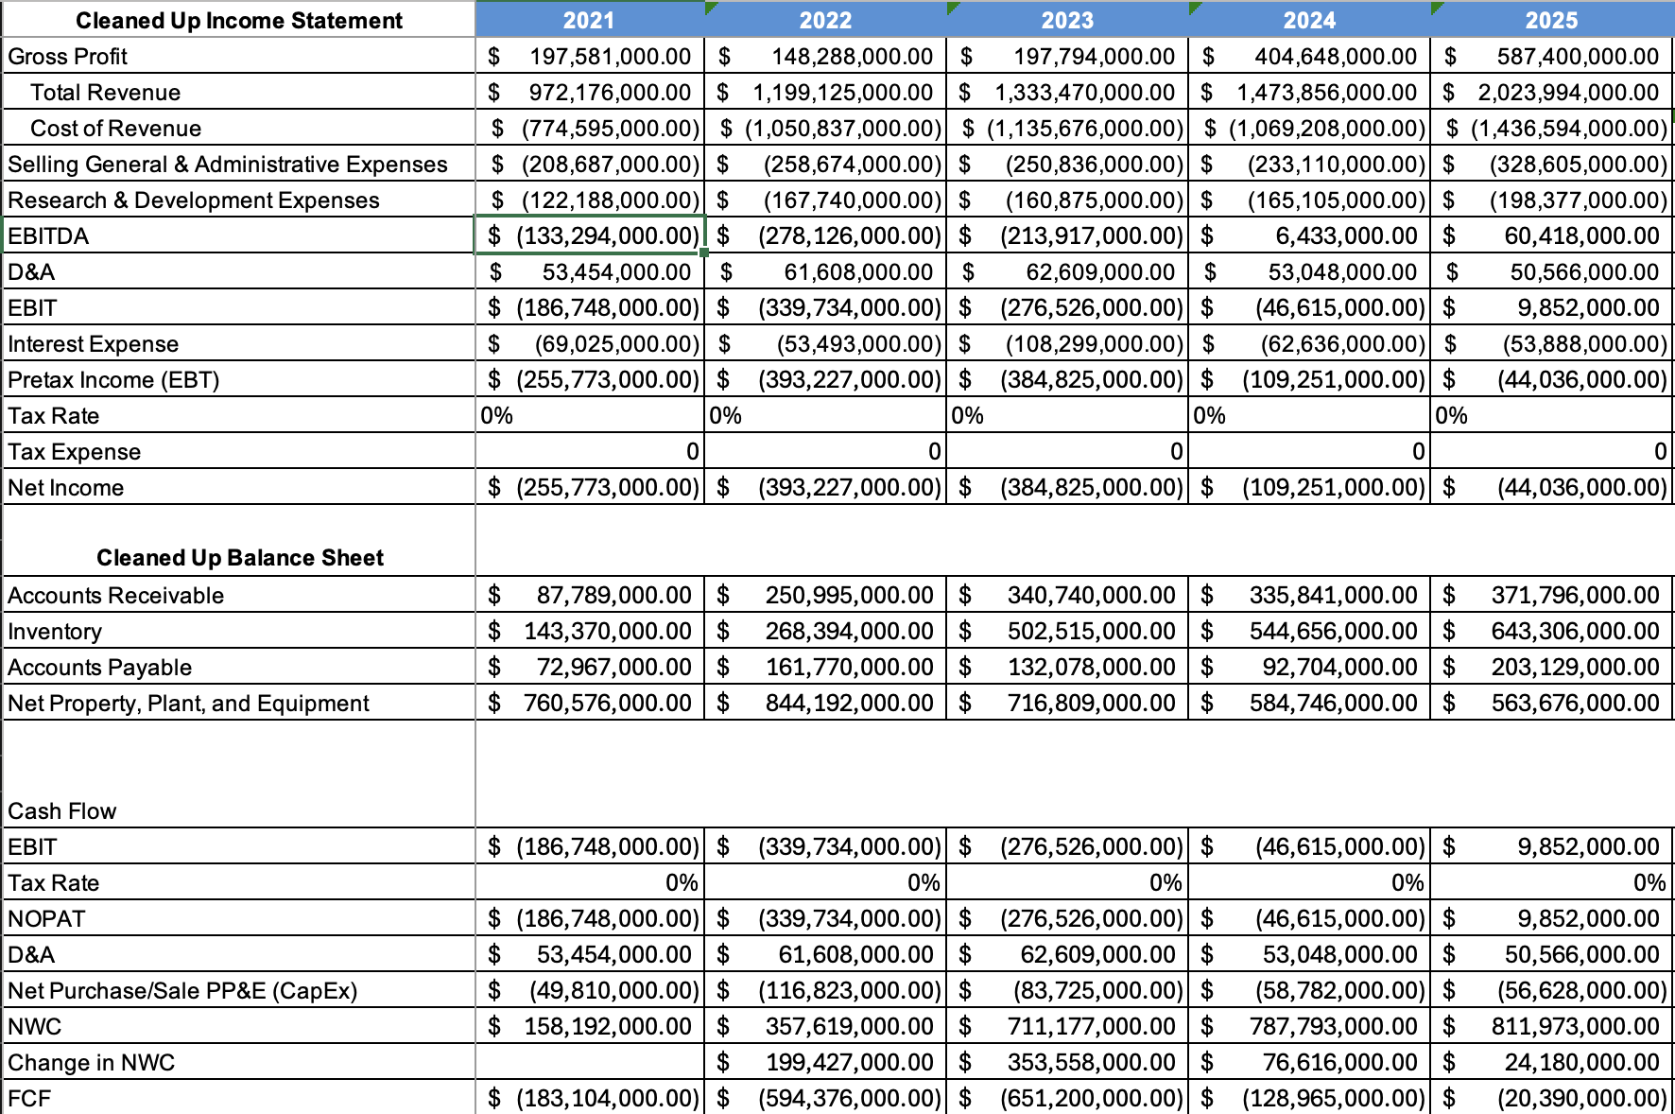

- Forecasted Financial Statements 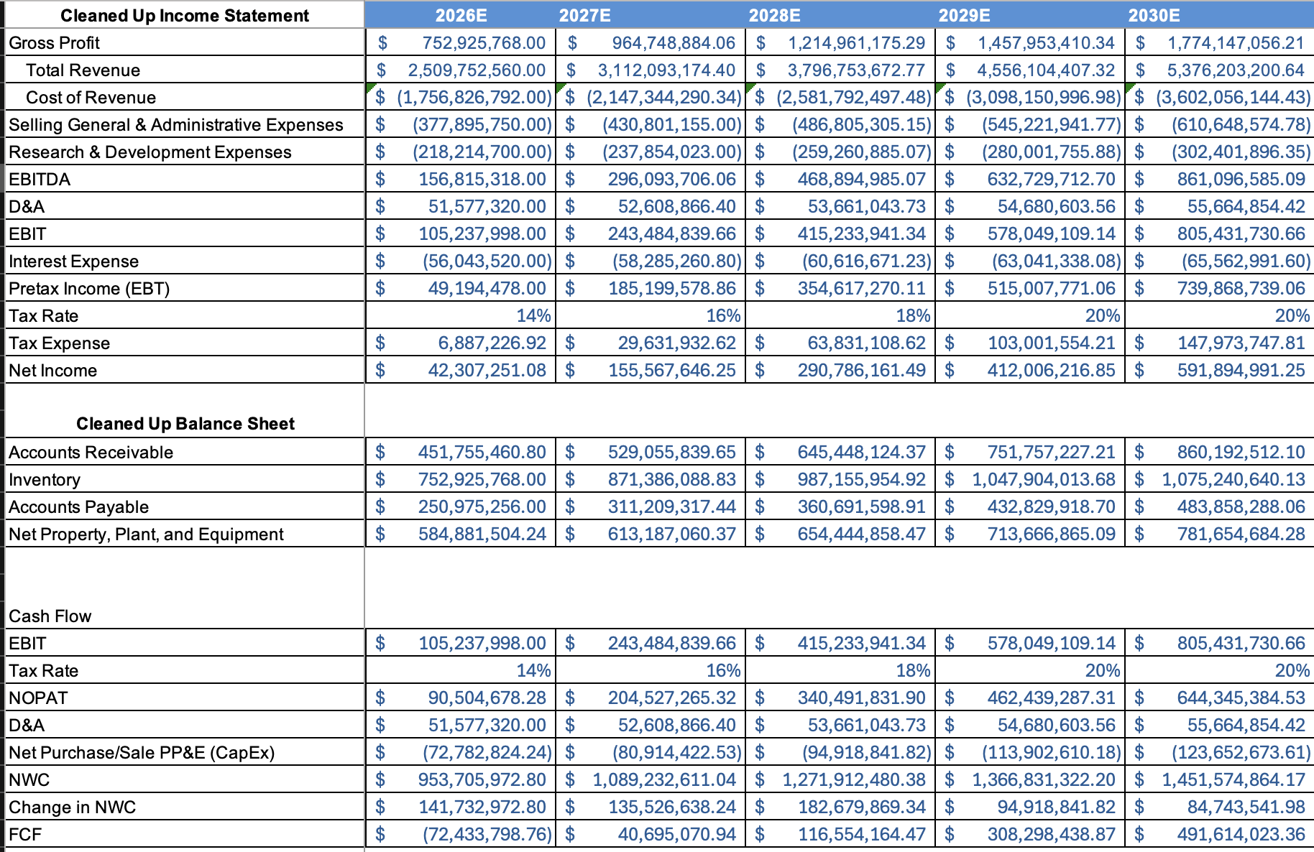

- Assumptions/Previous % Change 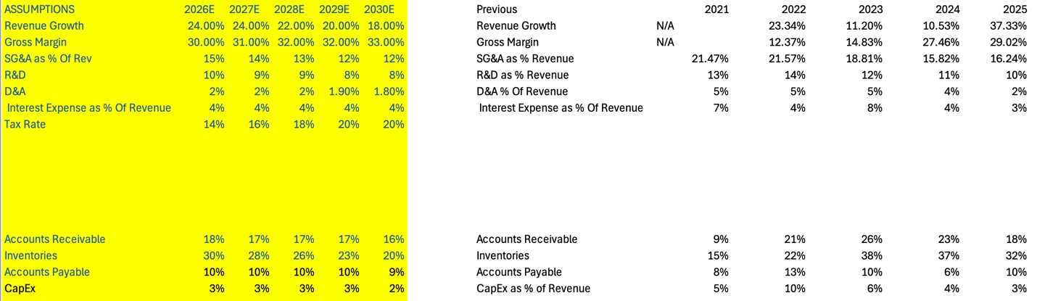

- Discounted Cash Flow Analysis 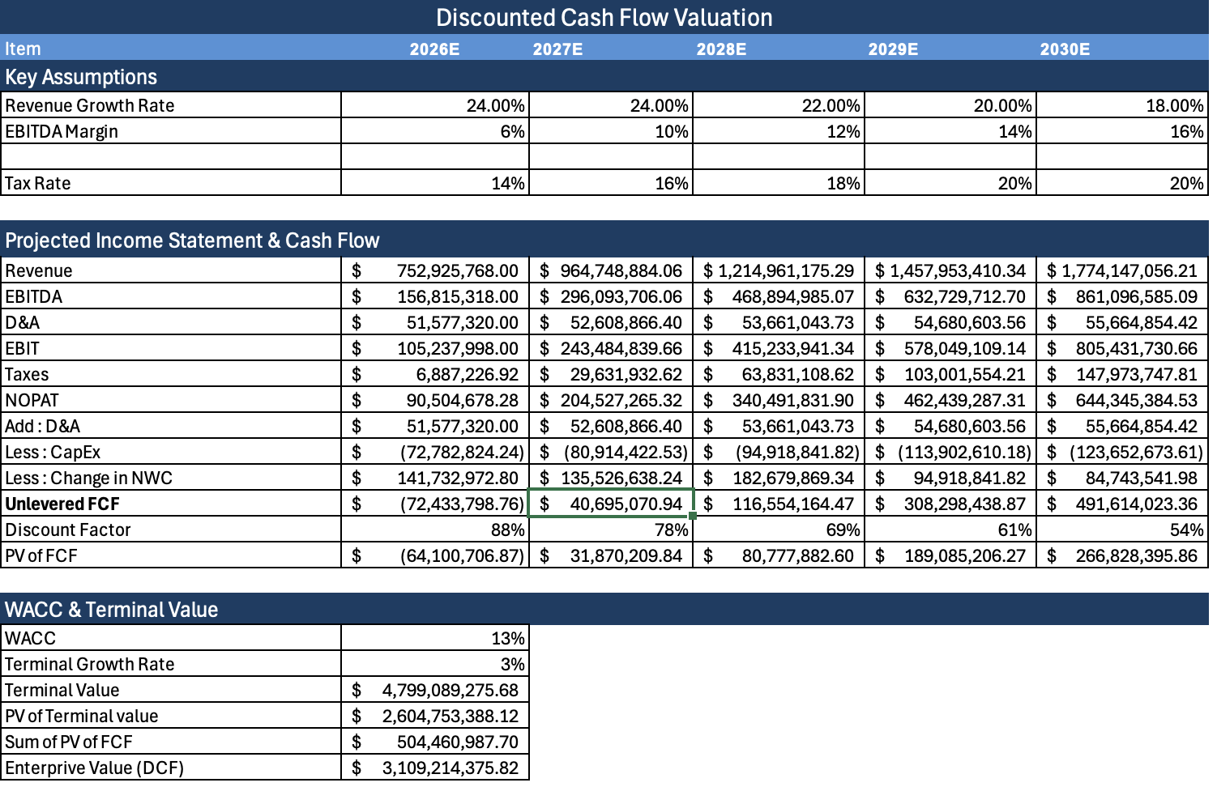

- Sensitivity Table 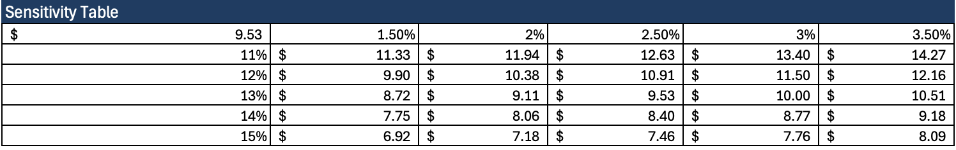

- Price History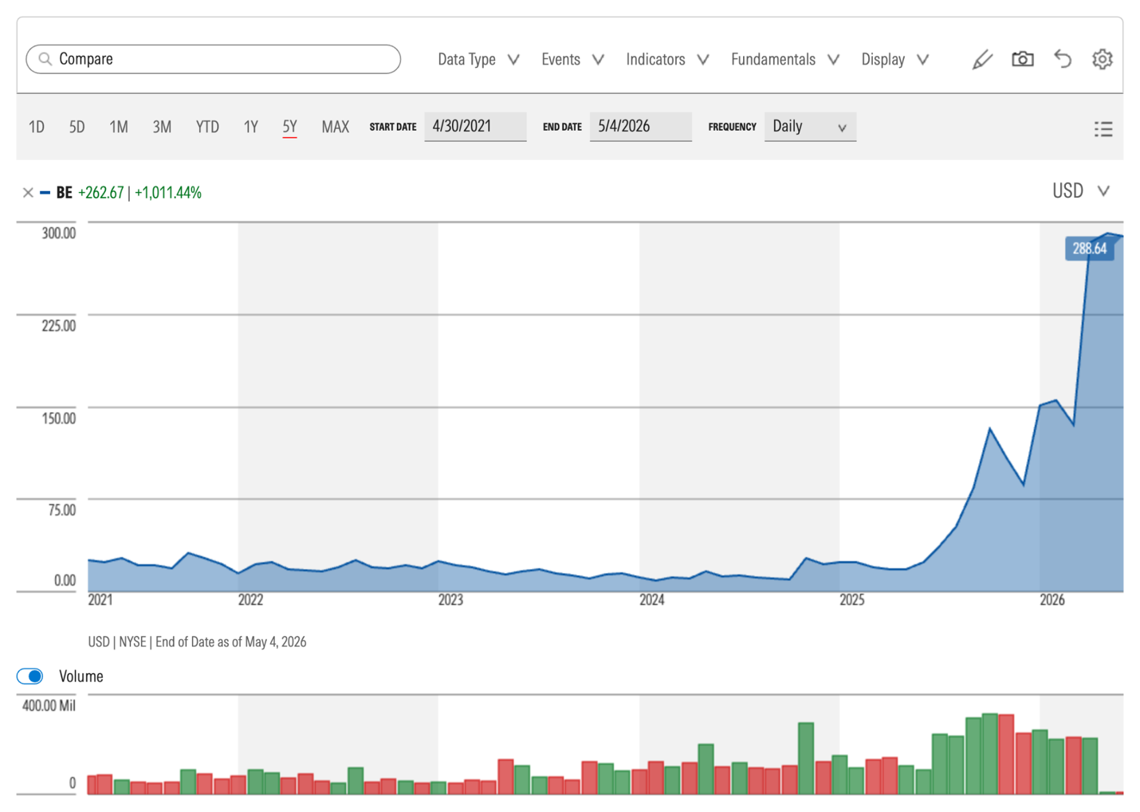

- Stock Trend Analysis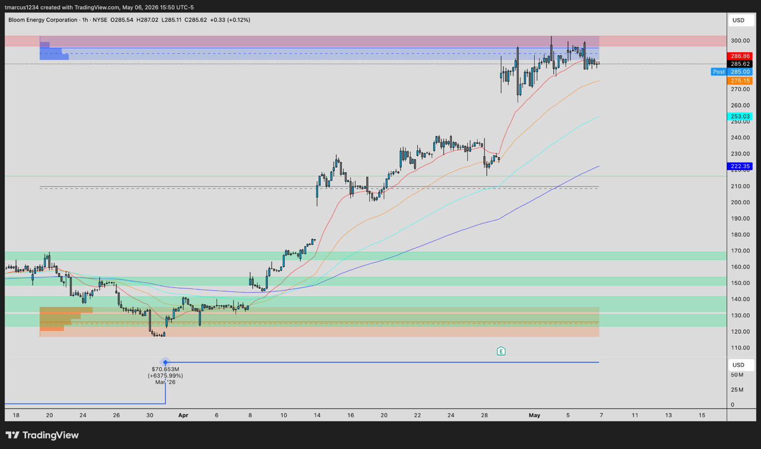

References:
https://energy.mit.edu/strategic-priorities/data-center-power-demand/
https://futurism.com/science-energy/data-centers-construction-supply
https://www.morningstar.com/stocks/xnys/be/quote

