Command history

79 git --version

80 cat /etc/os-release

81 sudo apt-get update

82 sudo apt-get install git

83 git --version

84 history

85 clear

86 mkdir projectX

87 ls

88 cd projectX/

89 pwd

90 ls

91 ls -a

92 echo "hello all" > sample.txt

93 ls

94 cat sample.txt

95 ls

96 git init

97 ls

98 ls -a

99 ls .git/

100 git config --global user.name "pavansw"

101 git config --global user.email "pavanwankhade4u@gmail.com"

102 cd .git/

103 ls

104 cat config

105 cat description

106 ls branches/

107 cd ..

108 pwd

109 clear

110 ls

111 echo "#this is first line of my code" > hello.java

112 cat hello.java

113 ls

114 git status

115 git add hello.java

116 git status

117 echo "#this is second line of my code" >> hello.java

118 cat hello.java

119 git status

120 echo "new line adding to txt" >> sample.txt

121 git status

122 cat hello.java

123 git checkout hello.java

124 cat hello.java

125 git status

126 git add sample.txt

127 git status

128 git rm --cached sample.txt

129 ls

130 git status

131 git commit -m "First copy of hello.java"

132 git status

133 ls

134 git log

135 clear

136 ls

137 git status

138 echo "#this is second line of my code" >> hello.java

139 git status

140 git diff hello.java

141 echo "#this is third line of my code" >> hello.java

142 git status

143 git diff hello.java

144 git add hello.java

145 git status

146 git commit -m "second copy of hello.java with 2 lines as comment"

147 git log

148 history

====================================================================

Create login on <https://github.com>

Ex mine : userid : pavansw [you have to mention your details instead of pavansw]

Create 1 new repo ex. Sample_hcl_learning

Copy the URL with https

On your practice VM clone it and follow these steps

git clone https://github.com/pavansw/sample_hcl_learning.git

153 ls

154 cd sample_hcl_learning

155 ls

156 ls -a

157 echo "# My first remote code I will write here soon" >> hello.java

158 ls

159 git status

160 git add hello.java

161 git status

162 git commit -m "My first commit on github for hello.java"

163 git log

164 git branch -M main

165 git push origin main

Pass the username and password of your account

======================================================

All the best :)

Second Day

For ssh Access

33 whoami

34 id

35 cd

36 ls -a

37 ssh-keygen

Generate a key here and copy the public key

38 cat /home/pavanwankhade4u/.ssh/id_rsa.pub

Get the public key and save it in github settings ⇒ ssh keys

39 clear

40 ls

41 git clone git@github.com:pavansw/sample_hcl_learning.git

42 ls

43 cd sample_hcl_learning/

44 ls

45 echo "Adding new line of code as sample code" >> newcode.java

46 git status

47 git add newcode.java

48 git commit -m "Update in newcode for ssh check"

49 git log

50 git push origin main

Merge conflicts

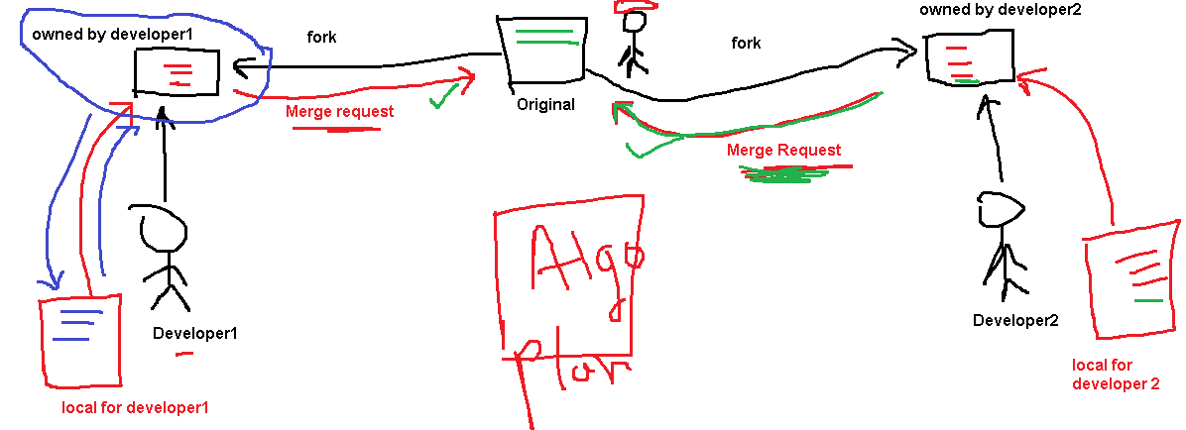

====================================================================

Git Branching and Merging

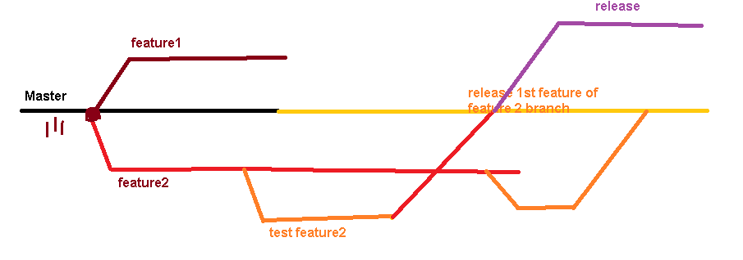

cd HCL_Demo/

116 git branch

117 ls

118 git branch feature1

119 git branch

120 touch abcd

121 ls

122 git checkout feature1

123 git add .

124 git commit -m "first feature added"

125 git log

126 git checkout master

127 git log

128 git merge feature1

129 git log