Westminster Chimes and Carillon Bells

Operating Manual
Version 8.1 Portable Version

Revised July 8, 2026
A practical daily-use guide for operating, scheduling, silencing, logging, and maintaining the portable bell system.

Table of Contents
Foreword 3
Usage Assumptions 3
What Is New in Version 8.1 4
Getting Started 5
Portable Drive Layout 5
Starting the Program 5
Main Screen Overview 6
Enable Schedule 7
Playlist Grid 7
Play Schedule Panel 8
Entering Times 9
Navigator Buttons and Editing 9
Setting Up a Song Schedule 10
Adding Songs 10
Group Maintenance 11
Random Music Directory Rotation 11
Silence Schedule 12
System Settings 12
Email Settings and Morning Reports 13
Show Remaining Schedule 14
Show Log 15
Themes 15
Manual Playback and System Volume 16
Clock Window 17
Good Operating Habits 18
Troubleshooting 18
Quick Reference 19
Final Daily Check 19

Foreword
Westminster Chimes and Carillon Bells is designed to run a church or organizational bell system from a portable drive. Once the songs, schedules, groups, silence windows, random music folders, and email settings are set up, the program can run continuously and play the correct audio at the correct time.
This guide is written for everyday operation. It explains what the screens are for, what the main controls do, and how to make normal changes without needing to know the internal source code or database design.
Portable operation: The program must be started from the portable drive root, such as E:\Carillon.exe or F:\Carillon.exe, or by using the included start_carillon.vbs or start_carillon.bat.

Starting it from the wrong working directory can prevent the database, logs, help, and music folders from being found.

Usage Assumptions
- The computer is running Windows 10 or later and has working audio output connected to the desired amplifier system.
- The portable drive contains Carillon.exe, the database folder, music folders, help files, logs folder, and email support files, as distributed in the packaged zip file.
- The person setting up the system understands the intended church or organization schedule.
- A current backup exists before major playlist, group, database, or release changes are made.
- Times are entered carefully. Version 8.1 supports seconds in schedules and silence windows.

What Is New in Version 8.1
Version 8.1 focuses on reliability, clearer editing, stronger schedule rebuilding, better theme consistency, and better reporting. These changes are practical operator improvements rather than a new workflow.
- Play-time fields and schedule displays support seconds, such as 4:05:00 PM or 22:15:30.
- The remaining schedule display uses a clean table with Time, Type, and Song/Purpose columns.
- A Silence schedule has been added to silence the bell system during times when silence is required. The entries in the schedule are shown with full seconds and suppress scheduled events during the silence window.
- Groups, Settings, Email Settings, Random Music, and Silence Schedule screens rebuild the active schedule when they close.
- Group maintenance copies group dates and the primary group play time to matching songs and clears stale extra play-time slots.
- Random Music exposes seven directory slots: one default folder and six date-window override folders. Users may schedule different types of random music for at six times during the year.
- Editable screens now use labeled navigator buttons so users know which button means Add, Delete, Save, Cancel, First, Prior, Next, and Last.
- Show Log opens a themed log viewer instead of just a plain viewer.
- Theme rules are improved so dark and light themes remain readable across the main and maintenance screens.
- Morning reports and the log viewer read the same log file used by playback logging.

Getting Started

The Portable Drive Layout
A working portable copy normally contains the following folders and files on the root of the flash drive or portable media. This data is distributed in a zip file, downloaded from the web site. This layout should NOT be changed since the application expects the files to be in a certain place.
Item | Purpose
Carillon.exe | The main program.
start_carillon.vbs | Preferred startup helper for normal launch.
start_carillon.bat | Batch startup helper.
databases\carillon.db | Saved playlist, settings, groups, random music slots, and silence schedule data.
Help | Compiled or web help files used by the Help menu.
logs\CarillonPlayLog.txt | Playback and transaction log, when logging is enabled.
Songs, Music, Random_songs, etc. | Audio folders used by normal scheduled playback and random music.
libeay32.dll and ssleay32.dll | Email support files used when email reports are enabled.

Starting the Program
- Insert the portable drive and note the drive letter assigned by Windows.
- Open the drive root in File Explorer.
- Start the program with start_carillon.vbs, start_carillon.bat, or Carillon.exe from that drive root.
- Confirm the main screen opens and the database loads without an unable-to-open-database message, or any other errors. There should be none.
- Confirm the Enable Schedule box is checked if automatic playback should run.
Important: If the program reports that it cannot open the database file, close it and restart it from the portable drive root. Opening the executable from another working directory can break relative paths and the application will not start.

Main Screen Overview
The main screen is the daily operating screen. It shows the grouped song list, the schedule editor for the selected song, manual playback controls, the system volume control, the schedule status, and the main menu.
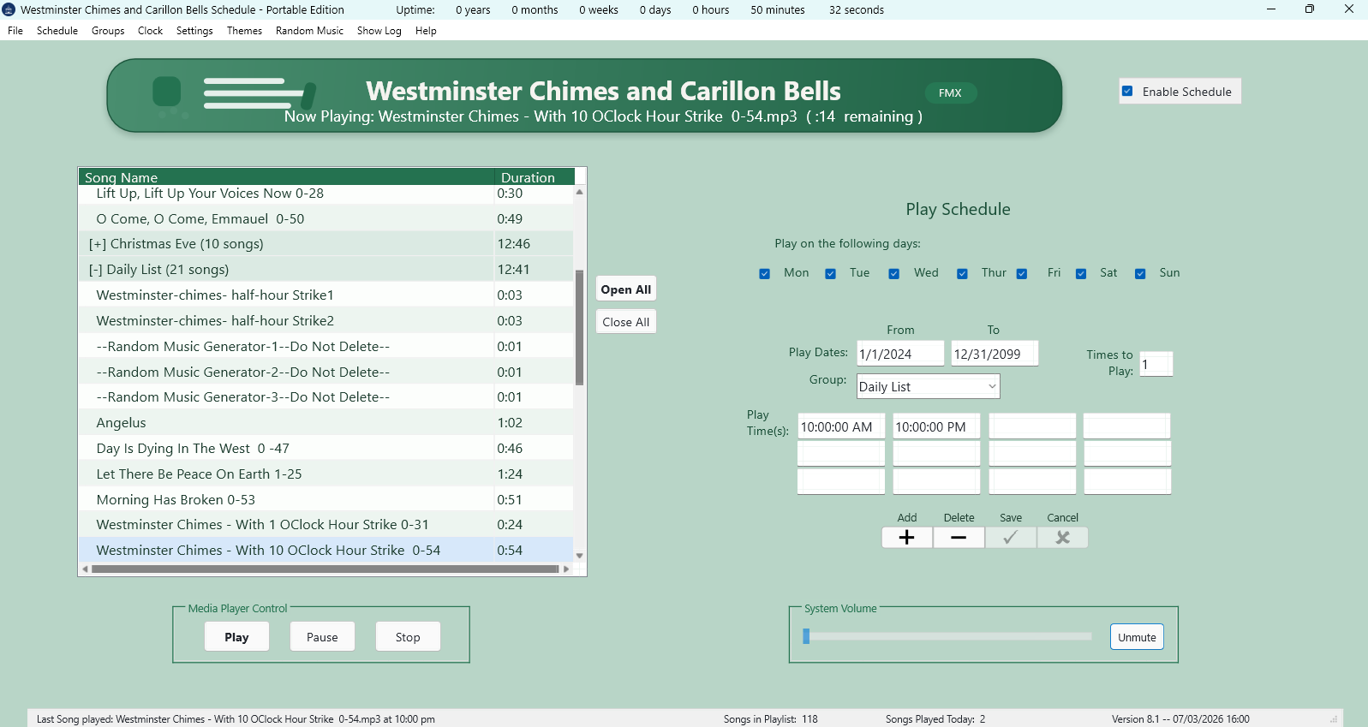
Area | What it does
Application header | Shows the program title and the active visual theme.
Enable Schedule | Turns automatic scheduled playback on or off.
Playlist grid | Shows songs grouped by season or purpose, with song duration.
Open All / Close All | Expands or collapses all song groups in the grid.
Play Schedule panel | Edits dates, weekdays, group, play times, and repeat count for the selected song.
Navigator | Adds, deletes, saves, or cancels playlist edits.
Media Player Control | Manually plays, pauses, or stops the selected song.
System Volume | Controls the Windows system volume and mute state.
Status bar | Shows recent playback, song counts, and version/status information.

Enable Schedule

When Enable Schedule is checked, the program builds the daily schedule and the schedule timer watches for due entries. When the box is unchecked, scheduled playback is stopped and the current schedule list is cleared.
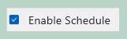
Many maintenance screens temporarily disable the schedule and then re-enable it when they close so changes are picked up when the schedule or other data is changed. If you intentionally turn the schedule off, turn it back on before leaving the computer unattended. Failure to do so will leave the schedule not running and no music will play.

Playlist Grid

The playlist grid is a work area for reviewing songs. It is grouped by the song group or season. A group line shows how many songs are inside the group and can be opened or closed.
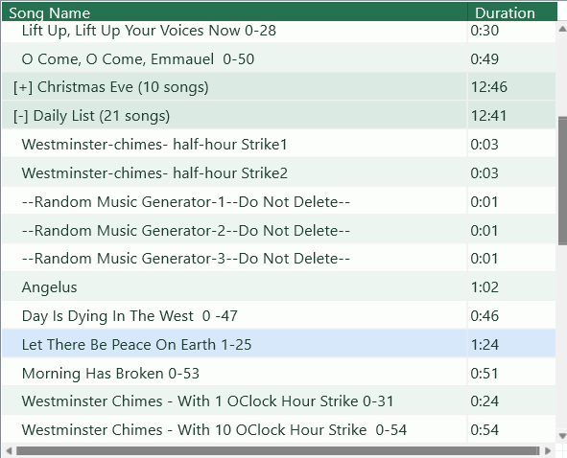
- Click a group line to open or close that group.
- Use Open All to expand every group.
- Use Close All to collapse every group.
- Select a song row to edit its schedule fields on the right side of the screen.
- Double-clicking or using Play can manually play the selected song.
Grid purpose: The grid is not the compiled daily schedule. It is the saved playlist and scheduling editor. Use Schedule > Show Remaining Schedule to see what is still due today.

Play Schedule Panel

The Play Schedule panel controls when the selected playlist row is eligible to play. A song normally needs a valid date range, at least one selected weekday, and at least one play time.
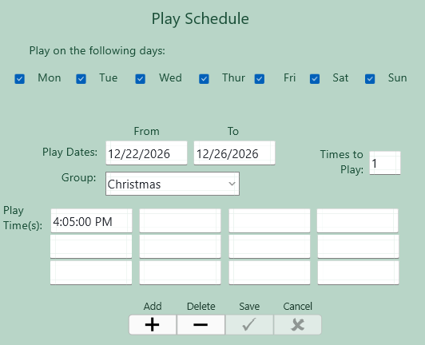
Field | How to use it
Play on the following days | Check the weekdays when the selected row may play.
Play Dates From / To | Enter the inclusive date range for the row.
Group | Select the group or season assigned to the row.
Play Time(s) | Enter up to twelve times. Seconds are allowed.
Times to Play | Enter how many times the selected item should repeat when triggered. Keep this low unless a repeat is intended.

Entering Times
Version 8.1 accepts both 12-hour and 24-hour time entries in schedule fields where the screen supports time input. Seconds may be included. The program normalizes display to a 12-hour time with AM or PM when appropriate.
You can enter | Typical display
4:05 PM | 4:05:00 PM
4:05:30 PM | 4:05:30 PM
16:05 | 4:05:00 PM
22:15:30 | 10:15:30 PM

Seconds matter: If you enter seconds, confirm them in Show Remaining Schedule. The schedule display should show full h:mm:ss AM/PM times.

Navigator Buttons and Editing

Editable screens use navigator buttons. The labels above the buttons identify the action. The most common buttons are Add, Delete, Save, and Cancel. Some maintenance screens also show First, Prior, Next, and Last.
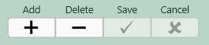
Button label | Meaning
Add | Insert a new record where adding is supported.
Delete | Delete the selected record where deletion is supported.
Save | Post pending changes to the database.
Cancel | Discard pending changes and restore the saved value.
First / Prior / Next / Last | Move through records on maintenance screens.

If you change a field and then save, the schedule is rebuilt where needed. If you cancel, the form should return to the saved database value.

Setting Up a Song Schedule

- Select the song in the playlist grid.
- Choose the weekdays when the song should play.
- Enter the Play Dates From and To fields.
- Select the group or season if one applies.
- Enter one or more play times. Use seconds when exact timing is needed.
- Set Times to Play.
- Click the navigator Save check mark.
- Use Schedule > Show Remaining Schedule to confirm the expected entries.
After edits: If the schedule was disabled for editing, it should rebuild after Save. If it remains disabled because you turned it off manually, check Enable Schedule again.

Adding Songs

A new song can be added to the playlist and then scheduled like any existing row. The exact file path must be preserved so the media player can find the audio file.
- Click the Add button in the main navigator.
- Choose or enter the song file path through the song-add workflow.
- Assign the group or season.
- Fill in dates, weekdays, play times, and Times to Play.
- Click Save.
- Confirm the song appears in the expected group and test it with Play if desired.
Do not strip paths: Songs need their full path to be found. If a song file is moved or renamed, update the playlist row or re-add the song.

Group Maintenance

The Group Maintenance screen manages seasonal group names, date windows, and the main group play time. It is used for holidays and seasonal collections such as Christmas, Easter, Thanksgiving, Memorial Day, Independence Day, and similar groups.
- Open it from Groups > Group Maintenance.
- Use the grid to review group dates and play times.
- Use the date and time fields to edit the selected group.
- Use Recalculate Dates for Upcoming Year when holiday dates need to be refreshed.
- Save changes with the navigator Save check mark.
When group information is applied to playlist songs, Version 8.1 copies the group date range and primary group play time to matching playlist rows. It also clears secondary time slots for that group so old extra times do not cause the group to play more than intended.

Random Music Directory Rotation

Random Music lets placeholder random entries choose a real song file from a folder. Version 8.1 has seven random directory slots. Slot 1 is the default fallback folder. Slots 2 through 7 can override the default folder during annual date windows.
Slot | Purpose
1 | Default random music directory. Used when no date-window slot applies.
2-7 | Optional date-window directories. Each may have a From and To month/day range.

- Open Random Music > Manage Directories.
- Set Slot 1 to the normal default random music folder.
- For Slots 2 through 7, enter a folder only when that date-window folder is needed.
- Enter From and To dates in month/day form, such as 07/01 and 07/31.
- Click Browse to choose folders when helpful.
- Click the navigator Save check mark.
Annual dates: Random directory dates are meant to repeat each year. If a full date exists internally, the practical rotation is based on the month and day date window.

Silence Schedule

The Silence Schedule screen defines daily time windows when scheduled playback should be suppressed. This is useful for services, classes, meetings, funerals, or other quiet periods.
- Open it from Schedule > Silence Schedule.
- There are twelve silence windows.
- Each window can be enabled or disabled.
- Each window has a purpose, start time, end time, and weekday selection.
- Start time must be before end time for the same day.
- Times may be entered in 12-hour or 24-hour form and may include seconds.
- Save with the navigator Save check mark.
When the schedule is built, normal playback entries during an active silence window are left out of the remaining schedule. The remaining schedule display shows the silence entry itself so the operator can see why music is not scheduled during that period.
Daily rebuild: The schedule rebuilds after midnight, around 00:05, so silence windows and date-based changes are picked up for the new day.

System Settings

System Settings stores organization information, logging status, and liturgical or special silence dates.
Area | Purpose
Organization Name | Name shown in program identity, splash/reporting areas, and related output.
Transaction Log | Turns logging on or off.
Liturgical Silence Days | Keeps dates such as Ash Wednesday, Holy Thursday through Saturday, All Souls Day, and funeral or other silence dates.
Recalculate Easter and All Souls Dates | Refreshes annual calculated dates.
Reset Funeral Date Fields | Clears funeral or special silence date fields.

Use the navigator Save and Cancel buttons for edits. If you close with pending changes, the form should warn you so you can save or discard them intentionally.

Email Settings and Morning Reports

Email Settings controls outbound email for reports or other messages as well as the optional morning report. The screen stores recipient lists, SMTP host and port, user name, password or app password, and test-recipient information. 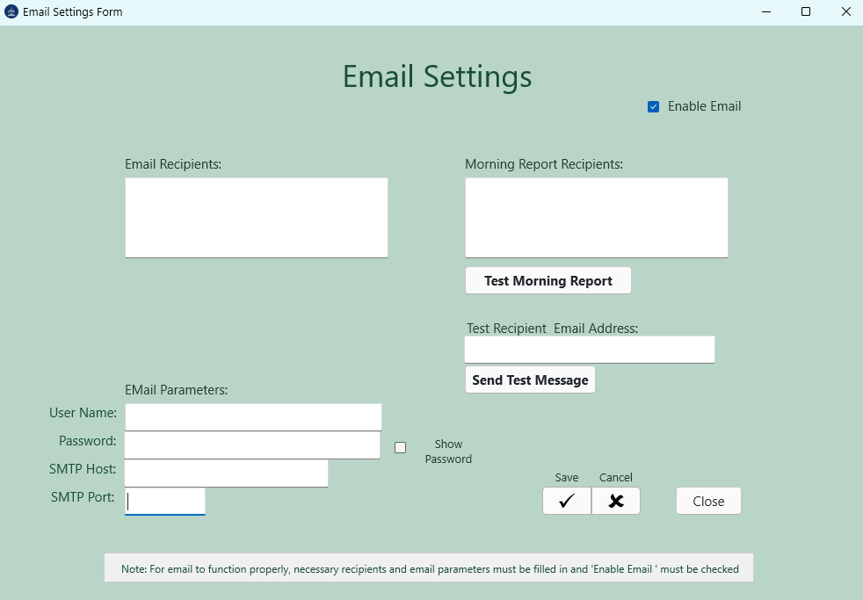
- Enable Email turns outbound email on or off.
- Send Test Message sends a simple test email to the test recipient.
- Test Morning Report builds and sends a morning report for verification.
- Morning Report Recipients are the addresses that receive the daily report.
- Show Password temporarily displays the stored password field so it can be checked.
The morning report reads the application log and summarizes system status, schedule status, recent plays, yesterday activity, and warnings or errors where available.
Email support files: Email features require the email support DLL files to be present with the portable runtime. If test email fails, check the SMTP settings, app password, recipients, and support files.

Show Remaining Schedule

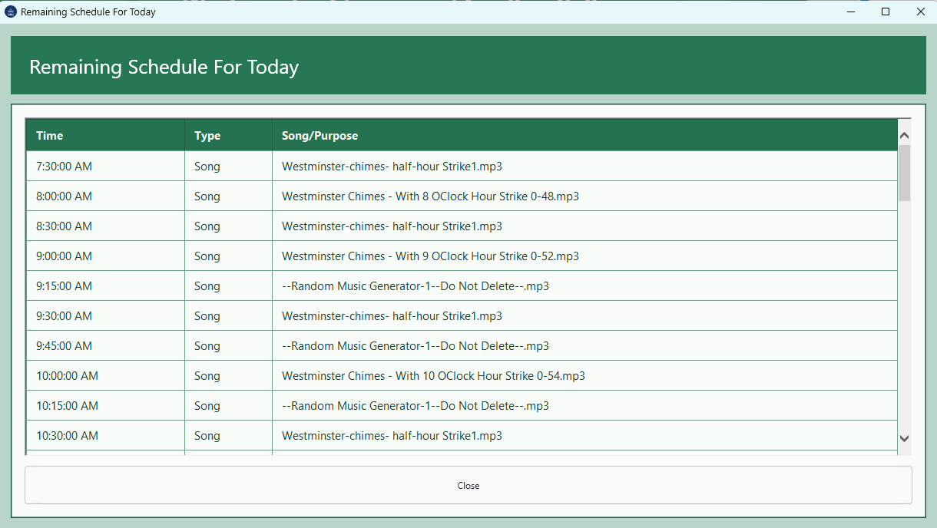

Use Schedule > Show Remaining Schedule to review what is still due today. The display is a themed table with Time, Type, and Song/Purpose columns.
- Song entries show the scheduled play time and file name or purpose.
- Silence entries show the start time and the silence purpose through the end time.
- Played entries are removed from the remaining schedule list.
- The Time column shows seconds, such as 4:59:05 PM.
- The list is sorted by time so the next event appears in the correct order.

Show Log

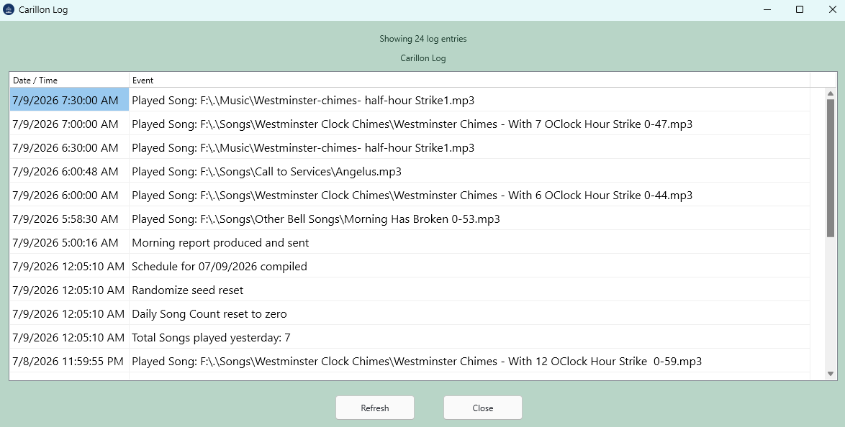
Show Log opens a themed log viewer from the main menu. It is placed between Random Music and Help. The log viewer shows Date / Time and Event columns and includes Refresh and Close buttons.
- Use Refresh to reload the log file after new activity.
- The log viewer reuses the existing window if it is already open.
- The displayed time is shown in 12-hour form with AM or PM.
- The log is read from the portable logs folder.

Themes
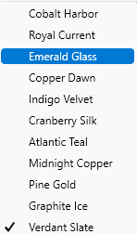
The Themes menu changes the appearance of the main form and maintenance screens. Version 8.1 centralizes theme definitions so labels, buttons, edit boxes, grids, headers, schedule dialogs, and status areas use consistent colors.

Theme | General character
Cobalt Harbor | Blue and teal accented light theme.
Royal Current | Darker royal/copper theme.
Emerald Glass | Soft green theme.
Copper Dawn | Warm copper and blue combination.
Indigo Velvet | Indigo and pink combination.
Cranberry Silk | Cranberry and soft surface theme.
Atlantic Teal | Teal/gold mix.
Midnight Copper | Dark graphite/copper theme.
Pine Gold | Green/gold combination.
Graphite Ice | Dark graphite and cool accent theme.
Verdant Slate | Muted green/slate theme.

Manual Playback and System Volume

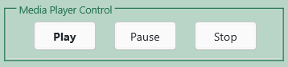
Manual playback is available even when you are not waiting for a scheduled time. Select a row in the playlist grid, then use the Media Player Control buttons.
Control | Action
Play | Starts the selected song.
Pause | Pauses playback and can resume playback when clicked again.
Stop | Stops the current media playback.
System Volume slider | Changes the Windows system volume.
Mute / Unmute | Mutes or unmutes the Windows audio endpoint.

The volume control tracks the Windows system volume, so changes made from Windows can also be reflected in the program.

Clock Window

The Clock menu opens the analog clock display. It is a separate utility window and can be closed when not needed.
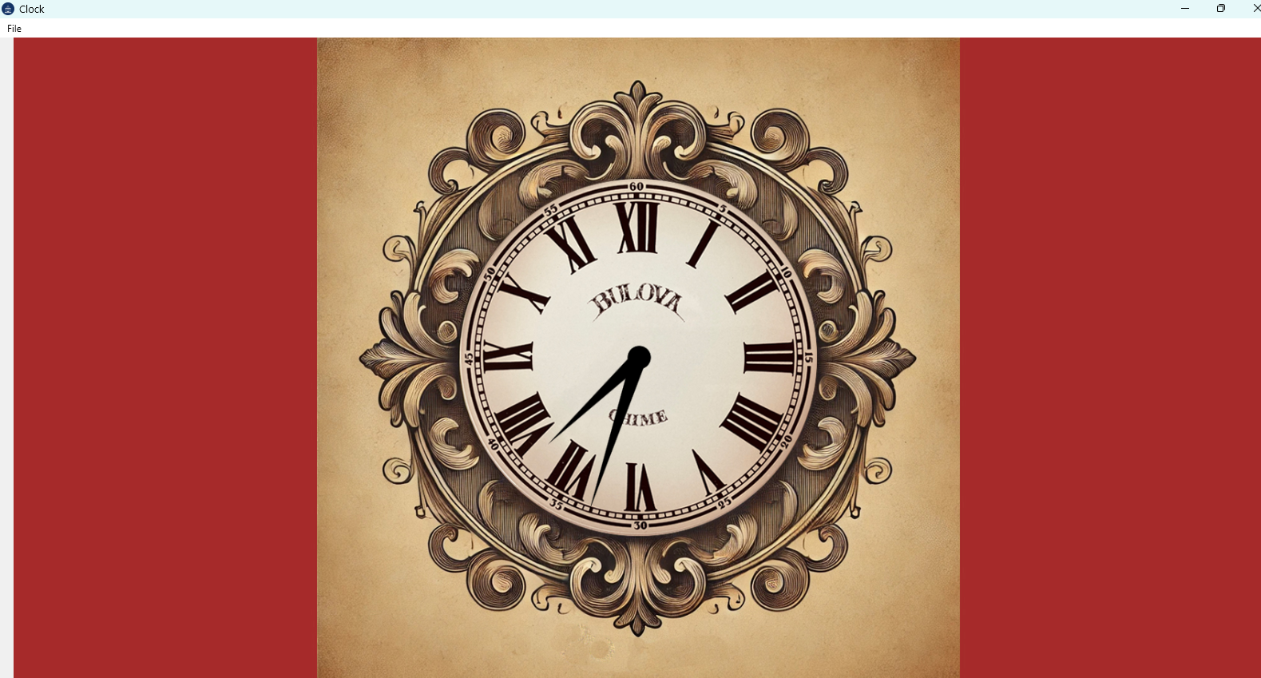

Good Operating Habits

- Confirm Enable Schedule is checked before leaving the system unattended.
- Use Show Remaining Schedule after important schedule, group, or silence changes.
- Keep the portable drive folder clean and avoid storing temporary work files in it.
- Make dated ZIP backups before major changes.
- Do not move or rename audio files without updating the playlist.
- Check random music folders before seasonal periods begin.
- Send a test email after email password, SMTP, or recipient changes.
- Review the log when diagnosing missed or unexpected playback.

Troubleshooting

Symptom | Likely cause | What to do
Unable to open database file | Program started from the wrong working directory. | Close the program and start it from the portable drive root.
Schedule is not running | Enable Schedule is unchecked or a modal window is open. | Check Enable Schedule and close any open dialog after saving or canceling changes.
Song does not play | Date, weekday, time, or file path is wrong. | Check the selected row, full file path, and Show Remaining Schedule.
Song plays more than expected | Extra play times or group mismatch. | Review the play-time boxes and the group maintenance row.
Random music does not play | Folder is missing, date window does not apply, or folder has no playable files. | Check Random Music > Manage Directories and confirm files exist.
Silence does not apply | Window disabled, wrong weekday, or invalid start/end time. | Open Silence Schedule and verify Enabled, days, start time, and end time.
Email does not send | SMTP settings, password, recipient, or support files are incorrect. | Use Send Test Message and check support DLLs.
Morning report lacks log data | Logging disabled or log path not from the same portable folder. | Enable Transaction Log and confirm logs\CarillonPlayLog.txt is being written.
Theme text is hard to read | A theme did not apply cleanly. | Reapply the theme and check the affected screen.

Quick Reference

Need | Go here
Review remaining events | Schedule > Show Remaining Schedule
Create or edit a silence window | Schedule > Silence Schedule
Maintain seasonal groups | Groups > Group Maintenance
Change global settings or logging | Settings > System Settings
Configure email or test morning report | Settings > Email Settings and Reports
Set random music folders | Random Music > Manage Directories
Review the play log | Show Log
Change colors | Themes menu
Open help | Help > Display Help
Start portable app correctly | Start from the flash drive root, such as F:\Carillon.exe

Final Daily Check
- Confirm the correct portable drive is inserted.
- Confirm the program was started from the portable drive root.
- Confirm Enable Schedule is checked.
- Open Show Remaining Schedule and confirm the next expected event.
- Confirm system volume and mute state.
- Close maintenance windows after saving or canceling changes.

