Website Analytics Engineering Guide
Public repository technical guide for maintainers and contributors
Last changed: July 23, 2026
Public repository edition draft

Table of Contents
Table of Contents 2
Engineering goals 3
Source module map 3
Runtime data model 3
SQLite schema and public repository policy 3
Authentication design 4
GA4 request design 4
UI engineering notes 4
Build and smoke test 5
Open-source hardening checklist 5
Contribution workflow 5
Future extension points 6

Engineering goals
- Keep the dashboard simple, fast, and readable.
- Keep FMX forms editable in the Delphi IDE. Avoid runtime-only UI construction unless the maintainer explicitly approves it.
- Keep analytics results memory-only. Persist only local settings and user-owned OAuth refresh material.
- Keep the public repository safe: no local databases, no secrets, no generated build output, no personal paths.

Source module map
Module | Responsibility
WebsiteAnalytics.MainForm.pas/.fmx | Main dashboard, filters, summary cards, grids/charts, update flow, status, help/settings buttons.
WebsiteAnalytics.GA4DataModule.pas | GA4 Data API requests, response parsing, standard report and realtime retrieval.
WebsiteAnalytics.AuthenticationDataModule.pas | OAuth desktop flow, loopback listener, token exchange, refresh-token retry, DPAPI protection.
WebsiteAnalytics.SettingsDataModule.pas | SQLite schema creation, defaults, and read/write access.
WebsiteAnalytics.SettingsForm.pas/.fmx | OAuth and dashboard settings UI, masked secret handling, connect/disconnect commands.
WebsiteAnalytics.PropertyManagerForm.pas/.fmx | Website property CRUD and property ID management.
WebsiteAnalytics.DiagnosticsForm.pas/.fmx | Diagnostics and self-test surface.
WebsiteAnalytics.Models.pas | Shared record/class models for GA4 rows and snapshots.

Runtime data model
The app separates persistent settings from transient analytics data. GA4 results are assembled into an in-memory snapshot and used to populate the dashboard. Closing the application discards those report rows.
- Persistent: website_properties, app_settings, OAuth setup values, saved grid widths, encrypted refresh token.
- Transient: KPI summaries, trend points, geography rows, content rows, realtime rows, chart data, status messages.

SQLite schema and public repository policy
The schema file is tracked so a clean checkout can create its local database. The generated database file is ignored.
Table | Important columns
app_settings | setting_name, setting_value, setting_group, description, updated_utc
website_properties | display_name, website_address, ga4_property_id, display_color, enabled, display_order
- databases/WebsiteAnalytics.schema.sql may be tracked.
- databases/*.sqlite3 must be ignored.
- Before public release, replace any maintainer-specific default property IDs with placeholders, sample IDs, or documented demo values as appropriate.

Authentication design
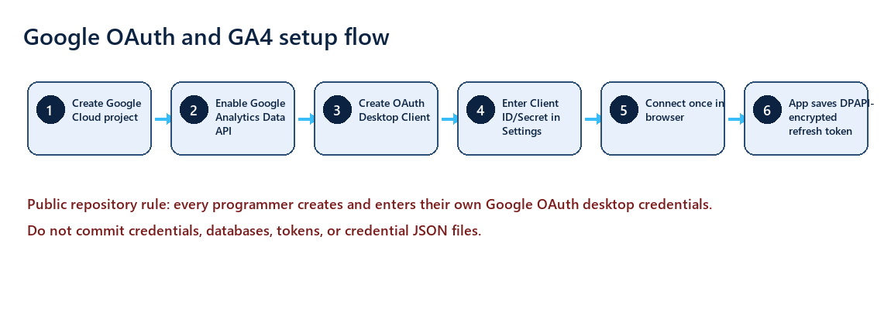
OAuth architecture for public users.
Authentication uses Google OAuth for installed/desktop applications. The app starts a local loopback listener, opens the user browser, receives the authorization code, exchanges it for tokens, and stores the refresh token encrypted with Windows DPAPI. The access token remains in memory.
- Scope: https://www.googleapis.com/auth/analytics.readonly.
- Client ID and secret are user-provided settings, not repository secrets.
- Refresh token setting: ga4_oauth_refresh_token_dpapi.
- Silent startup reconnect decrypts the saved refresh token for the current Windows account and refreshes the access token.
- If refresh fails, the app falls back to interactive Google connection from Settings.

GA4 request design
The GA4 data layer requests standard report rows for the selected property/date range and realtime rows for current activity. Reports should remain narrowly focused on the dashboard questions rather than attempting to mirror every GA4 screen.
Dashboard area | Typical GA4 dimensions/metrics
Locations | country, region, city; activeUsers, sessions
Pages/downloads | pageTitle, pagePath, eventName; activeUsers, eventCount
Users over range | date; activeUsers
Realtime | city, country or region; activeUsers and recent activity fields where available
Summary cards | aggregated users, views, events/downloads, top page, realtime counts

UI engineering notes
- The main form is FMX and should remain editable in the Object Inspector.
- When layout behavior truly requires code, keep it narrow, explain why, and avoid unnecessary helper code.
- Charts are custom painted and support hover tooltips for exact values.
- Grids persist user-adjusted column widths through settings.
- The UI should remain reasonably resizable for common desktop resolutions.

Build and smoke test
- Open a RAD Studio command prompt or call rsvars.bat from C:\Program Files (x86)\Embarcadero\Studio\37.0\bin, adjusted for the public user's installed version.
- Build Win64 Debug with msbuild WebsiteAnalytics.dproj /t:Build /p:Config=Debug /p:Platform=Win64.
- Build Win32 Debug if that target is supported.
- Smoke-test startup with -no-startup-auth so the form loads without forcing Google sign-in.
- Verify no FMX streaming errors such as missing properties or invalid property values.

Open-source hardening checklist
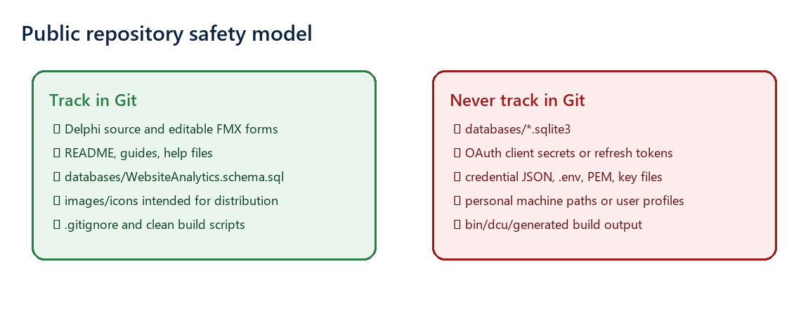
Repository safety checklist for maintainers.
- Review .gitignore before public release.
- Search for OAuth secrets, refresh tokens, sqlite files, credential JSON, personal folders, and private URLs.
- Use a clean public repository if private history ever contained secrets.
- Do not commit screenshots showing unredacted secrets.
- Use placeholders in docs: YOUR_OAUTH_CLIENT_ID, YOUR_OAUTH_CLIENT_SECRET, YOUR_GA4_PROPERTY_ID, and https://github.com/<your-user>/<repo>.

Contribution workflow
- Create a branch for changes.
- Make a pre-change backup when working under the maintainer's local directives.
- Keep edits scoped.
- Build and smoke-test.
- Stage only intended files.
- Commit with a clear message.
- Push and open a pull request when the repository is public.

Future extension points
- Traffic sources/referrers.
- Devices, browsers, and operating systems.
- Language/localization reports for worldwide users.
- Data quality reporting for not-set locations and missing dimensions.
- Optional exports, if the app later needs CSV/PDF reporting.

