Website Analytics User Guide
Public edition user guide for the GA4 desktop dashboard
Last changed: July 23, 2026
Public repository edition draft

Table of Contents
Table of Contents 2
What Website Analytics does 3
First-time setup 3
Hero section 3
Summary cards 4
Locations grid 4
Top pages and downloads graph 4
Users over time graph 4
Realtime panel 4
Settings 5
Properties 5
Running all day 6
Privacy and storage 6
Troubleshooting 6

What Website Analytics does
Website Analytics is a Delphi FireMonkey desktop dashboard that presents GA4 website data in a cleaner desktop layout. It is designed to answer a few practical questions quickly: who visited, where they came from, what pages or downloads they used, and what is happening right now.
- The dashboard retrieves GA4 data live when you click Update or when Auto 60 sec refreshes the view.
- The selected website property and date range control the main report data.
- The app can be left open as a glanceable monitor.
- Analytics report data is not saved after the app closes.
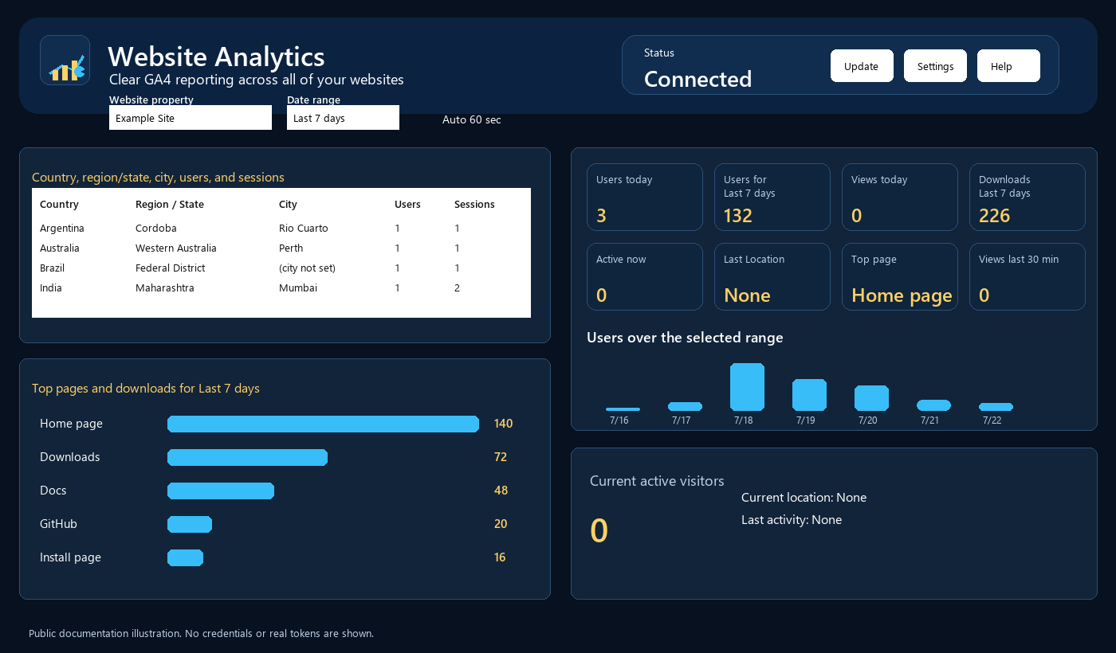
Dashboard areas shown with safe example data.

First-time setup
A public download of the source code does not include working Google credentials. You or your organization must provide a Google Cloud desktop OAuth client and GA4 property IDs.
- Open Settings.
- Enter the OAuth desktop client ID and client secret from your own Google Cloud project.
- Save settings.
- Open Properties and enter your website names, URLs, and numeric GA4 property IDs.
- Connect Google once. Complete the browser sign-in.
- Click Update to retrieve live GA4 data.

Hero section
- Website property selects the GA4 property to report on.
- Date range controls whether the report is Today, Last 7 days, Last 28 days, Last 90 days, or This year.
- Auto 60 sec refreshes data automatically while the app is connected.
- Status shows whether the app has a usable access token.
- Update retrieves live GA4 data immediately.
- Settings opens dashboard, OAuth, and startup options.
- Help opens the local help system.

Summary cards
The summary cards give a quick top-level read before you inspect details. Cards include users today, users for the selected range, views today, downloads for the selected range, active visitors now, last location, top page, and views in the last 30 minutes where GA4 supplies realtime data.

Locations grid
The locations grid groups returned GA4 rows by country, region or state, city, users, and sessions. It is intended for quick scanning, so rows are sorted alphabetically where practical.

Top pages and downloads graph
The pages/downloads chart summarizes the most-used pages, download actions, and events for the selected range. Hover over a bar to read the exact value. A slash path, /, is displayed as Home page where appropriate.

Users over time graph
The users graph shows users for the selected date range. The title includes the range so you know exactly what dates are plotted. Hover over a bar to see the precise value.

Realtime panel
The realtime panel shows current active visitors, current location when GA4 provides it, and last activity. Realtime and standard reports can differ briefly because GA4 processes them through different reporting windows.

Settings
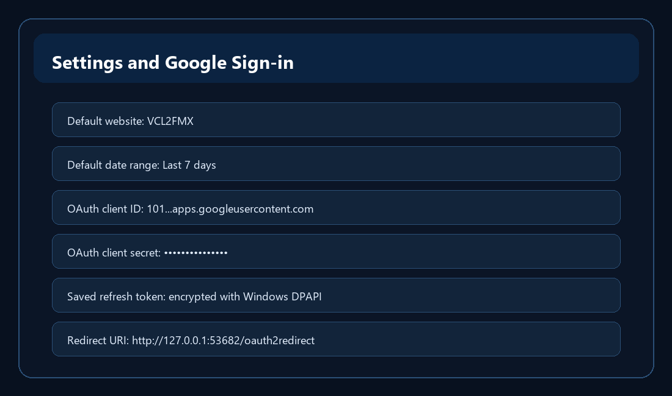
Settings screen with OAuth secret redacted.
- OAuth Client ID and Client Secret come from a Google Cloud Desktop app, not from your email address.
- The secret is masked by default. Reveal it only when editing.
- The refresh token is stored encrypted using Windows DPAPI after a successful sign-in.
- Disconnect clears the active token and saved encrypted refresh token.

Properties
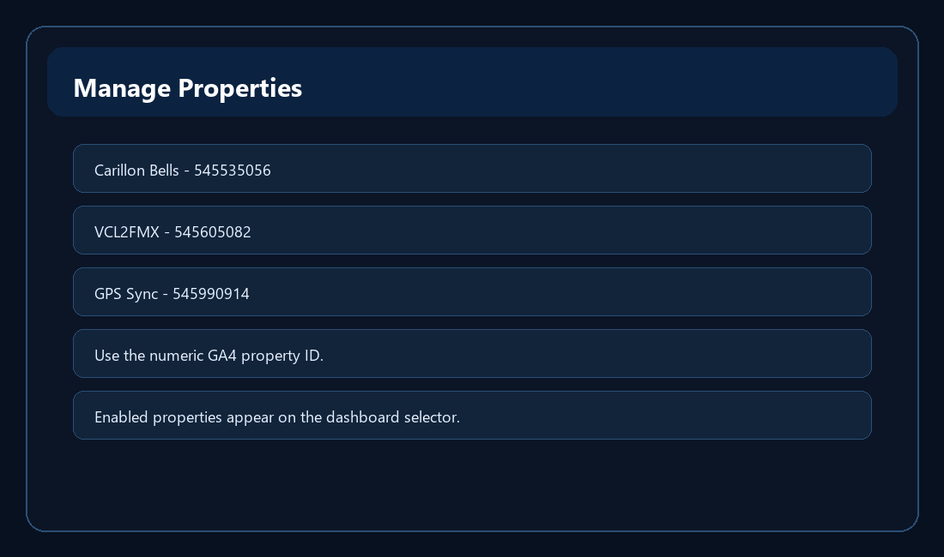
Property manager example.
- Add one row per website/GA4 property.
- Use numeric GA4 property IDs.
- Enable or disable properties without deleting them.
- Use display order and color to keep the dashboard organized.

Running all day
The app is meant to be left open. Keep Auto 60 sec checked if you want periodic refreshes. Google access tokens expire, but the saved encrypted refresh token normally lets the app refresh silently without showing Google login screens again.

Privacy and storage
- Report results are memory-only.
- SQLite stores settings, website definitions, grid widths, OAuth setup values, and the encrypted refresh token.
- Do not share your local SQLite file if it contains real settings or encrypted token material.
- For public-source use, each user should create their own OAuth client and enter their own GA4 property IDs.

Troubleshooting
Problem | What to check
No Google login screens after first connect | This is expected. Silent reconnect is working.
Google login appears again | Refresh token is missing, revoked, disconnected, or unavailable to this Windows account.
403 permission error | Check numeric GA4 property ID and GA4 Admin permissions for the signed-in Google account.
No data in a range | Try a longer range and confirm GA4 is collecting data.
Downloads missing | Confirm the website sends file_download or related click events to GA4.

