Design of a Quadcopter for Winning the Jerry Sanders Creative Design Competition

Jordan Bramble, Harold Merida, Ibtsam Khan
Department of Systems Engineering
George Mason University
Fairfax, VA

Abstract—In order to win the Jerry Sanders Creative Design Competition, it is neccesarry to design a quadcopter that can pick up cones and move them to territories in the arena. The quadcopter must be designed so that it is equipped with a mechanism for picking up cones. An optimal strategy must be determined that controls the third level territory in the shortest amount of time, and prevents other teams from entering the second level. (Abstract)

Introduction
The Jerry Sanders Creative Design Competition, sponsored by Advanced Micro Devices, and named after their former CEO, is a yearly competition in robotics held at the University of Illinois Urbana-Champaign. The 2014 competition will be held March 14th – 15th. Multidisciplinary teams of engineering students nationwide, participate in a game like competition for two days with robots they’ve designed and constructed. Each year the competition challenges change and require teams to develop innovative mechanisms for successfully scoring points.

Description of competition

Competition
The competition takes place in a 2000 sq. ft. arena (44.7 x 44.7 ft). For airborne robots, a sloping net is hung above the course that is always approximately 6 ft above the arena floor. The goal of the competition is fostering innovation and creativity within robotics and promoting the engineering disciplines. Each year thousands of spectators attend. In last year’s competition, 26 teams from six different universities participated in the competition, attempting to pick up cones and place them on pins in order to score points. All of the participating teams hail from universities within Illinois or Indiana. Historically only two airborne entries have competed. During last year’s competition, the Northern Illinois University Robotics club entered a quadcopter and they were successfully able to pick up cones, however they could not accurately place them on pins and the downward thrust from the propellers would occasionally blow away unsecured cones before they could pick them up.
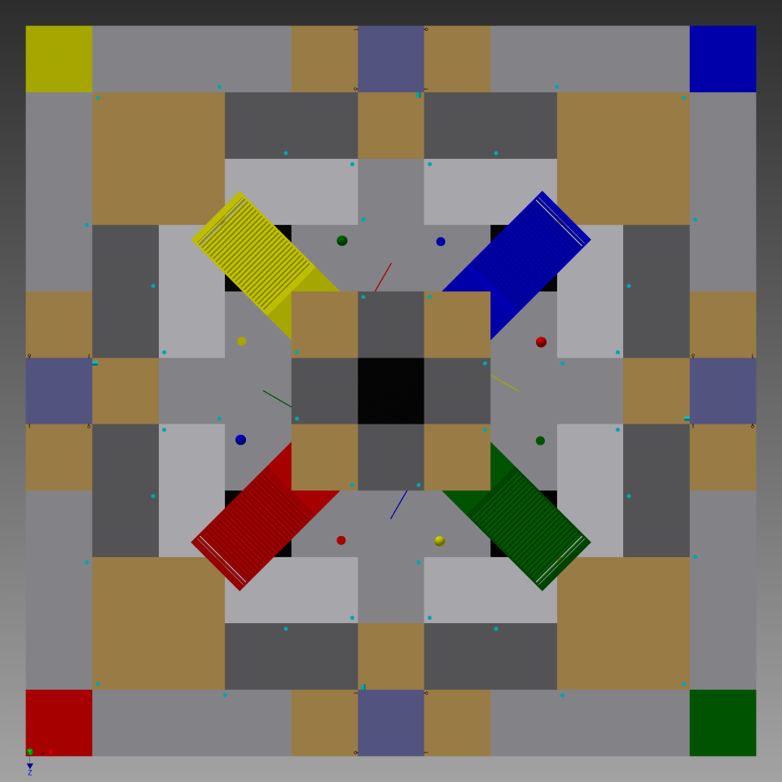
Figure 1: An eagle eye view of the course
The colored boxes in the corners correspond to each team’s starting area; the four colored rectangles represent ramps that lead up to the second level territories. At the base of the second level are small ‘soccer’ balls that are assigned by color to each team, these balls can be moved to their respective places, around the corner of the second level, in order to change direction of the ramps. The ramps are equipped with conveyor belts initially moving downward, but changing their direction causes the conveyor belt to change direction thus pulling a robot up. The central black box represents the third level territory, and the surrounding 8 boxes represent the second level. All of the other light blue dots represent the pins in the first level. The light purple boxes on each edge, are designed to hold cones for each team. 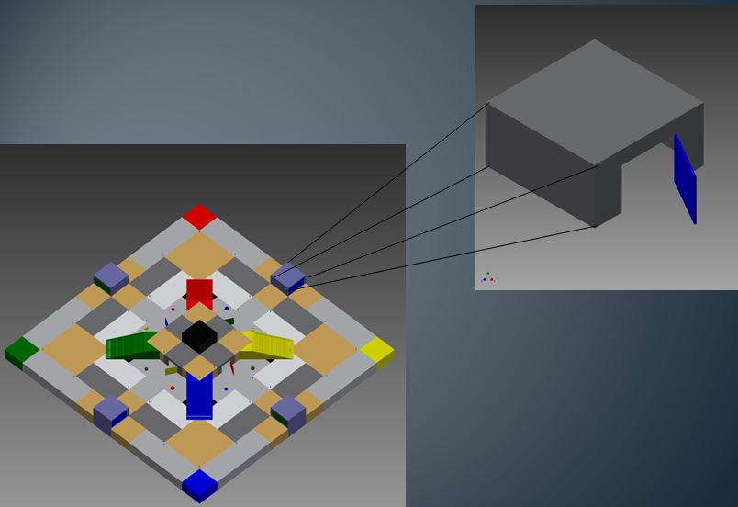
Figure 2: Location of the Hinge Door on Court
The competition shall consist of picking up and transporting cones of a specific color to pins corresponding to territories, where each pin is 1 inch in diameter. This is equivalent to controlling a “territory”, and the length of time a territory is controlled determines how many points are awarded.
Before going into detail about how points are awarded it is necessary to understand where the territories are placed. Below is a CAD diagram used to measure the distances between territories. The type of territory is color coded.
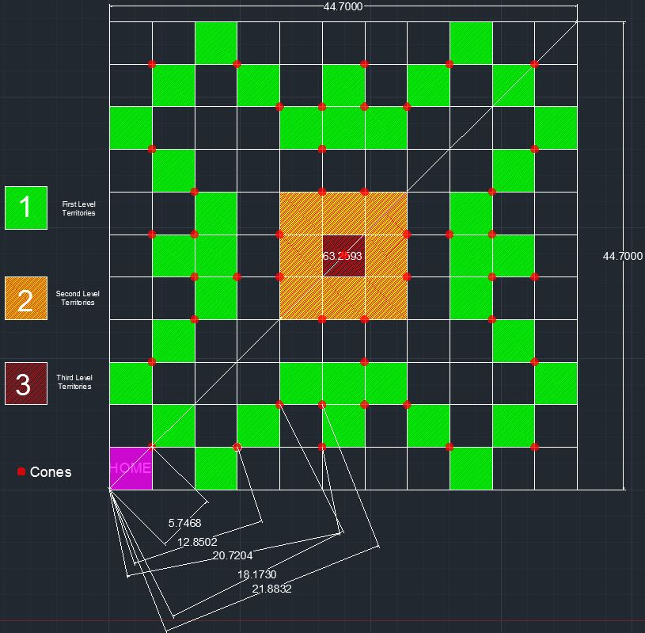
Figure 3: Arena With Location of Territories
Green represents first level territories, of which there are 36. Yellow represents the second level, of which there are 8. Finally, there is 1 third level territory marked in red. It is also necessary to understand how cones are placed in the course.
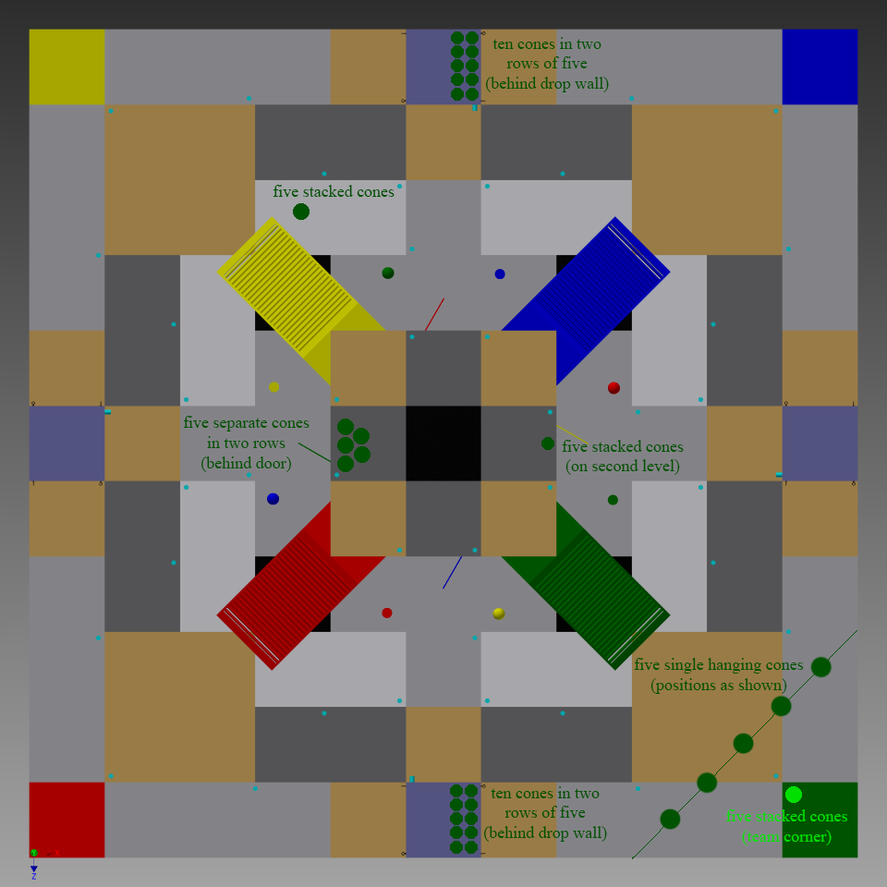
Figure 4: Cone Location
For the team starting in the green corner, their cones are arranged in this way. Ten cones are unstacked behind a drop wall that can be opened by pulling out two pins that hold the wall in place. 5 cones are in front of their home territory, hanging from strings. 5 more cones are placed behind a hinged door beneath the second level, that must be pulled open. They also have a stack of five cones in their home territory as well as 5 cones stacked at the second level and five opposite of the raised platform. Since the course layout is symmetrical, each other team has their cones located in equivalent positions throughout the course.

Scoring
There are many ways to score points. Airborne robots have a constant 3x multiplier when scoring cones. For each contiguous powered territory on the first level controlled at the end of the match, a team will be awarded ten (10) points. For each contiguous powered territory on the second level controlled at the end of the match, a team will be awarded thirty (30) points. For each contiguous powered territory on the third level controlled at the end of the match, a team will be awarded forty (40) points. Every ten (10) seconds that a team controls a first level territory will result in one (1) point. Every ten (10) seconds that a team controls a second level territory will result in three (3) points. Every ten (10) seconds that a team controls a third level territory will result in five (5) points. Completion of an action for the first time will result in ten (10) points being awarded to the team responsible. An action consists of opening the doors that hold pins or changing the direction of the ramp. The direction of the ramp can be changed by moving an assigned colored soccer ball at the base of the second territory to its holding area around the corner of the second level. Clearly, airborne robots are given a strategic advantage, and additionally, autonomous robots receive a 5x multiplier.

Description of competition rules

Core Rules of Competition
The core rules of the competition are as follows: Each match will be seven (7) minutes long, consist of four or fewer robots. The team’s color cone is the topmost in the stack of cones for control of a territory and teams cannot attempt to control a territory unless it would be contiguous

Airborne Entry Rules
Airborne entries have special specifications. They can weigh no more than 15 lbs. Any rotors must be made out of plastic and should not be able to cut through the safety netting which will be suspended over the course. The same battery rules apply to airborne entries. Since airborne entries could pose a greater safety risk, teams planning on submitting an airborne robot must contact the JSDC Rules Chair and Director by December 1st with a description of the expected weight, size, propulsion type, and any other specifications of their robot which will be helpful in determining what kind of risk such an entry might pose to the safety of spectators, competitors, JSDC officials and the game course. After the proposal has been received, the Rules Chair and Director will either approve or deny the entry by January1st.

Design of experiment
In order to later conduct a simulation and also analyze and compare potential strategies for winning the competition, it is necessary to conduct experimental trials to determine the performance attributes of a potential quadcopter that would be used in competition.

Experiment 1: Horizontal Velocity
Three different experiments were conducted. The first measured horizontal velocity over three separate distances, both taken from measurements on a CAD diagram that roughly corresponds to territory locations. The quadcopter was already hovering when the tests were conducted. The pilot would fly the quadcopter back and forth between the given distances of 20.5 ft, 30.7 ft, 47.7 ft. Each time an observer, watched the quadcopter travel the given distance the time would be recorded. These times, over 19 trials for each distance, were modeled as distributions using Arena.

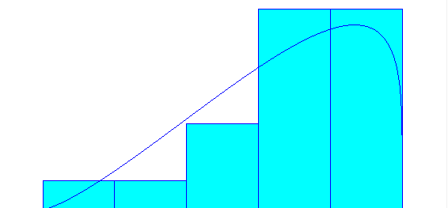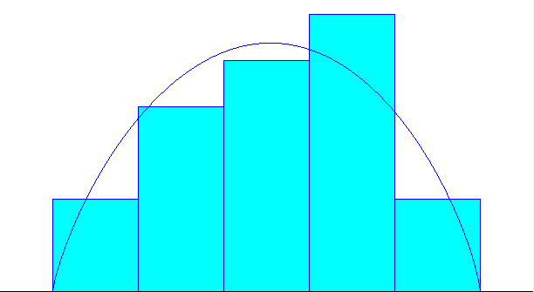
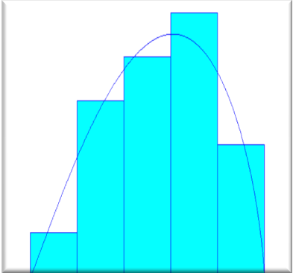
Figure 5: Vertical Velocity Distributions

Experiment 2: Vertical Velocity
The second experiment measured vertical velocity ascending velocity over 5 different distances, 2.5 feet, 4.5 feet, and 3.5 feet. Due to time constraints in the facility where tests were being conducted, only 5 trials were conducted for each distance. However the means for each distribution were very close together. The experiment was conducted by marking the distances on a wall and mounting a laser to the quadcopter. The laser was aligned with the wall in order to measure the vertical altitude of the quadcopter.
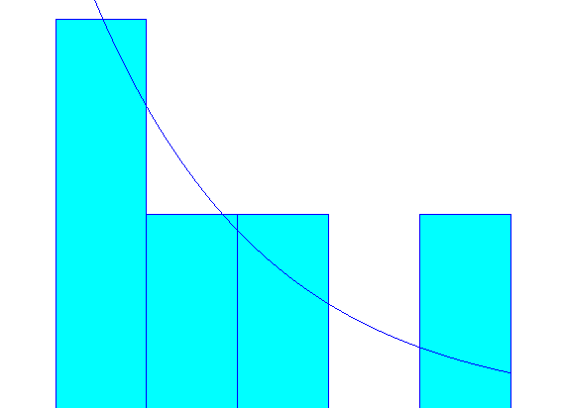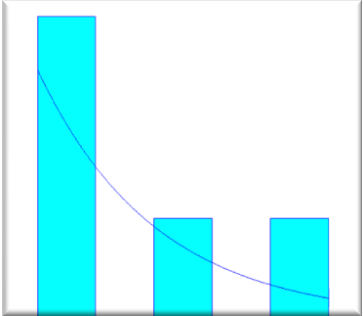

Figure 6: Horizontal Velocity Distributions

Experiment 3: Landing Accuracy
The third experiment was testing landing accuracy, in order to determine how accurately the quadcopter could hover and approach a cone. A target was created and the quadcopter pilot attempted to land the quadcopter in the center of the target from distances of 2.5, 4.5, and 5.5 feet. Pictures were taken of each landing, and the distances from the center were recorded. 8 trials were recorded from each distance.
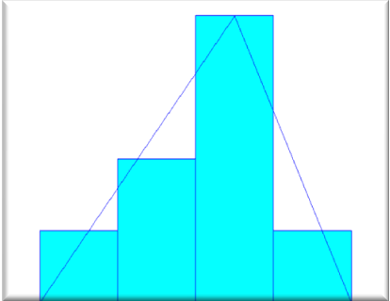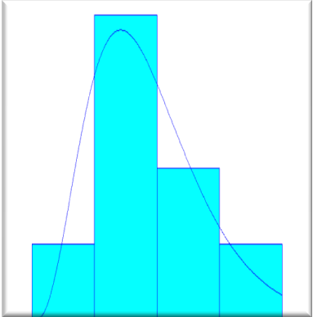
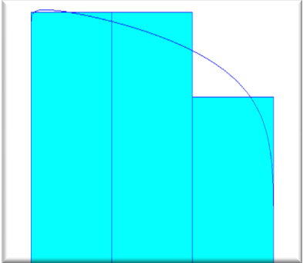
Figure 7: Landing Accuracy Distributions

Strategy Analysis
Armed with some of the performance capabilities of a standard quadcopter, as well as the placement of all cones on the course, a strategy for winning the competition can be developed. First, given the fact that a team can only control a territory that is contiguous to theirs, the heuristic approach is that their contiguous path will not be able to intersect with another teams until the second level at least. Once a team controls, the third level territory then all second level territories are contiguous to them, and they can then attempt to play defense by placing cones on top of any territories in the second level that become controlled by the other team. Thus the optimal strategy is one that allows a team to reach the third level first, and control it as long as possible. In order to do this, one must consider the placement of the cones on the course, and pick up cones such that they will have the shortest mean time between cone placements.
Using the distances to each territory mapped out in figure 4, we can use the mean times from our velocity distributions to determine an expected number of territories that can be controlled in a 7 minute period as well as the number of points that this would attain in a situation where there was no competition. The mean horizontal velocity was 3.91 ft/sec, mean ascending velocity is 1.14 ft/sec, the time to acquire a territory can be modeled by the following equation:

t = 2d / 3.91 + 2*4.5 / 1.14 + 15 (1)

This equation for time accounts for the time there and back motion between territories as well as ascending and descending. This equation incorporates an assumption that picking up and dropping off a cone requires 15 seconds. This is optimistic; it may take as long as 45 seconds. D is the distance in feet to territories in the arena. The time to gain control is estimated from the equation above. These distances represent the territories needed in order to control the third level. It takes 234.1 seconds to control the third level, out of a total of 420 seconds in the match. The remaining time can be used to play defense and prevent other players from entering the second level. The mean time to control a territory is 33.4 seconds, which leaves time for four more territories to be controlled in a 7 minute period. Thus, the expected number of cones is 12. In summary, because territories must be contiguous to other controlled territories, the strategy is to always approach the nearest territory. Once the third territory has been controlled then a defensive mode will be assumed, placing cones on top of other teams controlled territories if and when they enter the second level. Executing this strategy, without any competition taken into consideration yields 1908 points.
A mean time of 33.4 seconds to control a territory may be too optimistic. If it takes 30 seconds to pick up and drop a cone, then the mean time to control a territory is 48 seconds, which is enough to control 8 or 9 territories. This means the third level can be controlled, with two cones remaining to use defensively. In this case, the final point tally, not considering competition is 1,281.
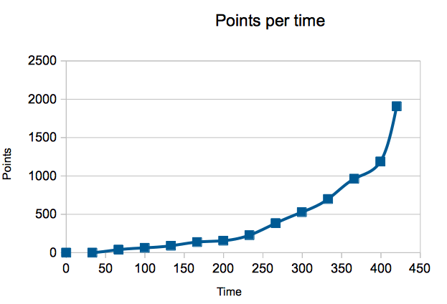
Figure 8: Points scored over time

Requirements
All projects have a set of requirements and they can be divided up into Mission, Functional, and Design Requirements.

Mission Requirements
- The Quadcopter shall compete in the Jerry Sanders Creative Design Competition.
- A strategic support tool shall be developed to determine and verify optimal strategies for winning the competition.
- The Quadcopter shall have a mechanism to pick up and carry cones, in order to place them on territories throughout the course.

Functional Requirements
- The Quadcopter shall have the ability to transmit a live video feed to a laptop.
- The Quadcopter shall be able to remain in flight for at least 7 minutes at a time. A 3 minute buffer is desirable.
- The Quadcopter’s batteries shall be rechargeable between rounds.
- The batteries shall provide sufficient power such that, the flight time and consistent thrust to carry necessary payloads can be achieved.
- The Quadcopter shall lift the cone to a sufficient height, at least 2 feet above the ground.
- The Quadcopter shall place cones on a 1 inch diameter 8 inch long pin.
- The Quadcopter shall have the ability to collect cones semi-autonomously.
- The Quadcopter shall be able to fly beneath a 6 feet net at all times, and have the ability to fly as low as 2 feet for an extended period, totaling no more than 20 seconds.
- The Quadcopter shall have a carrying capacity of at least 1kg, for a camera, cone acquisition mechanism, and cone.
- The Quadcopter shall be transportable, able to meet requirements to be checked onto a plane, or in the trunk of a sedan.
- The Quadcopter’s Arduino system shall be compatible with stability (fly-by-wire) software modules.

Design Requirements
- The Quadcopter shall fit within a 3’x3’x3’ cube.
- The Quadcopter shall weigh no more than 15lbs.
- The Quadcopter shall be equipped with a FPV camera.
- The Quadcopter shall have a mechanism for picking up Adams Saucer cones with a 2’’ diameter central hole and 2’’ height.
- The Quadcopter’s propellers shall be guarded such that they cannot damage the netting above the course.
- The Quadcopter shall be equipped with a mechanism for concentrating the thrust such that it will not blow cones away when attempting to pick them up.

Simulation design
Now that experiments have been conducted, in order to model horizontal velocity, landing accuracy, and vertical take off velocity, these distributions will be used in the simulation trials, alongside the distances of cones and territories to be controlled in order to determine expected number of territories that can be controlled, and output the number of points. The landing accuracy distributions will factor in to determining error potential for picking up cones as well as estimating the time to pick up a cone.

During the simulation, user error and precision can be combined with a random number to determine whether or not a cone is picked up or not. These stats can be used to determine a maximum amount of cones a robot can pick up.

Since a quadcopter will only be picking up cones that are in one of the three stacks, the time to pick up and drop off a cone will be the same. However for competing robots, it will take different lengths of time to pick up cones on strings and behind doors. Accurate estimations of this time will need to be factored into the simulation.

Simulation trials will be ran against 4 competitors, and all of their possible choices for cone placement and choices of cones to pick up, in order to see the outcomes. In the simulation, whichever team is currently in control of the third level territory will assume a defensive role in order to prevent the other team from controlling the third level.

Ideally this simulation will be conducted using MATLAB, and come complete with a GUI for user interaction and visualization of territories controlled by each team, as well as which cones they selected. Though if necessary, for web optimization, it could also be written in a more web friendly scripting language such as Python. The output will show the CAD diagram with highlighted controlled contiguous territories, as well as selection of cones.

VIII. Acknowledgment
The authors would like to thank Chris Vo, Mason Recreation, our sponsor Bo Pollet, and Ms. Paula Lewis for contributing towards the competition of this project.

References
- www.3drobotics.com
- www.diydrones.com
- JSDC Rules List: http://jsdc.ec.illinois.edu/news/2013/01/jsdc-2013-competition-rules
- Quadcopter, Dynamics, Simulation, Control - Andrew Gibiansky- for equations for simulation design

