Assignment 2

Tejasvini Mavuleti

4/9/2022

Setting working directory

getwd()

## [1] "C:/Users/mavul/OneDrive/Documents"

setwd("C:/Users/mavul/OneDrive/Documents")

# 1) Running the code to create two variables X and Y

set.seed(2017)   
X=runif(100)*10   
Y=X*4+3.45   
Y=rnorm(100)*0.29*Y+Y

## a) Ploting Y against X

plot(X,Y, xlab = "X (units)", ylab = "Y (units)", main = "Plot of Y vs X ", col = "green")

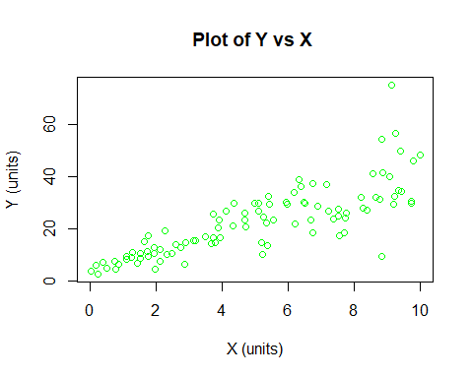 From the graph shown above there is a positive linear trend between X and Y variables

## b) Constructing a simple linear model of Y based on X

Model <- lm(Y~X)  
Model$coefficients

## (Intercept) X   
## 4.465490 3.610759

The formula to explain Y based on X from our linear model is: Y = 3.6108*X + 4.4655

## c) The relation of the coefficient of determination and coefficient correlation of X and Y

summary(Model)

##   
## Call:  
## lm(formula = Y ~ X)  
##   
## Residuals:  
## Min 1Q Median 3Q Max   
## -26.755 -3.846 -0.387 4.318 37.503   
##   
## Coefficients:  
## Estimate Std. Error t value Pr(>|t|)   
## (Intercept) 4.4655 1.5537 2.874 0.00497 **   
## X 3.6108 0.2666 13.542 < 2e-16 ***  
## ---  
## Signif. codes: 0 '***' 0.001 '**' 0.01 '*' 0.05 '.' 0.1 ' ' 1  
##   
## Residual standard error: 7.756 on 98 degrees of freedom  
## Multiple R-squared: 0.6517, Adjusted R-squared: 0.6482   
## F-statistic: 183.4 on 1 and 98 DF, p-value: < 2.2e-16

The R2 is 0.6517, that means 65% of the variability of Y is captured by X

# 2) Including the ‘mtcars’ dataset included in R distribution

# shows first 6 rows  
head(mtcars)

## mpg cyl disp hp drat wt qsec vs am gear carb  
## Mazda RX4 21.0 6 160 110 3.90 2.620 16.46 0 1 4 4  
## Mazda RX4 Wag 21.0 6 160 110 3.90 2.875 17.02 0 1 4 4  
## Datsun 710 22.8 4 108 93 3.85 2.320 18.61 1 1 4 1  
## Hornet 4 Drive 21.4 6 258 110 3.08 3.215 19.44 1 0 3 1  
## Hornet Sportabout 18.7 8 360 175 3.15 3.440 17.02 0 0 3 2  
## Valiant 18.1 6 225 105 2.76 3.460 20.22 1 0 3 1

## a) Constructing simple linear models using mtcars data

# Creating a linear model for weight vs horsepower and displays a plot of the points  
  
Model2 = lm(hp~wt, data = mtcars)  
summary(Model2)

##   
## Call:  
## lm(formula = hp ~ wt, data = mtcars)  
##   
## Residuals:  
## Min 1Q Median 3Q Max   
## -83.430 -33.596 -13.587 7.913 172.030   
##   
## Coefficients:  
## Estimate Std. Error t value Pr(>|t|)   
## (Intercept) -1.821 32.325 -0.056 0.955   
## wt 46.160 9.625 4.796 4.15e-05 ***  
## ---  
## Signif. codes: 0 '***' 0.001 '**' 0.01 '*' 0.05 '.' 0.1 ' ' 1  
##   
## Residual standard error: 52.44 on 30 degrees of freedom  
## Multiple R-squared: 0.4339, Adjusted R-squared: 0.4151   
## F-statistic: 23 on 1 and 30 DF, p-value: 4.146e-05

plot(mtcars$wt,mtcars$hp, xlab = "Weight (wt)", ylab = "Horsepower (hp)", main = "Plot of Weight vs Horsepower", col = "red")

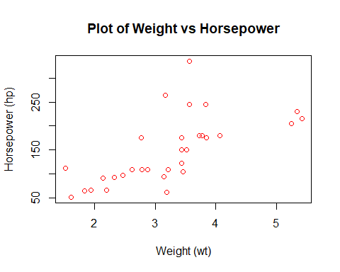 From this linear model we can see that weight results in a model that accounts for 43.39% of the variation in horsepower

# Creating a linear model for mpg vs horsepower and displays a plot of the points  
Model3 = lm(hp~mpg, data = mtcars)  
summary(Model3)

##   
## Call:  
## lm(formula = hp ~ mpg, data = mtcars)  
##   
## Residuals:  
## Min 1Q Median 3Q Max   
## -59.26 -28.93 -13.45 25.65 143.36   
##   
## Coefficients:  
## Estimate Std. Error t value Pr(>|t|)   
## (Intercept) 324.08 27.43 11.813 8.25e-13 ***  
## mpg -8.83 1.31 -6.742 1.79e-07 ***  
## ---  
## Signif. codes: 0 '***' 0.001 '**' 0.01 '*' 0.05 '.' 0.1 ' ' 1  
##   
## Residual standard error: 43.95 on 30 degrees of freedom  
## Multiple R-squared: 0.6024, Adjusted R-squared: 0.5892   
## F-statistic: 45.46 on 1 and 30 DF, p-value: 1.788e-07

plot(mtcars$mpg,mtcars$hp, xlab = "Miles per Gallon (mpg)", ylab = "Horsepower (hp)", main = "Plot of Miles Per Gallon vs Horsepower", col = "blue")

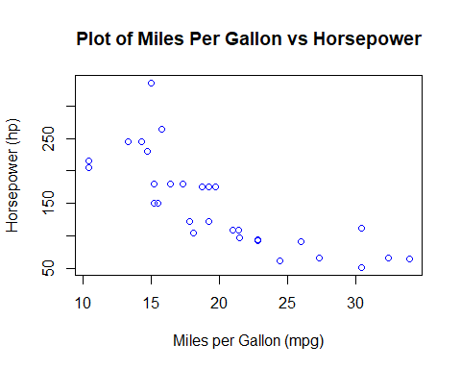

From this linear model the fuel efficiency results in a model that accounts for 60.24% of the variation of the horsepower. Therefore, the fuel efficiency (mpg) is considered statistically significant in this model.

## b) Building a model that uses the number of cylinders (cyl) and the mile per gallon (mpg) values of a car to predict the car Horse Power (hp)

# Shows which variables are factor or numeric  
str(mtcars)

## 'data.frame': 32 obs. of 11 variables:  
## $ mpg : num 21 21 22.8 21.4 18.7 18.1 14.3 24.4 22.8 19.2 ...  
## $ cyl : num 6 6 4 6 8 6 8 4 4 6 ...  
## $ disp: num 160 160 108 258 360 ...  
## $ hp : num 110 110 93 110 175 105 245 62 95 123 ...  
## $ drat: num 3.9 3.9 3.85 3.08 3.15 2.76 3.21 3.69 3.92 3.92 ...  
## $ wt : num 2.62 2.88 2.32 3.21 3.44 ...  
## $ qsec: num 16.5 17 18.6 19.4 17 ...  
## $ vs : num 0 0 1 1 0 1 0 1 1 1 ...  
## $ am : num 1 1 1 0 0 0 0 0 0 0 ...  
## $ gear: num 4 4 4 3 3 3 3 4 4 4 ...  
## $ carb: num 4 4 1 1 2 1 4 2 2 4 ...

# Converting cylinder into a factor  
mtcars$cyl = as.factor(mtcars$cyl)  
str(mtcars)

## 'data.frame': 32 obs. of 11 variables:  
## $ mpg : num 21 21 22.8 21.4 18.7 18.1 14.3 24.4 22.8 19.2 ...  
## $ cyl : Factor w/ 3 levels "4","6","8": 2 2 1 2 3 2 3 1 1 2 ...  
## $ disp: num 160 160 108 258 360 ...  
## $ hp : num 110 110 93 110 175 105 245 62 95 123 ...  
## $ drat: num 3.9 3.9 3.85 3.08 3.15 2.76 3.21 3.69 3.92 3.92 ...  
## $ wt : num 2.62 2.88 2.32 3.21 3.44 ...  
## $ qsec: num 16.5 17 18.6 19.4 17 ...  
## $ vs : num 0 0 1 1 0 1 0 1 1 1 ...  
## $ am : num 1 1 1 0 0 0 0 0 0 0 ...  
## $ gear: num 4 4 4 3 3 3 3 4 4 4 ...  
## $ carb: num 4 4 1 1 2 1 4 2 2 4 ...

A multiple regression model is used in this case to build a model that represents horsepower as a result of cylinders and miles per gallon

Model5 = lm(hp~cyl+mpg, data = mtcars)  
summary(Model5)

##   
## Call:  
## lm(formula = hp ~ cyl + mpg, data = mtcars)  
##   
## Residuals:  
## Min 1Q Median 3Q Max   
## -58.882 -20.904 -6.261 7.043 125.453   
##   
## Coefficients:  
## Estimate Std. Error t value Pr(>|t|)   
## (Intercept) 171.349 57.946 2.957 0.00625 **  
## cyl6 16.623 23.197 0.717 0.47955   
## cyl8 88.105 28.819 3.057 0.00487 **  
## mpg -3.327 2.133 -1.560 0.12995   
## ---  
## Signif. codes: 0 '***' 0.001 '**' 0.01 '*' 0.05 '.' 0.1 ' ' 1  
##   
## Residual standard error: 37.01 on 28 degrees of freedom  
## Multiple R-squared: 0.7368, Adjusted R-squared: 0.7086   
## F-statistic: 26.12 on 3 and 28 DF, p-value: 2.888e-08

# Predict the estimated horse power of a car with 4 cylinders and 22 mpg  
predict(Model5, data.frame(mpg = c(22), cyl = c("4")))

## 1   
## 98.15275

The estimated Horse Power of a car with 4 calendar and mpg of 22 is 98.15%

# 3) Using BostonHousing dataset

library(mlbench)

## Warning: package 'mlbench' was built under R version 4.1.3

data(BostonHousing)

## a) Building a model to estimate the median value of owner-occupied homes

str(BostonHousing)

## 'data.frame': 506 obs. of 14 variables:  
## $ crim : num 0.00632 0.02731 0.02729 0.03237 0.06905 ...  
## $ zn : num 18 0 0 0 0 0 12.5 12.5 12.5 12.5 ...  
## $ indus : num 2.31 7.07 7.07 2.18 2.18 2.18 7.87 7.87 7.87 7.87 ...  
## $ chas : Factor w/ 2 levels "0","1": 1 1 1 1 1 1 1 1 1 1 ...  
## $ nox : num 0.538 0.469 0.469 0.458 0.458 0.458 0.524 0.524 0.524 0.524 ...  
## $ rm : num 6.58 6.42 7.18 7 7.15 ...  
## $ age : num 65.2 78.9 61.1 45.8 54.2 58.7 66.6 96.1 100 85.9 ...  
## $ dis : num 4.09 4.97 4.97 6.06 6.06 ...  
## $ rad : num 1 2 2 3 3 3 5 5 5 5 ...  
## $ tax : num 296 242 242 222 222 222 311 311 311 311 ...  
## $ ptratio: num 15.3 17.8 17.8 18.7 18.7 18.7 15.2 15.2 15.2 15.2 ...  
## $ b : num 397 397 393 395 397 ...  
## $ lstat : num 4.98 9.14 4.03 2.94 5.33 ...  
## $ medv : num 24 21.6 34.7 33.4 36.2 28.7 22.9 27.1 16.5 18.9 ...

# Creating a linear model for median value based on crim, zn, ptratio, and chas.  
Model6 = lm(medv~crim+zn+ptratio+chas, data = BostonHousing)  
summary(Model6)

##   
## Call:  
## lm(formula = medv ~ crim + zn + ptratio + chas, data = BostonHousing)  
##   
## Residuals:  
## Min 1Q Median 3Q Max   
## -18.282 -4.505 -0.986 2.650 32.656   
##   
## Coefficients:  
## Estimate Std. Error t value Pr(>|t|)   
## (Intercept) 49.91868 3.23497 15.431 < 2e-16 ***  
## crim -0.26018 0.04015 -6.480 2.20e-10 ***  
## zn 0.07073 0.01548 4.570 6.14e-06 ***  
## ptratio -1.49367 0.17144 -8.712 < 2e-16 ***  
## chas1 4.58393 1.31108 3.496 0.000514 ***  
## ---  
## Signif. codes: 0 '***' 0.001 '**' 0.01 '*' 0.05 '.' 0.1 ' ' 1  
##   
## Residual standard error: 7.388 on 501 degrees of freedom  
## Multiple R-squared: 0.3599, Adjusted R-squared: 0.3547   
## F-statistic: 70.41 on 4 and 501 DF, p-value: < 2.2e-16

The R2 value in this model (crim, zn, ptratio, and chas) is 35.99% of the variability in median housing value. This is a weak model in terms of accuracy and can be improved by adding more variables into the model.

## b) Using the estimated coefficient

1. Based on the coefficients, the resulting formula from our model is:

medv = 49.91868 - 0.26018*crim + 0.07073*zn - 1.49367*ptratio + 4.58393*chas1

Therefore, if the only difference between two houses is that one borders the Chas River, then we focus on the chas variable coefficient. The house that borders the river would be $4,583.93 more than the one that does not.

4.58393 (coeff of chas) * 1 (value of chas) * 1000 (medv in $1,000 units) = $4,583.93

1. Based on the coefficients, the resulting formula from our model is:

medv = 49.91868 - 0.26018*crim + 0.07073*zn - 1.49367*ptratio + 4.58393*chas1

Therefore, if the only difference between two houses is the pupil-teacher ratio, then we focus on the ptratio variable coefficient. As a result, the house with the smaller pupil-teacher ratio value is more expensive, because the coefficient is found to be negative in our model. The difference in values between the houses is

-1.49367 (coeff of ptratio) * 0.03 (difference between ptratio values) * 1000 (medv in $1,000 units) = $44.81

Therefore, the house with the lower pupil-teacher ratio is $44.81 more expensive based on our model

## c) Which of the variables are statistically important?

Based on the model constructed from these variables, all of the variables (crim, zn, ptratio, and chas) were found to be statistically significant. This is true because all of the p-values calculated from our model at below the 0.05 threshold value for significance.

## d) Using the anova analysis and determine the order of importance of these four variables

# Returns the ANOVA results for the model used in this problem  
anova(Model6)

## Analysis of Variance Table  
##   
## Response: medv  
## Df Sum Sq Mean Sq F value Pr(>F)   
## crim 1 6440.8 6440.8 118.007 < 2.2e-16 ***  
## zn 1 3554.3 3554.3 65.122 5.253e-15 ***  
## ptratio 1 4709.5 4709.5 86.287 < 2.2e-16 ***  
## chas 1 667.2 667.2 12.224 0.0005137 ***  
## Residuals 501 27344.5 54.6   
## ---  
## Signif. codes: 0 '***' 0.001 '**' 0.01 '*' 0.05 '.' 0.1 ' ' 1

Based on the ANOVA values returned, the order of importance of these variables are:

1. “crim” - accounts for 15.08% of variability in the model
2. “ptratio” - accounts for 11.02% of variability in the model
3. “zn” - accounts for 8.32% of variability in the model
4. “chas” - accounts for 1.56% of variability in the model

The residuals in this model still account for 64.01% of variability in the model. There is still a lot of room for improvement in the accuracy of this model.