Machining Work

* Use spare 3mm rod(s) to test making D Profile, using Dremel
* Add Thread to end of primary shaft
* Add D profile to other end of primary shaft
* Cut spool shaft to length: 4.7 inches
* Cut .125 shaft to lengths:
  + 2x 1.56”
  + 2x 1.46”
  + 1x 1.95” (no D profile needed)
  + 1x 6.634” (no D profile needed)
  + 1x 3.00” (no D profile Needed)
  + 1x 1.00”
  + 1x 1.58” (not a concern if larger)
* All shafts need D profile added (except those marked):

1x 1.56” and 2x 1.46”:

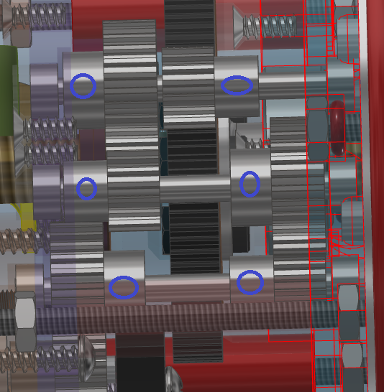

1x 1.58”:

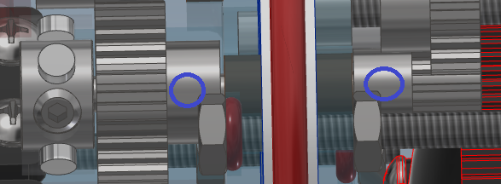

1x 1.00”:

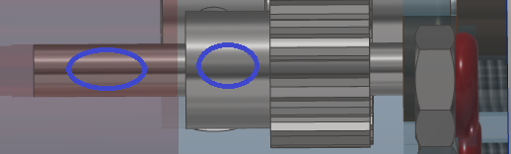

1x 1.56”:

