**Renewable energy grid (Dou, Zuo, Chang, & Chen, 2019)**

**Bank (Yoo, 2003)**

**Warehouse (Hay, 2006)**

**Manufacturer {Guide Jr, 2000 #4719}**

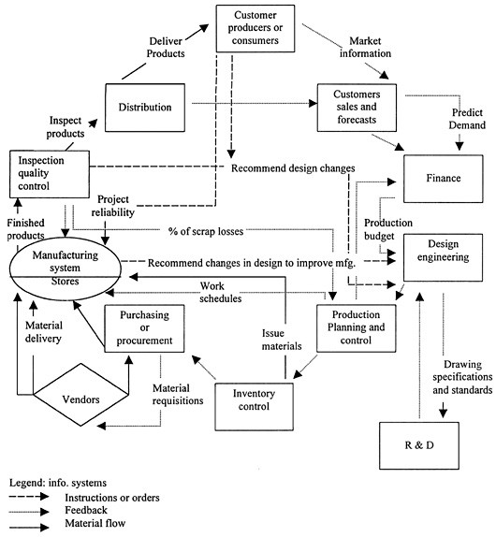

**Bibliography**

Dou, Y., Zuo, G., Chang, X., & Chen, Y. (2019). A study of a standalone renewable energy system of the Chinese Zhongshan Station in Antarctica. *Applied Sciences, 9*(10), 1968.

Hay, D. C. (2006). 3 - ACTIVITIES, FUNCTIONS, AND PROCESSES. In D. C. Hay (Ed.), *Data Model Patterns* (pp. 123-181). San Francisco: Morgan Kaufmann.

Yoo, S. (2003). Data Flow Diagrams.