**MEDASKO Episode Tracking Design Document**

Table of Contents

1. Episode Tracking Enhancements 3

2. Reference Images 4

2.1. New Episode 4

2.2. Active Episode 5

2.3. New Encounter 5

2.4. Edit Encounter as Admin user 6

2.5. Encounter Changed As Episode 6

2.6. Episode Grouping 7

1. Episode Tracking Enhancements
2. Created one new table and form for episodes and placed in a patient summary screen as a widget that replaces the “Billing widget”.
3. Form_encounter table is updated with episode_id.
4. Episodes widget should display the most recent episode and it has “New” and “Edit” Buttons on top of it. If no active episode exists , it should display “No Current Active Episodes” text.
5. New episode contains following fields.

1. Description

2. Episode start Date

3. Episode Length (default 60 days)

4. Episode End date

5. Admit Status (Admin, Pre-admit, Non-admit, Discharge, Dead)

5. Active (Yes, No)

6. Set Reminder (Yes, No)

1. If Reminder is set to “Yes” , entry will be made in the dated_reminder table with the message “ Episode – Episode name expires on episode end date “ and reminder date is One week before “Episode start date + Episode Length”
2. Without an active episode of the patient, we cannot able to create the Encounters.
3. Current active episode will be assigned to the “New encounter” by default.
4. Admin users can able to change the episode assigned to that encounter using “Edit encounter”.
5. Encounter viewing screens renamed as “Episodes”

Encounter History - > Episode History

Past Encounter List -> Past Episode List

Past Encounters and Documents -> Past Episodes and Documents

1. Encounters grouped by episodes and sorted by descending order with the collapsible groups, default Most current date is expanded
2. Reference Images
   1. New Episode

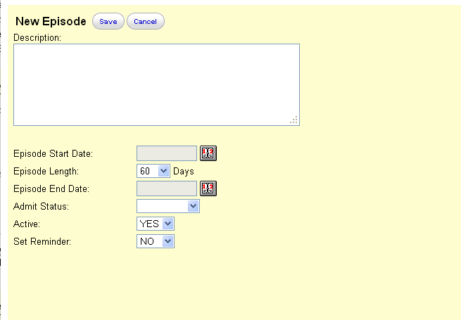

* 1. Active Episode

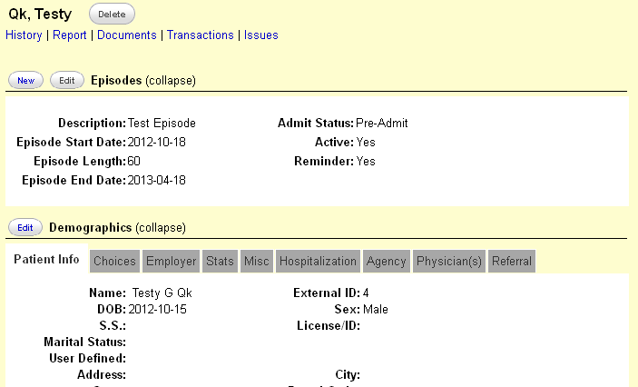

* 1. New Encounter

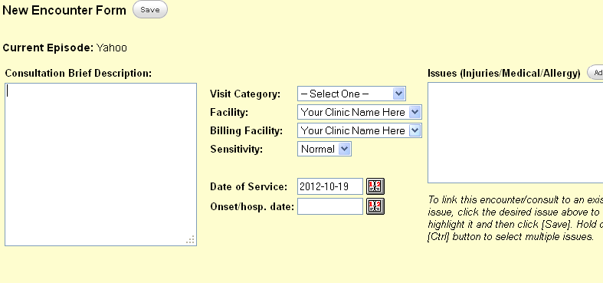

* 1. Edit Encounter as Admin user

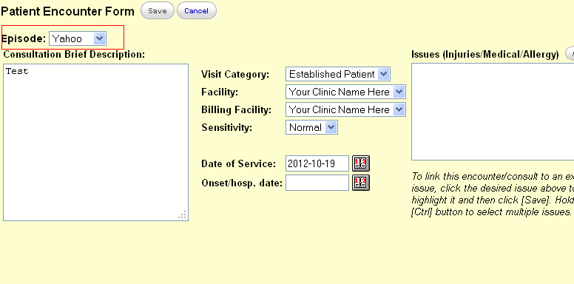

* 1. Encounter Changed As Episode

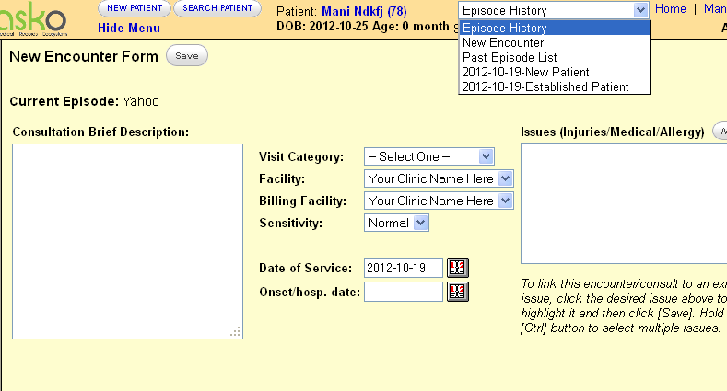

* 1. Episode Grouping

