**Lab 1: Basic installation**

1.Install NodeJS: <https://nodejs.org/en/download>

2.Open your terminal and use the command below:

**npm install -g expo-cli**

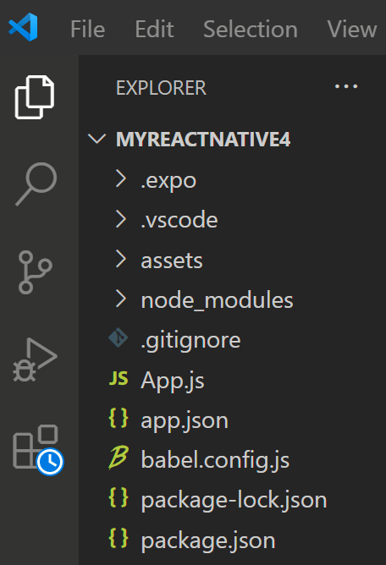3.Create new app:

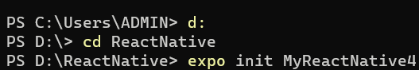

4.Run app in Android OS:

+Open Android Studio and run Emulator

+Run app

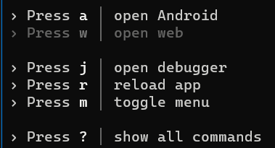

Result:

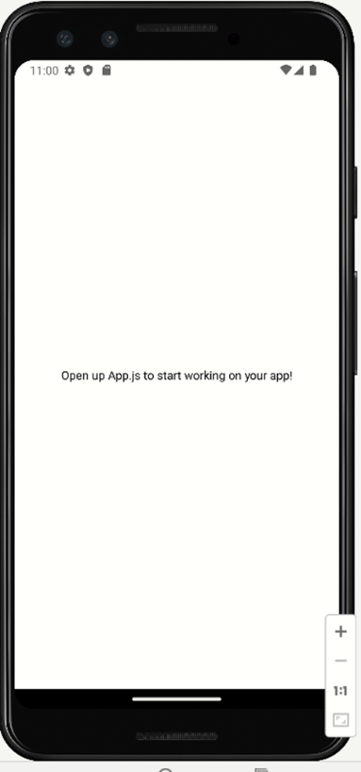

5.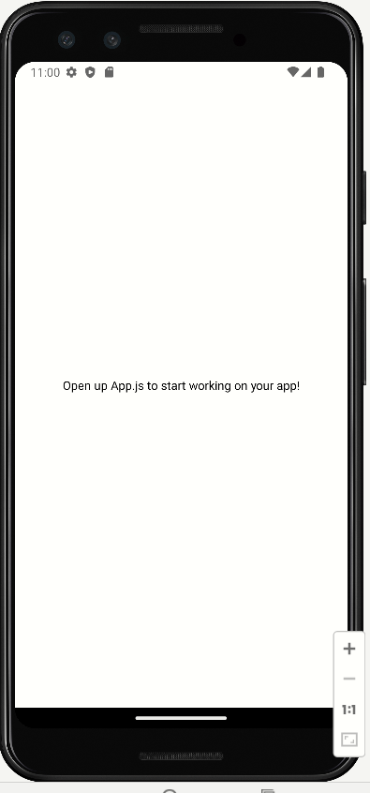Edit app:

+Open App.js

+Edit code and press double r :

export default function App() {

  return (

    <View style={styles.container}>

      <Text>Hello world</Text>

      <StatusBar style="auto" />

    </View>

  );

}

Result:

