**CSCE 110: Programming I**

**Lab 10**

**General Instructions:**

* The lab is due online by 11:59 pm of the due date. The assignment must be typed, not handwritten, or scanned.
* Make sure you understand everything in this lab before getting started. Also, make sure that your programs match the output exactly as given for each question. This is important as one of the keys to being a good programmer is attention to detail.
* Grading is based on correctness and clarity.
* **Copying work from another source and submitting it as your own is plagiarism and a violation of the code of honor. The minimum penalty for plagiarism is a grade of zero and will be reported to the Aggie honor system office.**

**Lab Question**

Sarge's Bagel Hut has asked you to write an application that their staff can use to record an order as it is requested. The general specifications are:

* Customers may call in and order
  + White and whole wheat, onion, or raisin bagels with a variety of toppings
* The application should display
  + The total of the order
* Bagels:
  + White bagel $1.29
  + Whole wheat bagel $1.59
  + Cinnamon Raisin bagel $1.69
  + Onion bagel $1.49
* **Toppings:**
  + Cream cheese $0.50
  + Butter $0.20
  + Blueberry jam $0.70
  + Peach jelly $0.70

**Sample outputs:**

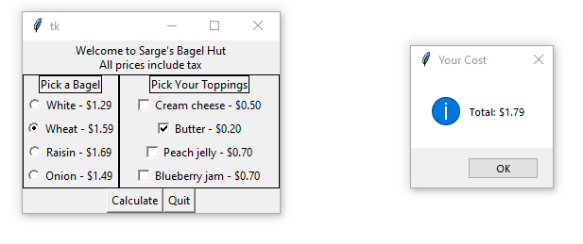

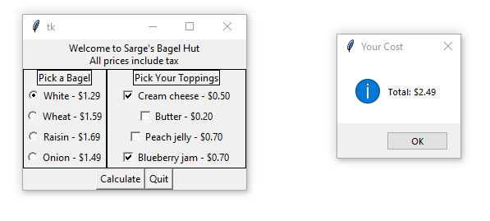

**General Guidance and hints:**

1. Import the appropriate modules (tkinter and tkinter.messagebox as in the lecture) to build your GUI.
2. Create a class for your Order Calculator.
3. Define a constructor (__init__ method) which performs the following operations:
   1. Create three frames: one for the greeting; one for the bagels and toppings; and one for the Calculate and Quit buttons
   2. The middle frame itself will need two inner frames. These should have borders around them.
   3. Create the two line greeting label and add it to the top frame.
   4. Populate the bagel frame:
      1. Create the label with a border around it.
      2. You will need to create an IntVar object for the radio buttons.
      3. Create the four radio buttons.
      4. Add the label and the radio buttons to the frame
      5. Preselect the white bagel
   5. Populate the topping frame:
      1. Create the label with a border around it.
      2. You will need to create an IntVar object for each of the Checkbutton objects
      3. Create the Checkbutton objects.
      4. Add the label and the Checkbutton objects to the frame
   6. Populate the bottom frame by creating the Calculate and Quit buttons and associating the appropriate command to them.
   7. Pack all the frames
4. Define the callback function for the Calculate button
   1. Define the constants of the costs of each bagel and topping if you have not done so previously.
   2. Define the show cost function, computing the total cost of all the options you have chosen.
   3. Round the cost to the nearest penny. (This is necessary, since floating point is never exact).
   4. Display the cost in an info message box.
5. Attempt to replicate the design of the windows as closely as you can.
   1. Lining up the checkbuttons requires additional features of tkinter that we are not covering in this course. If you wish to try to line them up, you are welcome to, but it is not a requirement of this lab.
   2. The graders will be grading based on the appearance and functionality. This is necessary to streamline the grading process so that it can be done efficiently and consistently. (You are welcome to try to refine your design as you wish for your own benefit, but you should turn in a program that mimics the examples given above.)

**Submission instructions:**

Once you have completed your program, submit your file (L10q1.py) electronically.

You may resubmit your files as many times as you need until the due date. Only the most recent submission is graded. You are required to include the following lines in the header of all your files:

|  |
| --- |
| **# File: filename.py # Author: Student name # Date: xx/xx/2021 # Section: Student section number  # E-mail: student_email@tamu.edu  # Description: # e.g. This program asks for ...** |

Submit your files on [gradescope.com](https://www.gradescope.com/)