CSCE 110: Programming I

Spring 2021  
 Lab 2

General Instructions:

* Lab is due online by 11:59 pm of the due date. The assignment must be typed, not handwritten or scanned.
* Label your Python programs q<num>.py, where num is the question number. For example, your solution to the first question, will be stored in the file q1.py.
* Make sure you understand everything in this lab before getting started. Also, make sure your programs match the output exactly as given for each question. This is important as one of the keys to being a good programmer is attention to details.
* Grading will be based on correctness and clarity. Copying work from another source and submitting it as your own is plagiarism. The minimum penalty for plagiarism is a zero on this lab.

# Lab Questions

1. Write a python program stored in a file q1.py that takes edge lengths of a box in feet (*ft*) as input and calculates the sum of all edges and volume of the box. Print the output with four digits after the decimal point. You need to take input in the same line, where different values are separated by a space.

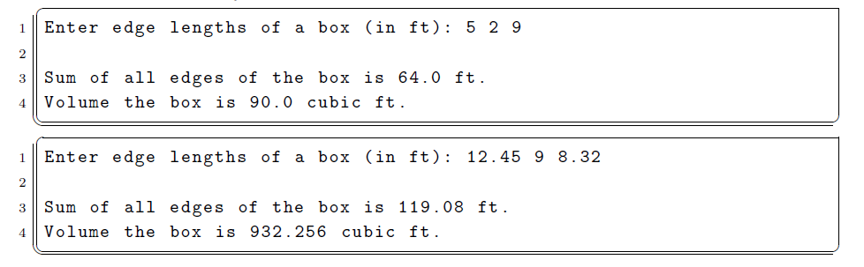

1. Write a program stored in a file q2.py that asks the user for today’s temperature and tomorrow forecast temperature. Afterwards, it prints the temperature difference and the percentage change in the forecast compared to today. The percentage must be rounded to the nearest integer. Please close attention to the wording of the output.

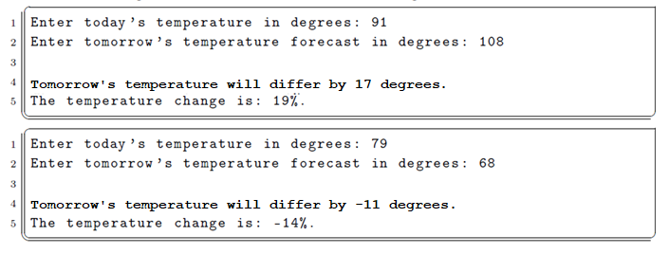

1. Suppose, you would like to apply for a bank loan of $15,000. But, you are not sure about the interest rate and loan period. Therefore, you want to plan ahead and calculate the total pay off amount using the loan amount, loan period and interest rate. Write a Python program stored in a file q2.py that asks the user for loan period (in years) and interest rate (in percentage) as user input and print out the total pay off amount.   
   Total payoff amount *C* can be calculated using the formula *C* = *P*(1 + *r*)*n*, where *P* is the loan amount in dollars), *n* is the loan period (in years), and *r* is the interest rate (0 ≤ *r* ≤ 1).

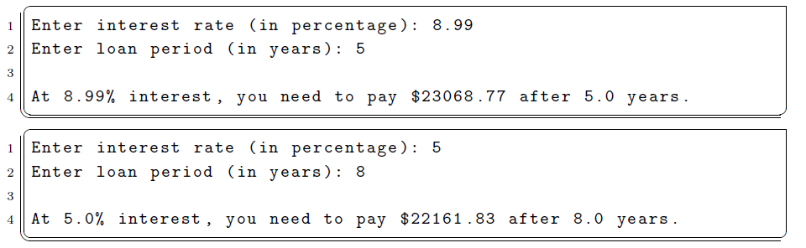

1. Write a program stored in a file q4.py that asks the user for the cost of lunch for five working days and prints out the average cost with two digits after the decimal point. You need to take input in the same line, where different values are separated by a space.

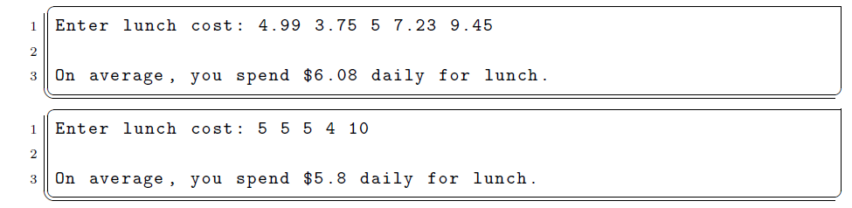

1. Write a program stored in a file q5.py that asks the user to enter a sentence without any punctuation. The program should then print the number of letters and number of vowels in that sentence. For your convenience, you might want to convert the input sentence into uppercase or lowercase.

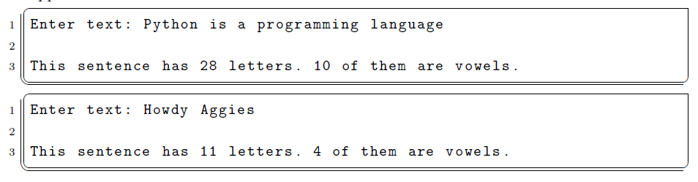

# Submitting Your Assignment

Once you have completed your programs, submit each of them (q1.py, q2.py, q3.py, q4.py, and q5.py) electronically.

You may resubmit your files as many times as necessary until the due date. Only the most recent submission will be graded

You are required to include the following lines in the header of all your files:

# File: filename.py

# Author: Student name

# Date: xx/xx/2021

# Section: Student section number # E-mail: student_email@tamu.edu # Description:

# e.g. This program asks for the coordinates of two points and computes   
# the distance between the two points.

Submit your files on Gradescope