**Magenic Masters React: Week 2 Assignment**

**Pre-requisite**

This assignment assumes that you already configured your local environment and your application layout is already working.

**Deadline**

Deadline is on Feb 2, Thursday EOD

First 5 to submit a working solution will receive +10 on the assignment grade (Send your submission to your proctor assigned and CC the other proctor so we can monitor who submitted first)

**User Story**

As a user, I want to add a new task to Task List table, so I can manage my tasks

**Requirement #1: Task Master List component**

* Create a task table similar to screenshot below

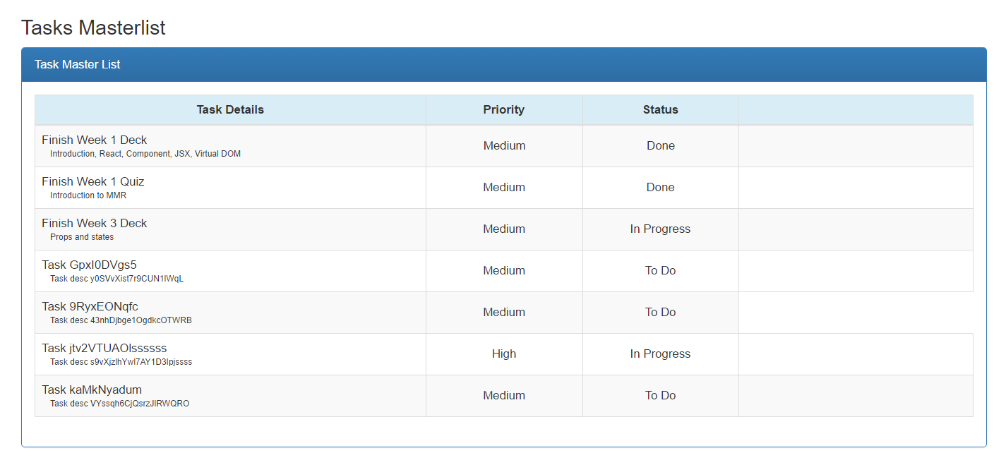

* Task data fieldsl are: TaskId, Name, Description, Priority (1,2,3) and StatusId (Todo, Inprogress, Done)
* You may use HTML Local Storage or Json file to persist your data
* You don’t need to implement Add, Edit or Delete for this assignment
* You need to create your own components, using third party library for table rendering is not allowed
* You may put data logic inside components, we will update this component once we discussed FLUX architecture

**Requirement #2 (+1 Challenge): React Routing**

* Implement routing using [React-Router library](https://www.npmjs.com/package/react-router)
* Update the header component to include navigation menu links similar to screenshot below

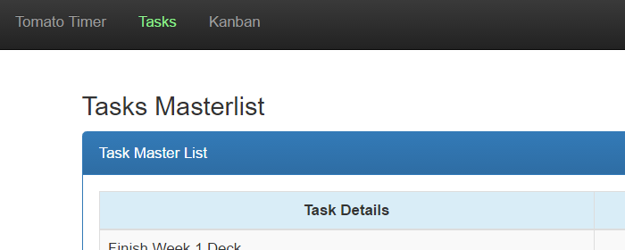

* Clicking on the Tasks menu item will show Tasks Masterlist component
* Successful routing implementation will receive +1 on final grade