**EECE-5626 (IP&PR) : Homework-1**

## Due on September 24, 2020 by 11:59 pm via submission portal.

### NAME: McKean, Tyler



### Instructions:

1. You are required to complete this assignment using Live Editor.
2. Enter your MATLAB script in the spaces provided. If it contains a plot, the plot will be displayed after the script.
3. All your plots must be properly labeled and should have appropriate titles to get full credit.
4. Use the equation editor to typeset mathematical material such as variables, equations, etc.
5. After completing this assignment, export this Live script to PDF and submit the PDF file through the provided submission portal.
6. You will have two attempts to submit your assignment. However, make every effort to submit the correct and completed PDF file the first time. If you use the second attempt, then that submission will be graded.
7. Your submission of problem solutions must be in the given order, i.e., P1, P2, P3, etc. Do not submit in a random order.
8. Please submit your homework before the due date/time. A late submission after midnight of the due date will result in loss of points at a rate of 10% per hour until 8 am the following day, at which time the solutions will be published.

**Reading Assignment**: Chapters 1 and 2 from DIP4E and DSPUM3E.



# Problem-1: DIP4E Problem 2.10

**Solution**:

Assuming the automobile manufacturer provides proper illumination sources within the manufacturing facilities, I would recommend using an RGB sensor, or photodiode, attached to a simple microcontroller like an Arduino to process sensor data from the photodiode. Each color we are trying to determine has a specific energy and wavelength in the visible Electromagnetic spectrum with Blue being 450-495nm, Green being 495-570nm, and Red being the largest at 620-750nm. The RGB sensor uses ratios of the three colors intensities (Red, Green, and Blue) to determine to the color that is being reflected by the object the photodiode is sensing. So, the values for a Red component would have a higher Red intensity from the photodiode, Blue having the most energy of the three would have its highest values in the Blue intensity, and likewise for a Green component and corresponding Green intensity values. Since White light represents light that is balanced in all visible wavelengths, the sensor values of the RGB sensor would be relatively equal for the red, blue, and green intensities. So, colored components would be determined by each individual red, green, and blue intensities and when all three values are close to equal. The price of using an RGB sensor and Arduino would be around $30 at market value. Mechanical motion could also be used like in an assembly line to quickly present the colored component to the sensor and then sort into a bin or immediately move to another stage where the assembly robots can mount the component to the respective sport cars.



# Problem-2: DIP4E Problem 2.13

**Solution**:

**(a)** 

we can then use the mod function on both sides with respect to M to give us

= 

where  must be integer values and the modulus of an integer plus an integer multiple of will only be equal to the first integer, resulting in



**(b)** 

to derive the y-coordinate indices we first start by dividing both sides by  to get



subtract terms to keep  on the left side

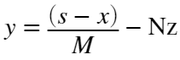

we can then use the mod function on both sides with respect to N to give us

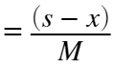

where  must be integer values and the modulus of an integer plus an integer multiple of will only be equal to the first integer, resulting in

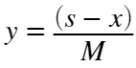



# Problem-3: DIP4E Problem 2.52

**Solution**:

**(a)** Suppose that rearranging and forming the grouping  we can see the range, 

and then being the number of times the value  occurs in the observations means 

Then using Eq (2-110) we'd get 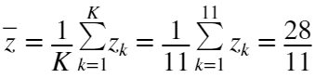 and in a similar manner, if we used  we'd get  rearranging the latter equation, we see that 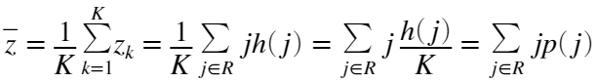 which equates Eq (2-92) to Eq (2-110) and results in the same estimate of the mean.

**(b)**  (Eq. 2-93) and 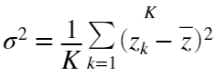 (Eq. 2-111) can be expanded and using substitution from the previous section

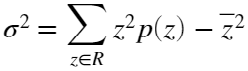

**(c)**  (Eq. 2-96)



# Problem-4: DIP4E Project 2.10

**Solution**:

% Part A

function u = centralMoments4e(f,n)

% Computes the mean, variance, and higher-order statistical central moments

% based on Eq. (2-96) from the DIP4E book. Output u is an n-dimensional

% vector that is computed using p(z), which is the histogram computed from

% input image f to the nth degree based on input n.

%Initialize output u as an n-dimensional array

u = zeros(1,n);

% Compute Histogram of image g

p = imageHist4e(f);

%Check if intensity values are between [0,1] or [0,255] and compute an

%increment variable that will alter values of z

if max(f(:)) <= 1

inc = 1/255;

z = 0:inc:1;

else

inc = 1;

z = 0:inc:255;

end

%Compute the mean

mean = sum(z.*p);

u(1) = mean;

%Compute remaining moments from Eq. 2-96

for i = 2:n

u(i) = sum(((z - mean).^i).*p);

end

end

% Part B

f1 = imread('rose1024.tif');

figure

imshow(f1)

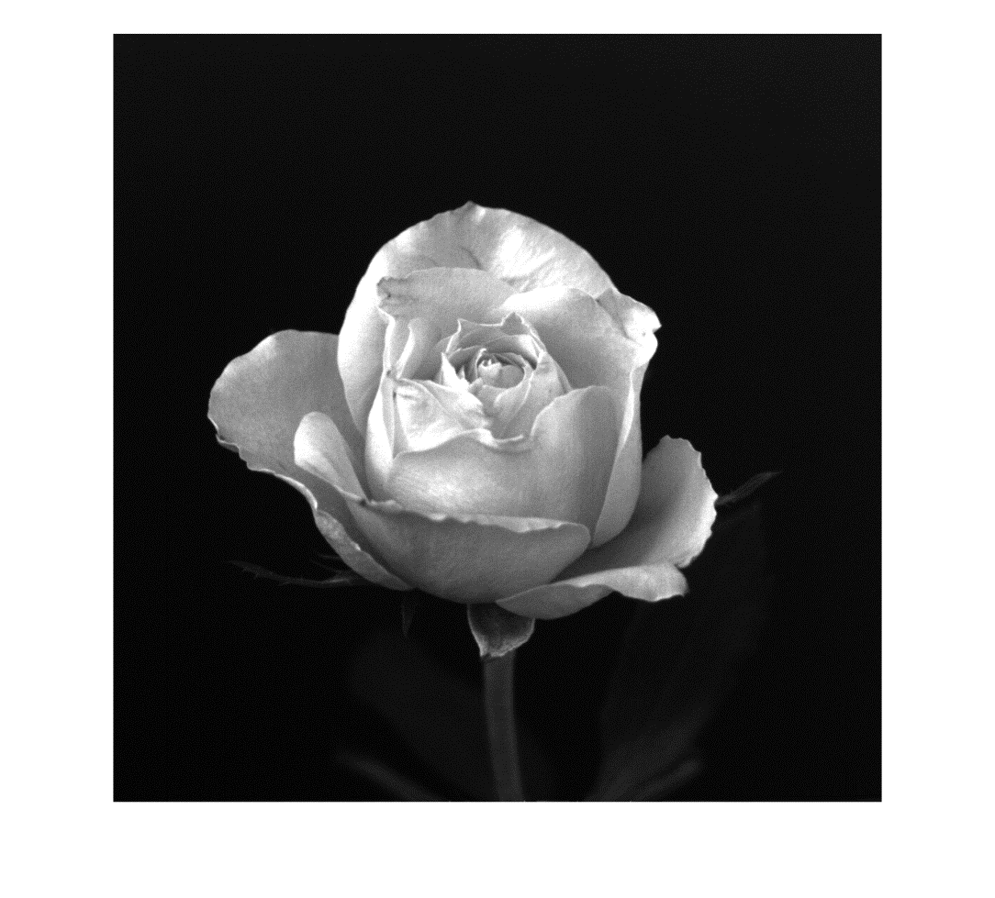

u1 = centralMoments4e(f1,4);

format shortEng

disp(u1)

46.7894e+000 4.3698e+003 503.5215e+003 89.4575e+006

% Part C

f2 = imread('angiography-live-image.tif');

figure

imshow(f2)



u2 = centralMoments4e(f2,4);

display(u2)

u2 = 1×4

129.3007e+000 1.8572e+003 14.9847e+003 10.2903e+006

% Part D

hist1 = imhist(f1);

hist2 = imhist(f2);

bar(hist1,'linewidth',1)

set(gca,'xlim',[0,256],'xtick',(0:64:256));

xlabel('Intensity Level (z)','fontsize',10,'fontweight','bold');

ylabel('Probability Density (p(z))','fontsize',10,'fontweight','bold');

title('Histogram of Rose Image','fontsize',12)

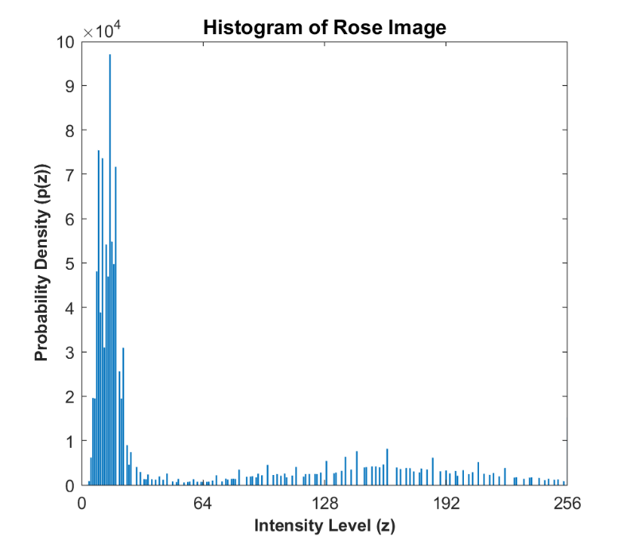

bar(hist2,'linewidth',1)

set(gca,'xlim',[0,256],'xtick',(0:64:256));

xlabel('Intensity Level (z)','fontsize',10,'fontweight','bold');

ylabel('Probability Density (p(z))','fontsize',10,'fontweight','bold');

title('Histogram of Angiography Image','fontsize',10);

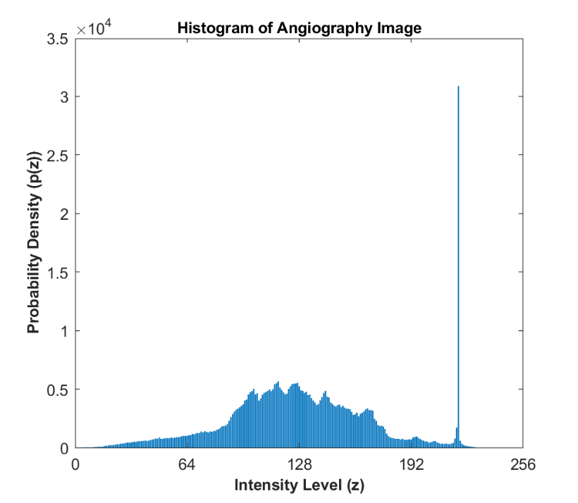

% Part E

The spikes of the histograms represent the number of pixels that represent a certain intensity level with 0 being black and 255 being white. The Rose image had a mean of about 47 indicating that it's average values were darker than most of the total range of intensity and the Angiography image had a mean of about 129 meaning it contained lighter intensities out of the total range of values. The Rose image also had a higher variance value compared to the second image, which indicates that it had a higher contrast than the Angiography image. The third moment value, or skewness, for the second image was also smaller than the first image and resulted in it's histogram being more symmetrical regardless of the thin spike to the right of the mean. Though, both skewness values were positive meaning which explains why both histogram slightly lean towards the left about the mean. The first image had a larger skewness value and explains the influence of the peaks on the left side of the histogram. Regarding the fourth central moment, the kurtosis, the Rose image had a higher value which indicates why the histogram is flatter than the second image that has more of a bell shape.



# Problem-5: DIPUM3E MATLAB Projects 2.3 and 2.6

**Solution**:

**(a)** **MP 2.3**:

function [W,S] = iswholeTest(A)

% ISWHOLETEST Elements of an array that are whole numbers (integers)

% [W,S] = ISWHOLETEST(A) returns a logical array, W, of the same size as A,

% with 1s (TRUE) in the locations corresponding to whole numbers in A, and

% 0s (FALSE) elsewhere. Scalar S is 1 (TRUE) if ALL elements of A are whole

% numbers; otherwise S is 0 (FALSE). A must be a real, numeric array. S is

% used in cases where testing the entire as a unit is required.

L = length(A);

W = logical(zeros(1,L));

for i = 1:L

if (A(i) == floor(A(i)))

W(i) = 1;

elseif (A(i) > floor(A(i)))

W(i) = 0;

end

if (sum(W) == length(A))

S = logical(1);

else

S = logical(0);

end

end

**(b)** **MP 2.6**:

% Part A

function f = testImage(type, param)

%TESTIMAGE Generates gray scale test images.

% F = TESTIMAGE(TYPE,PARAM) generates a grayscale image of size M-by-N and

% class double. TYPE is a string, and PARAM is a vector of parameters, as

% described below:

%

% TYPE PARAM DESCRIPTION

% 'checkerboard' [M,N,n] Checkerboard image of size M-by-N

% with each square of size n-by-n

% pixels. Note: Both M N must be

% divisible by 2n; otherwise the

% checkerboard will not make sense.

% 'unoise' [M,N] Image of size M-by-N whose pixels

% are uniformly distributed random

% numbers in the range [0,1].

% 'gnoise' [M,N] Image of size M-by-N whose pixels

% are random numbers drawn from a standard

% normal distribution (i.e., a normal (Gaussian)

% distribution with mean of 0 and standard

% deviation equal to 1).

% 'vstripe' [M,N,n] M-by-N black image with a white,

% centered, vert stripe n pixels wide.

% n cannot exceed N.

% 'hstripe' [M,N,n] M-by-N black image with a white,

% centered, horz stripe n pixels wide.

% n cannot exceed M.

t = string(type);

% First parameter 'checkerboard'

if(t == 'checkerboard')

M = param(1);

N = param(2);

n = param(3);

n2 = 2*n;

if( iswholeTest(M/(2*n)) ~= 1)

error('M and N are not divisible by 2n!');

end

f = zeros(M,N);

f = (checkerboard(n, M/n2, N/n2) > 0.5);

end

% Second parameter 'unoise'

if(t == 'unoise')

M = param(1);

N = param(2);

f = zeros(M,N);

f = rand(M,N);

end

% Third parameter 'gnoise'

if(t == 'gnoise')

M = param(1);

N = param(2);

mu = 0; sig = 1;

f = sig.*randn(M,N,'double') + mu;

end

% Fourth parameter 'vstripe'

if(t == 'vstripe')

M = param(1);

N = param(2);

n = param(3);

if( n > N)

error('value of n cannot exceed value of N!')

end

f = zeros(M,N);

f(:,(M/2-n : M/2+n)) = 1;

end

% Fifth parameter 'hstripe'

if(t == 'hstripe')

M = param(1);

N = param(2);

n = param(3);

if( n > M)

error('value of n cannot exceed value of M!')

end

f = zeros(M,N);

f((M/2-n : M/2+n),:) = 1;

end

end

% Part B

M = 512;

N = 512;

f_checkerboard = testImage('checkerboard', [M, N, 32]);

figure, imshow(f_checkerboard)



f_unoise = testImage('unoise',[M,N]);

figure,imshow(f_unoise)



f_gnoise = testImage('gnoise',[M,N]);

figure,imshow(f_gnoise)



f_vert = testImage('vstripe',[M,N, 100]);

figure,imshow(f_vert)



f_horz = testImage('hstripe',[M,N, 55]);

figure,imshow(f_horz)





# Problem-6: DIPUM3E MATLAB Project 2.8

**Solution**:

% Part A

function infoC = myimageinfoC(f)

%MYIMAGEINFOC Numerical information about an image.

%INFO = MYIMAGEINFOC(F) extracts numerical information from image F and

%outputs it using the following cell array forms. In general, F canbe of

% size M-by-N-by-P, with P >= 1 (for example, for RGB images, P = 3).

%

% infoC{1} = number of rows in the image.

% infoC{2} = number of columns.

% infoC{3} = number of image planes.

% infoC{4}(I) = maximum value of each image plane, I = 1:P.

% infoC{5}(I) = minimum value each image plane, I = 1:P.

infoC{1} = size(f,1);

infoC{2} = size(f,2);

infoC{3} = size(f,3);

P = infoC{3};

C_max = {zeros(1:P)};

C_min = {zeros(1:P)};

% Calculate MAX and MIN values of image planes

for i = 1:P

C_max{i} = max(max(f(:,:,i)));

C_min{i} = min(min(f(:,:,i)));

end

infoC{4} = C_max;

infoC{5} = C_min;

end

% Part B

f = imread('ballerina.tif');

figure, imshow(f)



infoC = myimageinfoC(f)

infoC = 1×5 cell

|  | **1** | **2** | **3** | **4** | **5** |
| --- | --- | --- | --- | --- | --- |
| **1** | 644 | 656 | 3 | 1×3 cell | 1×3 cell |

num_rows = infoC{1}

num_rows = 644

num_cols = infoC{2}

num_cols = 656

num_image_planes = infoC{3}

num_image_planes = 3

max_img_planes = infoC{4}

max_img_planes = 1×3 cell

|  | **1** | **2** | **3** |
| --- | --- | --- | --- |
| **1** | 255 | 255 | 255 |

min_img_planes = infoC{5}

min_img_planes = 1×3 cell

|  | **1** | **2** | **3** |
| --- | --- | --- | --- |
| **1** | 0 | 0 | 1 |

format short



# Problem-7

Let  be an input image,  be an impulse response, and  be the corresponding output image obtained via the 2-D convolution. Prove the following volume conservation property:

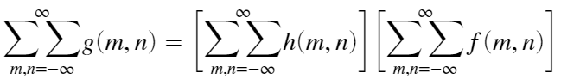

**Proof**:

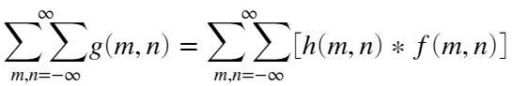

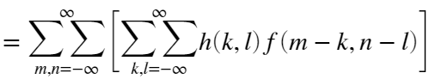

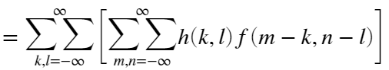

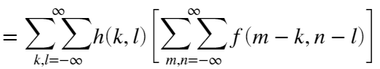

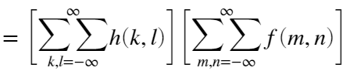

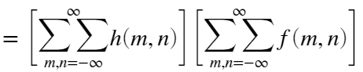



# Problem-8

Consider the following two-dimensional signal , where the bracketed element denotes the  location

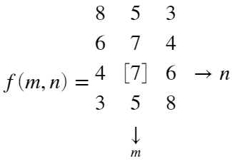

**(a)** Determine the convolution of  with each of the following signals

**i.** 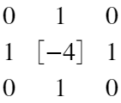

**Solution** :

f1 = [8, 5, 3; 6, 7, 4; 4, 7, 6; 3, 5, 8];

h1 = [0, 1, 0; 1, -4, 1; 0, 1, 0];

g1 = conv2(f1,h1)

g1 = 6×5

0 8 5 3 0

8 -21 -2 -3 3

6 -5 -6 0 4

4 0 -6 -5 6

3 -3 -2 -21 8

0 3 5 8 0

**ii.** 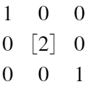

**Solution** :

f2 = [8, 5, 3; 6, 7, 4; 4, 7, 6; 3, 5, 8];

h2 = [1, 0, 0; 0, 2, 0; 0, 0, 1];

g2 = conv2(f2,h2)

g2 = 6×5

8 5 3 0 0

6 23 14 6 0

4 19 28 13 3

3 13 28 19 4

0 6 14 23 6

0 0 3 5 8

**iii.** 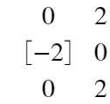

**Solution** :

f3 = [8, 5, 3; 6, 7, 4; 4, 7, 6; 3, 5, 8];

h3 = [0, 2; -2, 0; 0, 2];

g3 = conv2(f3,h3)

g3 = 6×4

0 16 10 6

-16 2 8 8

-12 10 16 18

-8 4 12 24

-6 -2 -2 12

0 6 10 16

**(b)** Verify your answers in each case via the ***volume conservation*** property proved in **Problem 7** above.

**Solution** :

% For each convolution operated above, the resulting g(m,n) should equal to

% the sum of the product of h(m,n) and f(m,n)

% First Convolution

sum_f1 = sum(sum(f1)); sum_h1 = sum(sum(h1)); sum_g1 = sum(sum(g1));

if(sum_g1 == sum_h1 * sum_f1)

disp('volume conservation property verified')

end

volume conservation property verified

% Second Convolution

sum_h2 = sum(sum(h2)); sum_g2 = sum(sum(g2));

if(sum_g2 == sum_h2 * sum_f1)

disp('volume conservation property verified')

end

volume conservation property verified

% Third Convolution

sum_h3 = sum(sum(h3)); sum_g3 = sum(sum(g3));

if(sum_g3 == sum_h3 * sum_f1)

disp('volume conservation property verified')

end

volume conservation property verified

# 

# Functions

P4 - DIP4E 2.10 function

function u = centralMoments4e(f,n)

% Computes the mean, variance, and higher-order statistical central moments

% based on Eq. (2-96) from the DIP4E book. Output u is an n-dimensional

% vector that is computed using p(z), which is the histogram computed from

% input image f to the nth degree based on input n.

%Initialize output u as an n-dimensional array

u = zeros(1,n);

% Compute Histogram of image g

p = imageHist4e(f);

%Check if intensity values are between [0,1] or [0,255] and compute an

%increment variable that will alter values of z

if max(f(:)) <= 1

inc = 1/255;

z = 0:inc:1;

else

inc = 1;

z = 0:inc:255;

end

%Compute the mean

mean = sum(z.*p);

u(1) = mean;

%Compute remaining moments from Eq. 2-96

for i = 2:n

u(i) = sum(((z - mean).^i).*p);

end

end

P5 - DIPUM3E Matlab Project 2.3 function

function [W,S] = iswholeTest(A)

% ISWHOLETEST Elements of an array that are whole numbers (integers)

% [W,S] = ISWHOLETEST(A) returns a logical array, W, of the same size as A,

% with 1s (TRUE) in the locations corresponding to whole numbers in A, and

% 0s (FALSE) elsewhere. Scalar S is 1 (TRUE) if ALL elements of A are whole

% numbers; otherwise S is 0 (FALSE). A must be a real, numeric array. S is

% used in cases where testing the entire as a unit is required.

L = length(A);

W = logical(zeros(1,L));

for i = 1:L

if (A(i) == floor(A(i)))

W(i) = 1;

elseif (A(i) > floor(A(i)))

W(i) = 0;

end

if (sum(W) == length(A))

S = true;

else

S = logical(0);

end

end

end

P5 - DIPUM3E Matlab Project 2.6 function

function f = testImage(type, param)

%TESTIMAGE Generates gray scale test images.

% F = TESTIMAGE(TYPE,PARAM) generates a grayscale image of size M-by-N and

% class double. TYPE is a string, and PARAM is a vector of parameters, as

% described below:

%

% TYPE PARAM DESCRIPTION

% 'checkerboard' [M,N,n] Checkerboard image of size M-by-N

% with each square of size n-by-n

% pixels. Note: Both M N must be

% divisible by 2n; otherwise the

% checkerboard will not make sense.

% 'unoise' [M,N] Image of size M-by-N whose pixels

% are uniformly distributed random

% numbers in the range [0,1].

% 'gnoise' [M,N] Image of size M-by-N whose pixels

% are random numbers drawn from a standard

% normal distribution (i.e., a normal (Gaussian)

% distribution with mean of 0 and standard

% deviation equal to 1).

% 'vstripe' [M,N,n] M-by-N black image with a white,

% centered, vert stripe n pixels wide.

% n cannot exceed N.

% 'hstripe' [M,N,n] M-by-N black image with a white,

% centered, horz stripe n pixels wide.

% n cannot exceed M.

t = string(type);

% First parameter 'checkerboard'

if(t == 'checkerboard')

M = param(1);

N = param(2);

n = param(3);

n2 = 2*n;

if( iswholeTest(M/(2*n)) ~= 1)

error('M and N are not divisible by 2n!');

end

f = zeros(M,N);

f = (checkerboard(n, M/n2, N/n2) > 0.5);

end

% Second parameter 'unoise'

if(t == 'unoise')

M = param(1);

N = param(2);

f = zeros(M,N);

f = rand(M,N);

end

% Third parameter 'gnoise'

if(t == 'gnoise')

M = param(1);

N = param(2);

mu = 0; sig = 1;

f = sig.*randn(M,N,'double') + mu;

end

% Fourth parameter 'vstripe'

if(t == 'vstripe')

M = param(1);

N = param(2);

n = param(3);

if( n > N)

error('value of n cannot exceed value of N!')

end

f = zeros(M,N);

f(:,(M/2-n : M/2+n)) = 1;

end

% Fifth parameter 'hstripe'

if(t == 'hstripe')

M = param(1);

N = param(2);

n = param(3);

if( n > M)

error('value of n cannot exceed value of M!')

end

f = zeros(M,N);

f((M/2-n : M/2+n),:) = 1;

end

end

P6: DIPUM3E Matlab Project 2.8 function

function infoC = myimageinfoC(f)

%MYIMAGEINFOC Numerical information about an image.

% INFO = MYIMAGEINFOC(F) extracts numerical information from image F and

% outputs it using the following cell array forms. In general, F can be of

% size M-by-N-by-P, with P >= 1 (for example, for RGB images, P = 3).

%

% infoC{1} = number of rows in the image.

% infoC{2} = number of columns.

% infoC{3} = number of image planes.

% infoC{4}(I) = maximum value of each image plane, I = 1:P.

% infoC{5}(I) = minimum value each image plane, I = 1:P.

infoC{1} = size(f,1);

infoC{2} = size(f,2);

infoC{3} = size(f,3);

P = infoC{3};

C_max = {zeros(1:P)};

C_min = {zeros(1:P)};

% Calculate MAX and MIN values of image planes

for i = 1:P

C_max{i} = max(max(f(:,:,i)));

C_min{i} = min(min(f(:,:,i)));

end

infoC{4} = C_max;

infoC{5} = C_min;

end