Data was originally downloaded from here: https://celltypes.brain-map.org/data
Download Cell Feature Data
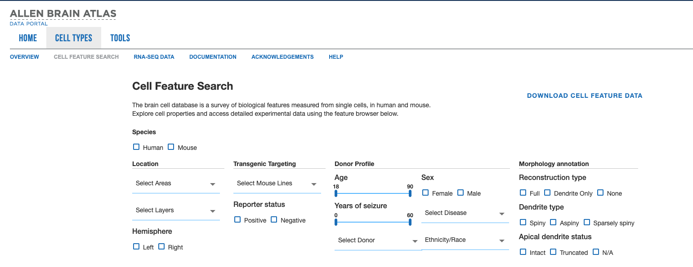

Date of download: 11/10/2023
Main website: https://celltypes.brain-map.org/

Column names in the csv file
- Order is based on appearance (not alphabetical)

Cell Metadata Descriptions
- line_name – Indicates the cell types that were labeled with Cre-recombinase
- genetic manipulation- mouse only
- specimen_id – A unique identifier
- Note: an individual can contribute multiple cells; in that case, the same specimen_id differs across rows, but the donor__id remains the same
- specimen_name – A unique identifier
- Human cells start with 'H’
- Each ID is unique, but donor__id is the same for cells from the same donor
- specimen_hemisphere – Indicates whether the sample is from the right or left side of the brain
- structure_id – Unique number for the brain structure
- structure_name – Full name of the brain region
- structure_acronym – Abbreviated text code for the brain region
- structure_parent_id – More general numerical code for the broader brain region (not layer-specific)
- structure_parent_acronym – Abbreviated text code for the parent brain region (no cortical layer info)
- structure_layer – Indicates the cortical layer of the brain

Morphological Features
- nr__max_euclidean_distance – Maximum Euclidean distance of a branch and its path length (µm)
- nr__number_stems – Number of processes attached to the soma
- nr__number_bifurcations – Number of points where a process splits into two daughter branches
- nr__average_contraction – Average ratio between Euclidean distance of a branch and its path length
- nr__average_parent_daughter_ratio – Average ratio between the diameter of a daughter branch and its parent branch
- nr__reconstruction_type – Indicates whether reconstruction is full or dendrite-only (empty if N/A)
- nrwkf_id – Identifier (purpose unclear in documentation)
- erwkf_id – Identifier (purpose unclear in documentation)

Electrophysiological Features (ef)
- ef__fast_trough_v_long_square – Minimum membrane potential value within 5 ms after the peak
- ef__upstroke_downstroke_ratio_long_square – Ratio between absolute values of AP peak upstroke and downstroke
- ef__adaptation – Rate at which firing speeds up or slows down during a stimulus
- ef__f_i_curve_slope – Slope of the curve between firing rate (f) and injected current (i)
- ef__threshold_i_long_square – Current (pA) required to elicit an action potential (threshold) during a 1-second long square current injection
- ef__tau – Membrane time constant (ms)
- ef__avg_isi – Mean interspike interval within a sweep
- ef__avg_firing_rate – Average firing rate (spikes/s)
- ef__ri – Input resistance (MΩ)
- ef__peak_t_ramp – Timestamp of the maximum membrane potential during an AP in response to a ramp stimulus
- ef__vrest – Resting membrane potential (mV)

Additional Morphological Features
- si__height – Measurement (details unclear in documentation)
- si__width – Measurement (details unclear in documentation)
- si__path – File path to specimen details (likely not relevant)
- csl__x – 3D compartment position (x-coordinate) for morphology reconstructions
- csl__y – 3D compartment position (y-coordinate) for morphology reconstructions
- csl__z – 3D compartment position (z-coordinate) for morphology reconstructions
- csl__normalized_depth – Depth of the soma normalized between pia (0) and white matter (1)
- cell_reporter_status – Reporter expression status (mouse only; positive or negative)
- m__glif – Indicates the existence of a generalized leaky integrate-and-fire (GLIF) model for the cell (number indicates type; 0 = none)
- m__biophys – Indicates existence of a biophysical model (0 = none)
- m__biophys_perisomatic – Indicates a perisomatic biophysical model (0 = none)
- m__biophys_all_active – Indicates an all-active biophysical model (0 = none)
- tag__apical – Extent of apical dendrite preservation (intact or truncated; N/A if not applicable)
- tag__dendrite_type – Type of dendritic spines: spiny, aspiny, or sparsely spiny
- morph_thumb_path – File path to morphology thumbnail (not relevant)
- ehpys_thumb_path – File path to electrophysiology thumbnail (not relevant)
- ephys_inst_thresh_thumb_path – File path to electrophysiology threshold thumbnail (not relevant)

Donor Characteristics
- donor__age – Age (years)
- donor__sex – Biological sex (Male or Female)
- donor__disease_state – Disease state for human tissue (e.g., tumor or epilepsy)
- donor__race – Race/ethnicity of the human donor
- donor__years_of_seizure_history – Duration of seizure history (0 = none)
- donor__species – Species: mouse (Mus musculus 🐭) or human (Homo sapiens 🧑)
- donor__id – Unique ID assigned to the individual (pairs with donor__name)
- donor__name – Shortened identifier (prefix of specimen_id)

Resources/More Information:
https://community.brain-map.org/c/how-to/cell-types-db/32
https://community.brain-map.org/t/cell-types-database-api/3016
https://community.brain-map.org/t/cell-types-database-physiology-and-morphology/2987

