Wyndos User Guide
Quick start, full instructions and worker guide
September 2026

Contents
- Welcome to Wyndos
- Quick start
- Getting around
- Working a day
- Planning with the Scheduler
- Areas and frequency
- Customers
- Quotes and one-off jobs
- Payments and accounting
- Texts
- Printing and sharing the day
- Settings
- Worker guide
- FAQ and troubleshooting

Welcome to Wyndos
Wyndos runs a window-cleaning round from one place. It holds your customers and the areas they belong to, plans which day each area is cleaned, and gives you and your team a simple list to work through on the phone. It also records who has paid and sends the reminder texts.

Who this guide is for
If you are… | Start here
The owner setting Wyndos up for the first time | Quick start
The owner or office, day to day | Getting around, then the chapters you need
A worker on the round | Worker guide. It stands on its own, so you can send just that chapter to new starters
Anyone stuck | FAQ and troubleshooting

How the screenshots work
Most screenshots have red numbered boxes. Each number is explained in the list under the picture.
- Pictures with a dark menu down the left side are from a computer.
- Tall narrow pictures are from a phone.
The screens are the same on both. The phone just stacks things vertically and puts the menu along the bottom.
Tip: Boxes like this one hold tips and warnings.

Five words worth knowing
- Area: a group of customers you clean together, such as a village or an estate. Each area has its own frequency, for example every 4 weeks. A customer’s frequency always comes from their area.
- Day: one area booked on one date. A date can have several days on it, such as Cuckney and Edwinstowe both on Tuesday.
- Job: one customer’s clean on a day.
- Done / Done & Paid: how a job is ticked off. Use Done when they’ll pay later and Done & Paid when they paid at the door.
- Carry over: jobs you didn’t get to move on to another date when you finish the day.

Quick start
This gets a new business from an empty account to a first worked day in about half an hour. Each step links to the full instructions.

1. Sign in
Go to wyndos.io and sign in with your email and password.
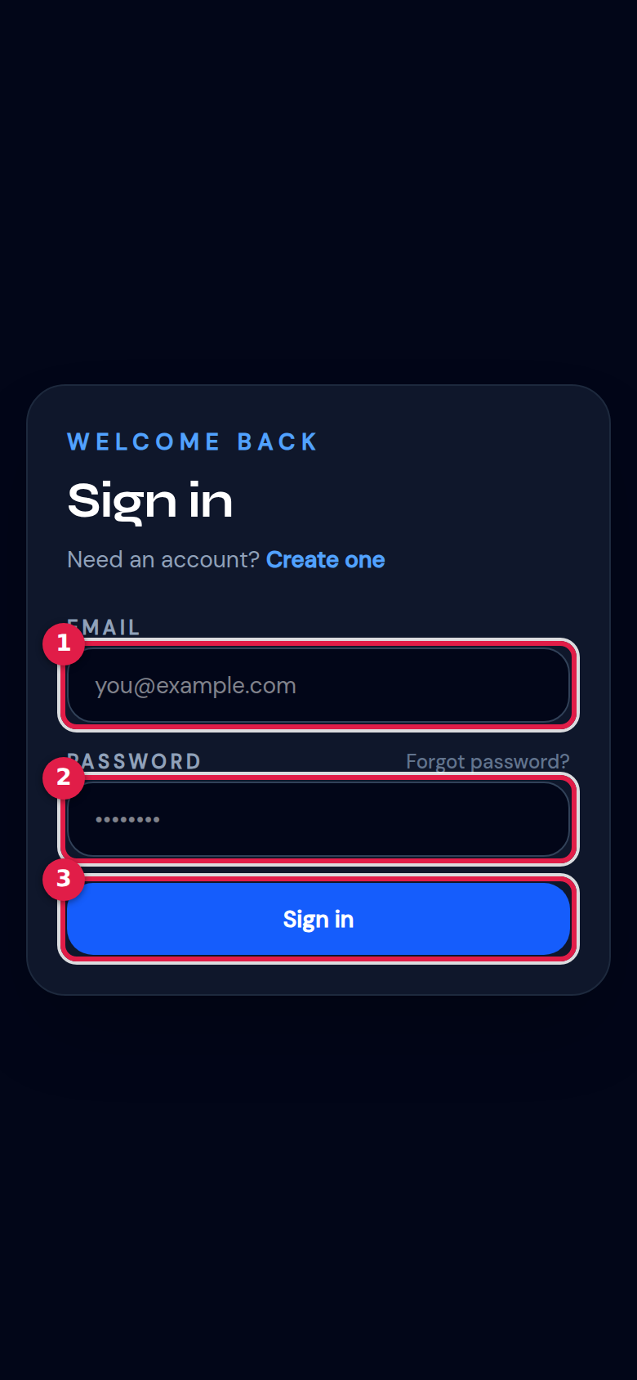
Sign-in screen on a phone
- Your email address.
- Your password. If you’ve forgotten it, use Forgot password?.
- Sign in.
Tip: On a phone, add Wyndos to your home screen. It then opens like an app and keeps working when the signal drops. See Install on your phone.

2. Fill in your business details
Open Settings → Business. Enter your business name, phone number and address, and put your bank / payment details in the box near the bottom. These details appear on invoices and in the “windows cleaned, here’s how to pay” text. Press Save Changes.
See Settings → Business.

3. Create your areas
Open Areas and press + Add Area for each village or estate you clean. For each one, set:
- how often it’s cleaned (every 4 weeks, for example)
- when it’s next due
Every customer in an area follows that area’s frequency. If some customers need a different frequency, give them their own area, for example “Cuckney (8 weekly)”.
See Areas and frequency.

4. Add your customers
You can add customers in either of two ways:
- Import a spreadsheet. Go to Customers → Import and upload your existing list (Excel or CSV). This is best if you have more than a handful. See Importing customers.
- Add them one by one. Go to Customers → + Add Customer. See Adding a customer.
After importing, open Customers → Tidy addresses and check that the house, street and town were split correctly. The street order on your day sheets depends on it.

5. Put the areas in the diary
Open the Scheduler on a computer and drag each area onto the day you’ll clean it. After that, Wyndos books each area’s next visit for you whenever you complete a day.
See Planning with the Scheduler.

6. Invite your team (optional)
In Settings → Team, type a worker’s email, choose Worker, Senior worker or Office / admin, and press Send invite. They set their own password. You decide exactly what each person can see.
See Team and permissions.

7. Choose how texts are sent
In Settings → Messaging, choose how texts go out:
- From my phone (free): each text opens in your phone’s Messages app ready to send.
- Automatic (VoodooSMS): texts are sent for you.
While you’re getting started, leave Test mode on. Texts are then only written to the log and nothing reaches customers.
See Texts.

8. Work your first day
On your phone, open Schedule and tap Work today as one list.
- Press Start day.
- Tick each house off with Done or Done & Paid as you go.
- When you’re finished, press Complete Day. Anything you didn’t get to is carried over.
See Working a day.
That’s it. From now on, completing an area books its next visit automatically. Your daily routine is: open today, work the list, complete the day.

Getting around

On a computer
The menu runs down the left-hand side. You only see the items your permissions allow. The owner sees all of them.
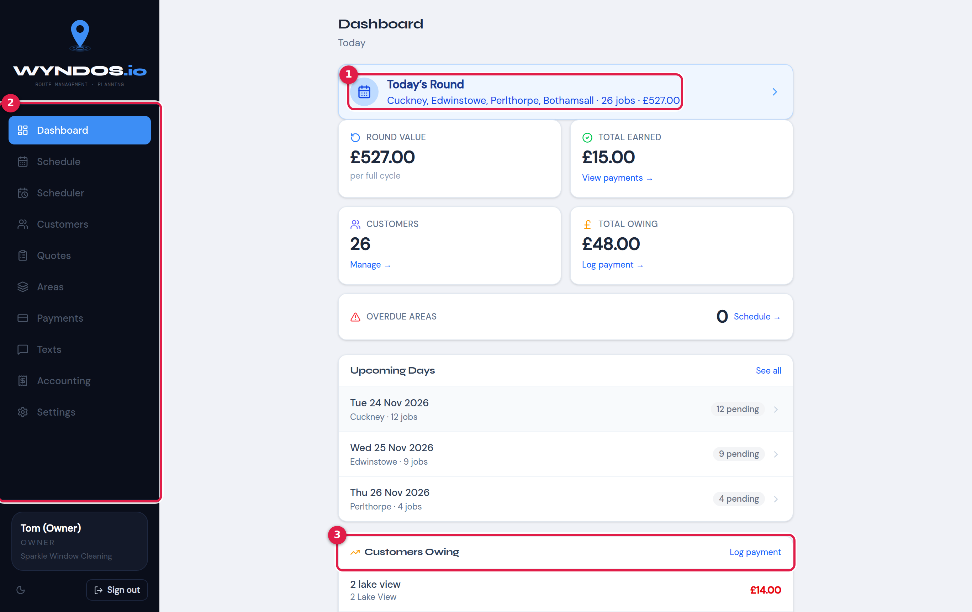
Dashboard on a computer
- Today’s Round: the areas booked for today, with job count and value. Click it to open today’s work.
- The menu:
  - Dashboard: today at a glance.
  - Schedule: your list of days.
  - Scheduler: the planning diary. This is on computers only.
  - Customers, Quotes, Areas and Payments.
  - Texts: reminders and bulk messages.
  - Accounting: income, expenses and tax year.
  - Settings.
- Customers Owing: who owes you money, with a shortcut to log a payment.
The dashboard also shows the round value, what’s been earned, how many customers you have, the total owed, any overdue areas, and the next few booked days.

On a phone
On a phone the menu moves to a bar along the bottom. The round + button in the middle opens Quick add.
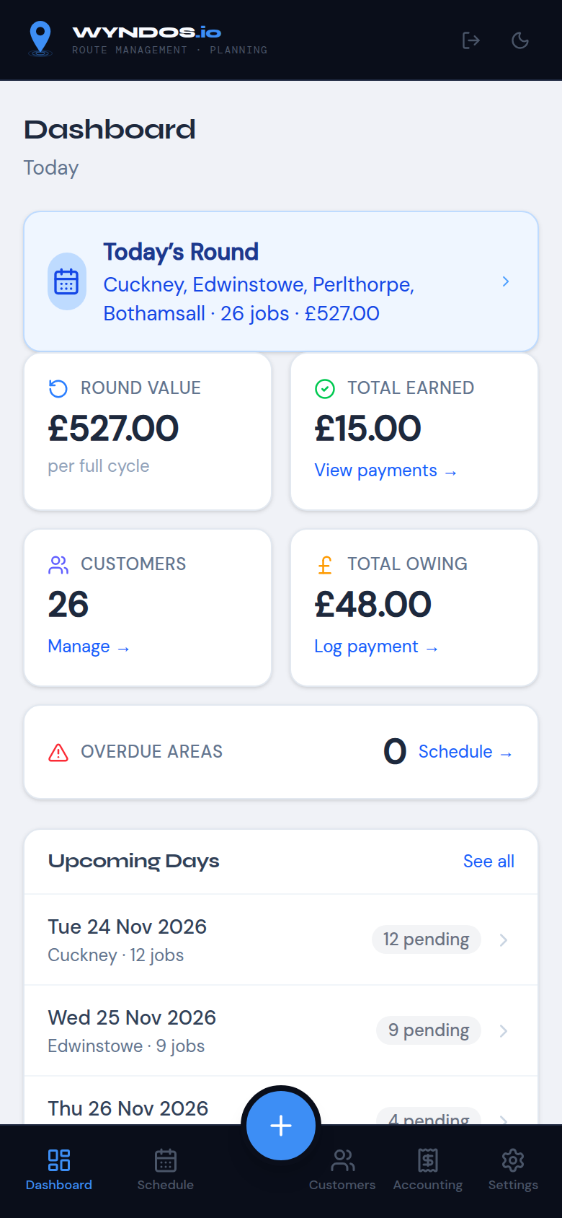
Dashboard on a phone
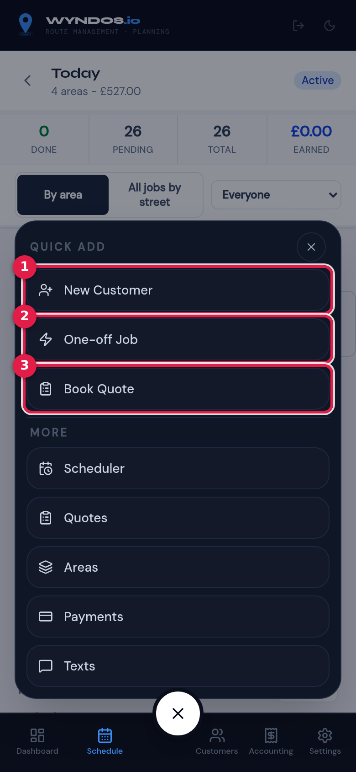
Quick add menu
- New Customer: add a customer.
- One-off Job: book a single clean for a new or existing customer on any date.
- Book Quote: book a visit to price up a new customer.
Under More are the pages that don’t fit on the bottom bar: Scheduler, Quotes, Areas, Payments, Texts and so on.

Install Wyndos on your phone
Wyndos works in the phone’s web browser, but it’s better installed on the home screen:
- iPhone (Safari): tap the Share button, then Add to Home Screen.
- Android (Chrome): tap the ⋮ menu, then Install app or Add to Home screen. Wyndos may also offer “Add Wyndos to home screen” itself.
Once installed, Wyndos opens full-screen and keeps working with no signal. If you tick jobs off offline, they’re saved on the phone and sent as soon as signal returns. If something couldn’t be saved, you’ll see a warning: “Some offline changes couldn’t be saved”.

Light and dark mode
The moon or sun button at the top (on a phone) or bottom-left (on a computer) switches between light and dark mode.

Signing out
Use the Sign out button: at the bottom-left on a computer, or the arrow icon at the top on a phone.

Working a day
This is the screen you’ll use most. It’s designed for a phone in one hand, but it works just as well on a computer.

Open the day
Tap Schedule on the bottom bar. Today’s areas are listed at the top.
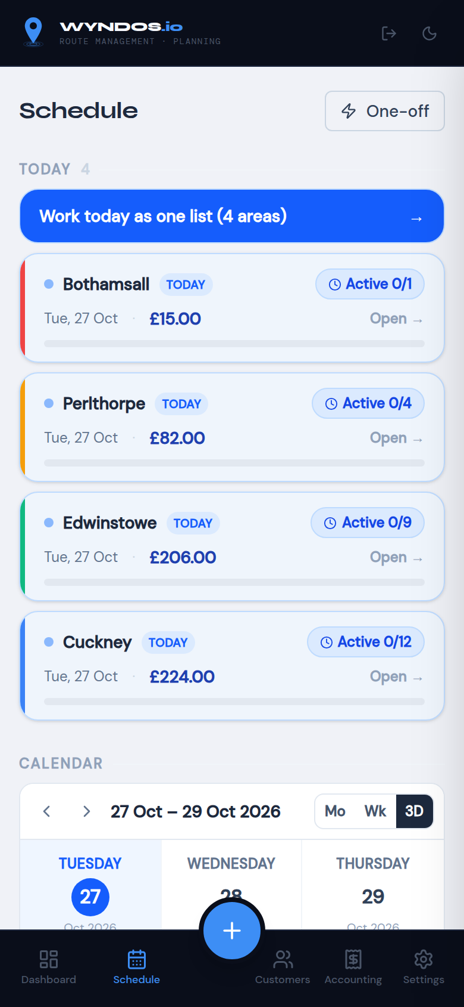
Schedule list
- Tap Work today as one list to see every area booked today in one list. This is usually what you want.
- Tap a single area (for example Cuckney → Open) to see only that area.
- Use One-off to book a single extra job.

The day screen
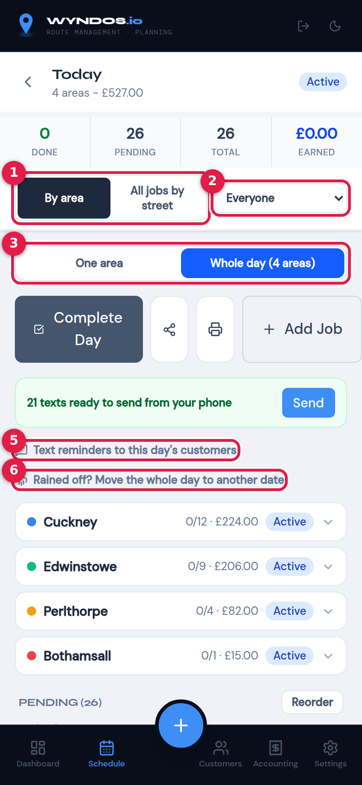
Whole day, grouped by area
The four boxes at the top show jobs Done, Pending, Total and money Earned so far. Below them:
- By area / All jobs by street: how the list is arranged.
  - By area keeps each area together, in your saved route order.
  - All jobs by street mixes every area into one list, sorted by town, then street, then house number. This is handy when areas overlap.
- Show jobs for: filter to one person’s jobs, or show Everyone.
- One area / Whole day: switch between the single area and every area booked on this date.
- Start day: marks the day as under way. It then changes to Complete Day. Next to it are:
  - Share: sends the day as a PDF.
  - Print: opens the run sheet.
  - Add Job: adds a one-off job to the day.
- Text reminders: text everyone on this day. See Texts.
- Rained off?: move the whole day to another date. See Rained off.

Area cards
Each area booked today has a card showing jobs done out of total, value and status. Tap a card to open it.
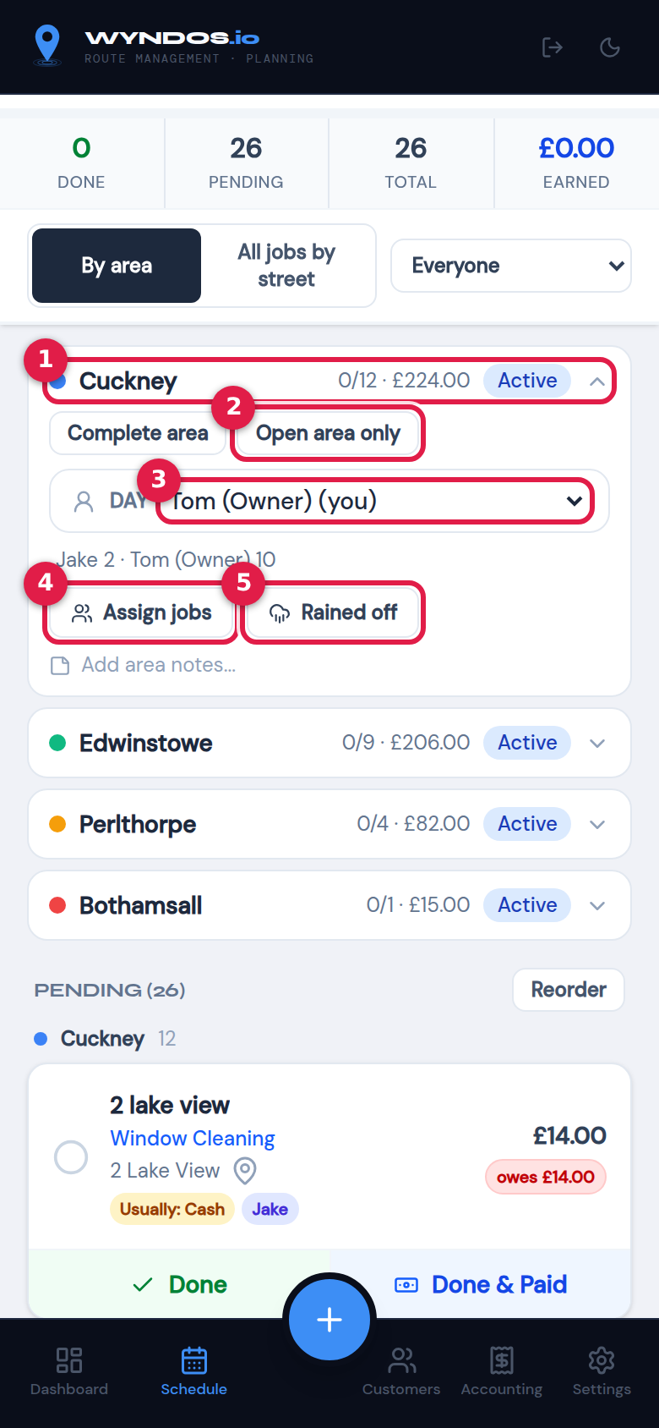
An opened area card
- The area. Tap it again to close the card.
- Open area only: jump to just this area’s page.
- Who is doing this day: give the whole area to one person. The line underneath shows how the jobs are split, for example “Jake 2 · Tom 10”.
- Assign jobs: split the area’s jobs between people (see below).
- Rained off: move just this area to another date.
Under those buttons you can add area notes, such as “park by the church”, which everyone working the area will see.

Split jobs between workers
Tap Assign jobs. Tick the jobs you want to hand out, then choose who does them. Each job shows who has it now.
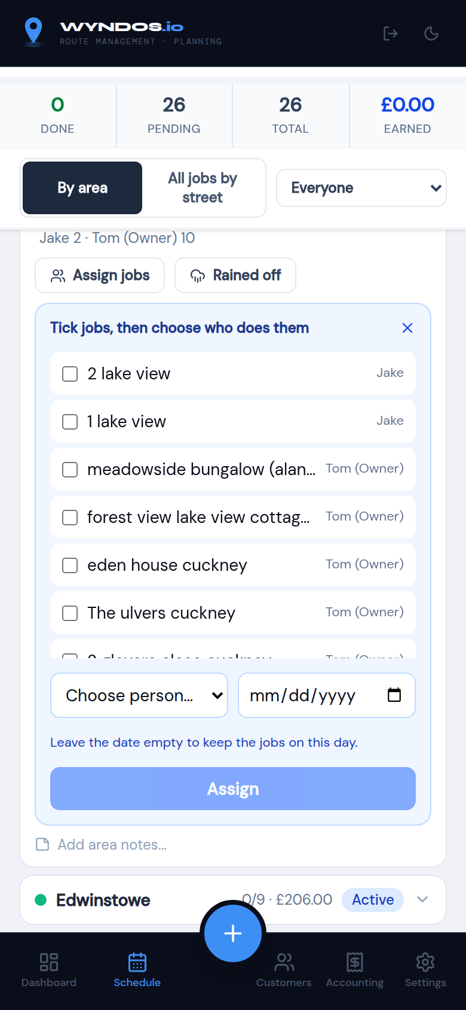
Assign jobs panel
Workers only see the jobs given to them. Use Show jobs for at the top to check one person’s list.

Ticking off jobs
Every job has a card:
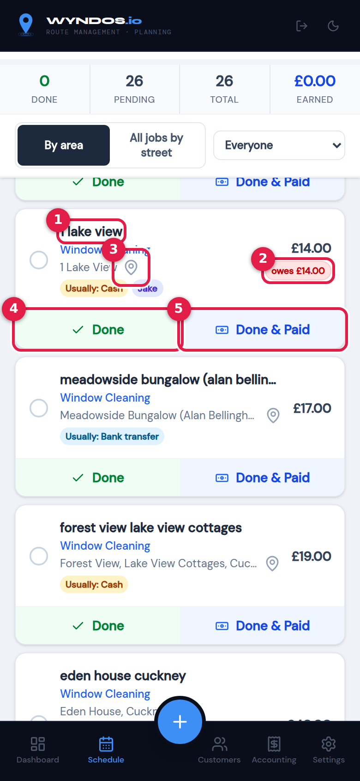
A job card
- The customer, their job type and address. Tap the name to open the job’s options (see below).
- Owes £…: they have unpaid cleans from before. The coloured tags show how they usually pay (Cash, Bank transfer and so on) and who the job is assigned to.
- Map pin: opens the address in Google Maps.
- Done: the job is finished but not paid. It’s added to what they owe.
- Done & Paid: the job is finished and paid at the door.

Done & Paid
When you tap Done & Paid, choose how they paid:
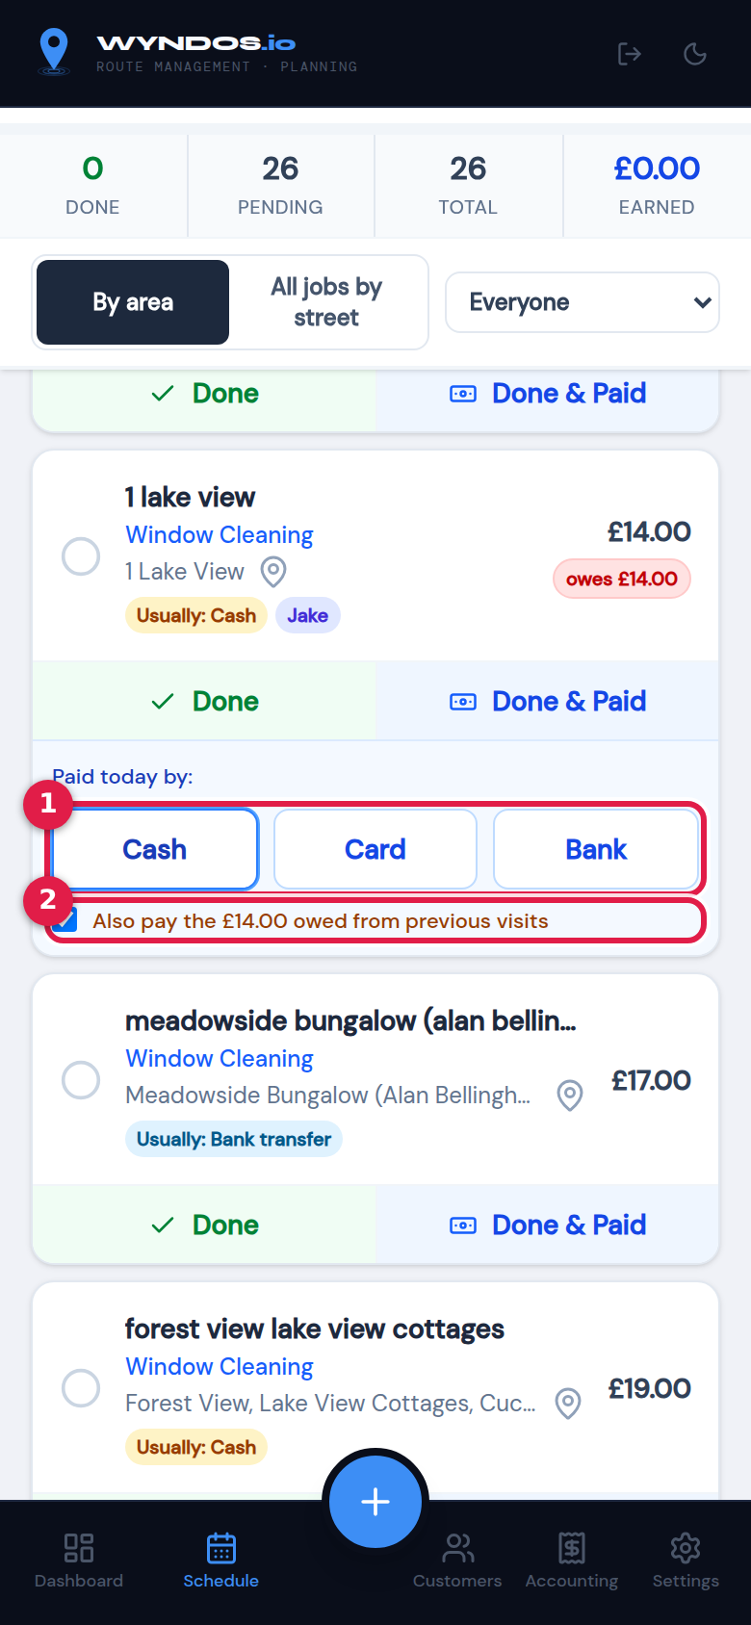
Paid today by
- Cash, Card or Bank.
- If they owed money from earlier visits, this box is ticked to settle that too. Untick it if they’re only paying for today.

Changing the price, adding a note, or skipping
Tap the customer’s name to open the job’s options:
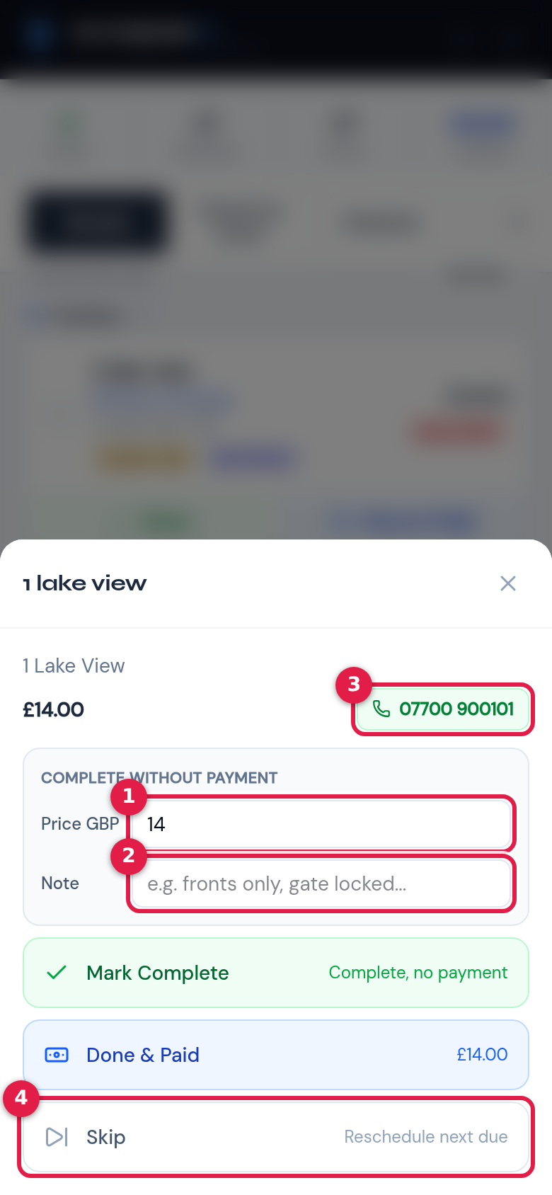
Job options
- Price: change today’s price, for example if you only did the fronts. This changes today’s visit only.
- Note: for example “gate locked, fronts only”.
- Phone: tap to ring the customer.
- Skip: not cleaned this time. The job moves to their next normal visit.
Mark Complete is the same as Done, and Done & Paid works the same as on the card.
Made a mistake? Tap a finished job to open it again and use Undo.

Changing the order
In By area view, tap Reorder above the pending list, then drag jobs into your route order. Tap Done reordering when finished. The order is remembered for next time.

Completing the day
When you’re finished, press Complete Day. To finish just one area while the others carry on, open its card and press Complete area.
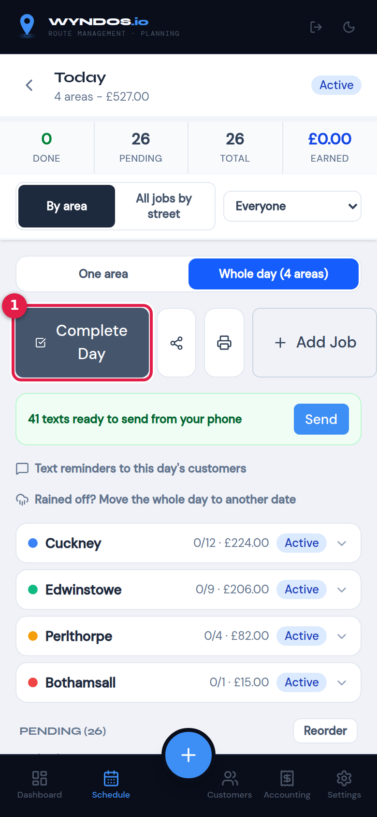
Complete Day
If any jobs are left, Wyndos asks what to do with them:
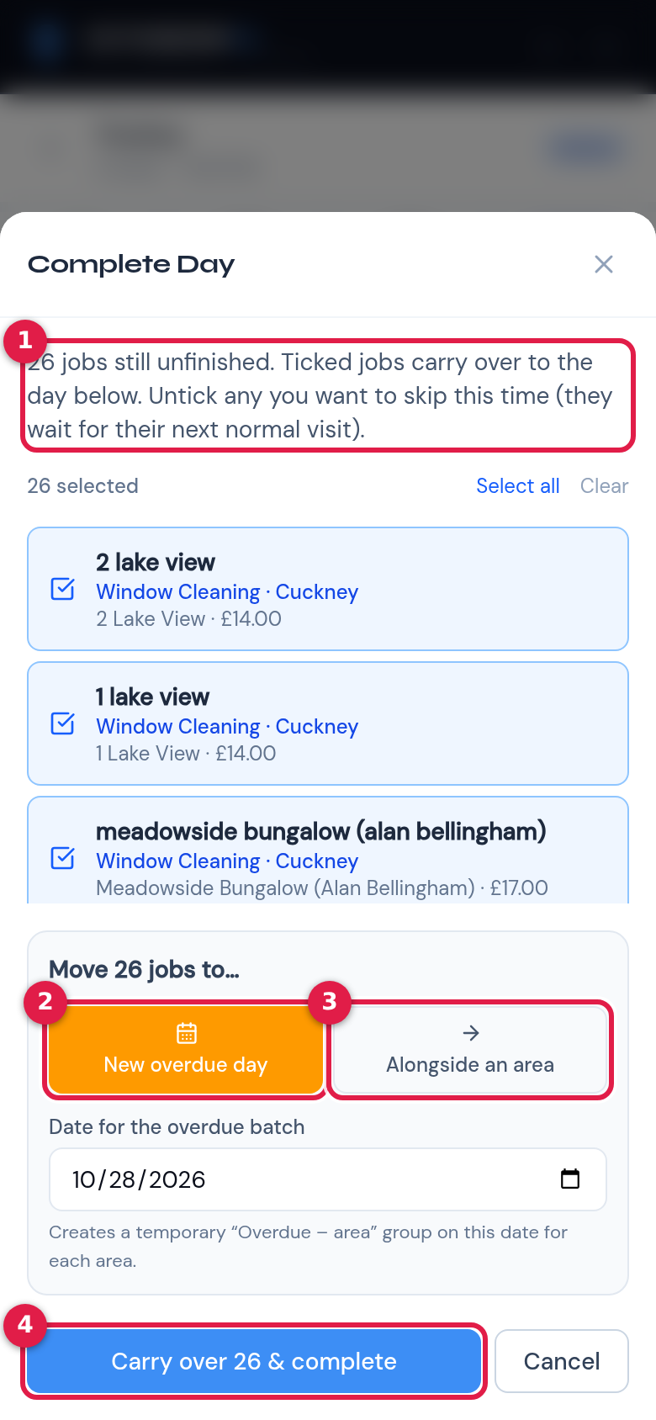
Carry over unfinished jobs
- How many jobs are unfinished. Ticked jobs are carried over. Untick any you want to skip until their next normal visit.
- New overdue day: puts the carried-over jobs in a temporary “Overdue” group on the date you choose.
- Alongside an area: adds them to another area’s booked day.
- Carry over & complete: finishes the day.
When an area is completed, Wyndos:
- books the area’s next visit using its frequency, counted from the day it was actually done
- sends (or queues) the “windows cleaned, here’s how to pay” text, if you’ve switched it on. See Automatic texts.

Rained off: move the day
Tap Rained off? Move the whole day to another date. You can also use Rained off on a single area card.
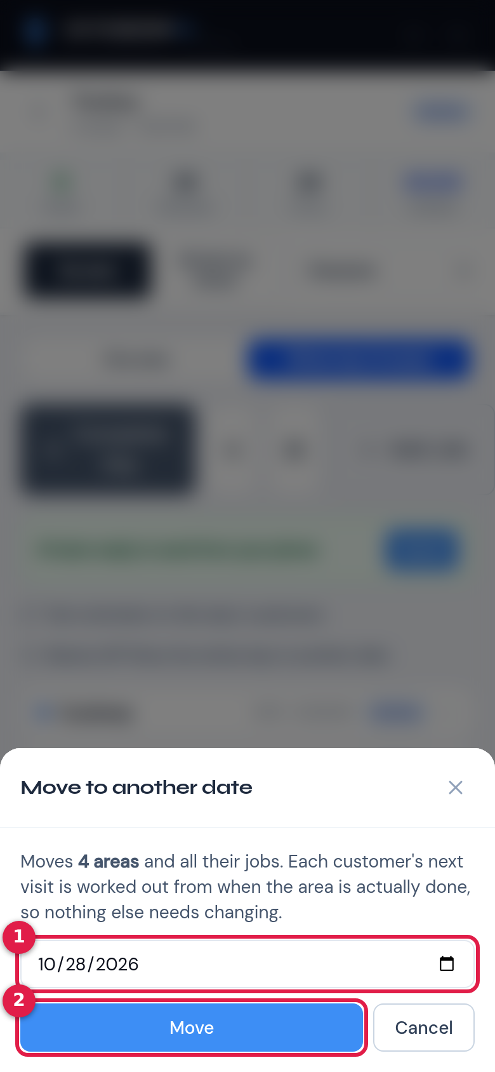
Move to another date
- Pick the new date.
- Press Move.
Everything moves together. Each customer’s next visit is still worked out from when the area is actually done, so nothing else needs changing.

Texts waiting on your phone
If you send texts from your phone, a green bar shows how many are still waiting, for example “41 texts ready to send from your phone”. Tap Send to carry on where you left off.

Planning with the Scheduler
The Scheduler is the diary where you decide which area is cleaned on which day. It’s built for a computer or tablet, so it doesn’t appear on the phone’s bottom bar. It needs the Plan the diary permission.
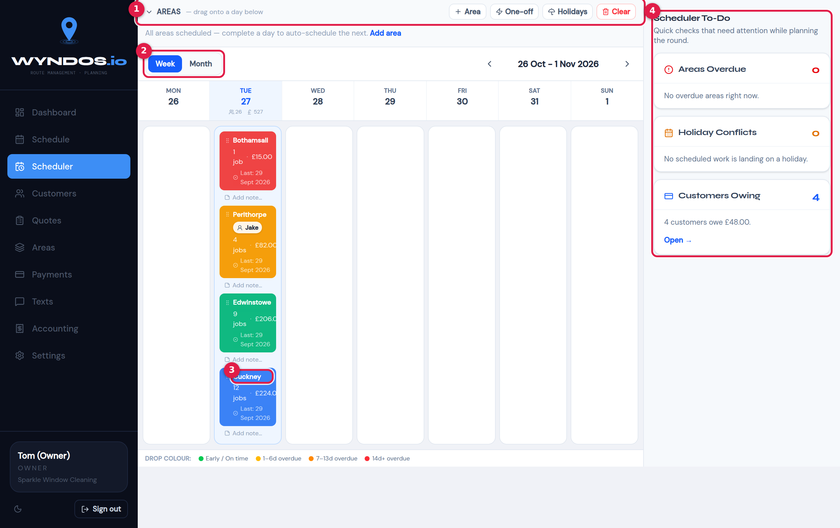
Scheduler, week view
- Areas: every area, with a colour showing how due it is. Drag an area onto a day to book it. The buttons along this bar:
  - + Area: create a new area.
  - One-off: book a single job.
  - Holidays: block out days you’re away. Booked work that lands on a holiday is flagged.
  - Clear: removes all future booked days. You’ll be asked to confirm first.
- Week / Month: change the view. Use the arrows to move between weeks or months.
- A booked day: one area on one date, with its job count and value. Drag it to another date to move it, or click it to open the day (see below).
- Scheduler To-Do: quick checks while you plan:
  - Areas overdue: press Open to jump to the area.
  - Holiday conflicts.
  - Customers owing.
The key at the bottom explains the colours: early/on time, 1–6 days overdue, 7–13 days overdue, and 14 or more days overdue.

How booking works
- Drag an area onto a date to book its customers who are due.
- After you complete an area, its next visit is booked automatically using the area’s frequency, counted from the day it was actually done. You mostly use the Scheduler to check and adjust, not to book everything by hand.
- To move a booked day, drag it to another date. You can also use Rained off on the day itself (see Working a day).

The day pop-up
Click a booked day to manage it without leaving the diary.
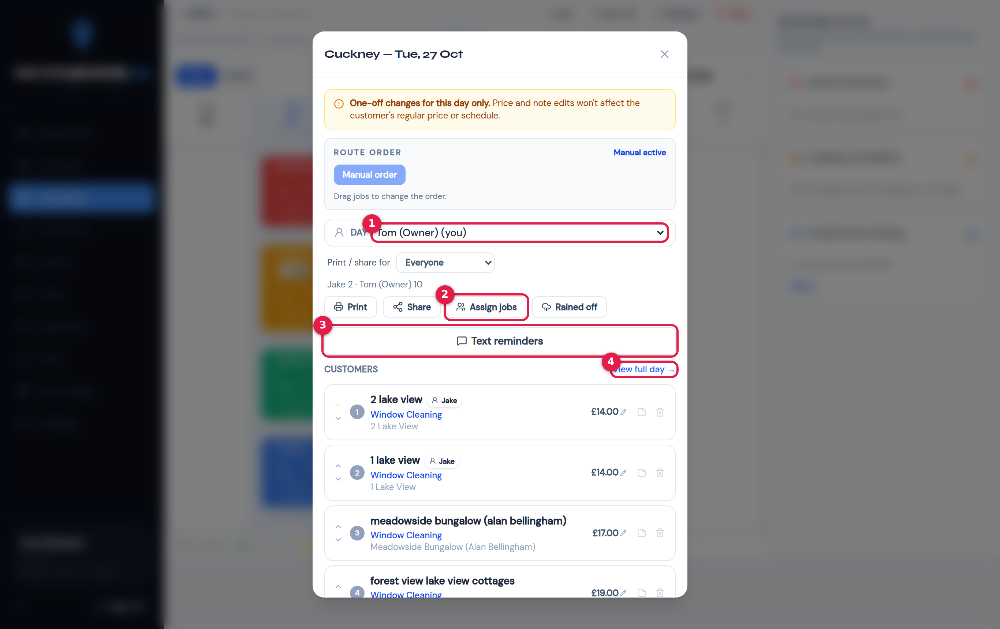
Day pop-up in the Scheduler
- Who is doing this day: give the whole day to one person.
- Assign jobs: split the jobs between people. Print / share for chooses whose jobs go on the printout or PDF.
- Text reminders: text everyone on this day. See Day reminders.
- View full day: open the full day screen.
The pop-up also lets you:
- change a price or note for this day only, without changing the customer’s regular price
- drag jobs into your route order
- mark jobs paid
Tip: On a phone, use Schedule instead. You can do the same assigning and texting from the day screen itself.

Areas and frequency
An area is a group of customers cleaned together, usually a village, an estate or a group of streets. Areas are the heart of Wyndos: you book areas, not individual customers.
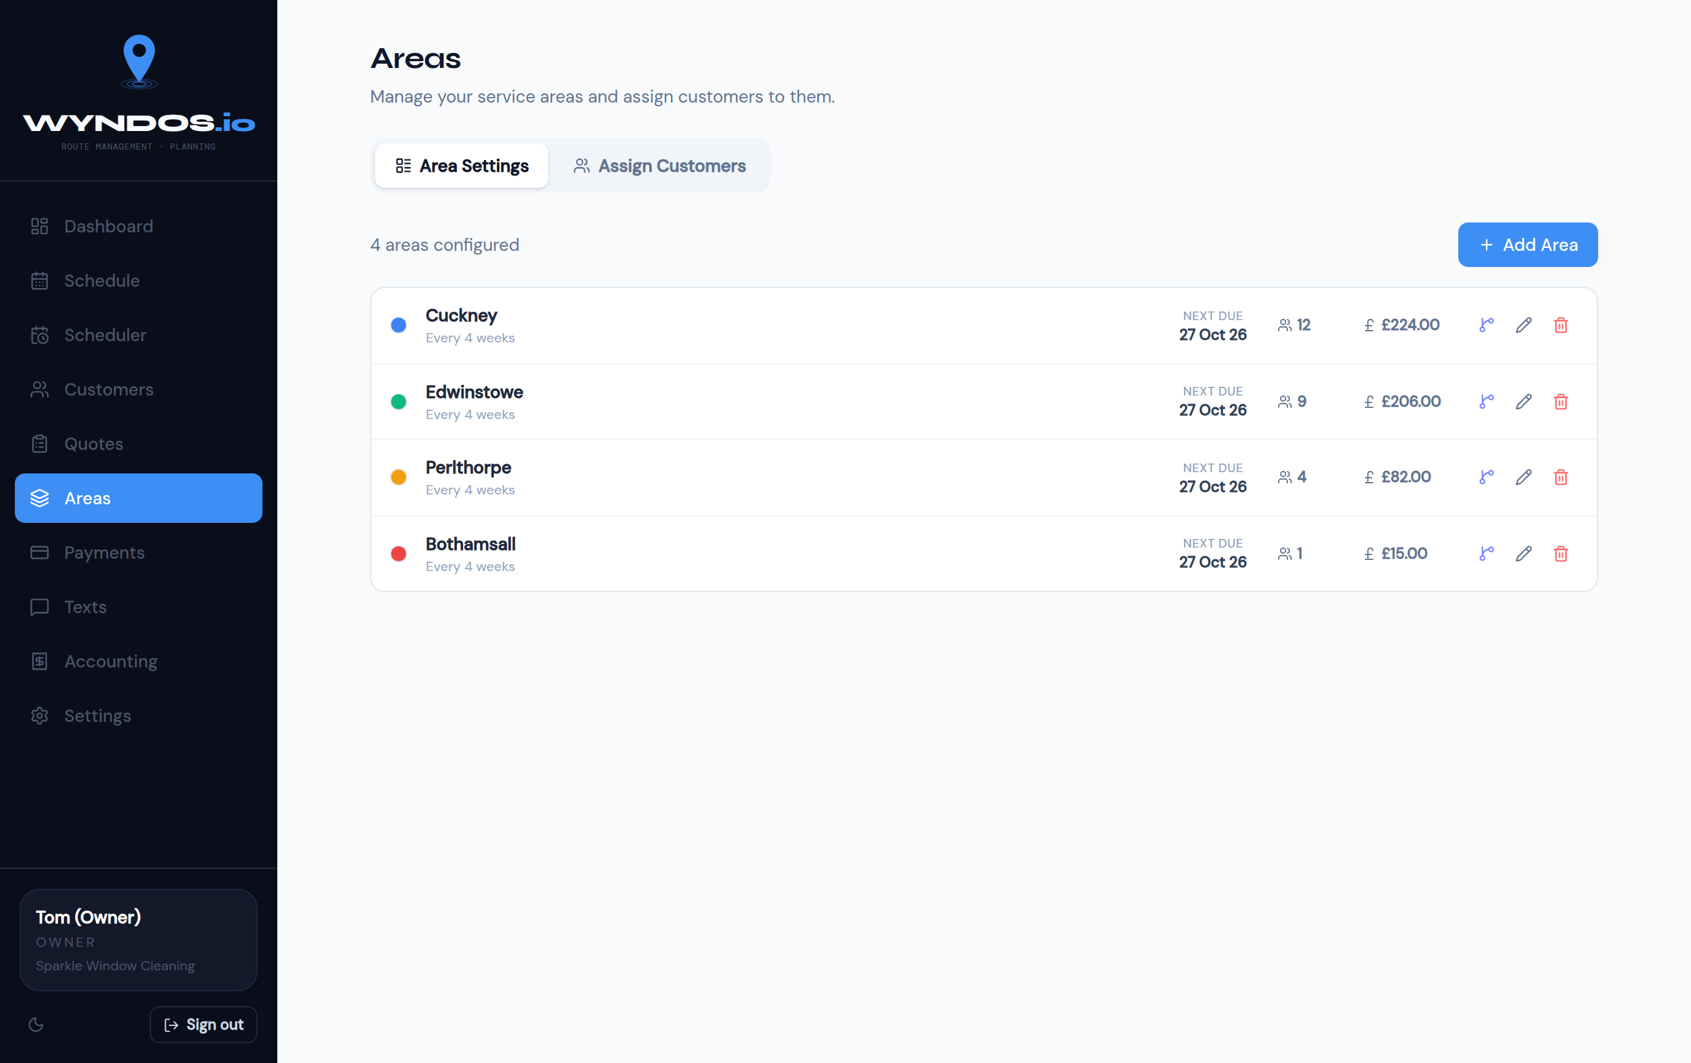
Areas page
Each row shows:
- the area’s colour
- how often it’s cleaned
- when it’s next due
- how many customers it has
- the value of one round
The icons on the right edit or delete the area.

Add or edit an area
Press + Add Area, or the pencil icon next to an existing area. Then set:
- Area name, for example “Cuckney”.
- Schedule type. There are two kinds:
  - Every N weeks: set Repeat every, for example 4 weeks.
  - Monthly (fixed day): pick a day of the month. Use 1–28 to avoid problems at the end of short months.
- Next due date: when this area should next be cleaned.

Frequency belongs to the area
Every customer in an area is cleaned at the area’s frequency. If you change an area from 4 weekly to 6 weekly, all its customers change with it.
If a few customers in the same village need a different frequency, make them their own area. For example:
- Cuckney: every 4 weeks
- Cuckney (8 weekly): every 8 weeks
The import does this for you. A row whose frequency differs from its area goes into an area named “area (N weekly)”.

Moving customers between areas
Choose whichever way suits you:
- On the Areas page: open Assign Customers, choose a Target Area, then drag customers across or use the Move button.
- On a customer’s page: press Change Area.
- For many at once: use Customers → Bulk Edit and change the Area column.

Route order within an area
The order of houses on a day comes from the area’s route order. To change it:
- On the day screen: drag jobs using Reorder (see Working a day).
- In the Scheduler: drag jobs in the day pop-up.

Customers

The customer list
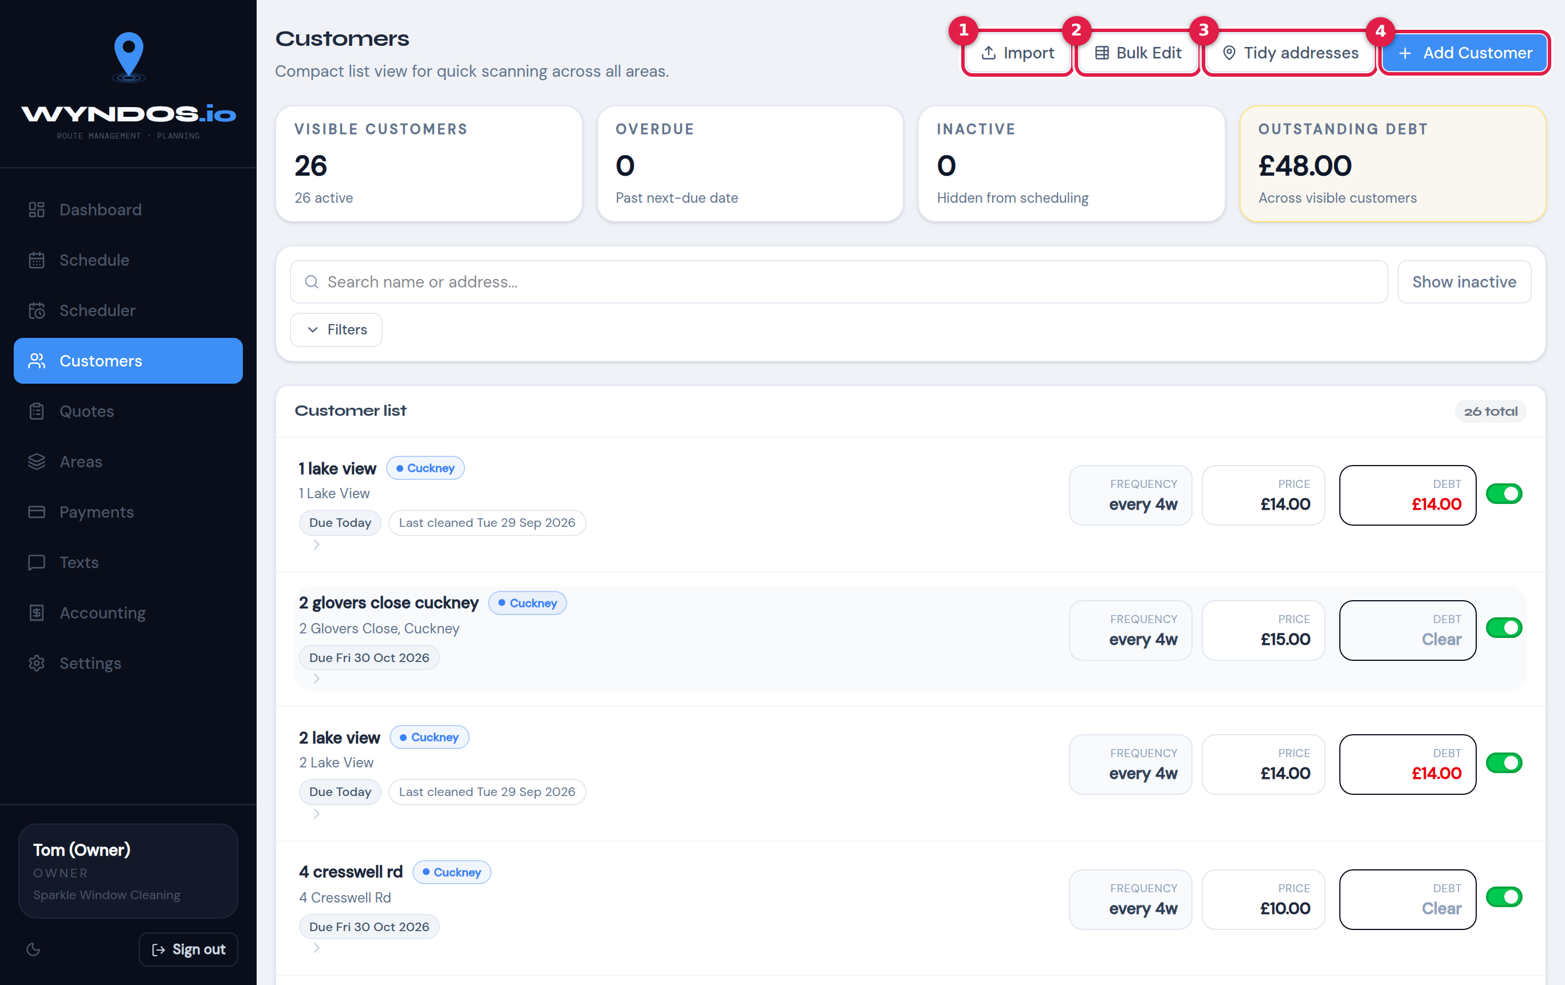
Customers list
The boxes at the top count visible customers, overdue customers (past their due date), inactive customers (hidden from scheduling) and the outstanding debt.
- Import: bring in customers from a spreadsheet.
- Bulk Edit: change many customers at once in a table.
- Tidy addresses: check how addresses were split into house, street and town.
- + Add Customer: add one customer.
Use the search box to find someone by name or address. Filters narrows the list and Show inactive includes paused customers.
Each row shows the customer’s area, when they’re next due, their frequency, price and what they owe. The switch on the right makes a customer active or inactive. Inactive customers are kept on file but never booked.

Add a customer
Press + Add Customer. On a phone, use + → New Customer.
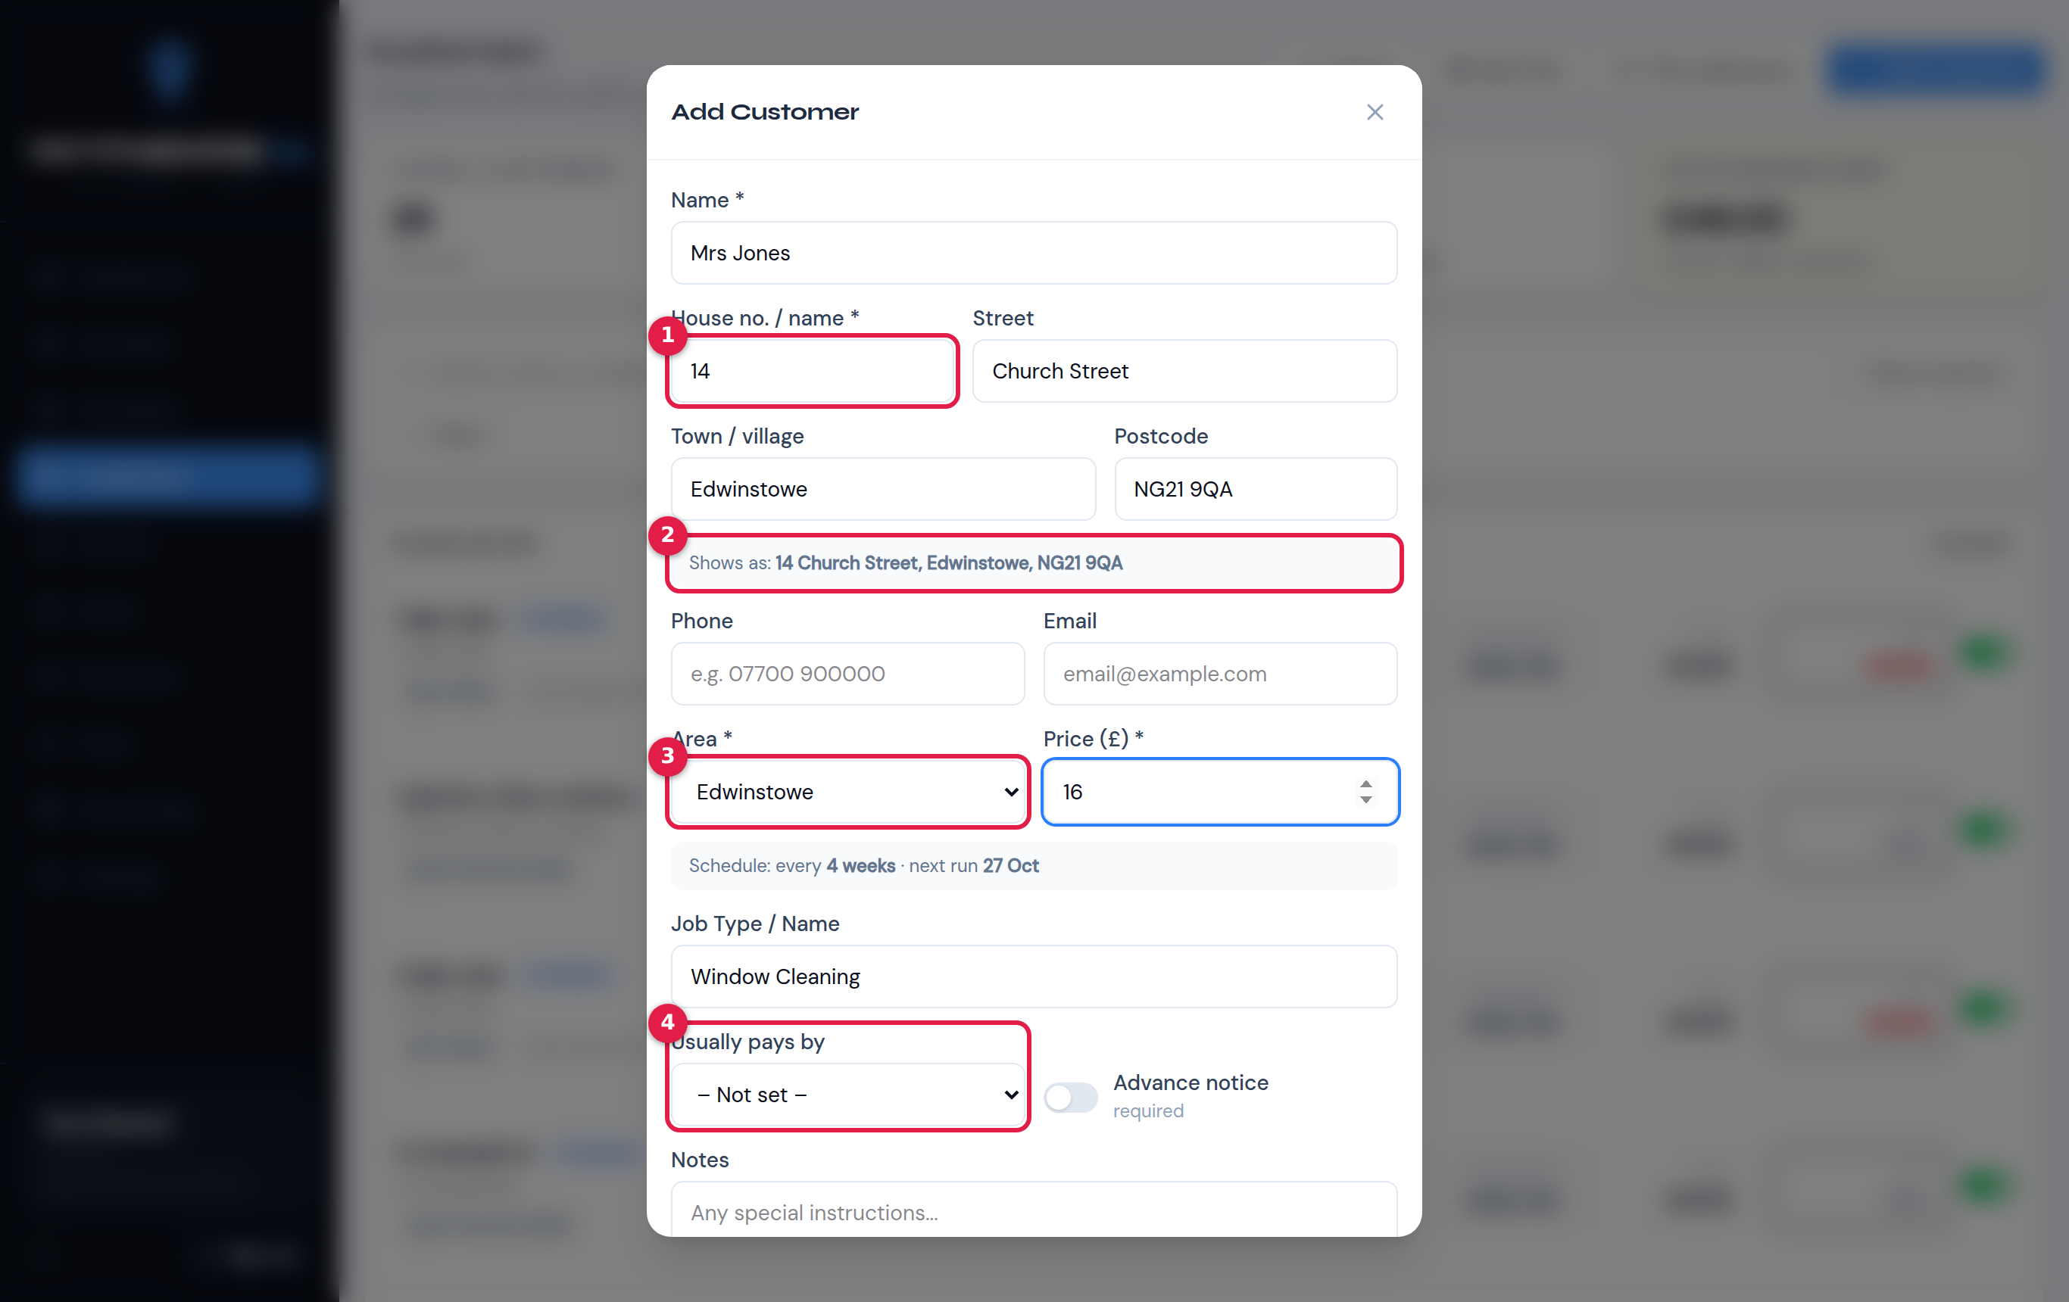
Add Customer form
- House no. / name and Street, then Town / village and Postcode. Keep these separate: the day sheet sorts houses by street and house number.
- Shows as: a preview of the full address that customers and workers will see.
- Area and Price. The line underneath confirms the frequency, which comes from the area, and the next run, for example “Schedule every 4 weeks · next run 27 Oct”.
- Usually pays by: Cash, Bank transfer, Card and so on. This shows as a tag on the job card.
The rest of the form:
- Phone: a UK mobile, if you want to text them.
- Email.
- Job type: for example “Window Cleaning”.
- Advance notice: tick this if they want warning before you come.
- Notes: shown on the job card, such as “watch overhead cables”.

The customer page
Click any customer to open their page.
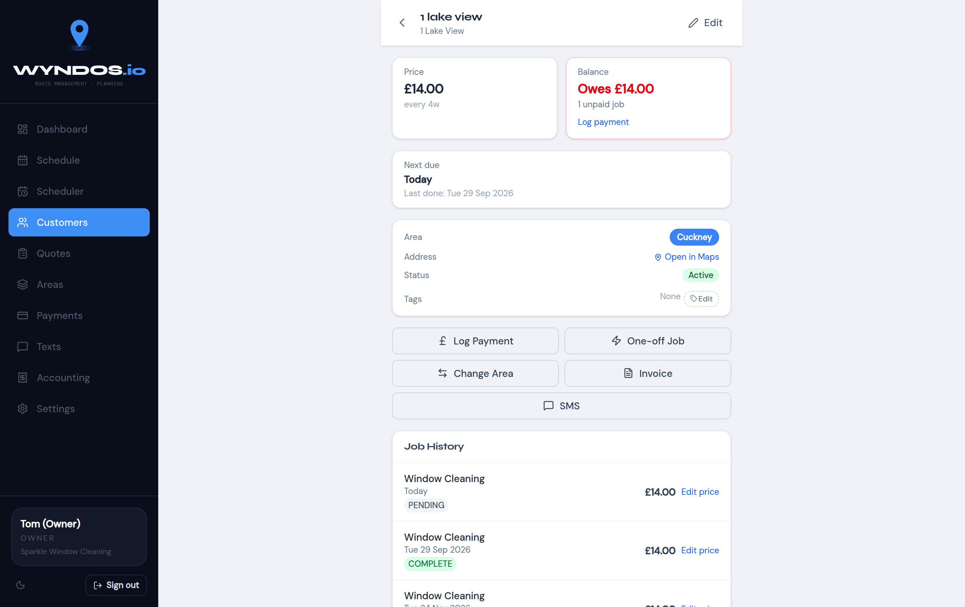
Customer page
At the top are their price and balance. A red balance means they owe money. Below that are their next due date, area, address (with Open in Maps), status and tags.
The buttons:
- Log Payment: record money received.
- One-off Job: book an extra clean on any date.
- Change Area: move them to another area. Their frequency changes to the new area’s.
- Invoice: produce a PDF invoice.
- SMS: text this one customer.
Job History lists every visit, with its date, price and status: pending, complete, skipped or moved. You can correct a past price with Edit price.

Edit a customer
Press Edit at the top of their page.
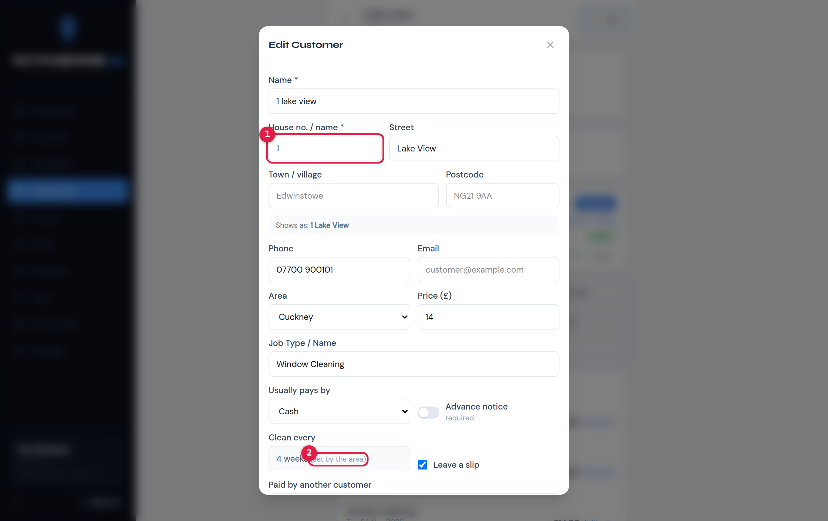
Edit Customer
- The address parts, the same as when adding.
- Clean every is shown but can’t be changed here, because it’s set by the area. To change it, change the area’s frequency or move the customer to an area with the frequency you want.
You can also set:
- Leave a slip: leave a note or slip after cleaning.
- Paid by another customer: for example a landlord who pays for several houses.
- Active customer: untick to pause them.
- GoCardless details, if you use it.

Tidy addresses
Older or imported addresses are often one long line. Customers → Tidy addresses splits them into house, street and town, and lets you check the guesses.
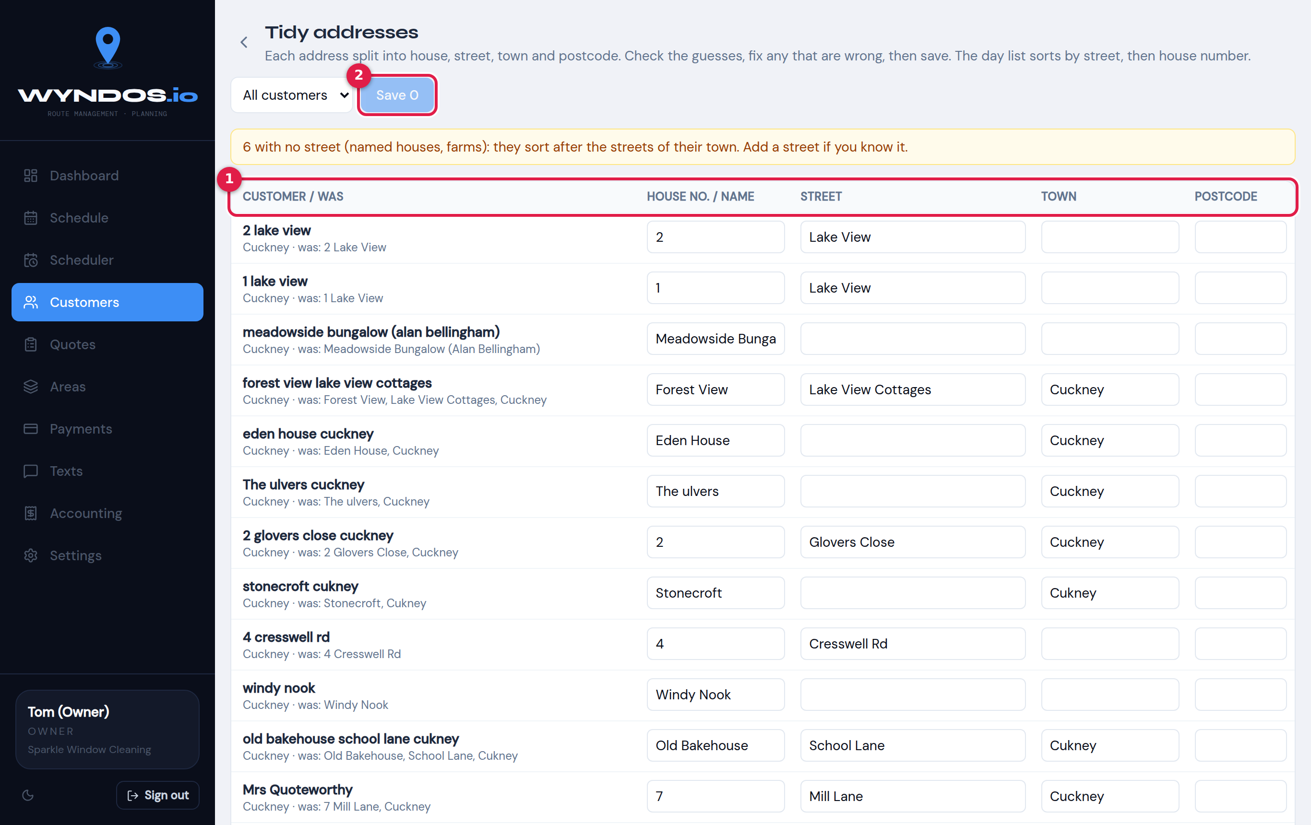
Tidy addresses
- Each row shows the customer, what the address was, and the split parts. Correct any box that’s wrong. The yellow note at the top lists named houses with no street, which sort after the numbered houses in their town. Add a street if you know it.
- Press Save when you’re done.

Bulk Edit
Bulk Edit shows every customer in a spreadsheet-style table so you can fix lots of details quickly.
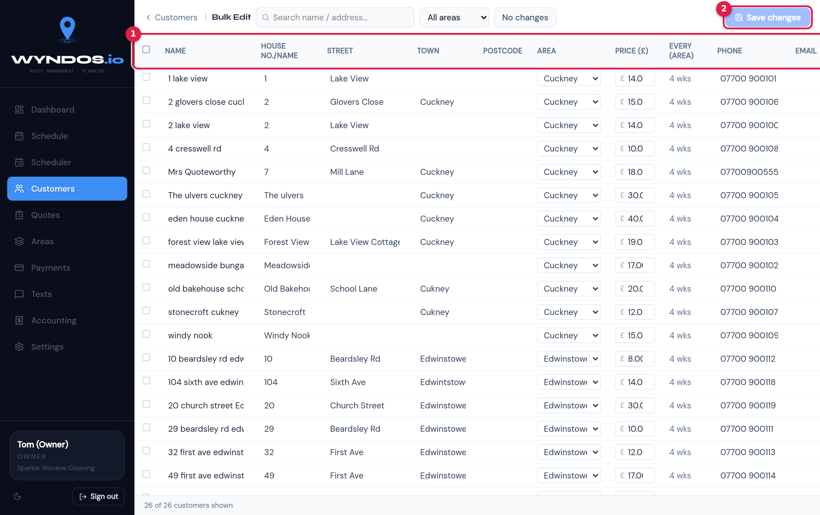
Bulk editor
- The columns:
  - name, house no./name, street, town, postcode
  - area and price
  - every (read-only, from the area)
  - phone, email
  - usually pays, slip, advance notice
- Changed cells are highlighted. Filter by area or search at the top.
- Save changes saves every edit in one go. The counter next to it shows how many rows you’ve changed.

Import customers from a spreadsheet
Customers → Import takes an Excel (.xlsx, .xls) or .csv file. The column headings must be on the first row.

Step 1: Upload
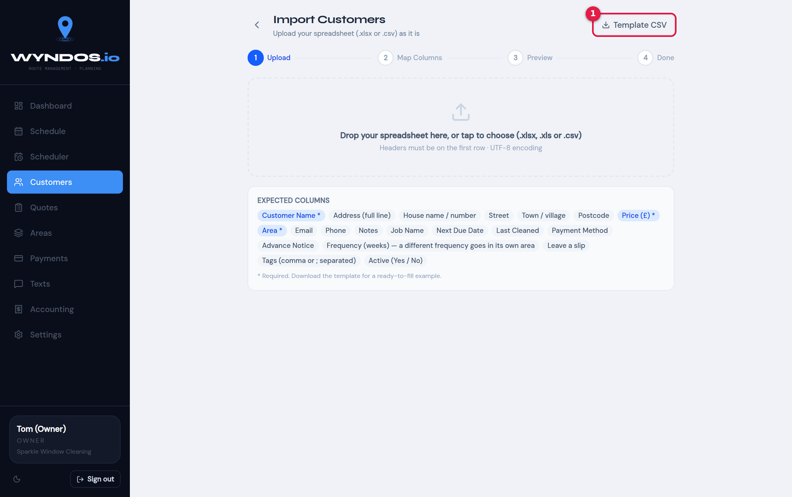
Import step 1
- Template CSV downloads a ready-made spreadsheet with every column Wyndos understands. Starting from it is the easiest way.
The columns Wyndos recognises:
Column | Notes
Customer Name | Required
Area | Required. New areas can be created automatically
Price (£) | Required
Address (full line) | Or use the separate parts below
House name / number, Street, Town / village, Postcode | Better than a full line
Phone, Email, Notes, Job Name
Next Due Date, Last Cleaned | Dates
Payment Method, Advance Notice, Leave a slip | Yes/No or text
Frequency (weeks) | A different frequency for the same area puts the customer in its own area
Tags | Separate with commas or semicolons
Active | Yes / No
A file exported from Settings → Data → Customers imports straight back in.

Step 2: Map the columns
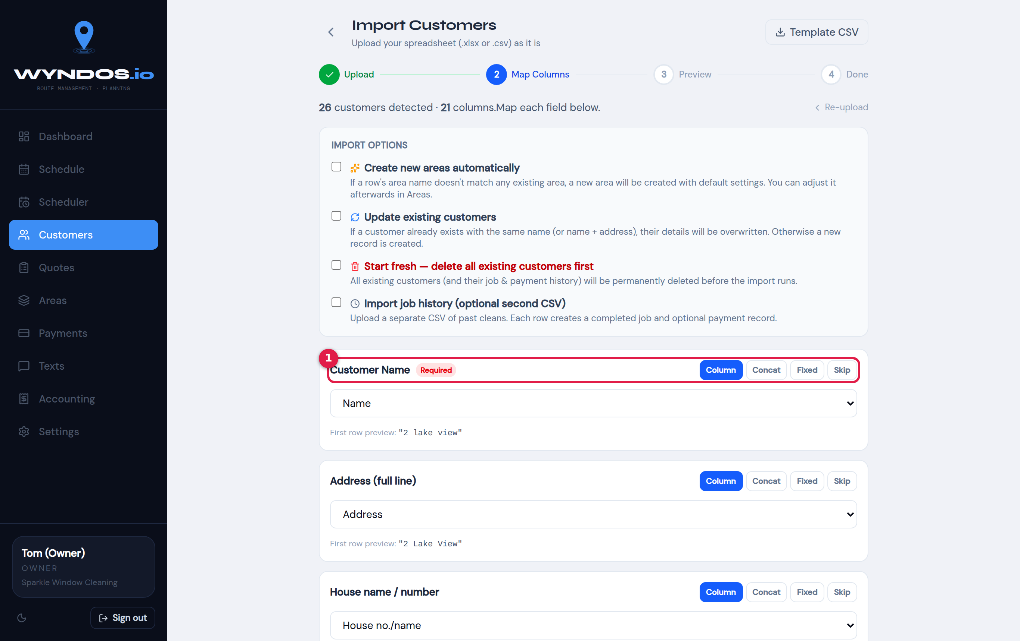
Import step 2
- For each Wyndos field, choose which column of your file it comes from. You can also:
  - Concat: join several columns together.
  - Fixed: use the same value for every row.
  - Skip: leave it out.
- A preview of the first row is shown under each field.
Import options at the top:
- Create new areas automatically: area names that don’t exist yet are created.
- Update existing customers: customers with the same name, or the same name and address, are updated instead of added twice.
- Start fresh: deletes all existing customers first.
- Warning: Start fresh can’t be undone.
- Import job history: a second optional CSV of past cleans.

Step 3: Preview and import
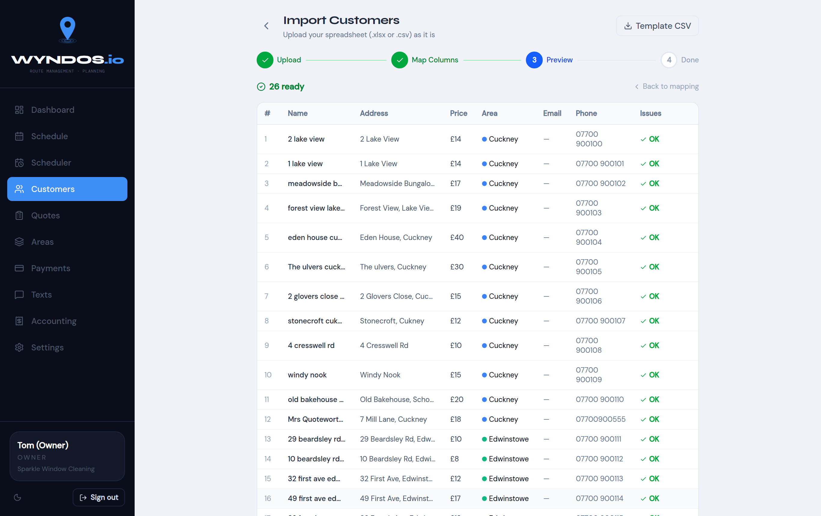
Import step 3
Every row is checked before anything is saved. The Issues column flags problems such as a missing price or “not a mobile” (that number can’t be texted). Fix them in your file, or go Back to mapping. When it says ready, run the import.

Quotes and one-off jobs

Book a quote visit
When someone asks for a price, book a quote visit. It appears on that day’s list like any other job, so whoever is nearby can call in and price it up.
On a phone, tap + → Book Quote. On a computer, use Quotes → + Book quote.
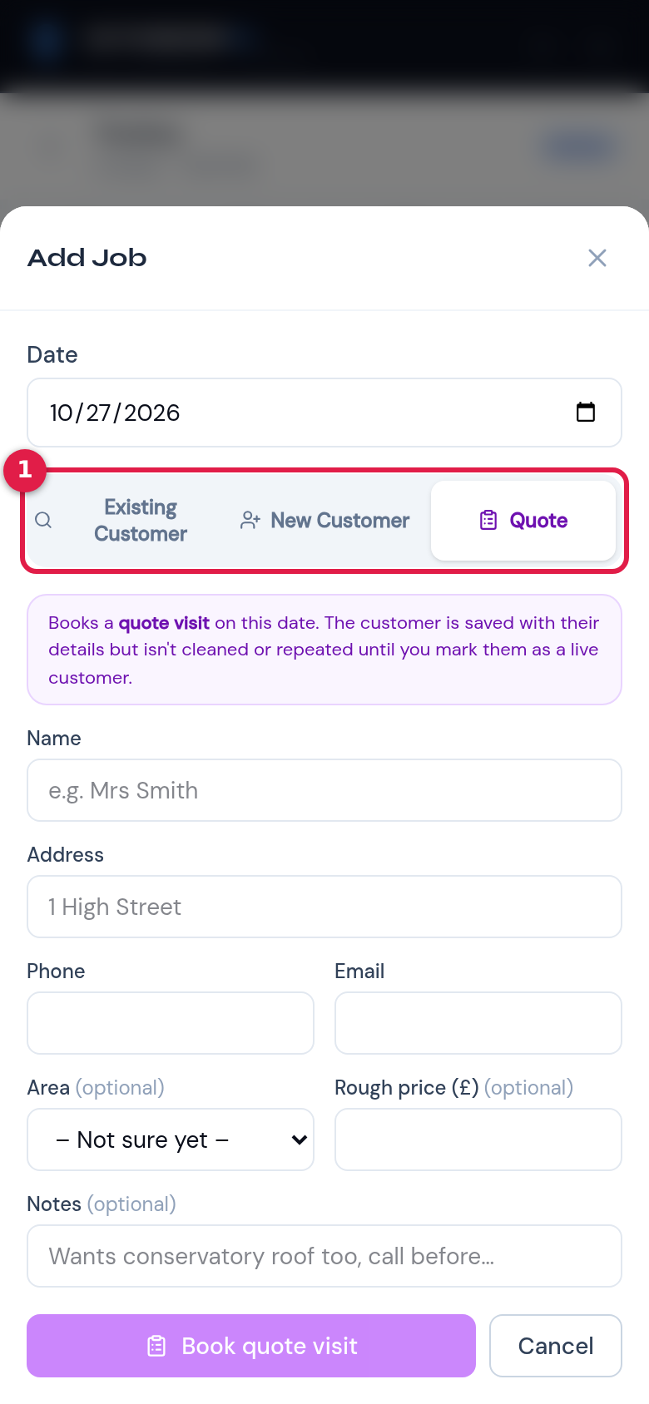
Book a quote visit
- Choose what you’re booking:
  - Existing Customer: an extra job for someone already on your books.
  - New Customer: a one-off job for someone new.
  - Quote: a visit to price up a new customer. This is the purple option in the picture.
For a quote, fill in:
- the date of the visit
- their name, address, phone and email
- the area, if you know it
- a rough price, if you have one
- any notes
Press Book quote visit. The person is saved with their details, but they won’t be cleaned or repeated until you mark them as a live customer.

On the day: mark quoted, won or lost
A quote visit shows on the day list with purple buttons:
- Mark quoted: enter the price quoted and how often, plus a note such as “wants a callback Friday”. Press Save quote.
- Mark live customer: they said yes. Choose their area, confirm the price and how they’ll usually pay, and press Make live customer. They join that area’s runs from now on.
- Lost: they said no. The quote is kept for your records.

The Quotes page
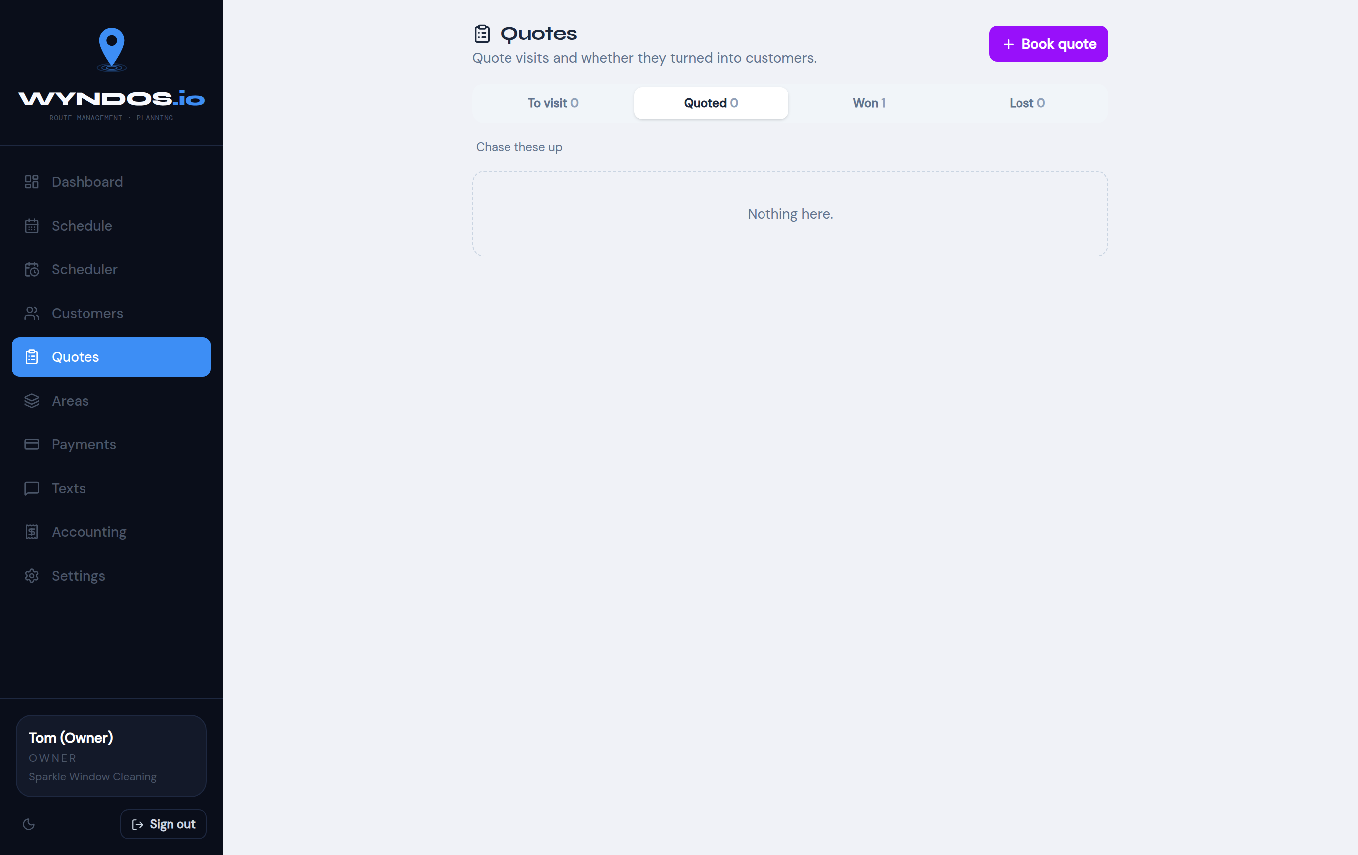
Quotes page
The Quotes page follows every quote through four tabs:
- To visit: quote visits booked but not done yet.
- Quoted: priced, waiting for an answer. These are the ones to chase.
- Won: turned into live customers.
- Lost.

One-off jobs
A one-off job is a single clean that doesn’t repeat, such as a gutter clear, a conservatory roof or an end-of-tenancy clean. Book one from:
- + → One-off Job on a phone
- One-off on the Schedule page or in the Scheduler
- One-off Job on a customer’s page
- Add Job on the day screen
You can book it for an existing customer or a new one. It appears on the chosen date like any other job.
Workers with the “Their days” permission can book quotes and one-off jobs too. The job goes on their own day.

Payments and accounting

How money is tracked
A customer starts to owe money when a job is marked Done. There are several ways to settle it:
- Done & Paid on the day, choosing Cash, Card or Bank.
- Log Payment on the Payments page or on the customer’s page.
- GoCardless direct debits, matched automatically by Sync GoCardless.
When they pay, the money is set against their oldest unpaid cleans first.

Payments page
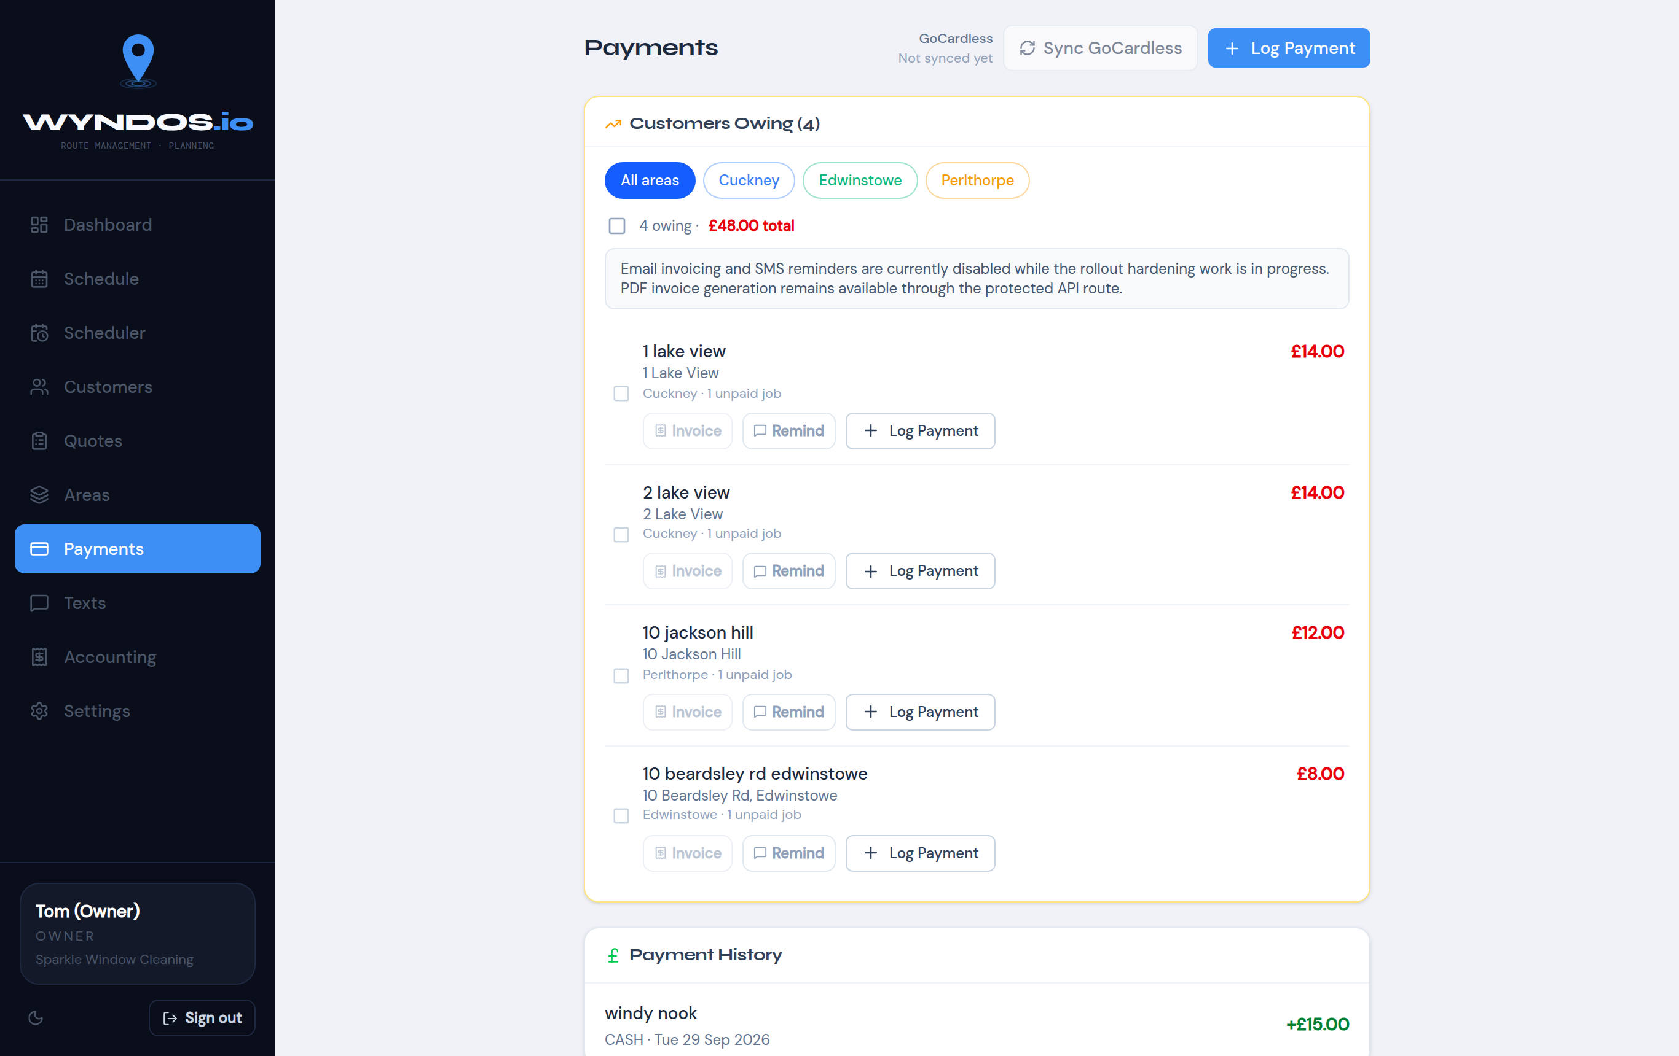
Payments page
- Customers Owing lists everyone with a balance. The coloured buttons filter it by area.
- Each customer has three buttons:
  - Log Payment: record money received.
  - Invoice: produce a PDF.
  - Remind: send a payment reminder.
- Tick several customers to deal with them together.
- + Log Payment at the top records a payment for anyone.
- Payment History, further down, lists every payment received with the method and date.
Tip: The easiest way to chase lots of people at once is Texts → Unpaid cleans. See Bulk texts. Wyndos can also send payment reminders automatically after a set number of days.
Only people with the All payments permission see this page. A worker who takes payment at the door only needs Their days.

Accounting
The Accounting page shows your profit for each UK tax year (6 April to 5 April). It needs the Accounting permission.
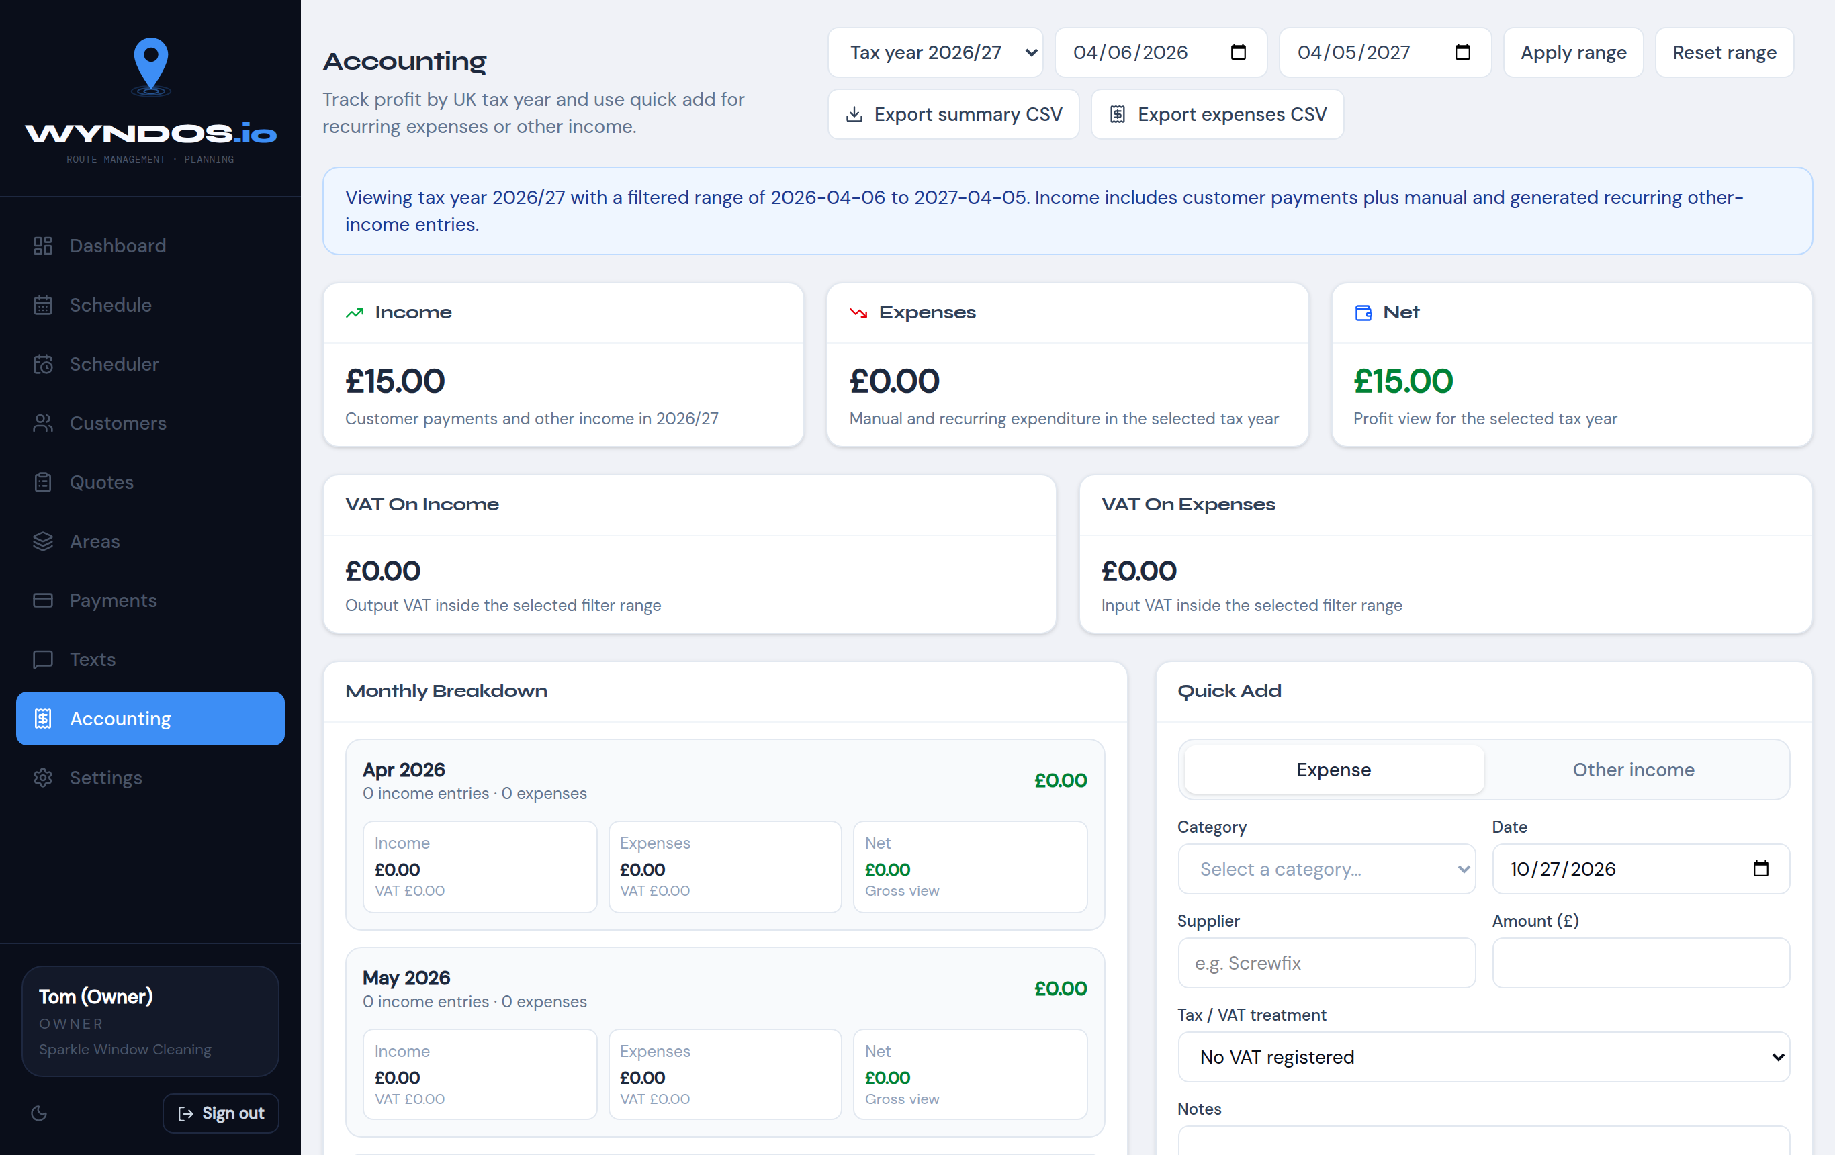
Accounting page
- Tax year and date range (top): choose the tax year, or set your own dates and press Apply range.
- Income, Expenses, Net: totals for the chosen period. Income includes customer payments, anything you add by hand, and recurring income.
- VAT on income / VAT on expenses: shown if you’re VAT registered.
- Monthly breakdown: income, expenses and net for each month.
- Quick add: record an Expense or Other income. Enter:
  - category
  - date
  - supplier
  - amount
  - VAT treatment
  - notes
- Expenses can repeat every so many days, weeks or months, for insurance, phone contract, van finance and so on.
- Export summary CSV / Export expenses CSV: send the figures to your accountant.

Texts
Wyndos texts customers for you:
- Day reminders: “we’re coming tomorrow”.
- Cleaned, here’s how to pay: sent when an area is completed.
- Payment reminders: chasers for unpaid cleans.
- Bulk texts: to any group of customers you choose.

Two ways to send
 | From my phone (free) | Automatic (VoodooSMS)
Cost | Free on your phone plan | Pay per text (VoodooSMS credits)
How | Each text opens in your phone’s Messages app, ready to go. You tap Send, come back, and the next one opens | Sent for you in the background
Replies | Come straight to your phone | Go to VoodooSMS
Best for | Small rounds, and when you want replies | Large batches and fully automatic texts
Set the default in Settings → Messaging. Every send screen also has a From my phone / Automatic switch, so you can choose each time.
Test mode. While Test mode is on, automatic texts are not sent. They’re written to the Log so you can check the wording. The yellow banner at the top of the screen reminds you. Turn test mode off in Settings → Messaging when you’re ready.

Day reminders
On the day screen, tap Text reminders to this day’s customers. In the Scheduler, open a day and press Text reminders.
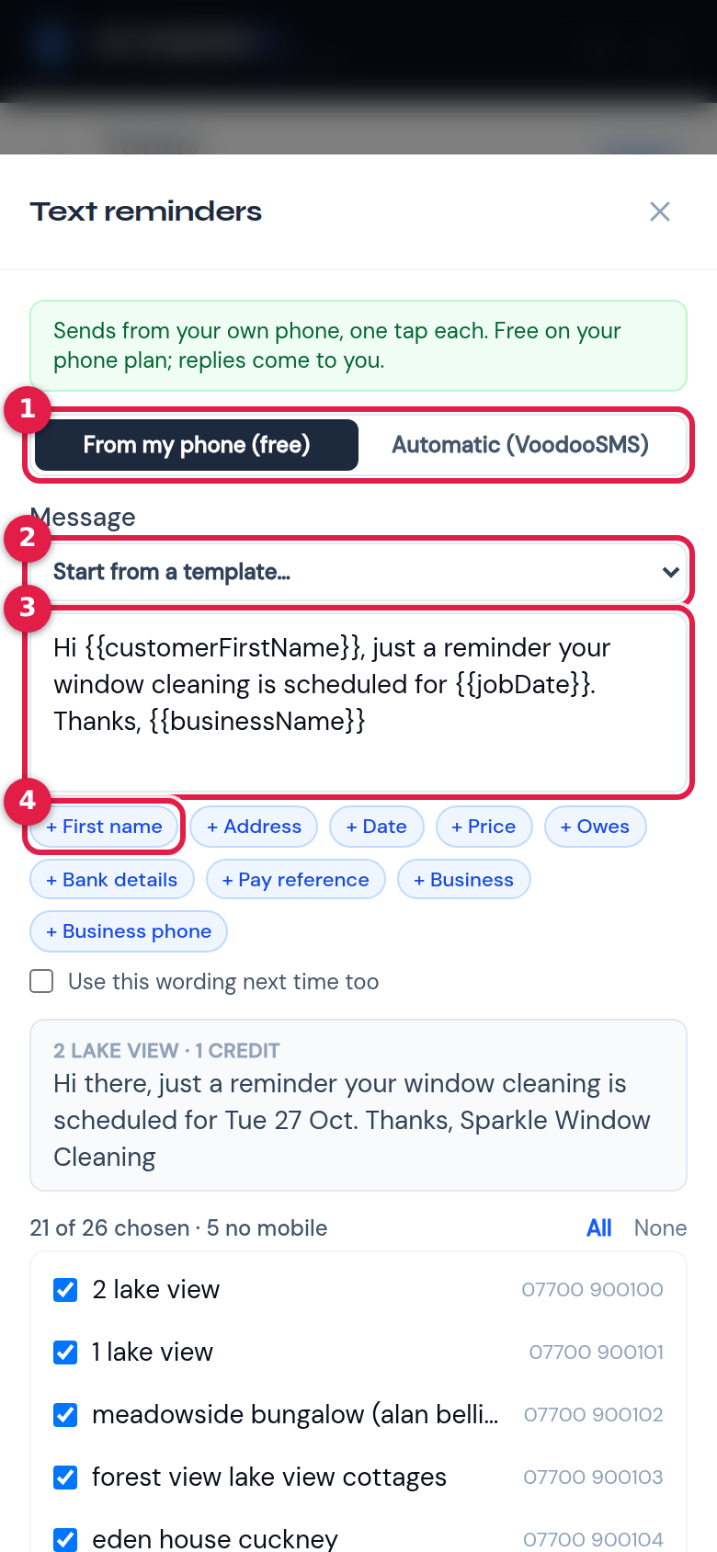
Text reminders, top
- Send from: your phone or automatic.
- Start from a template: choose any saved wording, such as Day reminder, Payment reminder or Cleaned / how to pay.
- The message: edit it freely for this send. Tick Use this wording next time too to make it the new default.
- Placeholders: tap one to insert customer details at the cursor. See Placeholders.
Scroll down to see who will get it:
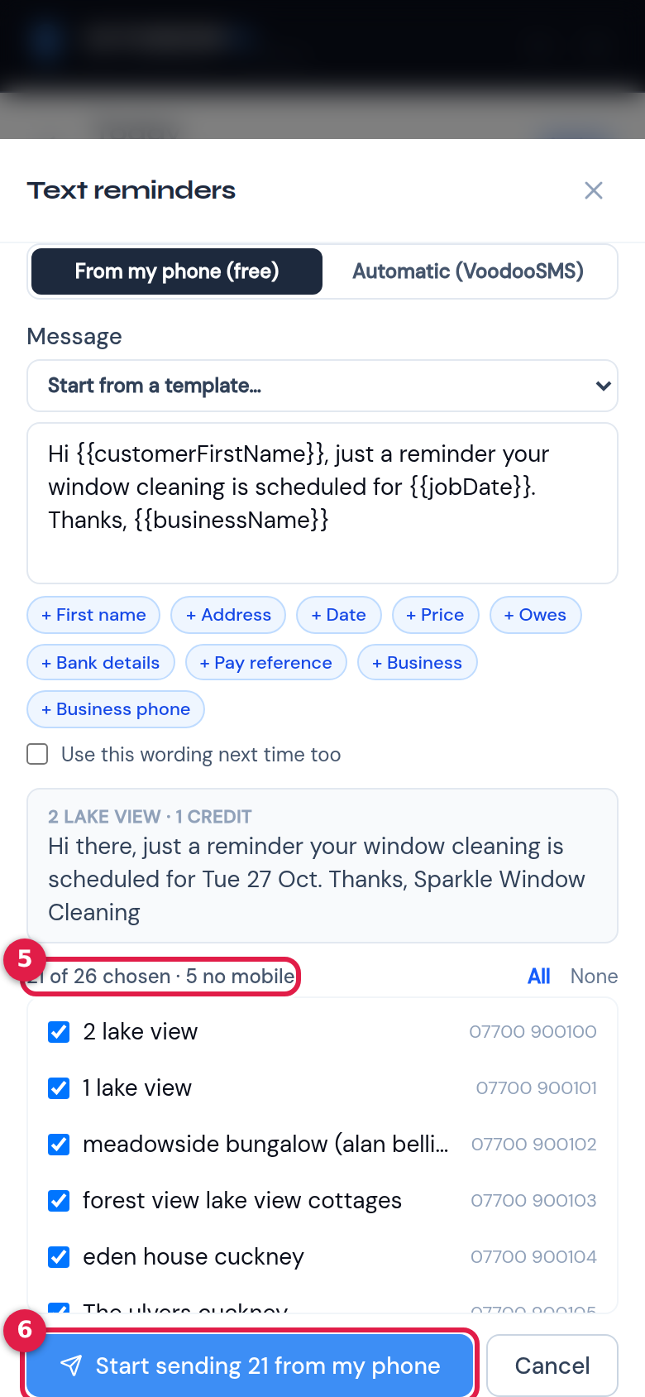
Text reminders, bottom
- Who’s chosen: everyone on the day with a mobile number is ticked, and “no mobile” customers are greyed out. Untick anyone you want to leave out, or use All or None. The grey box above shows a preview for the first customer and how many text credits it will use.
- Start sending: from your phone, or Send / Test send for automatic.

Sending from your phone, one by one
When you start sending from your phone, Wyndos works through the list with you:
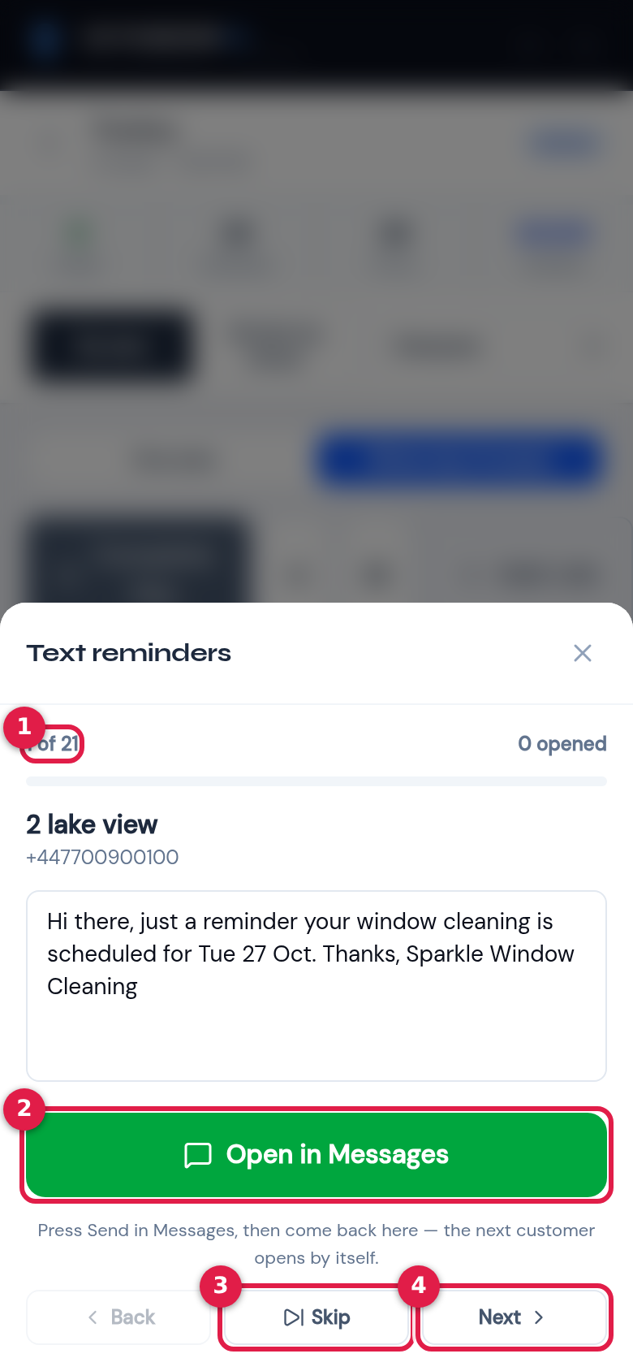
Phone send queue
- Progress: which text you’re on, and how many have been opened.
- Open in Messages: opens your Messages app with the number and text filled in. Press Send there, then come back to Wyndos. The next customer opens by itself. You can still edit the text before opening it.
- Skip: leave this customer out.
- Back / Next: move through the list without sending.
This works on both iPhone and Android. If you stop part-way, the rest wait for you. A green bar shows “N texts waiting to send from your phone” on the day screen and the Texts page. Press Send now to pick up where you left off.

Bulk texts and chasing payments
The Texts page sends to any group of customers.
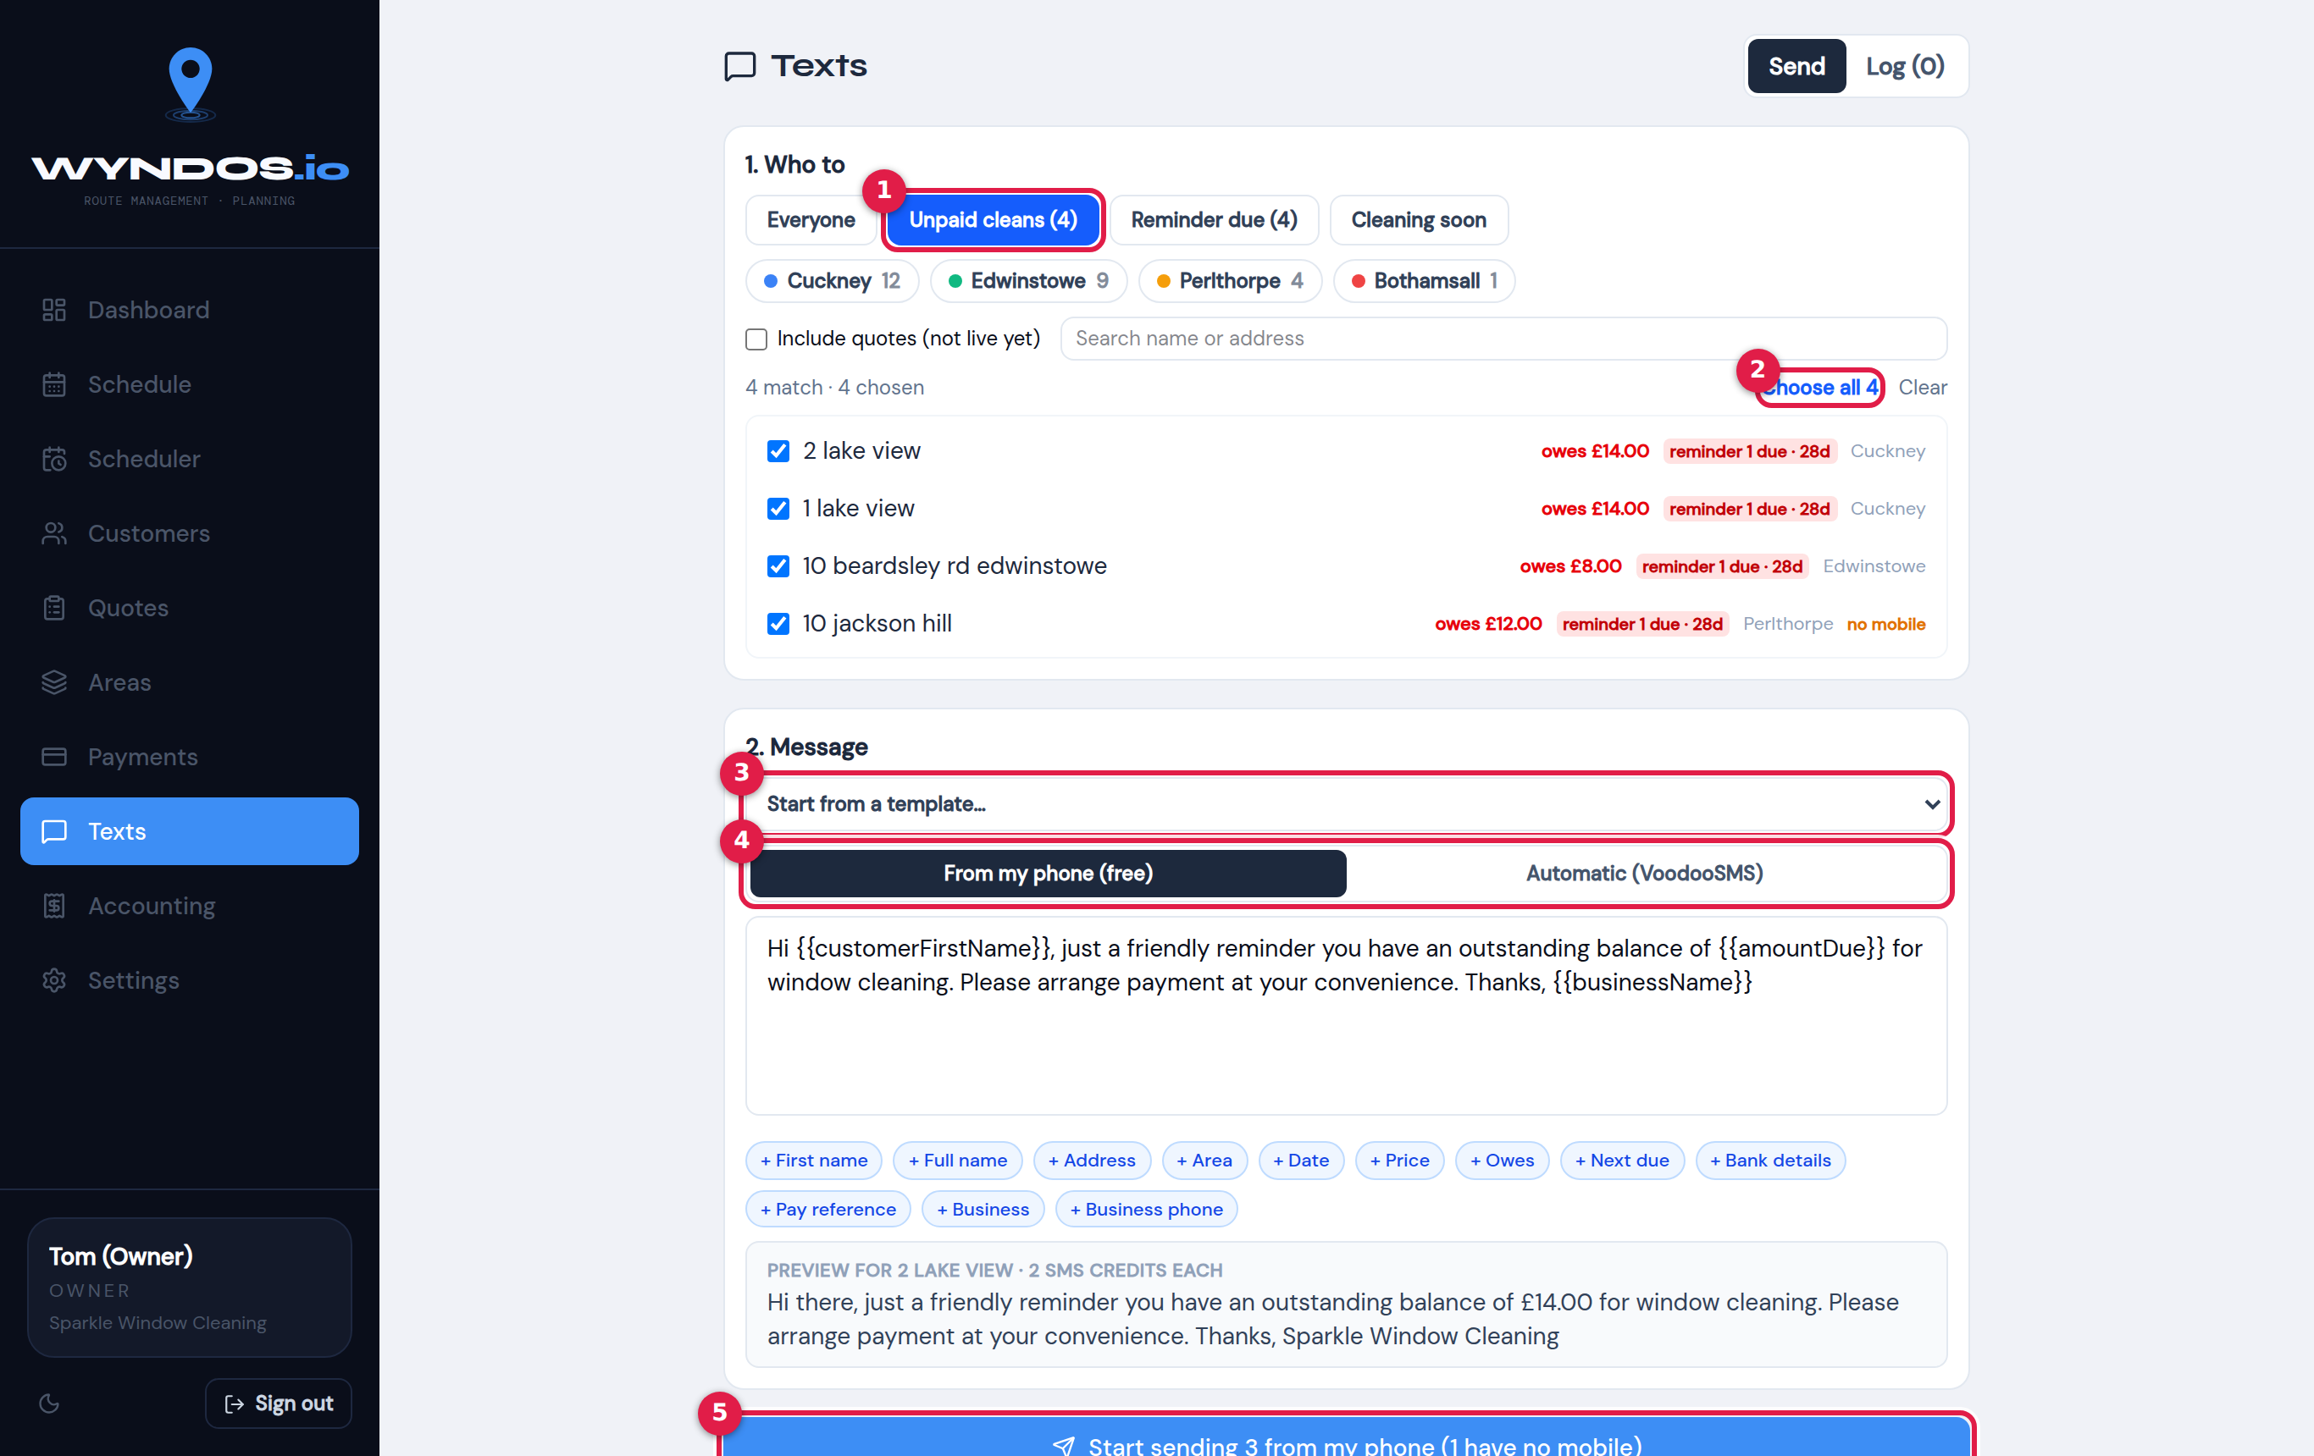
Texts page, Send tab
- Who to: pick a ready-made group:
  - Everyone.
  - Unpaid cleans: anyone with completed cleans they haven’t paid for.
  - Reminder due: unpaid customers whose next payment reminder is due.
  - Cleaning soon: customers with a clean coming up.
- Narrow it further by area, tag or search. Each person shows what they owe and which reminder they’re on.
- Choose all: tick everyone in the list. You can also tick people one at a time.
- Start from a template: for example Payment reminder 1.
- Send from: your phone or automatic.
- Start sending or Send.

The text log
The Log tab lists every text: who it went to, which kind it was, the wording and when.
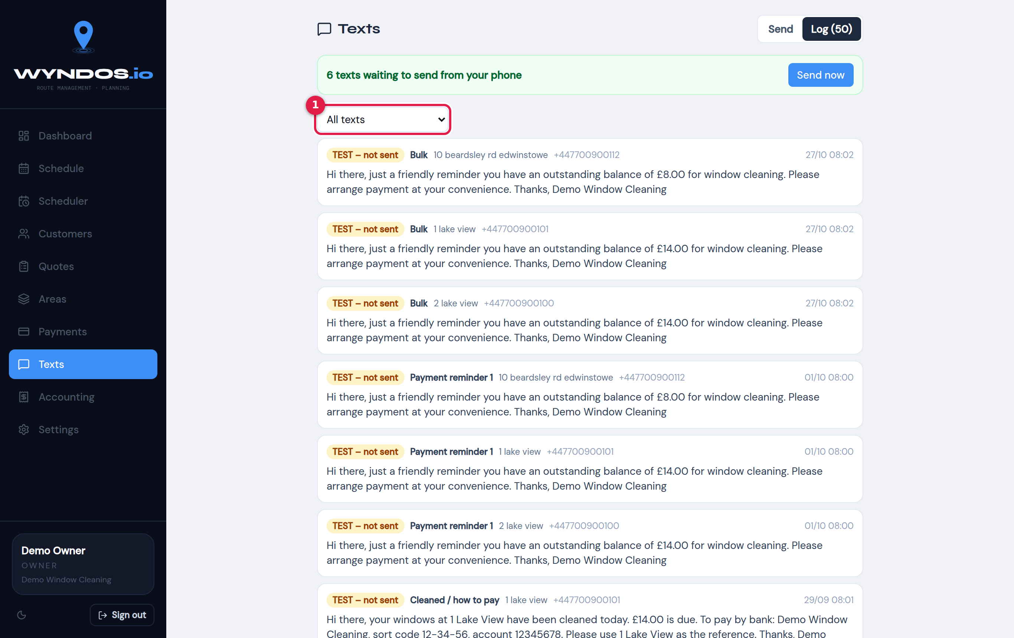
Text log
- Filter the log by kind of text.
Each text shows one of these statuses:
Status | Meaning
TEST – not sent | Written in test mode. Nothing reached the customer
Sent | Delivered by VoodooSMS
Failed | VoodooSMS couldn’t send it
Waiting (phone) | In your phone queue, not opened yet
Opened on phone | Opened in your Messages app

Automatic texts
Settings → Messaging controls the texts Wyndos sends by itself.
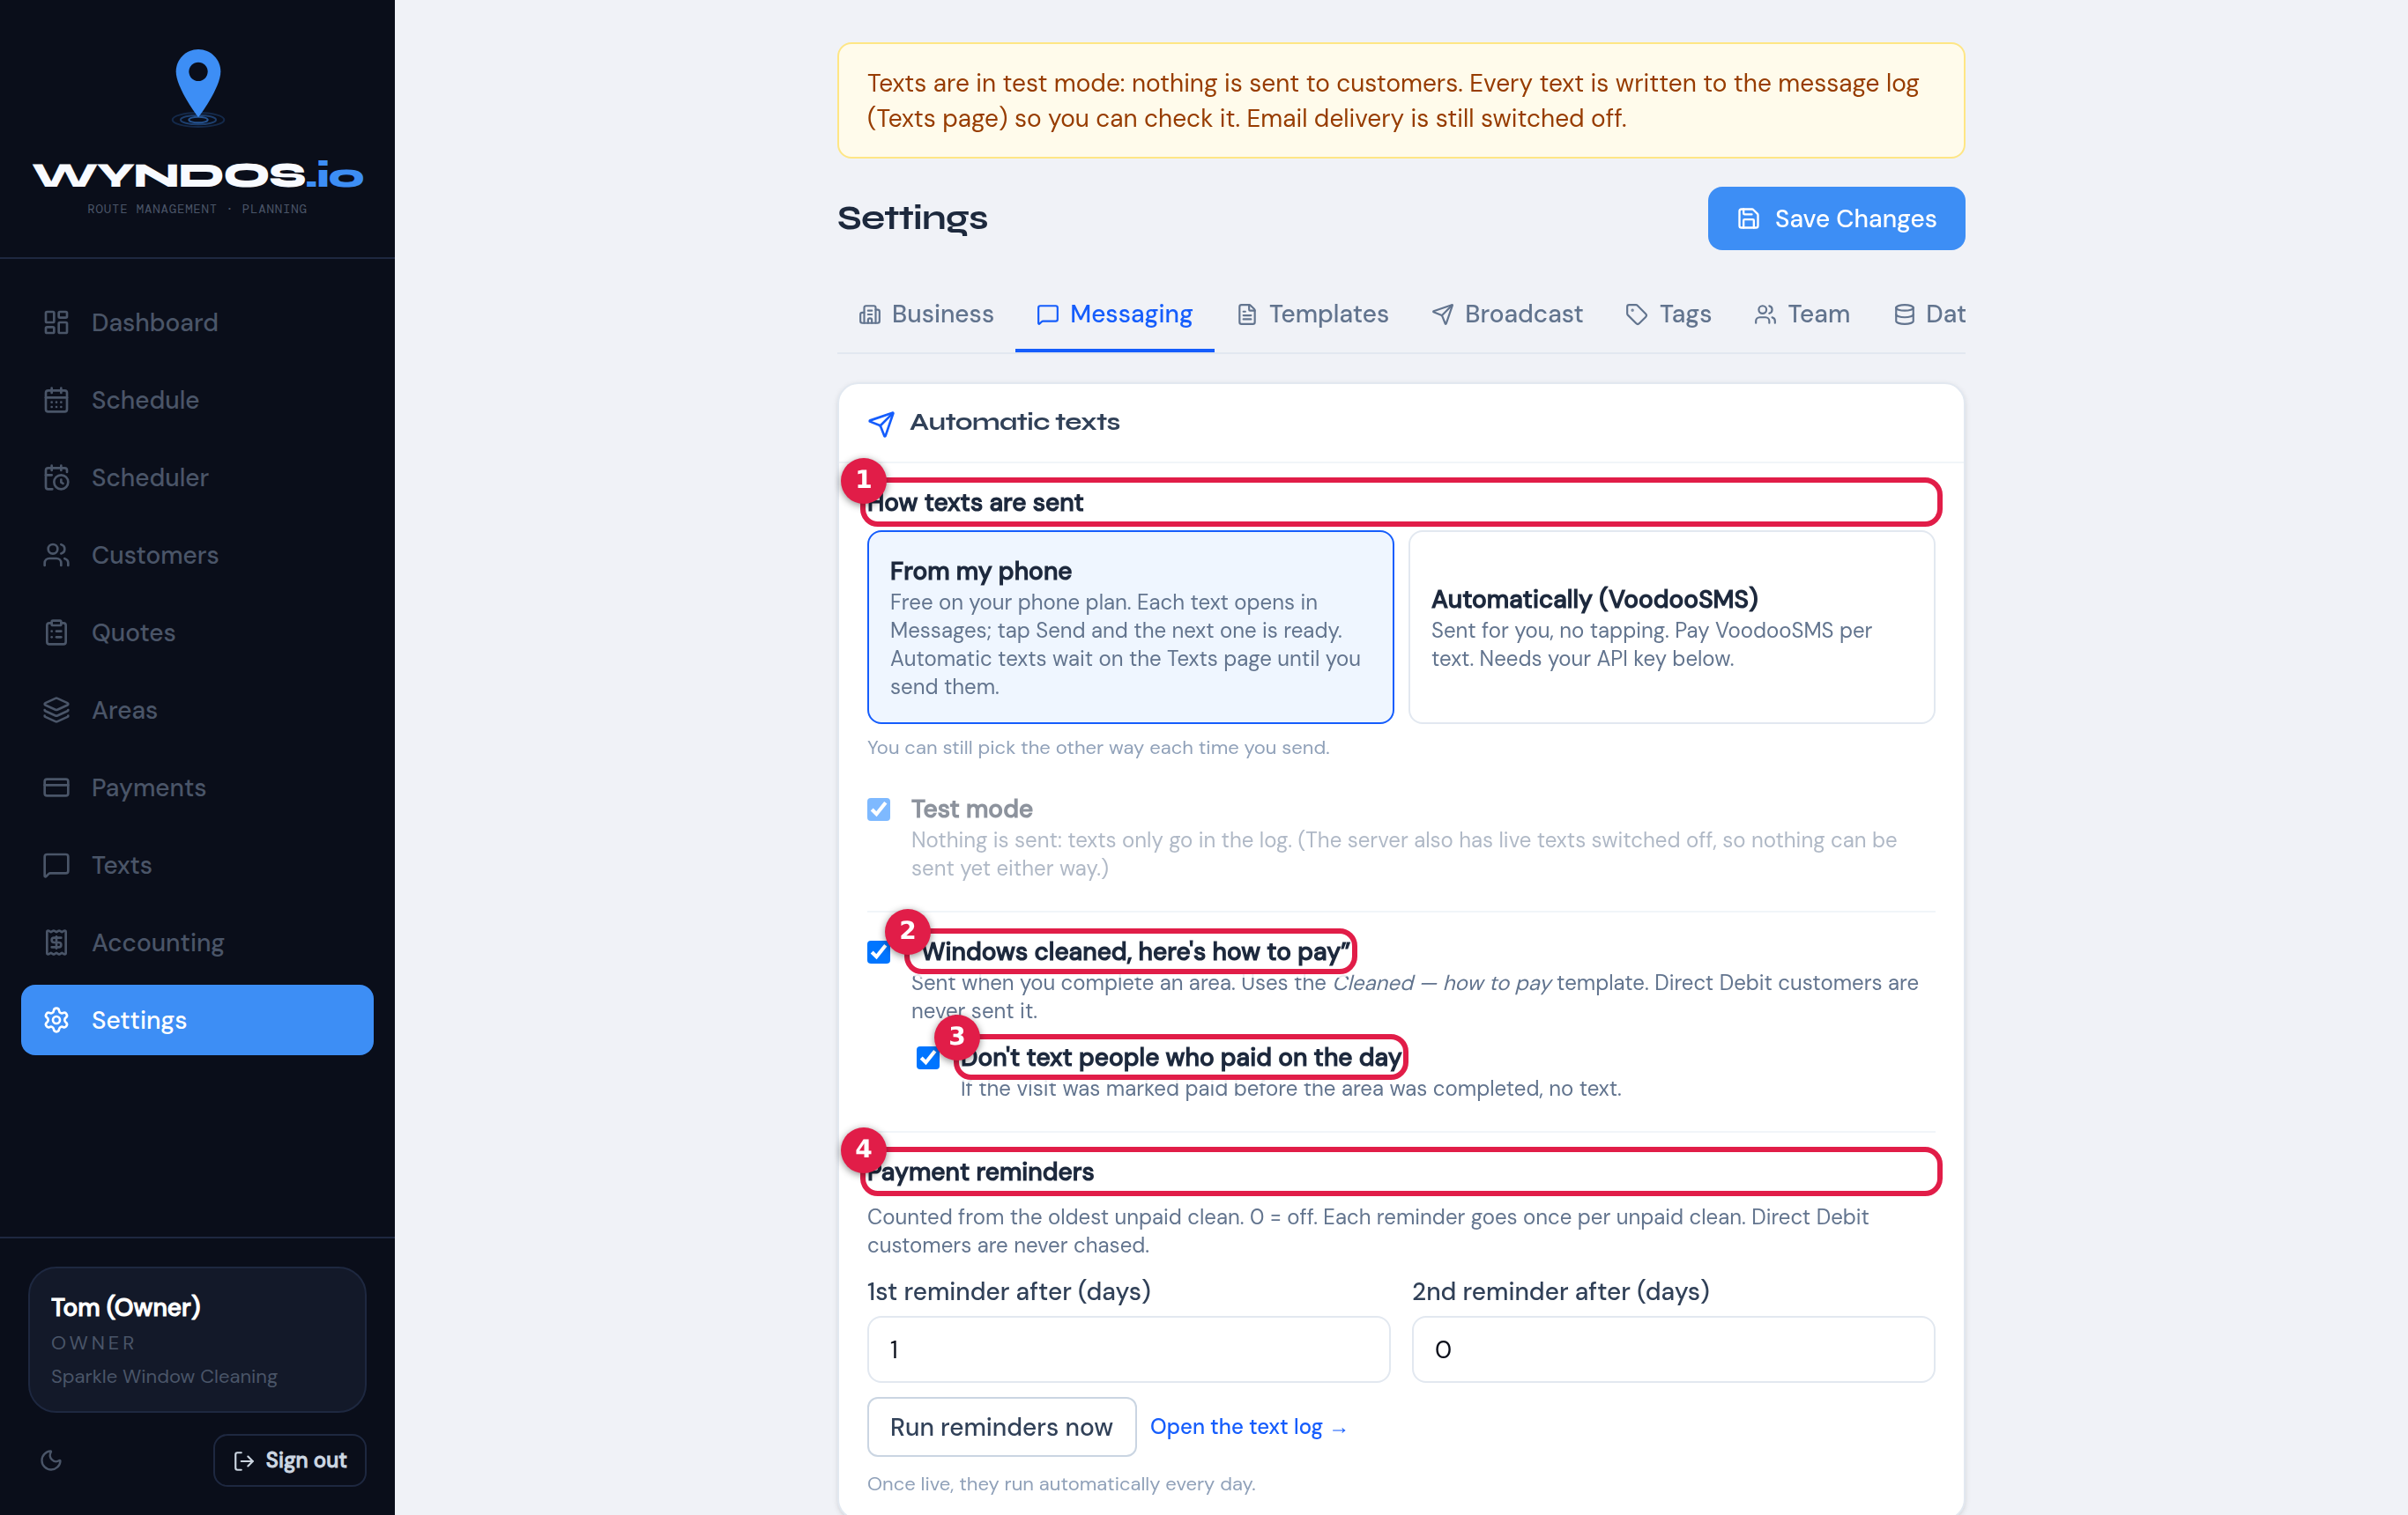
Messaging settings
- How texts are sent: your phone or VoodooSMS, plus the Test mode switch. If you use your phone, automatic texts wait on the Texts page until you tap to send them.
- Windows cleaned, here’s how to pay: sent to each customer when you complete their area. It includes your bank details and uses the first line of their address as the payment reference. Direct debit customers are never sent it.
- Don’t text people who paid on the day: skips anyone marked Done & Paid.
- Payment reminders: how many days after an unpaid clean to send the 1st and 2nd reminders (0 means off). Each reminder goes once for each unpaid clean. Run reminders now sends any that are due straight away. Once switched on, they run automatically every day.

Templates
Settings → Templates holds the saved wording for every kind of text: day reminder, cleaned (how to pay), job complete, the three payment reminders, payment received, and so on.
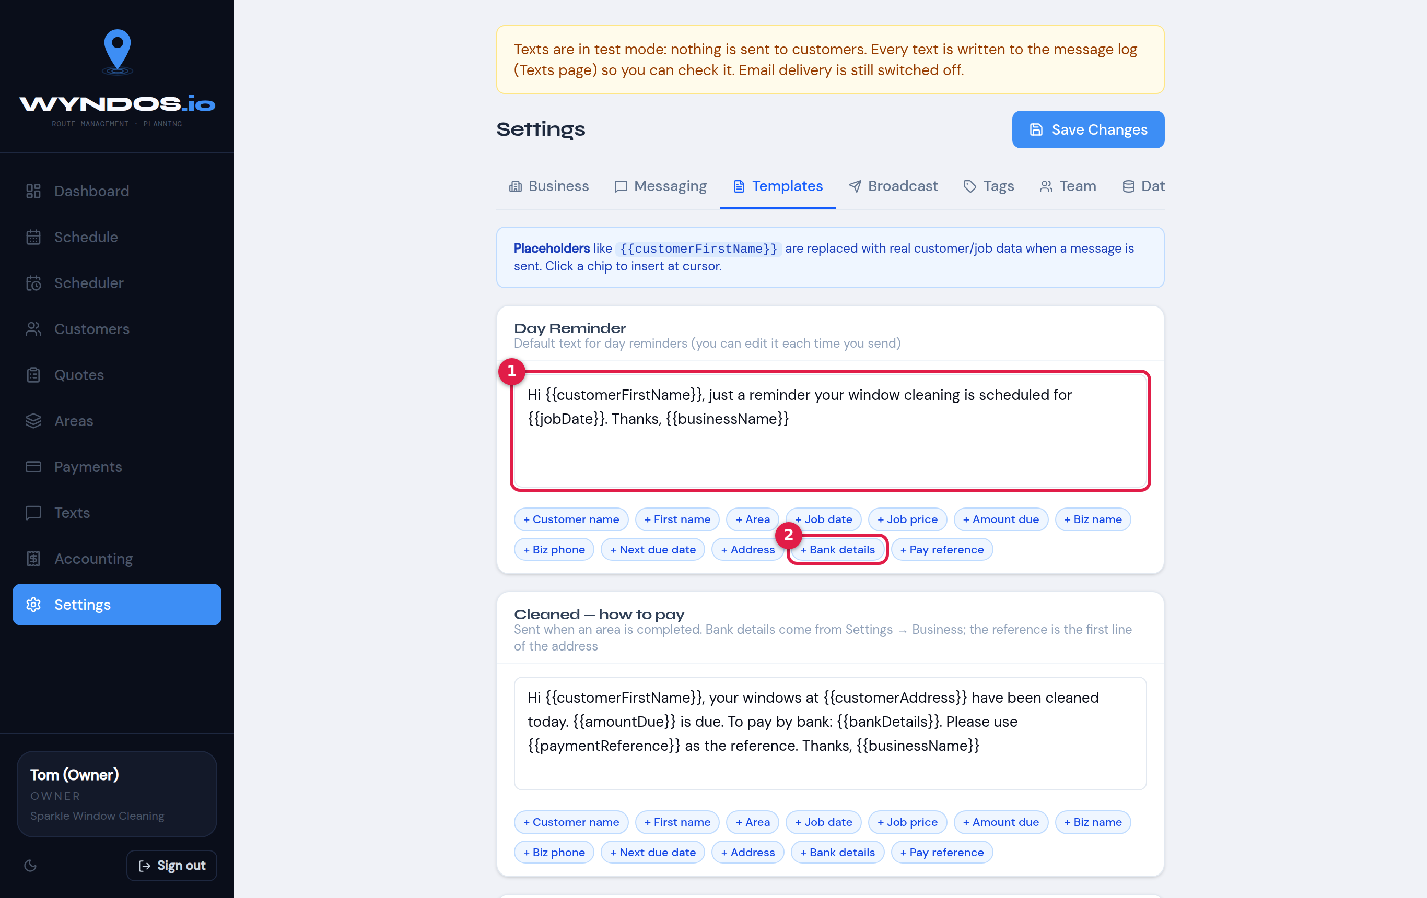
Templates
- Edit the wording in the box.
- Tap a placeholder button to insert it at the cursor. Bank details is highlighted here.
Remember to press Save Changes at the top.

Placeholders
Placeholders are swapped for each customer’s details when the text is sent:
Button | Placeholder | Becomes
First name | {{customerFirstName}} | Their first name. If the name looks like an address, it becomes “there”
Full name | {{customerName}} | Their full name
Address | {{customerAddress}} | Their address
Area | {{areaName}} | Their area
Date | {{jobDate}} | The clean’s date, for example “Tue 27 Oct”
Price | {{jobPrice}} | The price of the clean
Owes | {{amountDue}} | Their total balance
Next due | {{nextDueDate}} | When they’re next due
Bank details | {{bankDetails}} | From Settings → Business
Pay reference | {{paymentReference}} | The first line of their address
Business | {{businessName}} | Your business name
Business phone | {{businessPhone}} | Your phone number
A text of up to 160 characters costs 1 credit on VoodooSMS. The preview shows how many credits each text will use.

Printing and sharing the day
Any day can be printed as a run sheet or shared as a PDF, for example over WhatsApp to a worker without the app.

Print or share from the day screen
On the day screen, the two buttons next to Start day are:
- Share (three connected dots): makes a PDF of the day and opens your phone’s share menu, so you can send it by WhatsApp, email, Messages and so on. On a computer, the PDF downloads instead.
- Print (printer): opens the run sheet ready to print.
The sheet follows whatever you’re looking at:
- By area or All jobs by street order.
- One area or the whole day.

Print for one worker
When a day is split between people, choose whose jobs to print. Open an area card, or the day pop-up in the Scheduler, and set Print / share for:
- Everyone, or
- one person, to get a sheet with only their jobs.

The run sheet
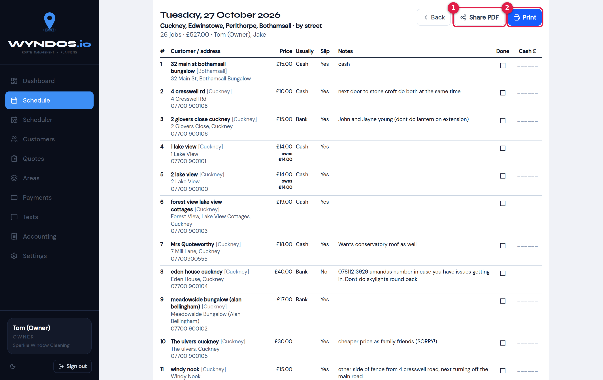
Run sheet
- Share PDF: the same PDF, shared from this page.
- Print: sends the sheet to your printer.
For each house the sheet lists:
- the customer and address
- phone number
- price, and anything owed
- how they usually pay
- whether to leave a slip
- notes
There are Done and Cash £ columns to fill in by hand. Use Back to return to the day.
Prices are left off the sheet for anyone who doesn’t have the See prices permission.

Settings
Settings is split into tabs along the top. Business, Messaging, Templates, Broadcast and Tags need the Settings permission. Team and Data are for the owner only. Remember to press Save Changes after editing.

Business
Your business name, owner name, phone, email, address and logo. The logo is shown on invoices.
Further down are the other business settings:
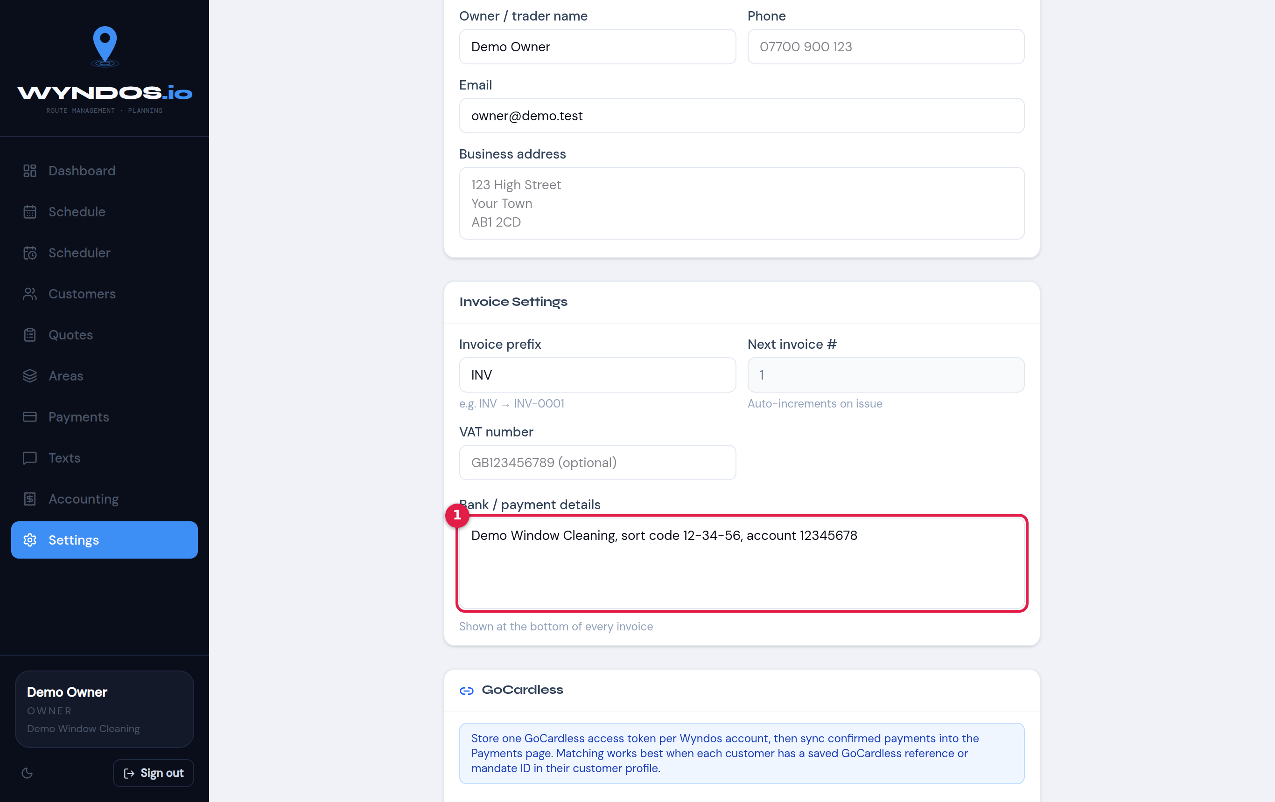
Business settings: bank details
- Bank / payment details. These are printed at the bottom of every invoice and put into texts with the Bank details placeholder. Write them the way you’d want a customer to read them, for example: “Demo Window Cleaning, sort code 12-34-56, account 12345678”.
The rest of this tab:
- Invoice settings:
  - Invoice prefix: for example “INV” gives INV-0001.
  - Next invoice number.
  - VAT number, if you have one.
- GoCardless: paste your GoCardless access token so direct-debit payments can be matched on the Payments page.

Messaging and Templates
These tabs control how texts are sent, test mode, the automatic texts, and the saved wording. They’re explained in full in Texts.
Broadcast takes you to the Texts page for bulk messages.

Tags
Create customer tags, such as “Commercial”, “Key holder” or “Gutters”. You can then tag customers on their page and filter by tag when texting.

Team and permissions
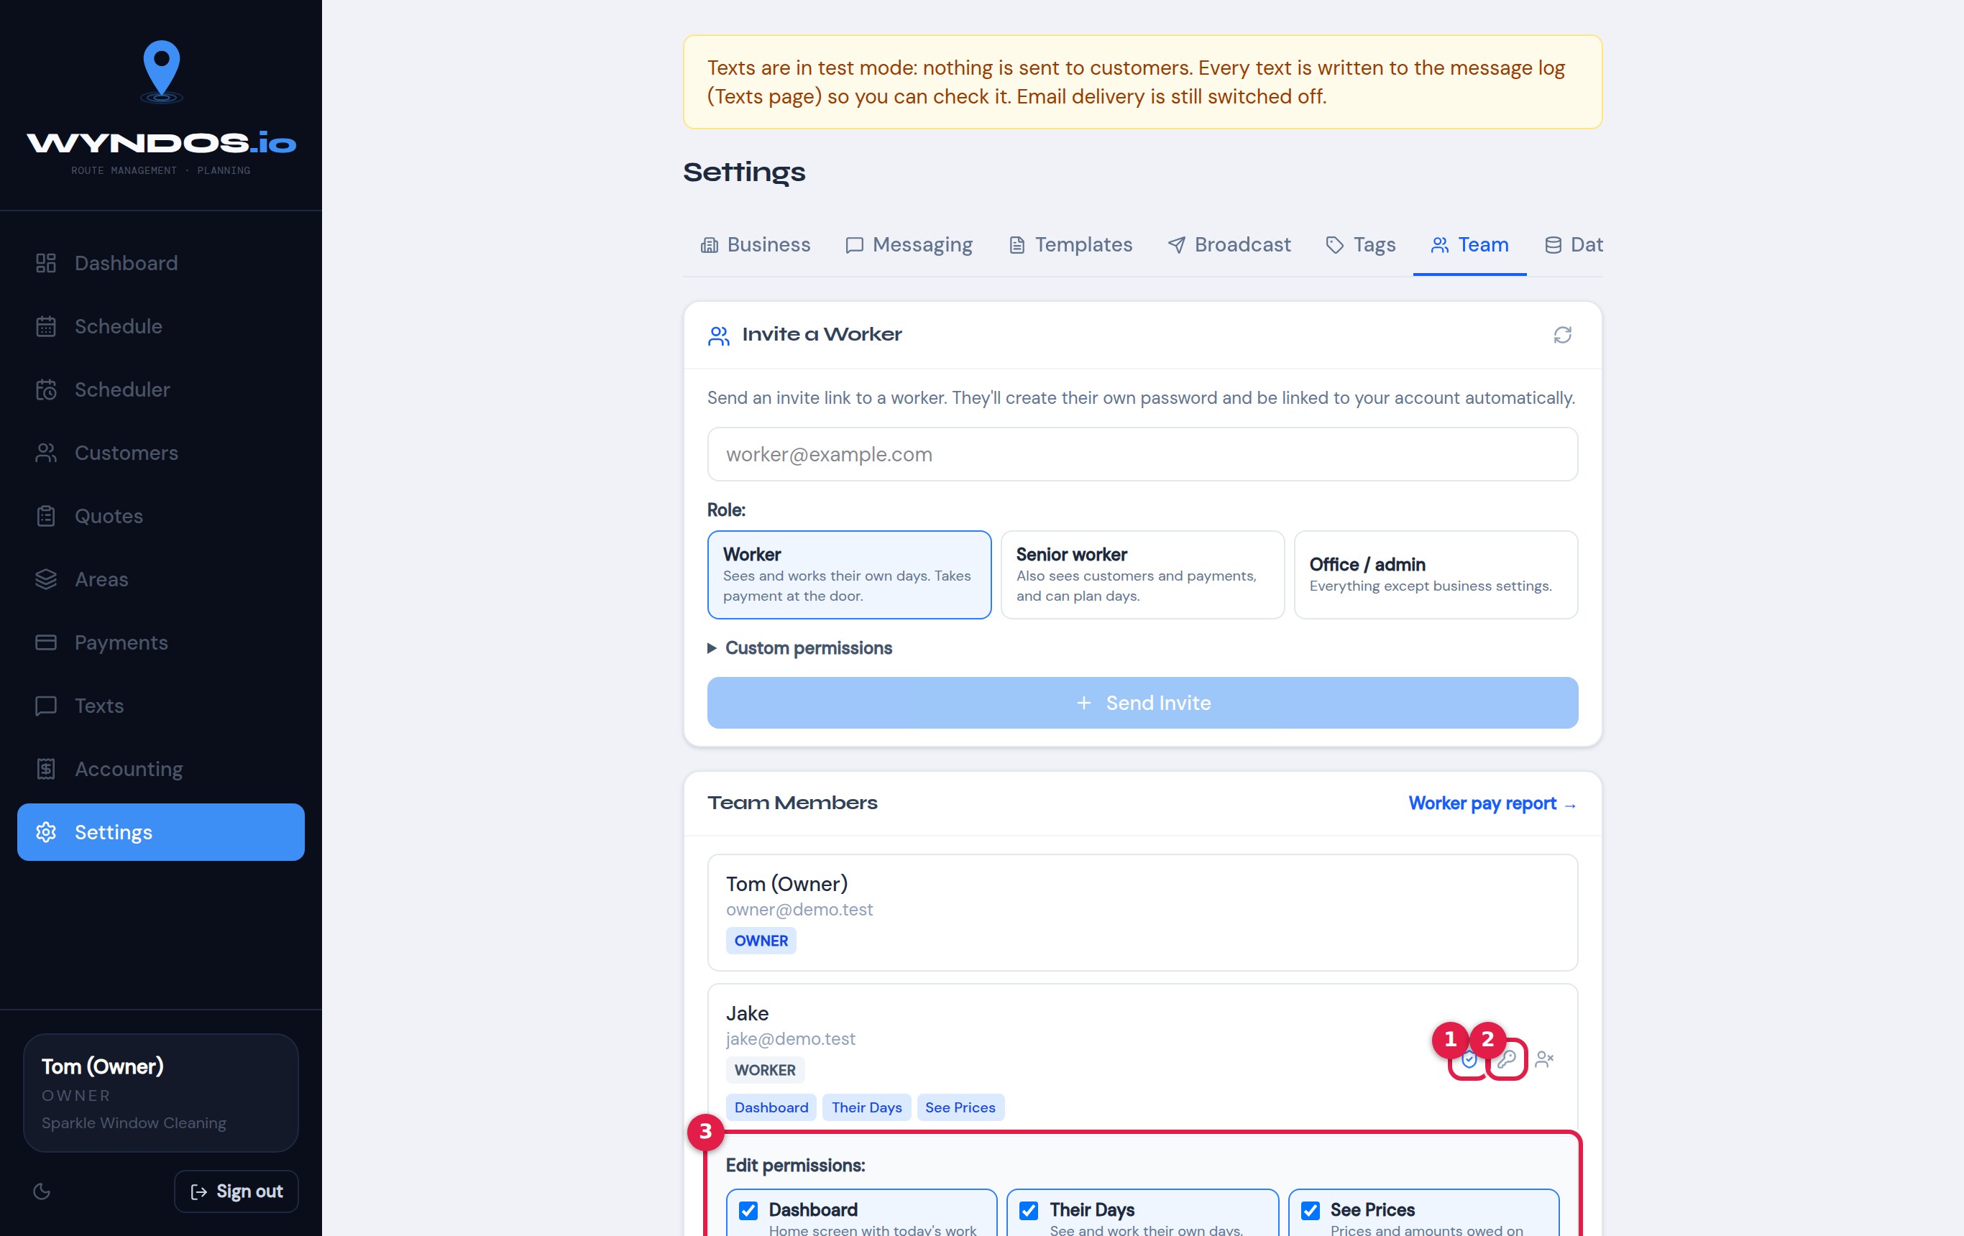
Team settings

Invite someone
- Type their email under Invite a Worker.
- Choose a starting role:
  - Worker: sees and works their own days, and takes payment at the door.
  - Senior worker: also sees customers and payments, and can plan days.
  - Office / admin: everything except business settings.
- Open Custom permissions to fine-tune the role, then press Send invite.
They get a link, create their own password, and join your business.

Team members
Each person is listed with their role and permission tags. The numbered boxes in the picture:
- Edit permissions (pencil icon): change what this person can do.
- Reset password (key icon): set a new password for someone who’s locked out. Type one, or leave it blank and Wyndos makes one up. Give it to them; they can change it later in Settings → Security.
- The permission switches: tick or untick each one. Changes apply straight away.
Worker pay report shows each person’s completed work for paying them.

What each permission allows
Permission | Lets them…
Dashboard | See the home screen with today’s work
Their days | See and work the days or jobs given to them, take payment at the door, book quotes and one-off jobs on their own day
See prices | See prices and amounts owed on their jobs. Without it, prices are hidden, even on printouts
Customers | View, add and edit customers; see Quotes
All payments | See every customer payment, log or edit any payment, send invoices
Texts | Send day reminders and bulk texts
Plan the diary | Use the Scheduler: book, move and give out days
Areas | Create and change areas and their frequency
Accounting | See expenses, other income and business finances
Settings | Change business settings (not Team or Data)
The owner always has everything. Giving someone Their days lets them take payment for their own jobs. It does not open the Payments or Accounting pages; those need All payments and Accounting.

Security (your own password)
Settings → Security lets anyone change their own password: enter the current password, then the new one.

Data
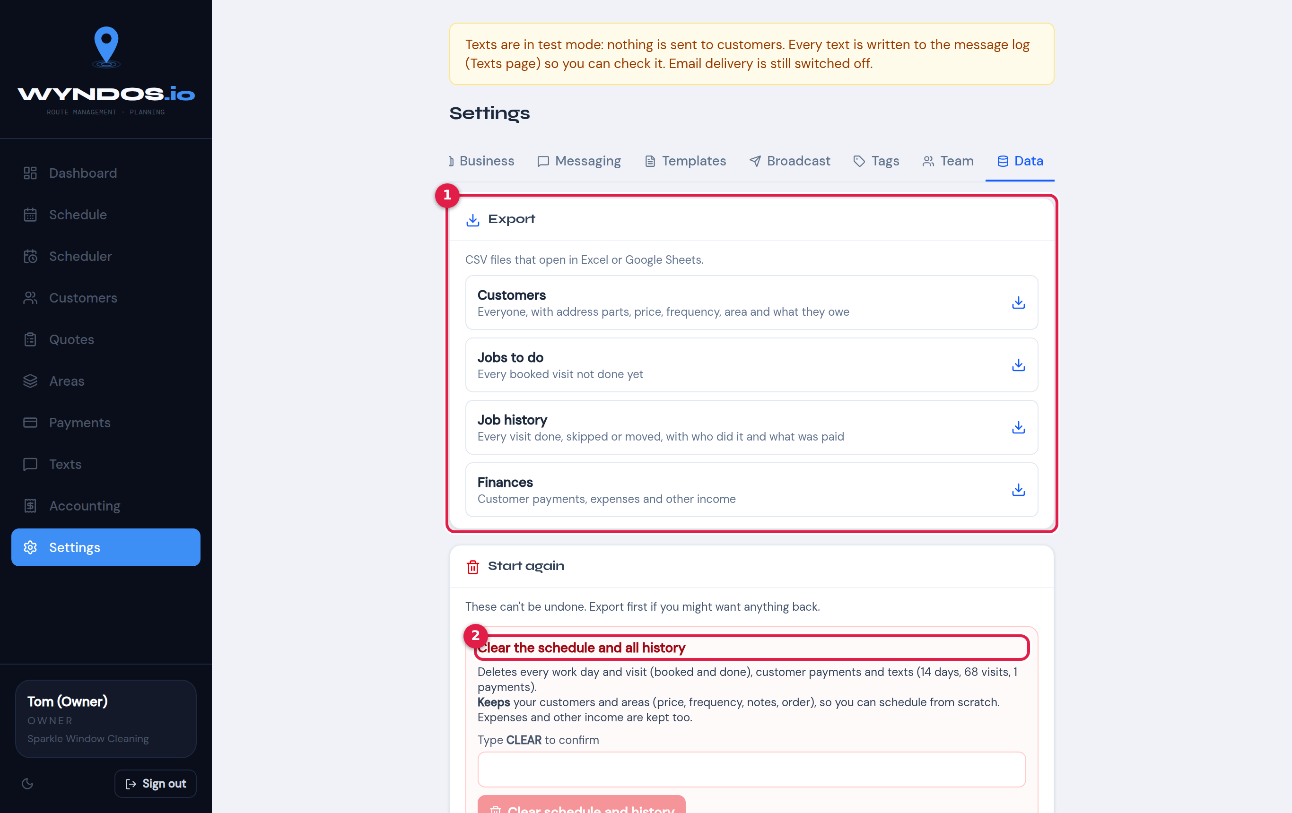
Data settings
- Export: downloads CSV files that open in Excel or Google Sheets:
  - Customers: everyone, with address parts, price, frequency, area and balance. This file can be imported straight back in.
  - Jobs to do: every booked visit not yet done.
  - Job history: every visit done, skipped or moved, with who did it and what was paid.
  - Finances: customer payments, expenses and other income.
- Clear the schedule and all history: deletes every booked day and visit, every payment and every text log. Keeps your customers and areas (price, frequency, notes, order), so you can schedule from scratch. Expenses and other income are also kept. Type CLEAR to confirm.
- Clear everything: deletes customers, areas, the schedule, history, payments, expenses, tags, holidays and texts. Keeps your business details, settings, templates and team. Type DELETE EVERYTHING to confirm.
Warning: Neither clear can be undone. Export first.

Worker guide
This chapter is for people working the round. You’ll mostly use Wyndos on your phone. What you can see depends on what the owner has switched on for you, so your screens may have a few more or fewer buttons than these.

Getting started
- The owner sends you an invite link by email. Open it and choose your own password.
- Go to wyndos.io and sign in with your email and that password.
- Add Wyndos to your home screen so it opens like an app and works with no signal:
  - iPhone (Safari): tap Share, then Add to Home Screen.
  - Android (Chrome): tap ⋮, then Install app.
Forgotten your password? Tap Forgot password? on the sign-in screen, or ask the owner to reset it for you.

Your dashboard
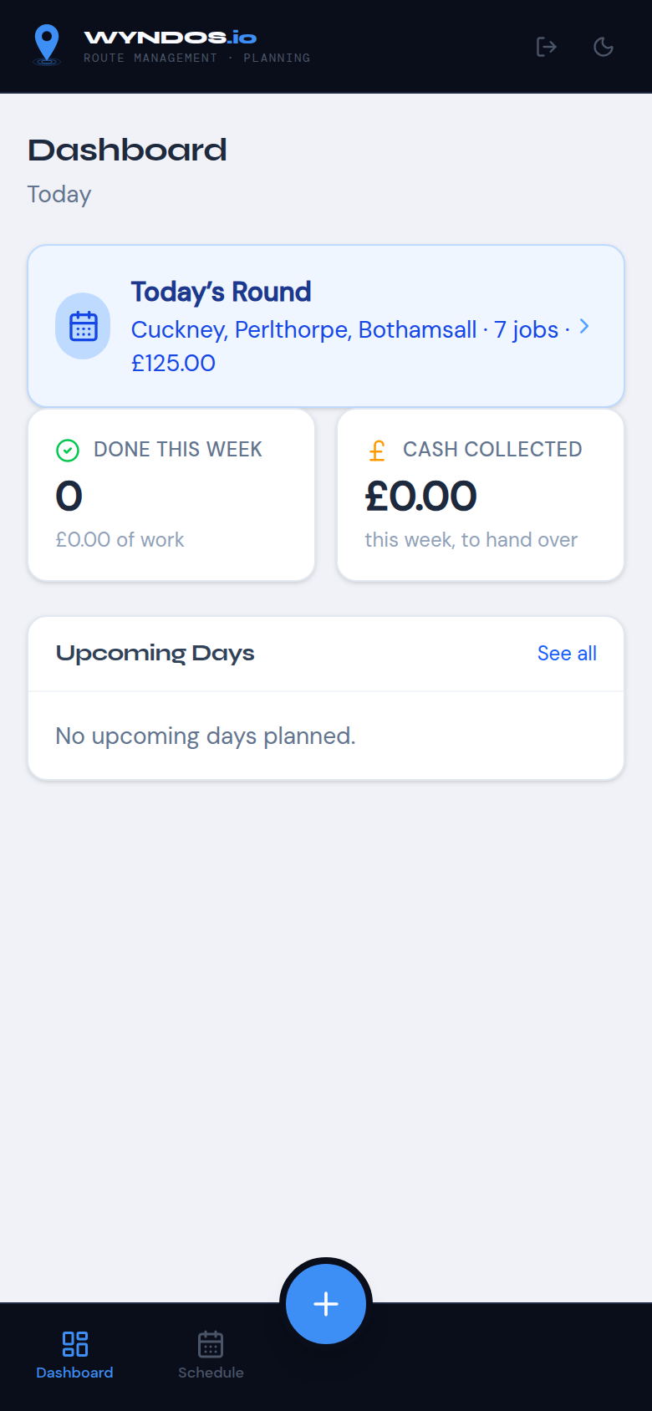
Worker dashboard
- Today’s Round: your areas today, with the number of jobs. Tap it to start.
- Done this week: how many jobs you’ve finished.
- Cash collected: cash taken this week, which you hand over to the owner.
- Upcoming days: your next days.

Your days
Tap Schedule on the bottom bar.
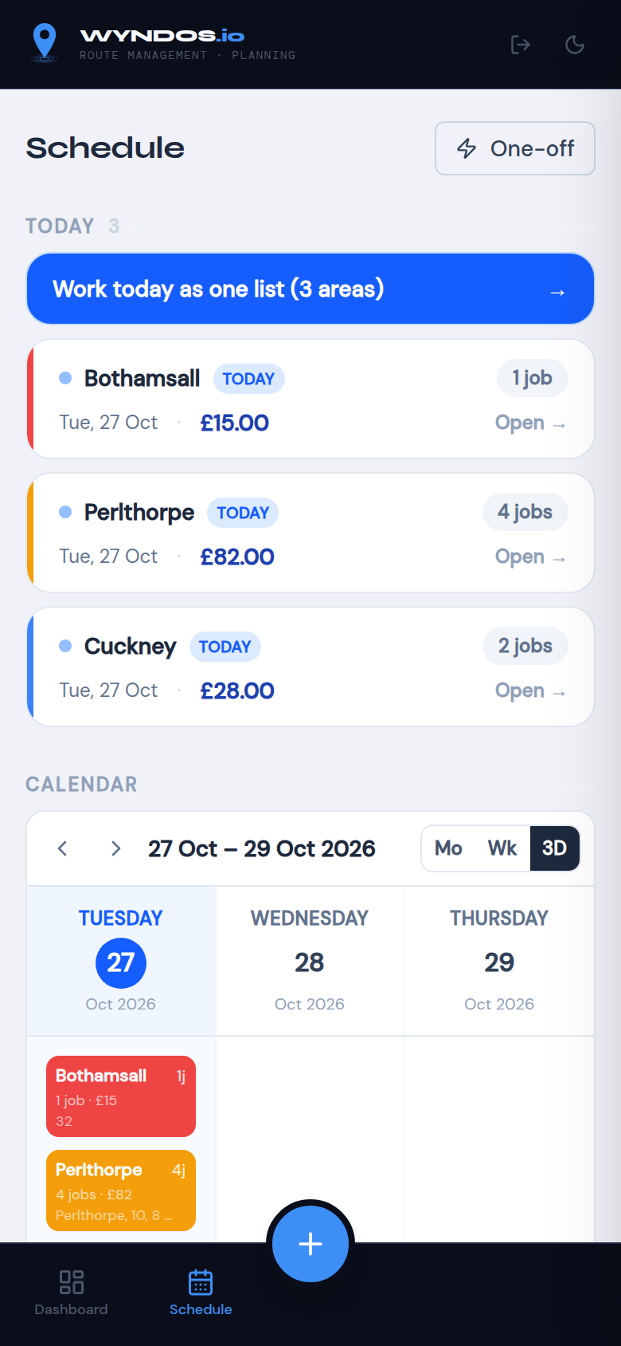
Worker schedule
Today’s areas are at the top. Tap Work today as one list to see all your jobs together. The calendar underneath shows your upcoming days (switch between Month, Week and 3Day).

Working through your jobs
You only see the jobs given to you.
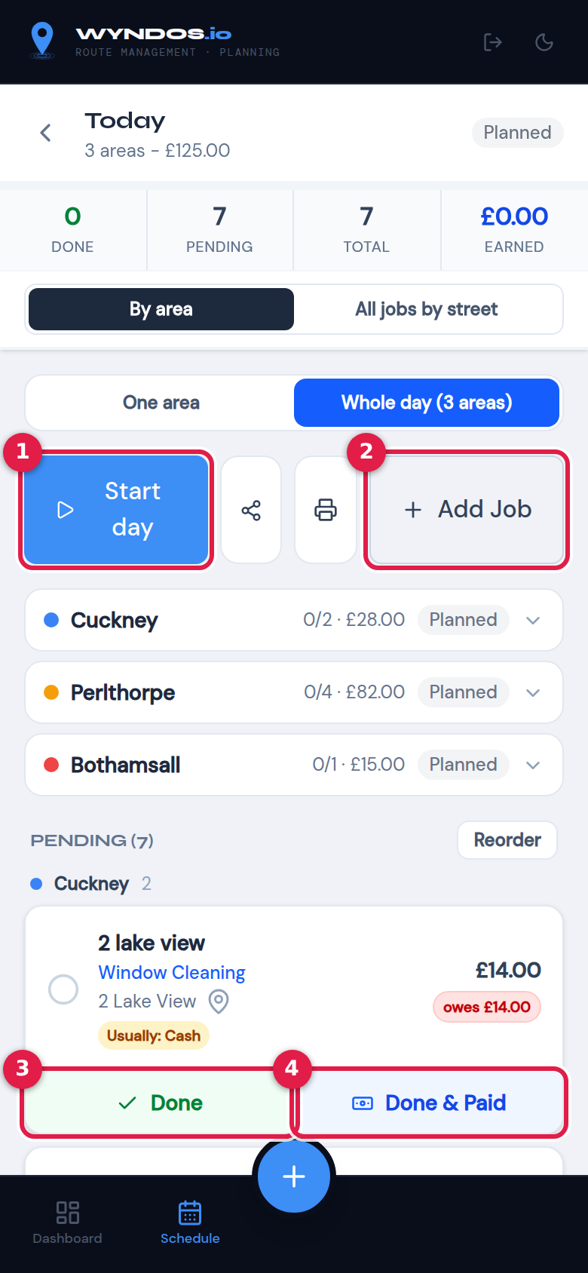
Worker day
- Start day: tap when you begin.
- Add Job: add a one-off job to your day.
- Done: tap when a house is cleaned and they’ll pay later.
- Done & Paid: tap when they paid you there and then. Choose Cash, Card or Bank.
More things you can do:
- By area / All jobs by street: switch between keeping areas together and one list sorted by street.
- Tap a customer’s name to:
  - change today’s price, for example fronts only
  - add a note, such as “gate locked”
  - ring them
  - Skip them if you couldn’t clean
- Map pin: opens the address in Google Maps.
- Tags:
  - Usually: Cash: how they normally pay.
  - Owes £…: they have money outstanding. If they pay it, leave the “Also pay the … owed” box ticked when you choose Done & Paid.
- Notes on the card, such as “watch overhead cables”, come from the office. Read them before you start.
- Tapped the wrong one? Tap the job again and use Undo.
When you’ve finished, tap Complete Day. Anything you didn’t get to is carried over, and the office can see it.
No signal? Keep going. Your taps are saved on the phone and sent when the signal comes back. Don’t close the app until they’ve gone through.

Quick add
Tap the round + button at the bottom.
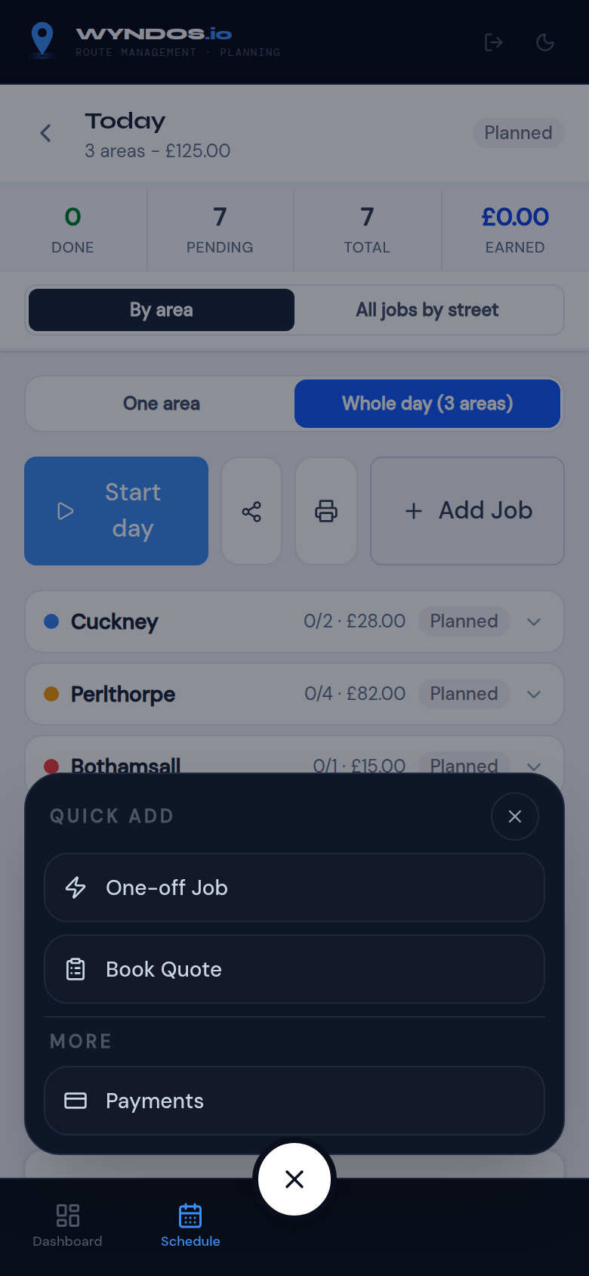
Worker quick add
- One-off Job: book an extra clean, for someone new or existing, onto your day.
- Book Quote: someone asked for a price. Book a quote visit with their name, address and phone. See Quotes for how to mark it quoted, won or lost.
- Payments: if you have the All payments permission.

Payments (if switched on)
Some workers can also see the Payments page, to log money received for any customer.
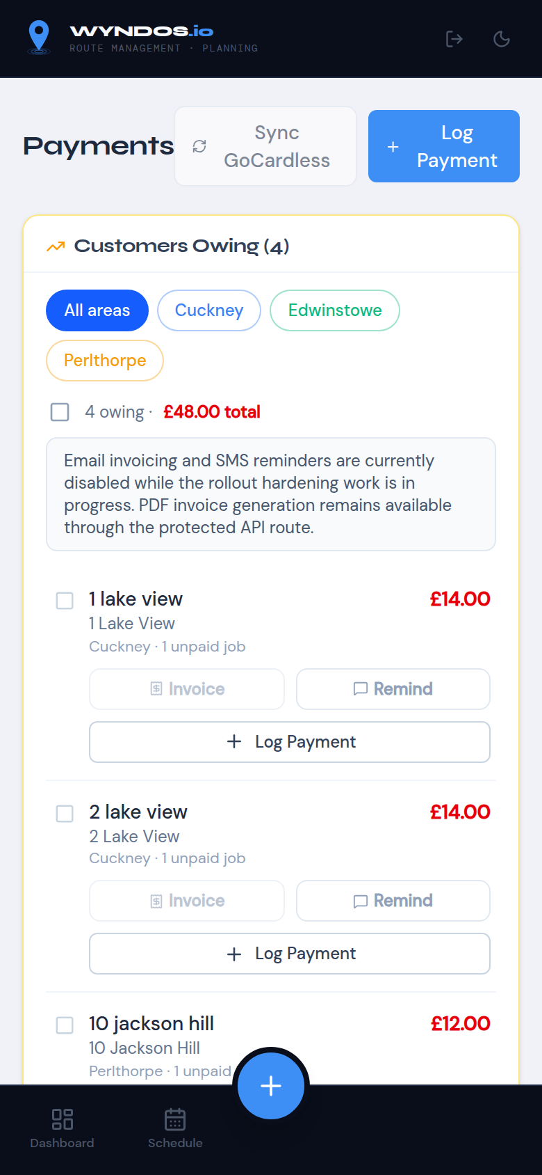
Worker payments

Printing your sheet
The printer button on the day screen prints your jobs only. The share button sends them as a PDF. See Printing and sharing.

Worker FAQ
I can’t see a customer or a page the owner mentioned. Your permissions don’t include it. Ask the owner to switch it on in Settings → Team.
Prices don’t show. The owner hasn’t given you See prices. You can still tick jobs off.
My day is empty. Jobs may be assigned to someone else. Check with the office, or look at the Show jobs for list.

FAQ and troubleshooting

Schedule and areas
How do I change how often a customer is cleaned? Frequency belongs to the area. Either change the area’s frequency, which changes everyone in it, or move the customer to an area with the frequency you want, for example “Cuckney (8 weekly)”. Create that area first if it doesn’t exist.
An area wasn’t booked after I completed it. The next visit is booked when the area is completed. Check the day was completed, and not just had every job ticked. Look in the Scheduler under Areas overdue.
I clicked a day on the Scheduler and want the full list. Press View full day in the pop-up.
How do I move one customer to a different day this time only? Skip them on the day (they move to their next normal visit), or book a One-off Job for them on the day you want.

On the round
I ticked the wrong job. Tap the job again and press Undo.
No signal. Carry on. Taps are saved on the phone and sent when you’re back online. If something couldn’t be saved, you’ll see a warning.
The price was different today. Tap the customer’s name and change the Price before marking the job done. This changes today’s visit only. To change their regular price, edit the customer.
The list order is wrong. In By area view, use Reorder and drag the jobs. For a street-by-street order, switch to All jobs by street. It relies on tidy addresses, so check Customers → Tidy addresses.

Texts
Nobody received my texts. Check the yellow banner. If Test mode is on, texts only go to the log. Turn it off in Settings → Messaging. Also check that the customer’s number is a UK mobile; landlines are marked “no mobile”.
Sending from my phone stopped after one text. After pressing Send in Messages, come back to Wyndos (swipe back or switch apps). The next customer opens by itself. If you left part-way, the green “texts waiting” bar lets you carry on.
Where do replies go? With From my phone, replies come to your own phone. With VoodooSMS, they go to your VoodooSMS account.
How much do texts cost? Texts from your phone cost nothing extra on most plans. On VoodooSMS, each text of up to 160 characters uses 1 credit. Longer texts use more, and the preview shows how many.

Team
A worker can see Accounting or Payments and shouldn’t. Open Settings → Team, press the pencil icon next to them, and untick All payments and Accounting. Their days alone still lets them take payment at the door.
A worker is locked out. Press the key icon next to them in Settings → Team to set a new password.
A worker can’t book a quote. They need the Their days permission. The quote goes on their own day.

Data
Can I get my data out? Yes. Go to Settings → Data → Export. The customers file can be imported back in at any time.
I want to start again with the same customers. Go to Settings → Data → Clear the schedule and all history. Export first.

