**QA Test Feedback**

**Date: 3rd October, 2024**

**Time: 8:00am**

**QA Tester: Gabriel Ameh**

**WHAT DID WORK**

1. **Downloaded the app**

Feedback: This process worked fine. – verdict PASSED

2. **Installation of the app**

Feedback: This process worked fine. – verdict PASSED

**3. Sign Up**

Feedback: This process worked fine. – verdict PASSED

1. **User Login**

Feedback: This process worked fine. – verdict PASSED

1. **User Log Out**

Feedback: This process worked fine. – verdict PASSED

**TEST REPORT FOR OCTOBER**

**What worked**

**Day 3 to 31**: I was able to see the daily devotion for the days–

**verdict – PASSED**

**TEST REPORT FOR NOVEMBER**

**What worked**

**Day 1 to 24**: I was able to see the daily devotion for the days– verdict **– PASSED**

**What did not work**

**Day 25**: I was not able to login, the error below came up when I clicked on **SIGN IN**

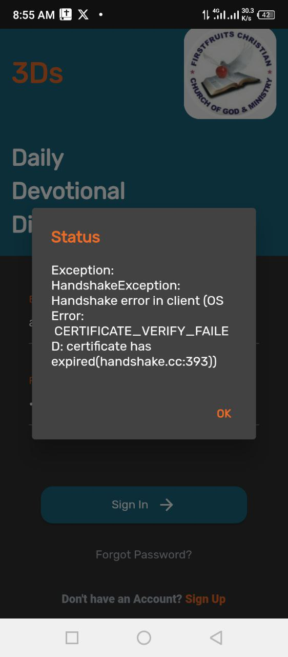

verdict **– Did not PASSED**

**TEST REPORT DECEMBER**

**What did not work**

Day 1 to 31: I was not able to sign in to see the daily devotion for any of the days below is the error I got when clicked on **SIGN IN**.



verdict **– Did not PASSED**