**QA Test Feedback**

**Date: 1st November, 2024**

**Time: 10:30am**

**QA Tester: Gabriel Ameh**

**WHAT DID WORK**

1. **Downloaded the app**

Feedback: This process worked fine. – verdict PASSED

2. **Installation of the app**

Feedback: This process worked fine. – verdict PASSED

**3. Sign Up**

Feedback: This process worked fine. – verdict PASSED

1. **User Login**

Feedback: This process worked fine. – verdict PASSED

1. **User Log Out**

Feedback: This process worked fine. – verdict PASSED

1. **Forgot Password**

Feedback: This process worked fine. – verdict PASSED

**TEST REPORT FOR NOVEMBER**

I was able to view the daily devotion from 1-30. verdict **– PASSED**

**What did not work**

* I could not minimize the app, it kept bring out an error and attempting to close by itself, see image below

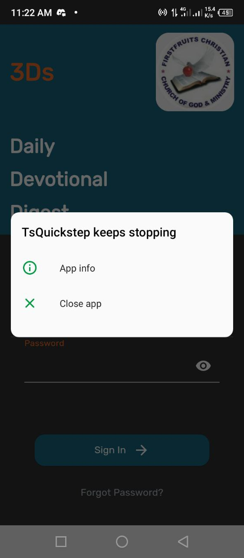

* The app icon is not displaying, see image below

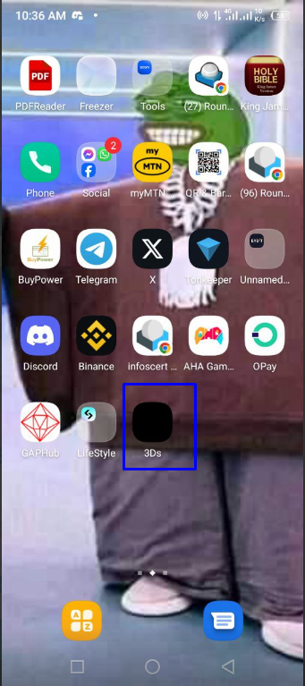

**TEST REPORT DECEMBER**

I was able to view the daily devotion from 1-31. verdict **– PASSED**

**What did not work**

* I could not minimize the app, it kept bring out an error and attempting to close by itself, see image below



* The app icon is not displaying, see image below

