BudgetMinder

# Technical Reference Manual

## Tim mcvicker

## Clemson CPSC4820

## Spring 2017

# Table of contents

Introduction 3

Features 4

Database 5

PHP 6

# Introduction

This Manual is intended for use by developers. It will cover the technical details regarding *BudgetMinder* and its multiple components.

*BudgetMinder* is an Android application that will track and remember purchases and incomes that a user enters through the app. It will keep track of how much money a user has (their balance), and help to alert the user when he or she is spending over what they should. It will provide detailed statistics of expenses and suggestions for how to save more money. There will be multiple users and each user will be able to specify a location for their expense. The application will then display statistics based on the sum of all users’ expenses, and will use these statistics to suggest deviations to everyday expenses that will help the user. *BudgetMinder* was developed using Android Studio 2.3.

JavaDoc comments will be located at <https://people.cs.clemson.edu/~tmcvick/cpsc4820/files/javadoc_budget/index.html> for download.

# Features

The following are core features of the application:

1. Allow a user to register and create an account
2. Allow a user to change their password/username/name
3. Allow users to enter purchases and incomes
4. Keep track of user's balance and display to the user
5. Display purchase/income history

# Database Design

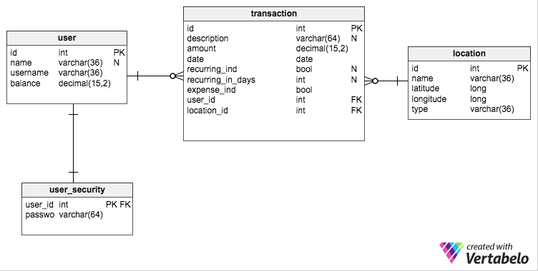*BudgetMinder* uses an external and internal database to persist data entered by users.

All four tables are located in the external database. Upon login, all rows from the transaction table for the user are synchronized with the internal database, as well as the user’s id and username in order to facilitate more efficient updates.

Each transaction has a user and a location. Each transaction also has a Boolean value to indicate whether it is a recurring transaction (recurring_ind) and if so, a value for how often it reoccurs. Each also has a Boolean that indicates whether the transaction is an expense or income (expense_ind = true if the transaction is an expense).

# PHP SCripts (webservice)

In order to facilitate population of the external database, *BudgetMinder* uses multiple PHP scripts. There is no authoring tool, due to the fact that there should be no modifications or additions to the tables through any medium except the application itself. Each PHP script utilizes query parameters to perform database operations. Links to the scripts are below, with query parameters as examples.

1. **Create User:** <https://people.cs.clemson.edu/~tmcvick/cpsc4820/budget/create_user.php?name=Tim&uname=tmcvick&balance=50.34&pword=tim>
2. **Get User by Username:** <https://people.cs.clemson.edu/~tmcvick/cpsc4820/budget/get_user.php?uname=tmcvick>
3. **Update User By ID:** <https://people.cs.clemson.edu/~tmcvick/cpsc4820/budget/update_user.php?name=Timupdate&uname=tmcvickupdate&balance=55.345&pword=passupdate&id=5>
4. **Get Transactions By UserId:** <https://people.cs.clemson.edu/~tmcvick/cpsc4820/budget/get_transactions_for_user.php?id=5>
5. **Create Transaction:** <https://people.cs.clemson.edu/~tmcvick/cpsc4820/budget/create_transaction.php?desc=testdesc&amount=50.05&rec=false&days=0&expense=false&user=5&location=1>
6. **Get All Users:** <https://people.cs.clemson.edu/~tmcvick/cpsc4820/budget/get_all_users.php>